Model Name

Date: 11/4/2009

Product Name: | DWS-4026
Revision: | A1
Picture: | 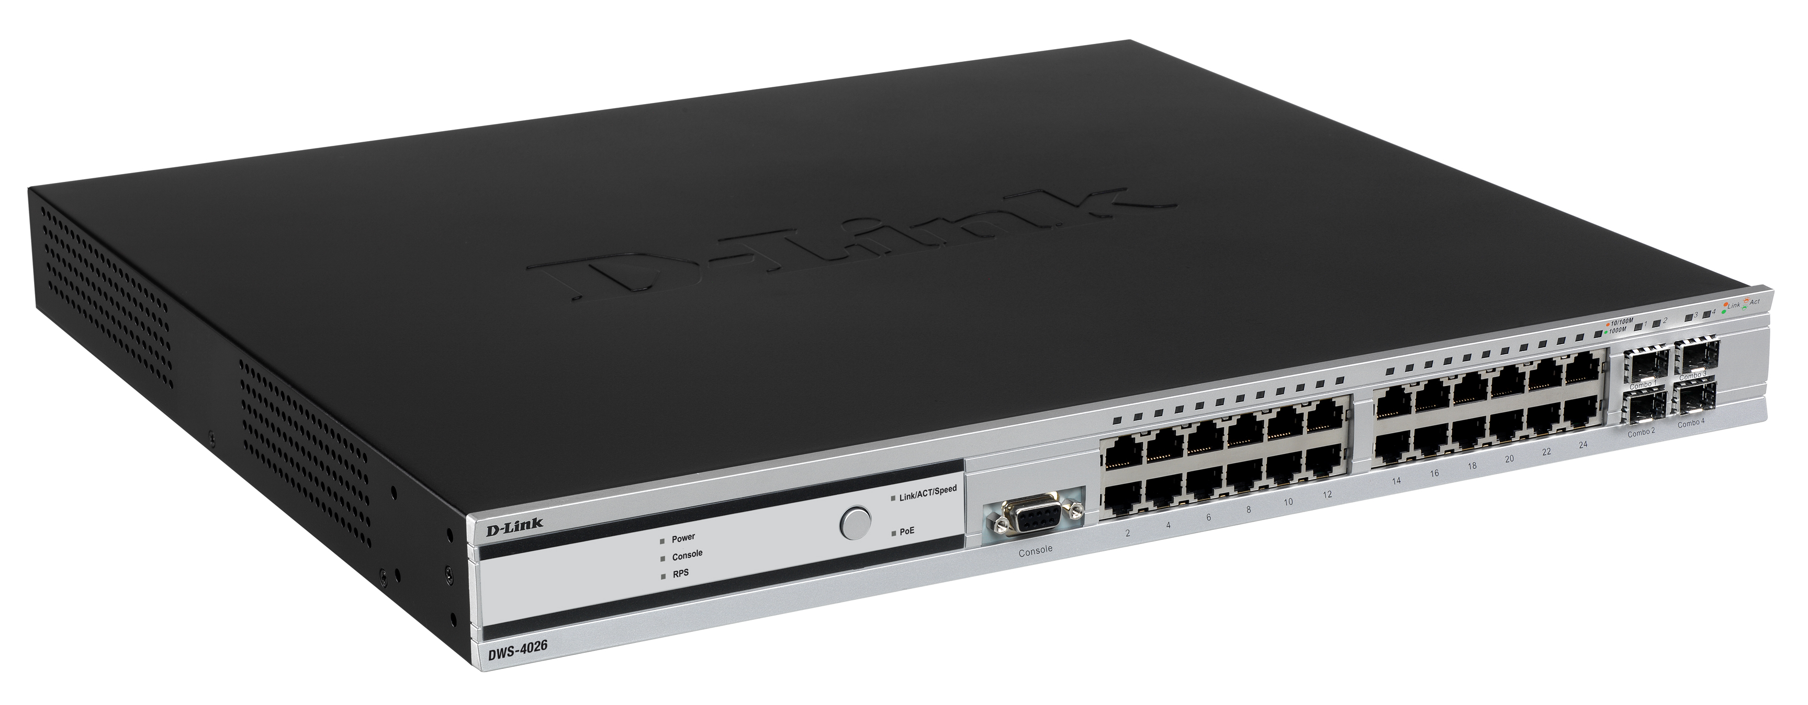
Why Sell This Product: | After two years of selling Unified Switch, D-Link sees a growing demand for higher throughput, more advanced switch features, the need for flexibility, scalability and 802.11n AP upgrade for wireless networks. DWS-4026 is D-Link’s next-generation Unified Switch with more advanced feature as well as 802.11n support. With DWS-4026, D-Link further expands its leadership in the Unified Wired and Wireless market.  Following the success of DWS-3024 and 3026 models, which manage IEEE 802.11a/b/g Access Points, DWS-4026 is able to manage 802.11n Access Point, DWL-8600AP, for higher throughput, reliability and scalability. It is a full-featured Unified Switch that centrally manages up to 64 Access Points, delivering integrated wireless mobility and security for both wired and wireless users.
Key Features: | - 24 PoE Gigabit Ports with 2 10G uplink  - Manages up to 64 APs per switch  - Supports DWL-8600AP 802.11n Dual-band Access Point.  - Manages up to 8 switches in one peer group  - Switch Clustering for single-IP management  - Wired and Wireless Captive Portal for robust client authentication  - Adaptable Wireless enables Tunnel (L3 Tunneling) and Non-Tunnel (VLAN Forwarding) Modes  - Seamless L2/L3 fast roaming from AP to AP  - AP-AP Tunnel enables client traffic to be forwarded across subnets at the edge  - Supports WEP, Dynamic WEP, WPA/WP2 Personal/Enterprise security  - Wireless Intrusion Detection System (WIDS)  - Rogue AP Detection, Classification and Mitigation  - Auto Power Adjustment and Auto Channel Selection for managed AP.  - Supports RIPv1/v2 dynamic routing
Technical Details: | Standards  - IEEE 802.3, 802.3u, IEEE 802.3ab 1000BASE-T Gigabit Ethernet, 802.3z, 802.3ae compliance  - Support Full-Duplex operations  - IEEE 802.3x Flow Control support for Full-Duplex mode, back pressure support for Half-Duplex mode  Protocol  - CSMA/CD  Switching Capacity  - 88 Gbps  Data Transfer Rates  - 65.47 Mpps  MAC address Table  - 8K  IP address Table  - 128 Static Route  External RPS Support  - DPS-600  Physical & Environmental  Max. Power Consumption  460 W  Operating Temperature  0 to 40 ℃  Storage Temperature  -10 to 70 ℃  Humidity  - Operation: 10%-90% RH  - Storage: 5% ~ 90% RH  Dimensions  441mm x 389mm x 44mm
EMI/EMC Report | ☑FCC No. ☑ CE No. ☑ VCCI No.  ◻ CTR-21 No. ◻ C-Tick No. ◻ A-Tick No.  ◻ FDA No. ◻ R&TTE No. ◻ BSMI No.  ◻ IC No ☑ Others: EN60601-1-2
Safety | ◻ TUV No. ☑ UL No. ◻ CSA No.  ☑ CB No. ☑ CE ◻ Others
Packaging Style | ◻Clamshell ◻ White Box ◻Gift Box Bulk ☑Brown Box ◻Others
Packaging Contents: | - DWS-4026 device x1  - AC Power Cord x 1  - Console Cable x 1  - Rack-mount kit (1 set)  - Screw for Rack-mount kit x 8  - Rubber feet x 4  - Generic Managed Switch Quick Installation Guide  - CD-ROM with Manuals  - Addendums for different regions
Country of Origin: | Taiwan

UPC Code:
  UPC |  | Part Number
  790069 | 325533 | BWS4026A.....A1
  790069 | 325540 | EWS4026M.....A1G
  790069 | 325557 | IWS4026A.....A1G
  790069 | 325564 | IWS4026B.....A1G
  790069 | 325571 | IWS4026E.....A1G
  790069 | 325588 | IWS4026N.....A1G
  790069 | 331565 | IWS4026Z.....A1G
  790069 | 325595 | NWS4026C.....A1G
  790069 | 325601 | TWS4026A.....A1G
  458221 | 7052103 | JWS4026J.....A1G
Units Per Carton: | For USA | For EU | For WW
Units Per Carton: | 2pcs/carton | 2pcs/carton | 2pcs/carton
Cartons Per Pallet: | For USA | For EU | For WW
Cartons Per Pallet: | Air:12, Sea: 18 | Air:18, Sea: 18 | Air:12, Sea: 18
Dimensions and Weight: | Box:  ◻ 237x168x36mm (Type A) ◻ 168x237x53mm (Type A53)  ◻ 225x150x75mm (Type B) ◻150x225x55mm (Type B1)  ◻ 269x162x65mm (Type C) ◻ 274x208x68mm (Type D)  ◻ 208x274x95mm(Type D95) ◻ 208x137x95mm (Type D95 half)  ◻ 274x208x118mm (Type D1) ◻ 274x208x138mm (Type D2)  ◻ 208x274x190mm (Type D4) ◻ 288x245x66mm (Type E)  ◻ 245x285x82mm(Type E1) ◻245x285x87mm(Type E2)  ◻ 256x356x97mm (Type F) ◻137x 208x 36mm (Type G)  ◻ 208x250x68mm (Type H) ◻253x 274x247mm (Type I)  ☑ Others __565x530x145mm__, 7.725 kg  Device (mm / g):  Carton (cm/ kg):  Pallet (cm/ kg):  INTRASTAT weight: 6.575kg  Packing material weight (Box):  - Paper: 0.885kg  - Plastic: 0.265kg  - Mixed: 0kg
  Device Length | Device Width | Device Height | Device Weight
  441mm | 389mm | 44mm | 6.2930kg
  Carton Length | Carton Width | Carton Height | Carton Gross Weight
  589mm | 310mm | 566mm | 15.45KG
  Carton per Air Pallet | Air Pallet PCS | Air Pallet Length | Air Pallet Width | Air Pallet Height
  US 12  EU 18  WW 12 | US 24  EU 36  WW 24 | US 1020mm  EU 1200mm  WW 1200mm | US 1220mm  EU 1100mm  WW 1100mm | US 1262mm  EU 1833mm  WW 1267mm
  Carton per Sea Pallet | Sea Pallet PCS | Sea Pallet Length | Sea Pallet Width | Sea Pallet Height
  US 18  EU 18  WW 18 | US 36  EU 36  WW 36 | US 1020mm  EU 1200mm  WW 1200mm | US 1220mm  EU 1100mm  WW 1100mm | US 1828mm  EU 1833mm  WW 1833mm

