DEM-423XT

Date: Oct 26,2005

Product Description: | 10G Single-Mode ER 40KM Transceiver (XFP)
Revision: | A1
Availability: | Nov., 2005
Picture: | 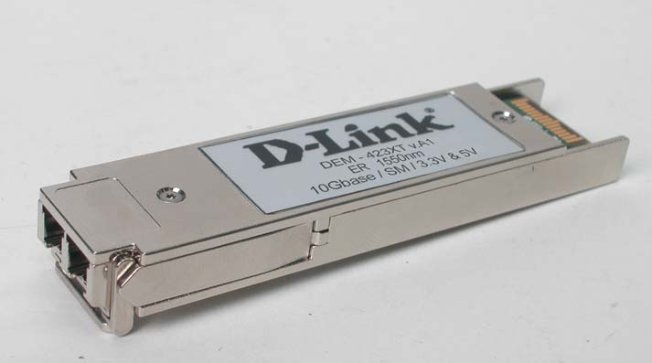
Why Sell This Product: | - This represents the 10Gigabit Fiber solution D-Link LAN switches: This transceiver provides 40KM long-distance 10G fiber connection and switch-to-the-backbone attachment applications.  - This transceiver allows you to provide a complete solution for the switch with 10Gigabit XFP slot and 10Gigabit optional module.  Selling Points  - Standard compliance: This transceiver fits into any XFP slot of the LAN switches or their optional modules.
Key Features: | - Up to 40 km single-mode fiber cable distance coverage  - Compliance with IEEE-802.3ae 10GBASE-ER specifications  - 9.95Gbps to 10.7Gbps transmission rates support  - 1550nm wave length  - +3.3V/5V power supply support  - Compliant with Multi-Source Agreement (MSA) Small Form Factor Pluggable  - Hot-pluggable XFP footprint  - Duplex LC connector
Technical Details: | Standard  IEEE 802.3ae 10GBASE-ER 10Gigabit Ethernet  Transceiver Type  XFP (Small Form Factor Pluggable)  Connector  Duplex LC  Data Rates  9.95Gbps to 10.7Gbps  Wavelength  1550nm  Cable Type  9/125um single-mode fiber  Maximum Cable Distance Coverage  40 km  Voltage  +3.3V and +5.0V support  Operating Temperature  -5 to 70 ℃  Storage Temperature  -40 to 85 ℃  Humidity  0% to 85% RH  Emission  - FCC Class B  - CE
EMI/EMC Report | ☑FCC No. ☑ CE No. ◻ VCCI No.  ◻ CTR-21 No. ☑ C-Tick No. ◻ A-Tick No.  ◻ FDA No. ◻ R&TTE No. ◻ BSMI No.  ◻ IC No. ◻ Others
Safety | Laser Eye Safety :  ☑ FDA No. ☑ CDRH No. ☑ TUV No.  ◻ CB No. ◻ Others  Electrical Safety :  ☑ TUV No. ☑ UL No. ☑ CSA No.  ◻ CB No. ◻ Others
Packaging Style | ◻ Clamshell ◻ White Box ◻ Gift Box ◻ Bulk ☑ Brown Box ◻ Others
Packaging Contents: | - DEM-423XT x 1
UPC Code:
  EEM423XT..A1G | 790069 | 288036
  IEM423XT..A1 | 790069 | 288043
  NEM423XT..A1 | 790069 | 288050
Units Per Carton: | For USA | For EU | For WW
Units Per Carton: | 34 | 34 | 34
Cartons Per Pallet: | For USA | For EU | For WW
Cartons Per Pallet: | N/A | N/A | N/A
Dimensions and Weight: | Box: 145 x 100 x 48 mm, 0.1 kg  Carton: 362 x 312 x 265 mm, 4.1 kg  Pallet: N/A  INTRASTAT weight: 0.097 kg (Box)  Packing material weight (Box):  - Paper: 0.09 kg  - Plastic: 0.007 kg  - Mixed: 0.00 kg

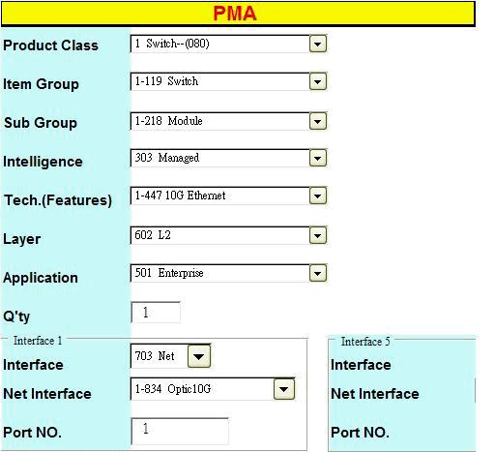

Approved | Checked | PM
Akira Huang | Crowley Wu | Heidi Yang

