DES-6506

Date: March 25, 2005

Product name: | 24 port 10/100Base-TX patch panel for DES-6510
Revision: | 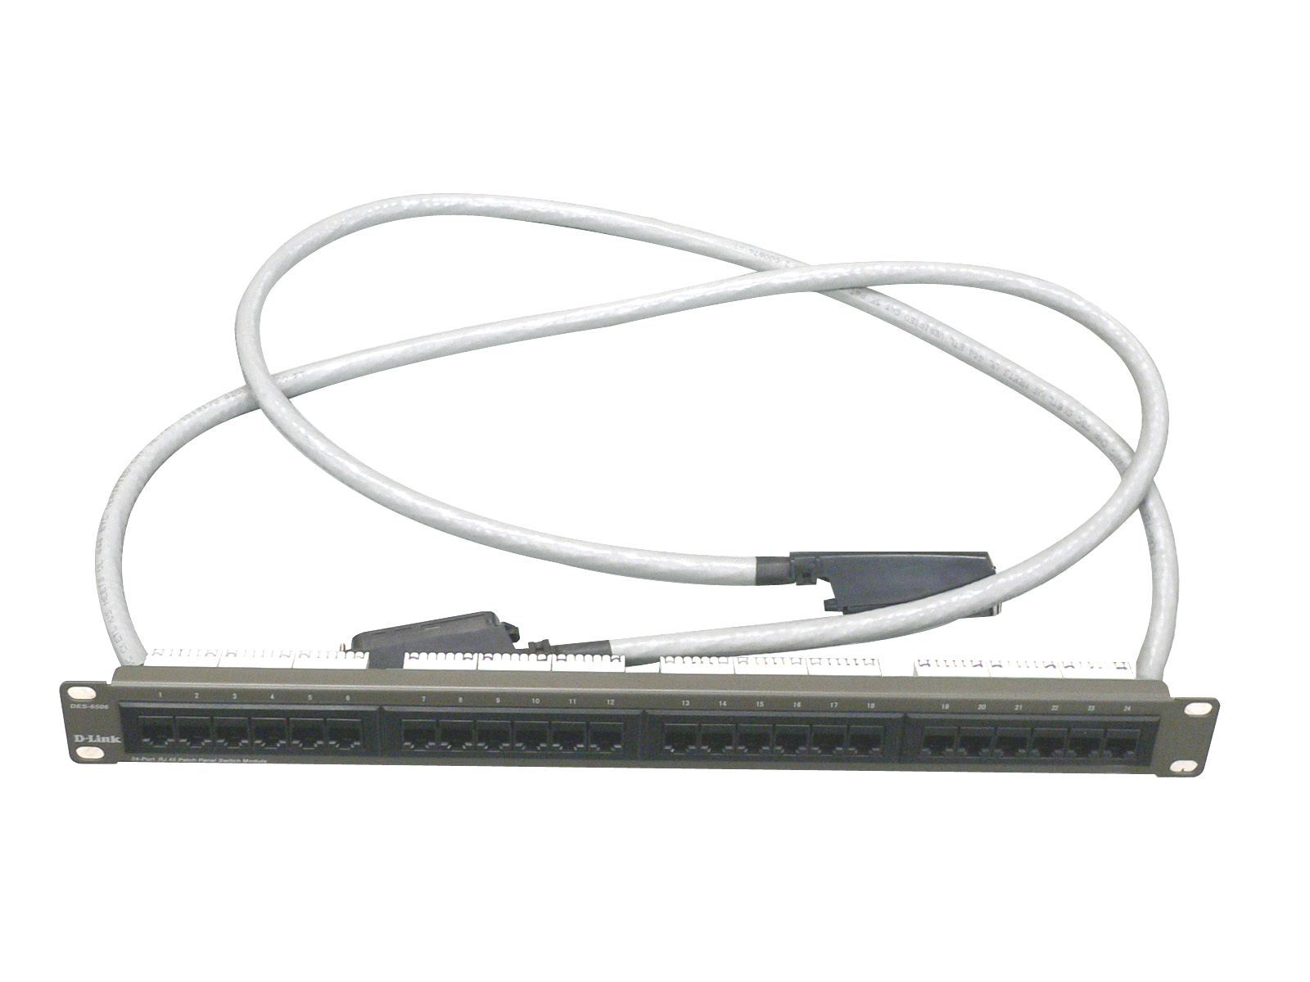  A1
Available: | 2004/12/8
Picture:
Why Sell This Product: | - The DES-6500 L3 chassis switch with many advanced functions has been released some time ago. However, sales of this enterprise solution switch could not really take off without many optional port modules waiting in the wing for completion. Now that these optional modules are available, we’re announcing the release of the DES-6506 24-port patch panel, which is designed to work with the 24-port (RJ-21 connector) 10/100BASE-TX DES-6510 module. System integrators wishing to set up a high port density network can install the DES-6510 modules in the DES-6500 chassis together with this DES-6506 patch panel.  - Target users: enterprise business users, system integrators.
Key Features: | - Patch panel for 24 Ethernet ports  - Equipped with 2 RJ-21 connectors, 24 RJ-45 connectors  - Works with 24-port DES-6510 Ethernet module for DES-6500 chassis switch  - Fully complies with IEEE 802.3 10BASE-T, 802.3u 100BASE-TX
Technical Details: | Standards  - IEEE 802.3 10BASE-T  - IEEE 802.3u 100BASE-TX  - ANSI/IEEE 802.3 NWay auto-negotiation  - IEEE 802.3x Flow Control  Topology  Star  Network Cable  Ethernet Cat. 5 cable (max. 100 m)  Number of Ports  24 10/100BASE-TX Ethernet ports  Connectors  - 2 RJ-21 connectors, each supports 12 Ethernet connections  - 24 RJ-45 connectors  Physical & Environmental  AC Input  None  Power Consumption  None  Operating Temperature  0 to 40 ℃  Storage Temperature  -25 to 55 ℃  Humidity  5% to 95% RH, non-condensing  Dimensions  485 mm x 50 mm x 45 mm  EMI  - FCC Class A  - CE  Box Includes  - DES-6506 24-port Ethernet patch panel  - Quick Installation Guide
EMI/EMC Report | ☑FCC No. ☑ CE No. ◻ VCCI No.  ◻ CTR-21 No. ◻ C-Tick No. ◻ A-Tick No.  ◻ FDA No. ◻ R&TTE No. ◻ BSMI No.  ◻ Others
Safety | ◻ TUV No. ◻ UL No. ☑ CSA No.  ◻ Others
Packaging Style | ◻ Clamshell ◻ White Box ◻ Gift Box ◻ Bulk ☑ White Box with D-Link Logo  ◻ Others
Packaging Contents: | - DES-6506  - Module QIG
UPC Code:
  DES6506…A1 | 790069272646
  NES6506...A1 | 790069272653
Units Per Carton: | 10
Cartons Per Pallet: | For USA Air:16, Sea: 20 | For WW Air:12, Sea: 16
Dimensions and Weight: | Box:  Others , 1.4 kg  Carton: 580x367x425 mm, 14.5 kg  Pallet: (by Air) 1020x1220x1598 mm, 245 kg (for USA)  1100x1200x 1425 mm, 189 kg (for WW)  (by Sea) 1020x1220x 1965 mm, 303 kg (for USA)  1100x1200x 1850 mm, 247 kg (for WW)  INTRASTAT weight: 0.2 kg (Box)  Packing material weight (Box):  - Paper: 0.15 kg  - Plastic: 0.05 kg

