DES-6510

Date: March 25, 2005

Product name: | 24-port 10/100Base-TX (2xRJ21) module for DES-6500
Revision: | A1
Available: | 12/8/2004
Picture: | 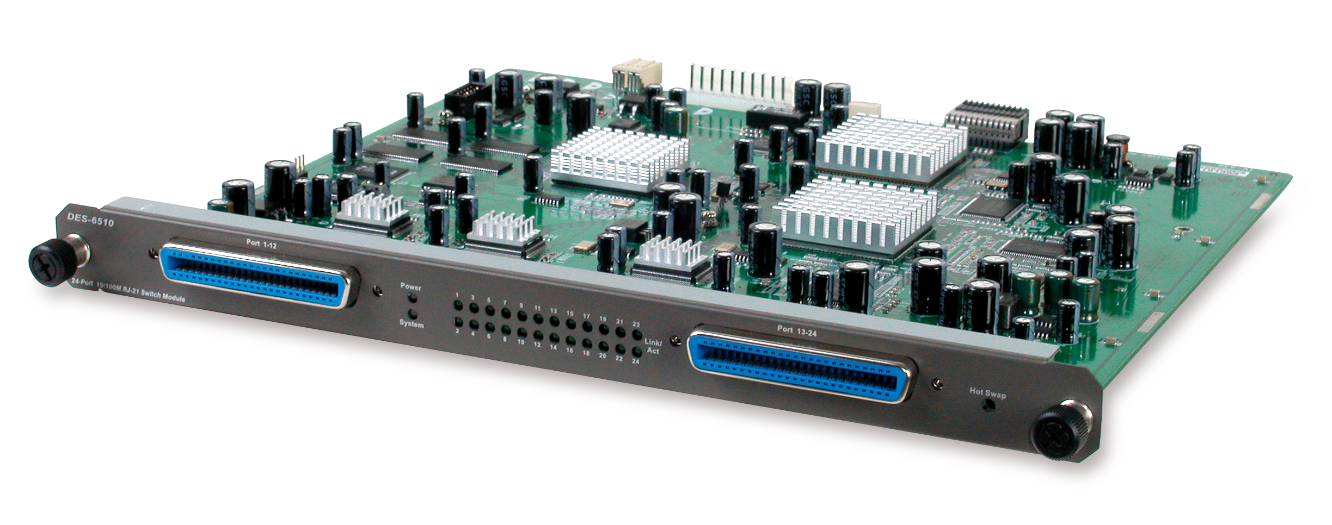
Why Sell This Product: | - The DES-6500 L3 chassis switch with many advanced functions has been released some time ago. However, sales of this enterprise solution switch could not really take off without many optional port modules waiting in the wing for completion. Now these optional modules have been fully tested and are available, we’re announcing their release, including that of the DES-6510 24-port Ethernet module. This particular module is equipped with 2 RJ-21 connectors, so all 24 ports can fit into a 19-inch rack-mount width card blade. A 24-port patch panel is available for use with this module. System integrators wishing to set up a high port density network can install this module in the DES-6500 chassis together with this DES-6506 patch panel.  - Target users: enterprise business users, system integrators.  Selling Points  - High port density on a single card blade.  - Low cost per port
Key Features: | - 24 10/100BASE-TX Ethernet ports in 2 RJ-21 connectors  - Slide-in card module for DES-6500 chassis switch  - Fully complies with IEEE 802.3 10BASE-T, 802.3u 100BASE-TX  - Auto-sensing and auto-negotiation of 10/100Mbps speeds  - IEEE 802.3x compliant Flow Control support for full-duplex  - Back pressure support for half-duplex mode
Technical Details: | Standards  - IEEE 802.3 10BASE-T  - IEEE 802.3u 100BASE-TX  - ANSI/IEEE 802.3 NWay auto-negotiation  - IEEE 802.3x Flow Control  Protocol  CSMA/CD  Topology  Star  Data Transfer Rates  - Ethernet:  10Mbps (half duplex)  20Mbps (full duplex)  - Fast Ethernet:  100Mbps (half duplex)  200Mbps (full duplex)  Network Cable  Ethernet Cat. 5 cable (max. 100 m)  Number of Ports  24 10/100BASE-TX Ethernet ports  Connectors  2 RJ-21 connectors, each supports 12 Ethernet ports  Physical & Environmental  AC Input  90 to 264 VAC, 47/63 Hz  Through DES-6500 chassis switch power supply  Power Consumption  28 watts max.  Operating Temperature  0 to 40 ℃  Storage Temperature  -25 to 55 ℃  Humidity  5% to 95% RH, non-condensing  Dimensions  330 mm x 281 mm x 27.5 mm  EMI  - FCC Class A  - CE  - VCCI  - C-Tick  Box Includes  - DES-6510 24-port 10/100BASE-TX module  - Quick Installation Guide
EMI/EMC Report | ☑FCC No. ☑ CE No. ◻ VCCI No.  ◻ CTR-21 No. ◻ C-Tick No. ◻ A-Tick No.  ◻ FDA No. ◻ R&TTE No. ◻ BSMI No.  ◻ Others
Safety | ◻ TUV No. ◻ UL No. ☑ CSA No.  ◻ Others
Packaging Style | ◻ Clamshell ◻ White Box ◻ Gift Box ◻ Bulk ☑ White Box with D-Link Logo  ◻ Others
Packaging Contents: | - DES-6510  - Module QIG
UPC Code:
  DES6510…A1 | 790069272684
  NES6510...A1 | 790069272691
Units Per Carton: | 5
Cartons Per Pallet: | For USA Air:18, Sea: 24 | For WW Air:12, Sea: 20
Dimensions and Weight: | Box:  Others , 1.9 kg  Carton: 496x417x395 mm, 10.5 kg  Pallet: (by Air) 1020x1220x1381 mm, 202 kg (for USA)  1100x1200x 1335 mm, 141 kg (for WW)  (by Sea) 1020x1220x 2114 mm, 265 kg (for USA)  1100x1200x 2125 mm, 225 kg (for WW)  INTRASTAT weight: 0.65 kg (Box)  Packing material weight (Box):  - Paper: 0.45 kg  - Plastic: 0.1 kg  - Mixed: 0.1 kg

