DPS-200, DPS-300, DPS-500, DPS-800, DPS-900
Redundant Power Supply
Quick Installation Guide

First Edition (August 2003)
6RPSQ…..01
Printed In Taiwan
RECYCLABLE

DPS-200, DPS-300, DPS-500,

DPS-800 & DPS-900

Redundant Power Supply

Quick Installation Guide

A redundant power supply provides a low-cost, simple solution to the equally simple yet vexing problem of internal power-supply failure, which can result in the shutdown of a single switching device or an entire network.

With a redundant power supply connected, an integrated detection circuit continuously monitors the switch’s internal power supply. In the event of a power interruption, the redundant power supply is immediately triggered so that the switch and connected devices can continue providing service.

This results in a more reliable network infrastructure and protects the network from a single failure of a network device power supply.

Description and Installation
The DPS-200, DPS-300 and DPS-500 are redundant power-supply units designed to conform to the wattage requirements of the switches being supported. (DPS-200 operates at 60 watt, the DPS-300 operates at 90 watt, the DPS-500 at 140 watt.)
The DPS-900 is a standard-size rack mount (5 standard units in height) designed to hold up to 8 redundant power supplies. And the DPS-800 is also standard-size rack mount (1.25 standard units in height) designed to hold up 2 redundant power supplies. These can be DPS-200s, DPS-300s, DPS-500s, or a combination of all.

DPS-200, DPS-300 and DPS-500 are connected to the master switch using a 14-pin DC power cable. A standard, three-pronged AC power cable connects the redundant power supply to the main power source.

Connection
Note: As a precaution, the AC power cord for the switch should be disconnected before proceeding with installation of the DPS-200/DPS-300/DPS-500.

Insert one end of the 14-pin DC power cable into the receptacle on the switch and the other end into the redundant power supply.

Using a standard AC power cable, connect the redundant power supply to the main AC power source. A green LED on the front of the DPS-200/DPS-300/DPS-500 will glow to indicate a successful connection.

Re-connect the switch to the AC power source. On certain switches, such as the DES-3326SR, an LED indicator will show that a redundant power supply is now in operation.

No change in switch configuration is necessary for this installation.

14-pin DC power cable

Single RPS
(DPS-200/DPS300/
DPS-500)

Inserting the single RPS (DPS-200/ DPS-300/DPS-500) into the DPS-800 (RPS rack)

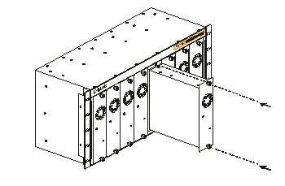
Inserting the single RPS (DPS-200/
DPS-300/DPS-500) into the DPS-900 (RPS rack)

Installing the DPS-800 in a standard electronics rack

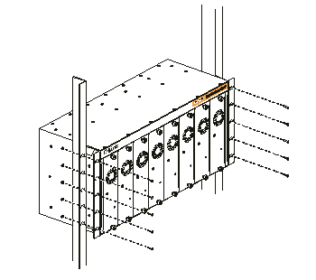

Installing the DPS-900 in a standard electronics rack

Below: A single RPS, mounted in the DPS-800 rack, is connected to the switch with RPS function

Below: Single RPS, mounted in the DPS-900 rack, is connected to the switch with RPS function

