Model DG-102S
VoIP Station Gateway
User’s Guide

Rev. 02 (August 2001)
6DG102S...02
Printed in Taiwan
RECYCLABLE
Trademarks
Copyright ©2000 D-Link Corporation.
Contents subject to change without prior notice.
D-Link is a registered trademark of D-Link Corporation/D-Link Systems, Inc. All other trademarks belong to their respective proprietors.
Copyright Statement
No part of this publication may be reproduced in any form or by any means or used to make any derivative such as translation, transformation, or adaptation without permission from D-Link Corporation/D-Link Systems Inc., as stipulated by the United States Copyright Act of 1976.
Hardware:
D-Link warrants each of its hardware products to be free from defects in workmanship and materials under normal use and service for a period commencing on the date of purchase from D-Link or its Authorized Reseller and extending for the length of time stipulated by the Authorized Reseller or D-Link Branch Office nearest to the place of purchase.
This Warranty applies on the condition that the product Registration Card is filled out and returned to a D-Link office within ninety (90) days of purchase. A list of D-Link offices is provided at the back of this manual, together with a copy of the Registration Card.
If the product proves defective within the applicable warranty period, D-Link will provide repair or replacement of the product. D-Link shall have the sole discretion whether to repair or replace, and replacement product may be new or reconditioned. Replacement product shall be of equivalent or better specifications, relative to the defective product, but need not be identical. Any product or part repaired by D-Link pursuant to this warranty shall have a warranty period of not less than 90 days, from date of such repair, irrespective of any earlier expiration of original warranty period. When D-Link provides replacement, then the defective product becomes the property of D-Link.
Warranty service may be obtained by contacting a D-Link office within the applicable warranty period, and requesting a Return Material Authorization (RMA) number. If a Registration Card for the product in question has not been returned to D-Link, then a proof of purchase (such as a copy of the dated purchase invoice) must be provided. If Purchaser's circumstances require special handling of warranty correction, then at the time of requesting RMA number, Purchaser may also propose special procedure as may be suitable to the case.
After an RMA number is issued, the defective product must be packaged securely in the original or other suitable shipping package to ensure that it will not be damaged in transit, and the RMA number must be prominently marked on the outside of the package. The package must be mailed or otherwise shipped to D-Link with all costs of mailing/shipping/insurance prepaid. D-Link shall never be responsible for any software, firmware, information, or memory data of Purchaser contained in, stored on, or integrated with any product returned to D-Link pursuant to this warranty.
Any package returned to D-Link without an RMA number will be rejected and shipped back to Purchaser at Purchaser's expense, and D-Link reserves the right in such a case to levy a reasonable handling charge in addition mailing or shipping costs.
Software:
Warranty service for software products may be obtained by contacting a D-Link office within the applicable warranty period. A list of D-Link offices is provided at the back of this manual, together with a copy of the Registration Card. If a Registration Card for the product in question has not been returned to a D-Link office, then a proof of purchase (such as a copy of the dated purchase invoice) must be provided when requesting warranty service. The term "purchase" in this software warranty refers to the purchase transaction and resulting license to use such software.
D-Link warrants that its software products will perform in substantial conformance with the applicable product documentation provided by D-Link with such software product, for a period of ninety (90) days from the date of purchase from D-Link or its Authorized Reseller. D-Link warrants the magnetic media, on which D-Link provides its software product, against failure during the same warranty period. This warranty applies to purchased software, and to replacement software provided by D-Link pursuant to this warranty, but shall not apply to any update or replacement which may be provided for download via the Internet, or to any update which may otherwise be provided free of charge.
D-Link's sole obligation under this software warranty shall be to replace any defective software product with product which substantially conforms to D-Link's applicable product documentation. Purchaser assumes responsibility for the selection of appropriate application and system/platform software and associated reference materials. D-Link makes no warranty that its software products will work in combination with any hardware, or any application or system/platform software product provided by any third party, excepting only such products as are expressly represented, in D-Link's applicable product documentation as being compatible. D-Link's obligation under this warranty shall be a reasonable effort to provide compatibility, but D-Link shall have no obligation to provide compatibility when there is fault in the third-party hardware or software. D-Link makes no warranty that operation of its software products will be uninterrupted or absolutely error-free, and no warranty that all defects in the software product, within or without the scope of D-Link's applicable product documentation, will be corrected.

D-Link Offices for Registration and Warranty Service
The product's Registration Card, provided at the back of this manual, must be sent to a D-Link office. To obtain an RMA number for warranty service as to a hardware product, or to obtain warranty service as to a software product, contact the D-Link office nearest you. An addresses/telephone/fax list of D-Link offices is provided in the back of this manual.
LIMITATION OF WARRANTIES
IF THE D-LINK PRODUCT DOES NOT OPERATE AS WARRANTED ABOVE, THE CUSTOMER'S SOLE REMEDY SHALL BE, AT D-LINK'S OPTION, REPAIR OR REPLACEMENT. THE FOREGOING WARRANTIES AND REMEDIES ARE EXCLUSIVE AND ARE IN LIEU OF ALL OTHER WARRANTIES, EXPRESSED OR IMPLIED, EITHER IN FACT OR BY OPERATION OF LAW, STATUTORY OR OTHERWISE, INCLUDING WARRANTIES OF MERCHANTABILITY AND FITNESS FOR A PARTICULAR PURPOSE. D-LINK NEITHER ASSUMES NOR AUTHORIZES ANY OTHER PERSON TO ASSUME FOR IT ANY OTHER LIABILITY IN CONNECTION WITH THE SALE, INSTALLATION MAINTENANCE OR USE OF D-LINK'S PRODUCTS
D-LINK SHALL NOT BE LIABLE UNDER THIS WARRANTY IF ITS TESTING AND EXAMINATION DISCLOSE THAT THE ALLEGED DEFECT IN THE PRODUCT DOES NOT EXIST OR WAS CAUSED BY THE CUSTOMER'S OR ANY THIRD PERSON'S MISUSE, NEGLECT, IMPROPER INSTALLATION OR TESTING, UNAUTHORIZED ATTEMPTS TO REPAIR, OR ANY OTHER CAUSE BEYOND THE RANGE OF THE INTENDED USE, OR BY ACCIDENT, FIRE, LIGHTNING OR OTHER HAZARD.
LIMITATION OF LIABILITY
IN NO EVENT WILL D-LINK BE LIABLE FOR ANY DAMAGES, INCLUDING LOSS OF DATA, LOSS OF PROFITS, COST OF COVER OR OTHER INCIDENTAL, CONSEQUENTIAL OR INDIRECT DAMAGES ARISING OUT THE INSTALLATION, MAINTENANCE, USE, PERFORMANCE, FAILURE OR INTERRUPTION OF A D- LINK PRODUCT, HOWEVER CAUSED AND ON ANY THEORY OF LIABILITY. THIS LIMITATION WILL APPLY EVEN IF D-LINK HAS BEEN ADVISED OF THE POSSIBILITY OF SUCH DAMAGE.
IF YOU PURCHASED A D-LINK PRODUCT IN THE UNITED STATES, SOME STATES DO NOT ALLOW THE LIMITATION OR EXCLUSION OF LIABILITY FOR INCIDENTAL OR CONSEQUENTIAL DAMAGES, SO THE ABOVE LIMITATION MAY NOT APPLY TO YOU.
FCC Warning
This equipment has been tested and found to comply with the limits for a Class B digital device, pursuant to part 15 of the FCC Rules. These limits are designed to provide reasonable protection against harmful interference in a residential installation. This equipment generates, uses and can radiate radio frequency energy and, if not installed and used in accordance with the instructions, may cause harmful interference to radio communications. However, there is no guarantee that interference will not occur in a particular installation. If this equipment does cause harmful interference to radio or television reception, which can be determined by turning the equipment off and on, the user is encouraged to try to correct the interference by one or more of the following measures:
-Reorient or relocate the receiving antenna.
-Increase the separation between the equipment and receiver.
-Connect the equipment into an outlet on a circuit different from that to which the receiver is connected.
-Consult the dealer or an experienced radio/ TV technician for help.

The device complies with part 15 of the FCC rules. Operation is subject to the following two conditions:
- This device may not cause harmful interface.
- This device must accept any interference received, including interference that may cause undesired operation.
.

Table of Contents
Introduction 1
Features 1
Unpacking and Setup 2
Unpacking 2
Identifying External Components 2
Front Panel 2
Rear Panel 2
Physical Installation 3
Connecting the Network Cable 3
Connecting the VoIP Gateway to a PC 4
Connecting the VoIP Gateway to a Hub/Switch 4
Understanding Indicators 5
Configuration 6
Configuring the VoIP Gateway 6
Configuring the VoIP Gateway using a Console 6
Setting Up a Console 6
Configuring the VoIP Gateway Using Telnet 7
Console Usage Conventions 7
First Time Connecting To The VoIP Gateway 7
Configuration Settings 8
Configure IP 8
Configuring the VoIP Gateway using a Web Browser 10
Setting Up the Connection 10
Using The Boot Menu 16
Configure IP 16
Configure SNMP 18
Device Information 18
Update Boot and Application 19
Save Changes 20
Factory Reset 21
Restart System 22
Web-Based Management 23
Introduction 23
Getting Started 23
Management 23
Config Device IP Address 24
Config Call Agent IP Address 25
Device Information 26
Telephony Configuration 28
Dynamic IP Assignment 29
Static IP Assignment 30
NAT Configuration 32
Local Server Configuration 33
SNMP Trap Configuration 35
Administration Management 36
Ethernet Statistics 37
DSP Statistics 38
Tcid Configuration 39
Coding Profile 40
xGCP Configuration 41
Firmware and Configuration Update 42
Save Changes 43
Factory Reset 44
Restart System 45
Command Line Interface 46
General Setup Commands 46
TFTP Client Setup Commands 48
Specifications 50

1

Introduction
Thank you for choosing the D-Link DG-102S, the value leader for VoIP products.
The D-Link DG-102S VoIP Station Gateway links traditional telephony networks to IP networks with conventional telephony devices such as analog phones or fax machines. The DG-102S includes two loop start Foreign Exchange Subscriber (FXS) interfaces with normal RJ-11 telephone connectors that provide voice/fax communication over the IP network, and it also provide two 10/100 Mbps dual speed Ethernet ports. One Ethernet port is for a DSL/Cable Modem or other WAN devices, and the other is for connection to create a home or small office LAN networks. The built-in DHCP server/client and Network Address Translation (NAT) function automatically assign IP address for LAN users, allowing multiple users to share a single Internet connection. It can be configured/monitored via the Console, Web browser or Telnet and SNMP management is also supported.
By routing calls over the Internet or any IP network, this gateway can reduce or eliminate long distance or inter-office phone charges. Corporations can also enjoy the benefits of network consolidation and reduction of leased lines by relying on the Internet service providers to deliver toll-quality voice communications over the IP networks.

Features
Designed for versatility and performance, the DG-102S VoIP Gateway provides the following features:
- Two analog loop-start FXS interfaces using female RJ-11 connectors
- One analog POTS interface for PSTN Life Line
- One 10/100 WAN port for connecting to a call agent
- One 10/100 LAN port for connecting to a local network
- IP address assignment using DHCP (Dynamic Host Configuration Protocol) or static configuration
- Silence suppression to reduce bandwidth consumption
- Comfort noise generation for a more natural feel
- Adaptive jitter buffer for smooth voice reception
- Lost packet recovery ability for improved voice quality
- Command port for easy configuration
- Remote software download/update
- Support IP sharing to allow multiple users to access the Internet via a single IP address
- Build-in PPPoE function to support dial-up connection for broadband technology
- Support Caller ID
- Support QoS to guarantee voice quality
- Life Line support
- Automatic fall back to PSTN in case of power failure or network breakdown
- Intelligent dialing mode (IP/PSTN Call) alternation via configurable hot key (“ # “ key is the default)
- Listening of incoming call from PSTN

2

Unpacking and Setup

Unpacking
Open the shipping carton and carefully remove all items. In addition to this User's Guide, ascertain that you have:
- One DG-102S VoIP Gateway
- A/C Power Adapter
If any item is found missing or damaged, please contact your local reseller or D-Link directly at one of the offices listed at the rear of the manual for replacement.

Identifying External Components
This section identifies all the major external components of the device. Both the front and rear panels are shown, followed by a description of each panel feature. The indicator panel is described in detail in the next chapter.

Front Panel
The figure below shows the front panels of the device.

- LED Indicator Panel Refer to the next chapter, “Understanding Indicators,” for detailed information about each of the VoIP Gateway’s LED indicators.

Rear Panel
The figure below shows the rear panel of the device.
- AC Power Connector For the included power adapter. If you use a power adapter other than the one included with the product please make sure it has a DC output of 12VDC/1A.
- Diagnostic Port An RS-232 serial port used to configure the device. Plug one end of a straight-through wired RS-232 cable to the device and the other end to a serial port of a PC running a terminal emulation program (such as Microsoft HyperTerminal) or a VT-100 terminal.
- Ethernet WAN A 10/100 dual-speed Ethernet port fitted with an RJ-45 connector used to connect the VoIP gateway to a WAN device (usually a router). This port accepts Category 3, 4 or 5 UTP cabling with an RJ-45 connector.
- Ethernet LAN A 10/100 dual-speed Ethernet port fitted with an RJ-45 connector used to connect the VoIP gateway to a LAN device (hub, switch, PC, etc.). This port accepts Category 5 or better UTP cabling with an RJ-45 connector.
- Line RJ-11 phone jack for connecting to a standard telephone wall outlet through an approved (No. 26 AWG or larger) telecommunications line cord.
- Phone 1 to 2 Normal RJ-11 phone jacks used to connect telephones and fax machines. Plug your normal telephone(s) and/or fax machine directly into any of these jacks.

Physical Installation
Use the following guidelines when choosing a place to install the VoIP Gateway:
- The surface must support at least 1 kg.
- The power outlet should be within 1.82 meters (6 feet) of the device.
- Visually inspect the power cord and see that it is secured to the AC power connector.
- Make sure that there is proper heat dissipation from and adequate ventilation around the device. Do not place heavy objects on the unit.
When installing the unit on a desktop or shelf, the rubber feet included with the device should first be attached. Attach these cushioning feet on the bottom at each corner of the device. Allow adequate space for ventilation between the device and the objects around it.

Connecting the Network Cable
Category 3, 4 or 5 UTP cable can be used to make the Ethernet connection to your WAN router.
The maximum cable run between the DG-102S and the supporting call agent is 100 meters. The cable must be straight (not a crossover cable) with RJ-45 connectors at each end. Make the network connection by plugging one end of the cable into the RJ-45 jack of the DG-102S, and the other end into a port on your WAN router.

Connecting the VoIP Gateway to a PC
Once the device has been connected to a PC, you will need a separate IP address and a straight cable.

Connecting the VoIP Gateway to a Hub/Switch
To connect the device to either a hub or switch, you must connect the straight cable to the Uplink port.

3

Understanding Indicators
Before configuring your VoIP Gateway, take a few minutes to look over this section and familiarize yourself with the front panel LED indicators depicted below.
- Power This LED is lit when the device is receiving power; otherwise, it is unlit.
- Status This LED will flash quickly when the CPE is either performing a self test or booting up. The LED will remain lit when the system is ready for a connection with the call agent; it will remain dark when the system is ready but can not receive an acknowledgement from the call agent.
- WAN This LED displays the connection speed, link status, and activity on the 10/100 dual-speed Ethernet port that is used to connect to your WAN device (usually a router).
10/100M − This indicator remains unlit when there is no connection, or the port is operating at 10Mbps through a connection to a 10BASE-T device. It is lit when the port is operating at 100Mbps through a connection to a dual-speed or 100BASE-TX Fast Ethernet device.
Link/Act − When a good link to a powered-up but idle device is detected on a port, this indicator shines steadily. When packets are received from the device, the indicator blinks off and on.
- LAN This LED displays the connection speed, link status, and activity on the 10/100 dual-speed Ethernet port that is used to connect to your LAN.
10/100M − This indicator remains unlit when there is no connection, or the port is operating at 10Mbps through a connection to a 10BASE-T device. It is lit when the port is operating at 100Mbps through a connection to a dual-speed or 100BASE-TX Fast Ethernet device.
Link/Act − When a good link to a powered-up but idle device is detected on a port, this indicator shines steadily. When packets are received from the device, the indicator blinks off and on.
- Line Lights when PSTN line is in use.
- Phone 1 to 2 Lights when standard phone port is in use

NOTE: If a powered-up device is connected to a port and the port’s Link/Act status indicator is unlit, the most probable cause is a cabling or connection problem (for example, wrong cable type or bad contact) or a device malfunction.

4

Configuration
In order to use the DG-102S VoIP gateway, you must first configure it.

Configuring the VoIP Gateway
There are two ways to configure the VoIP gateway, both of which are discussed below. They are:
- Using a terminal or PC running terminal emulation software connected to the diagnostic port via an RS-232 cable. In the discussion below, the terminal (or PC) is referred to as a console and the connection a console connection.
- Using a web browser on a PC connected to the device via the WAN or LAN Ethernet connections. In the discussion below, the PC running the browser is referred to as the management station.

Configuring the VoIP Gateway using a Console

Setting Up a Console
First-time configuration must be carried out through a "console," that is, either (a) a VT100-type serial data terminal, or (b) a computer running communications software set to emulate a VT100. The console must be connected to the Diagnostics port. This is an RS-232 port with a 9-socket D-shell connector and DCE-type wiring. Make the connection as follows:
- Obtain suitable cabling for the connection.
You can use either (a) a "null-modem" RS-232 cable or (b) an ordinary RS-232 cable and a null-modem adapter. One end of the cable (or cable/adapter combination) must have a 9-pin D-shell connector suitable for the Diagnostics port; the other end must have a connector suitable for the console's serial communications port.
- Power down the devices, attach the cable (or cable/adapter combination) to the correct ports, and restore power.
- Set the console to use the following communication parameters for your terminal:
- 9600 baud
- VT-100/ANSI compatible
- No parity checking (sometimes referred to as "no parity")
- 8 data bits (sometimes called a "word length" of 8 bits)
- 1 stop bit (sometimes referred to as a 1-bit stop interval)
- No Flow control
- VT-100/ANSI compatible
- Arrow keys enabled
A typical console connection is illustrated below:
Example of a Console Connection

Configuring the VoIP Gateway Using Telnet
Once you have set an IP address for your device, you can use a Telnet program (in a VT-100 compatible terminal mode) to access and configure it. Most of the screens are identical, whether accessed from the console port or from a Telnet interface.

Console Usage Conventions
The console interface makes use of the following conventions:
Items in <angle brackets> can be toggled on or off using the space bar.
Items in [square brackets] can be changed by typing in a new value. You can use the Backspace and Delete keys to erase characters behind and in front of the cursor.
The up and down arrow keys, the left and right arrow keys, the Tab key and the Backspace key can be used to move between selected items. It is recommended that you use the Tab key and Backspace key for moving around the console.
Items in UPPERCASE are commands. Moving the selection to a command and pressing Enter will execute that command, e.g. APPLY, etc.

Please note that the command APPLY only applies for the current session. Use Save Changes from the Main Menu for permanent changes.

First Time Connecting To The VoIP Gateway
First make the console connection to the device and then power it on. If your terminal (or terminal emulation program) is properly configured according to the specifications defined above, you will see the POST test and the boot up process. During this process, press <Ctrl+C> to reach the Boot Menu (shown below).
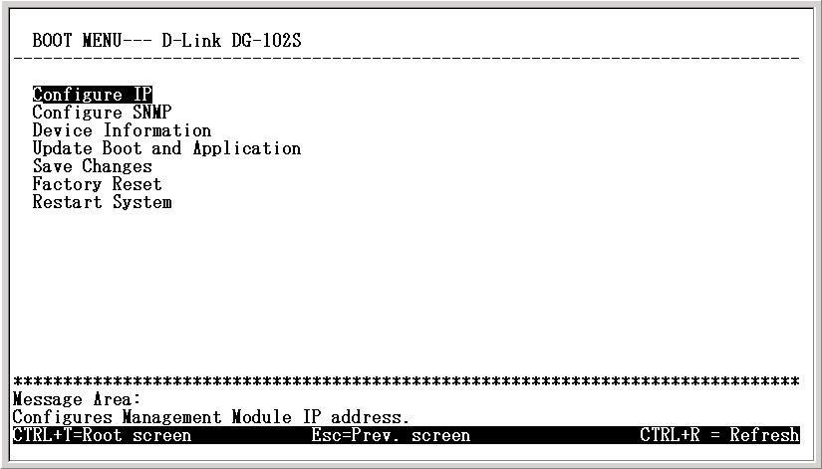
Initial Screen, First Time Connecting to the device
If the boot up process has proceeded too far and you did not reach the Boot Menu shown above, unplug the device, plug it back in (to restart the boot up process), and press <Ctrl+C> until the Boot Menu appears.

Configuration Settings
In order for the VoIP to function, you must provide the device with the following information:
- Define where the device receives its IP settings from.
- IP settings – IP Address, Subnet Mask, and Default Gateway
- Notify Entity – The address of the call agent
- Residential Gateway – A name for the VoIP gateway as it will be known by the call agent.
All of these settings are found in the first menu item in the Boot Menu named IP Configuration.

Configure IP
Use the <Tab> key to highlight the first menu item Configure IP and press <Enter>. The IP Configuration screen will now be displayed:
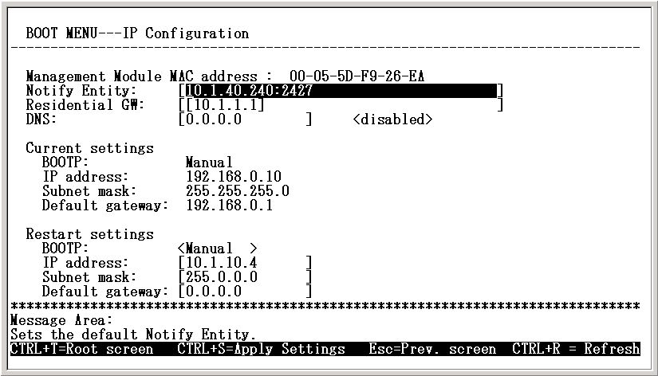
Boot Menu---IP Configuration screen
- Notify Entity Enter the appropriate information for you call agent into this field.
- Residential GW This is the name your VoIP gateway will be known as by the call agent. It usually consists of the IP address or a normal name.
- DNS Enter the IP address for the closest DNS server in this field if enables the DNS function.
- BOOTP Use the <Space> key to choose the method that the VoIP gateway will use to obtain its IP settings once it is rebooted (restarted). Choices include:
Manual – When Manual is chosen, the VoIP gateway will obtain its IP settings from the fields located just below.
BOOTP – When BOOTP is chosen, the VoIP gateway will attempt to obtain its IP settings from a BOOTP server located on your LAN.
DHCP – When DHCP is chosen, the VoIP gateway will attempt to obtain its IP settings from a DHCP server located on your LAN.
- IP Address Enter an IP address for the VoIP gateway.
- Subnet Mask Enter a subnet mask for the VoIP gateway.
- Default Gateway Enter the IP address of the WAN device (usually a router) you are using to make the WAN connection.
After you have finished, press <Ctrl+S> to save changes to RAM. Next, press the <Esc> key to return to the Boot Menu. Position the cursor over the Save Changes item and press <Enter>. This will save the settings to NV-RAM so they will still be present after powering off or restarting the device. Position the cursor over the Restart System item and press <Enter> for the changes to take effect.
Your VoIP is now configured for use.

Configuring the VoIP Gateway using a Web Browser

Setting Up the Connection
In order to use a web browser to configure the VoIP gateway, you must make sure it has a valid Ethernet connection to a PC or LAN via its LAN or WAN ports.
The VoIP gateway comes with a default IP address of 10.1.10.4. You must make sure the PC is in the same IP domain as the VoIP gateway. You can do this by changing the IP address of the PC as shown below.
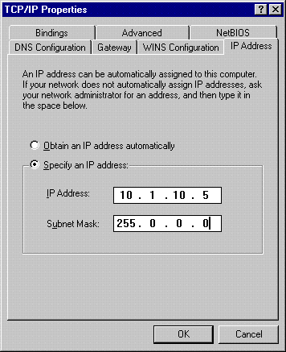
Once this is done, run any browser on the PC and point it to the default IP address of the VoIP as shown below:
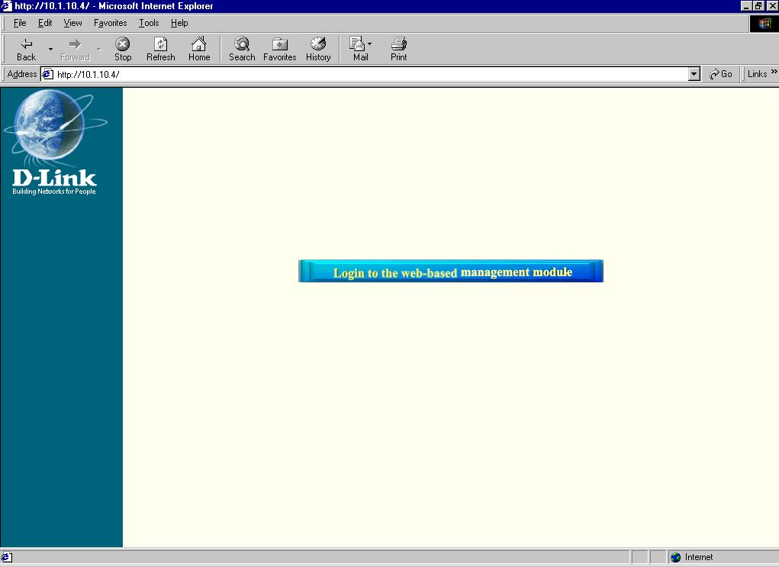
Initial Window, First Time Connecting to the Web-Based Management Module
Click on the Login to the web-based management module button in the middle of the window. The following window will be displayed:
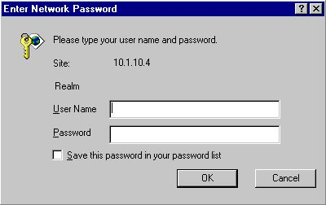
Initially, the VoIP gateway does not have a Username or Password. To log in, simply click on the OK button.
The following window will be displayed:
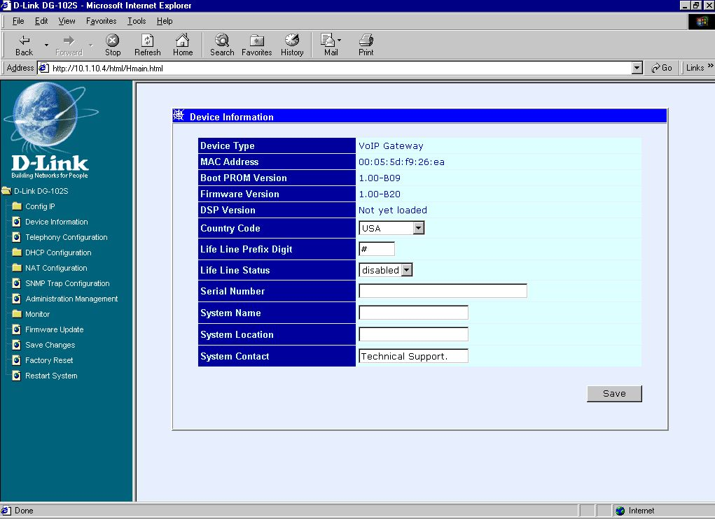
Device Information window

To begin configuring the device, click on the Config IP folder on the left-hand side of the window (shown below).
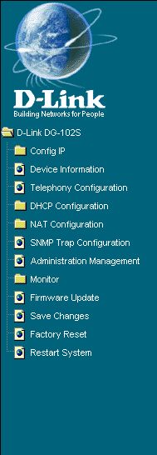

Next, click on Config Device IP Address. The following window will appear:
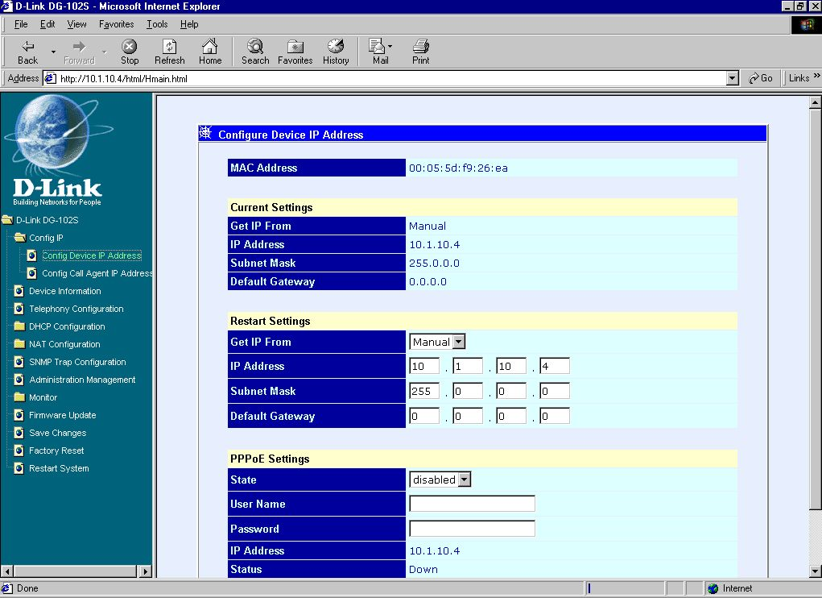
Configure Device IP Address window
The items on this window are described below:
Restart Settings
- Get IP From Choose the method the VoIP gateway will use to obtain its IP settings once it is rebooted (restarted). Choices include:
Manual – When Manual is chosen, the VoIP gateway will obtain its IP settings from the fields located just below.
BOOTP – When BOOTP is chosen, the VoIP will attempt to obtain its IP settings from a BOOTP server located on your LAN.
DHCP – When DHCP is chosen, the VoIP will attempt to obtain its IP settings from a DCHP server located on your LAN.
- IP Address Enter an IP address for the VoIP gateway.
- Subnet Mask Enter a subnet mask for the VoIP gateway.
- Default Gateway Enter the IP address of the WAN device (usually a router) you are using to make the WAN connection.
PPPoE Settings (for DSL users)
- State Enables or disables the PPPoE function.
- User Name Enter the User Name for the PPPoE function.
- Password Enter the Password for the PPPoE function.
Click on the Save button at the bottom right of the screen to save the settings.
Next, click on the Config Call Agent IP Address item in the list at the left of the screen. The following window will appear:
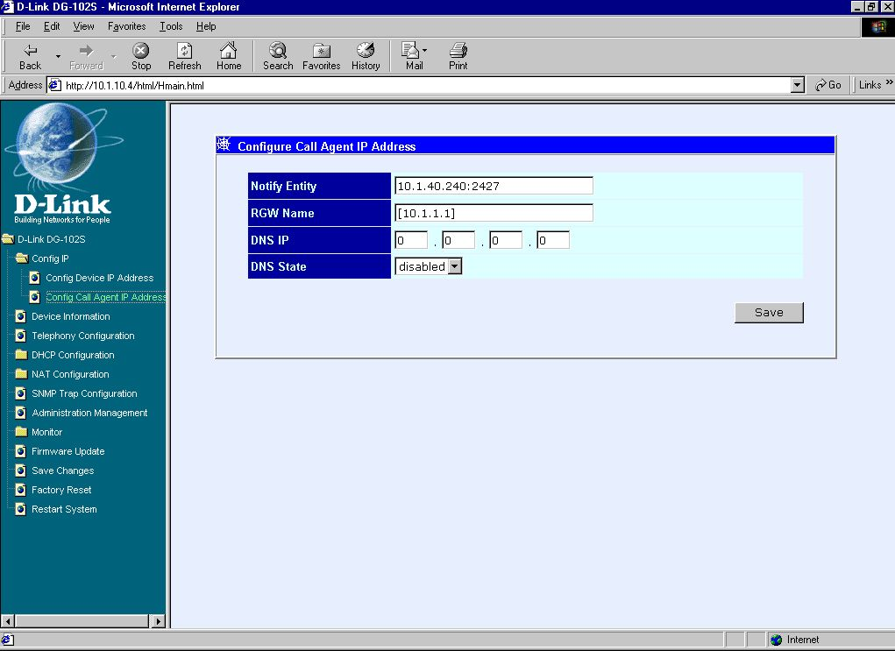
Configure Call Agent IP Address window
The items on this window are described below:
- Notify Entity Enter the appropriate information for you call agent into this field.
- RGW Name This is the residential gateway name your VoIP gateway will be known as by the call agent. It usually consists of the IP address or a normal name.
- DNS IP Enter the IP address for the closest DNS server in this field.
- DNS State When this item is enabled and the call agent is not responding, the device will try to get the call agent’s IP settings from the DNS server defined above.
Click on the Save button at the bottom right of the screen to save the settings.

5

Using The Boot Menu
The DG-102S VoIP gateway features a Boot Menu, which is described in this chapter.
To access the Boot Menu, you must first make sure the console is connected to the Diagnostics port (an RS-232 port with a 9-socket D-shell connector and DCE-type wiring) and the appropriate cabling for the connection is being used. Please see the previous chapter, “Configuration,” for additional information. Next, power the device on by simply plugging it in. You will see the POST test and the boot up process. During this process, press <Ctrl+C> to reach the Boot Menu. If the boot up process has proceeded too far and you did not reach the Boot Menu shown below, unplug the device, plug it back in (to restart the boot up process), and press <Ctrl+C> until the Boot Menu appears.
Boot Menu---Opening screen

Configure IP
This screen allows you to enter information necessary for the initial configuration of this device.
Use the arrow keys to highlight the first menu item on the Boot Menu, Configure IP, and press <Enter>. The IP Configuration screen will be displayed:
Boot Menu---IP Configuration screen
Each item on the IP Configuration screen is described below:
- Notify Entity Enter the appropriate information for you call agent into this field.
- Residential GW This is the name your VoIP gateway will be known as by the call agent. It usually consists of the IP address or a normal name.
- DNS Enter the IP address for the closest DNS server in this field if enables the DNS function.
- BOOTP Use the <Space> key to choose the method that the VoIP gateway will use to obtain its IP settings once it is rebooted (restarted). Choices include:
Manual – When Manual is chosen, the VoIP gateway will obtain its IP settings from the fields located just below.
BOOTP – When BOOTP is chosen, the VoIP gateway will attempt to obtain its IP settings from a BOOTP server located on your LAN.
DHCP – When DHCP is chosen, the VoIP gateway will attempt to obtain its IP settings from a DHCP server located on your LAN.
- IP address Enter an IP address for the VoIP gateway.
- Subnet mask Enter a subnet mask for the VoIP gateway.
- Default gateway Enter the IP address of the WAN device (usually a router) you are using to make the WAN connection.
After you have finished, press <Ctrl+S> to save changes to RAM. Next, press the <Esc> key to return to the Boot Menu. Position the cursor over the Save Changes item and press <Enter>. This will save the settings to NV-RAM so they will still be present after powering off or restarting the device. Make sure the Reset button on the rear panel of the device is in the down position. Position the cursor over the Restart System item and press <Enter> for the changes to take effect. Your VoIP is now configured for use.

Configure SNMP
This screen allows you to set an SNMP trap manager.
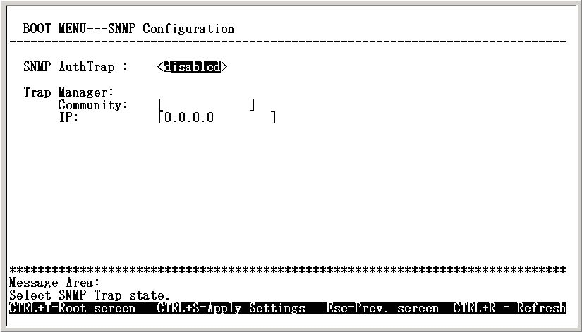
Boot Menu---SNMP Configuration screen
Each item on the SNMP Configuration screen is described below:
- SNMP AuthTrap Enables or disables the SNMP trap function.
- Community Enter the community name of the trap manager.
- IP Enter the IP address of the trap manager.

Device Information
This screen displays various types of information about the DG-102S as well as allowing you to enter information pertaining to name, location, and how to reach the person responsible for maintaining the device.
Use the arrow keys to highlight the second menu item on the Boot Menu, Device Information, and press <Enter>. The Device Information screen will be displayed:
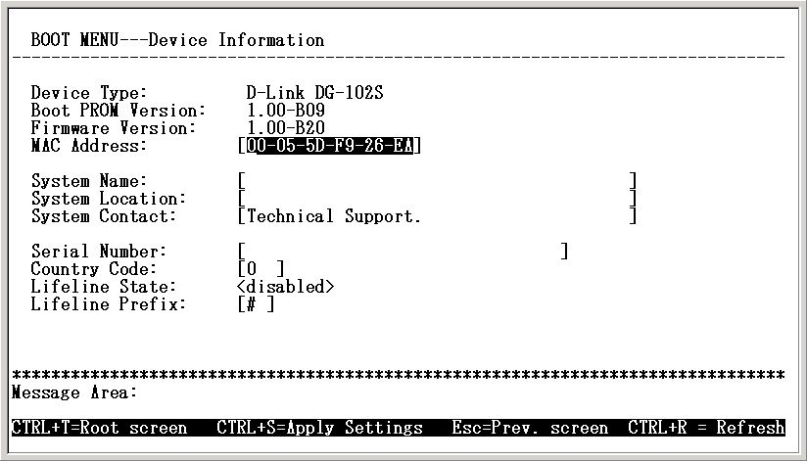
Boot Menu---Device Information screen
Each item on the Device Information screen is described below:
- Device Type This displays the model name of this device.
- Boot PROM Version This displays the version number of the device’s startup code.
- Firmware Version This displays the version number of the device’s runtime code.
- MAC Address This displays the MAC address of this device.
- System Name This is a user-defined name for this device.
- System Location This is a user-defined physical location of the device.
- System Contact This is user-defined contact information for the person or department responsible for the maintenance of this device.
- Serial Number This displays the serial number of this device
- Country Code This is a user-defined country code for this device. < 0:USA (Default), 1:Japan, 2:Hong Kong, 3:Sweden, 4:China >
- Lifeline State Enables or disables the Lifeline function
- Lifeline prefix This is a user-defined Lifeline prefixed key for this device. (Default is “#” key)

Update Boot and Application
New software can be downloaded from a TFTP server.
Use the arrow keys to highlight the third menu item on the Boot Menu, Update Firmware and Configuration Files, and press <Enter>. The Update Boot and Application screen will be displayed:
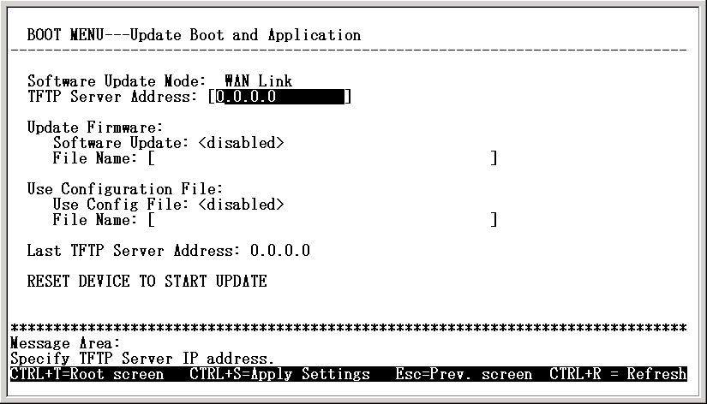
Boot Menu---Update Firmware and Configuration Files screen
After making your changes in the fields above, press RESET DEVICE TO START UPDATE to initiate the update sequence.
Each item on the Update Boot and Application screen is described below:
- Software Update Mode This specifies downloading the image file through a WAN Link.
- TFTP Server Address The IP address of the TFTP server where the runtime or configuration file is located. This entry is used only if the Firmware Update is set to Enable.
- Software Update Determines whether or not the device will try to look for a runtime image file on the TFTP server.
- File Name The complete path and filename of the runtime image file on your TFTP server to be uploaded to the device.
- Use Configuration File Toggle to Enabled to use the settings in a configuration text file when the device is reset (rebooted).
- File Name The complete path and filename on the TFTP server for the desired configuration file.
- Last TFTP Server Address This is a read-only field that displays the IP address of the last TFTP server to be accessed.

Save Changes
To save all the changes made in the current session to the device’s flash memory, use the arrow keys to highlight the fourth menu item on the Boot Menu, Save Changes, and press <Enter>. The Saving Settings screen will be displayed:
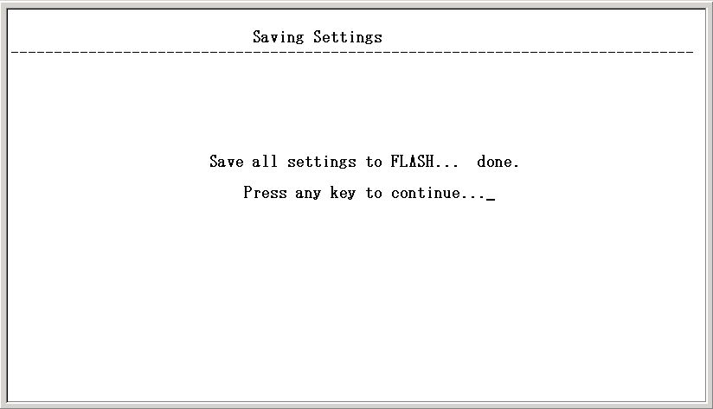
Boot Menu---Saving Settings screen
After the settings have been saved to NV-RAM, they will become the default settings for the device, and they will be used every time it is powered on, reset or rebooted. The only exception to this is a factory reset, which will clear all settings and restore them to their initial values, which were present when the device was purchased.

Factory Reset
Before performing a Factory Reset, be absolutely certain that this is what you want to do. Once the reset is done, all of the device’s settings stored in NV-RAM will be erased and restored to values present when the device was purchased.
Note: After performing the Factory Reset, make sure to redefine the IP settings for the device in the IP Configuration menu. Then perform a Restart System on the device. After these three procedures are performed, your Factory Reset is complete.
To perform a Factory Reset, use the arrow keys to highlight the fifth menu item on the Boot Menu, Factory Reset, and press <Enter>. The Factory Reset screen will be displayed:
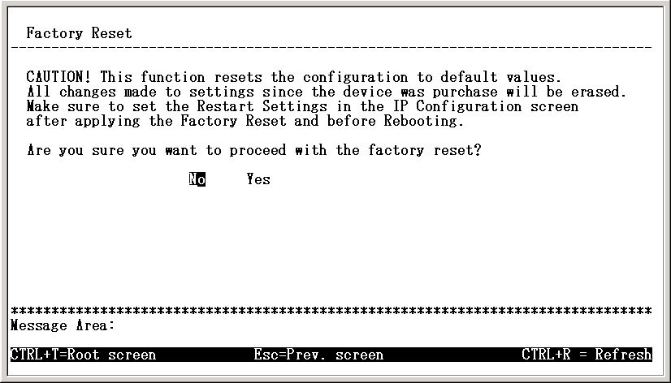
Boot Menu---Factory Reset screen

Restart System
To perform a system reset, use the arrow keys to highlight the last menu item on the Boot Menu, Restart System, and press <Enter>. The following Reboot Device screen will be briefly displayed:
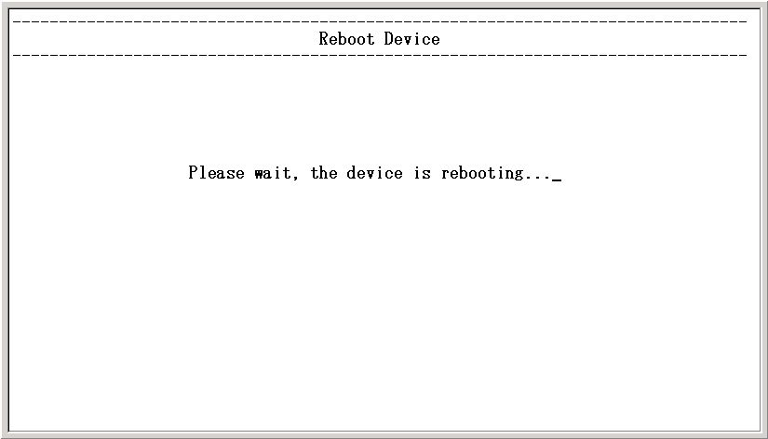
Boot Menu---Restart System screen

6

Web-Based Management

Introduction
The DG-102S VoIP gateway offers an embedded Web-based (hypertext) interface allowing users to manage the device from anywhere on the network through a standard browser such as Netscape Navigator/Communicator, 4.x or later, or Microsoft Internet Explorer, 4.x or later. The Web browser acts as a universal access tool and can communicate directly with the device using HTTP protocol. Your browser screen may vary with the screen shots (pictures) in this guide.
Note: This Web-based Management Module does not accept Chinese language input (or other languages requiring two bytes per character).

Getting Started
The first step in getting started in using Web-based management for your device is to secure a browser. A Web browser is a program that allows a person to read hypertext, for example, Netscape Navigator, 4.x or later, or Microsoft Internet Explorer, 4.x or later. Follow the installation instructions for the browser.
The second and last step is to configure the IP interface of the device. This can be done manually through a console. See the Configuring the VoIP Gateway using a Web Browser section of the “Configuration” chapter for specific instructions.

Management
To begin managing your device simply run the browser you have installed on your computer and point it to the IP address you have defined for the device. The URL in the address bar should read something like: http://123.123.123.123, where the numbers 123 represent the IP address of the device.
In the page that opens, click on the following Login to the web-based management module button:
This categories listed on the left-side of the web-based management module include: Config IP (Config Device IP Address and Config Call Agent IP Address), Device Information, Telephony Configuration, DHCP Configuration (Dynamic IP Assignment and Static IP Assignment), NAT Configuration (NAT Configuration and Local Server Configuration), SNMP Trap Configuration, Administration Management, Monitor (Ethernet Statistics, DSP Statistics, Tcid Configuration, Coding Profile, and xGCP Configuration), Firmware and Configuration Update, Save Changes, Factory Reset, and Restart System.

Config Device IP Address
Configure Device IP Address window
The items on this window are described below:
Restart Settings
- Get IP From Choose the method the VoIP gateway will use to obtain its IP settings once it is rebooted (restarted). Choices include:
Manual – When Manual is chosen, the VoIP gateway will obtain its IP settings from the fields located just below.
BOOTP – When BOOTP is chosen, the VoIP will attempt to obtain its IP settings from a BOOTP server located on your LAN.
DHCP – When DHCP is chosen, the VoIP will attempt to obtain its IP settings from a DCHP server located on your LAN.
- IP Address Enter an IP address for the VoIP gateway.
- Subnet Mask Enter a subnet mask for the VoIP gateway.
- Default Gateway Enter the IP address of the WAN device (usually a router) you are using to make the WAN connection.
PPPoE Settings (for DSL users)
- State Enables or disables the PPPoE function.
- User Name Enter the User Name for the PPPoE function.
- Password Enter the Password for the PPPoE function.
Click on the Save button at the bottom right of the window to save the settings.

Config Call Agent IP Address
Configure Call Agent IP Address window
The items on this window are described below:
- Notify Entity Enter the appropriate information for you call agent into this field.
- RGW Name This is the residential gateway name your VoIP gateway will be known as by the call agent. It usually consists of the IP address or a normal name.
- DNS IP Enter the IP address for the closest DNS server in this field.
- DNS State When this item is enabled and the call agent is not responding, the device will try to get the call agent’s IP settings from the DNS server defined above.
Click on the Save button at the bottom right of the window to save the settings.

Device Information
Device Information window
The items on this window are described below:
- Device Type This displays the model name of this device.
- MAC Address This displays the MAC address of this device.
- Boot PROM Version This displays the version number of the device’s startup code.
- Firmware Version This displays the version number of the device’s runtime code.
- DSP Version This displays the Digital Signal Processor version, if any.
- Country Code This is a user-defined country code for this device. < 0:USA (Default), 1:Japan, 2:Hong Kong, 3:Sweden, 4:China>
- Life Line Prefix Digit This is a user-defined Lifeline prefixed key for this device (Default is “#” key).
- Life Line Status Enables or disables the Lifeline function
- Serial Number This field is for a user-determined identification number.
- System Name This is a user-defined name for this device.
- System Location This is a user-defined physical location of the device.
- System Contact This is user-defined contact information for the person or department responsible for the maintenance of this device.
Click on the Save button at the bottom right of the window to save the settings.

Telephony Configuration
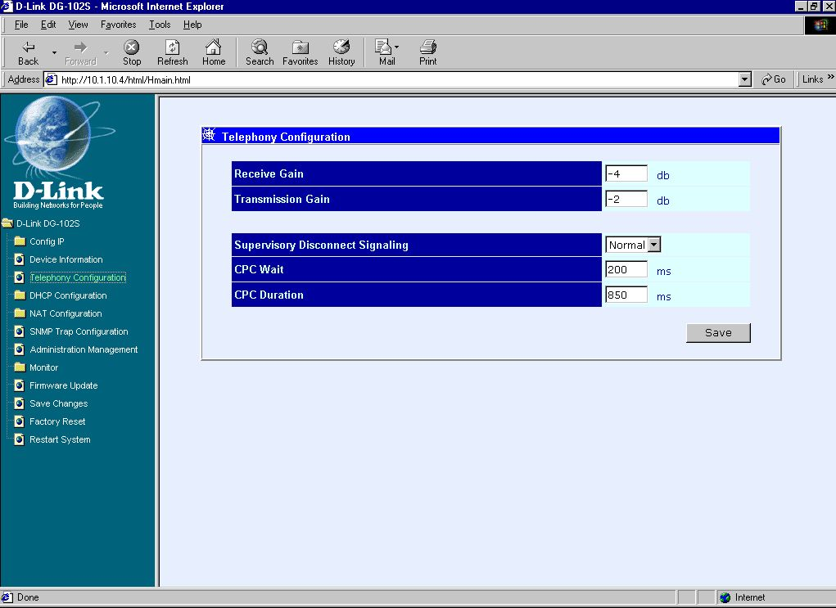
Telephony Configuration window
Enter the desired information on the window above and then click Save.

Dynamic IP Assignment
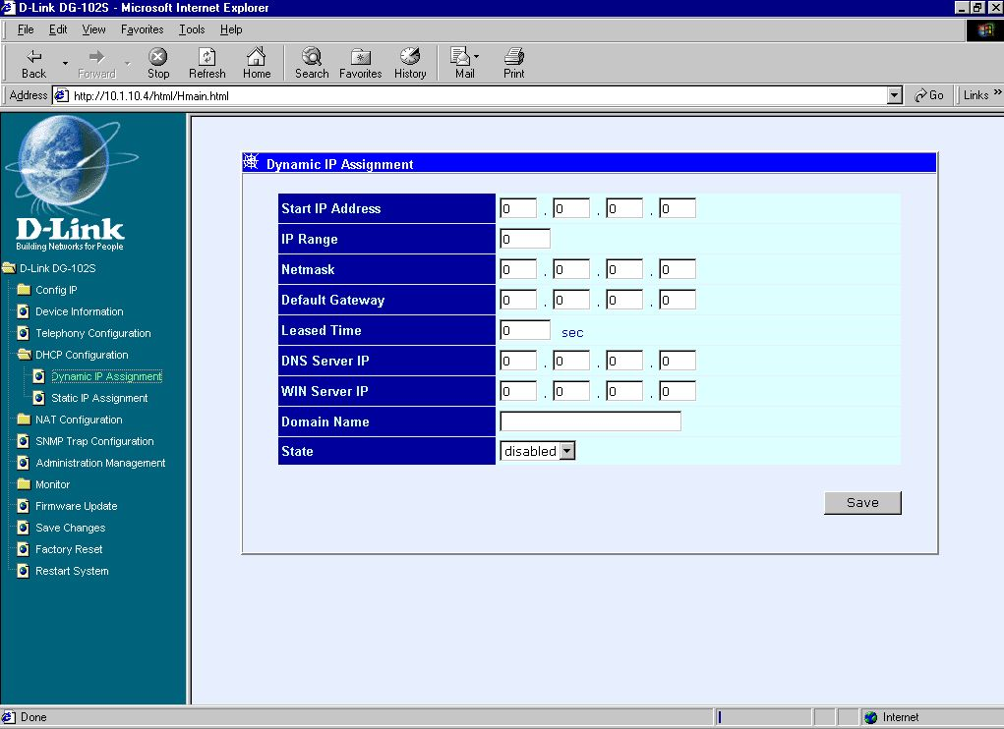
Dynamic IP Assignment window
Enter the desired information on the window above and then click Save.

Static IP Assignment
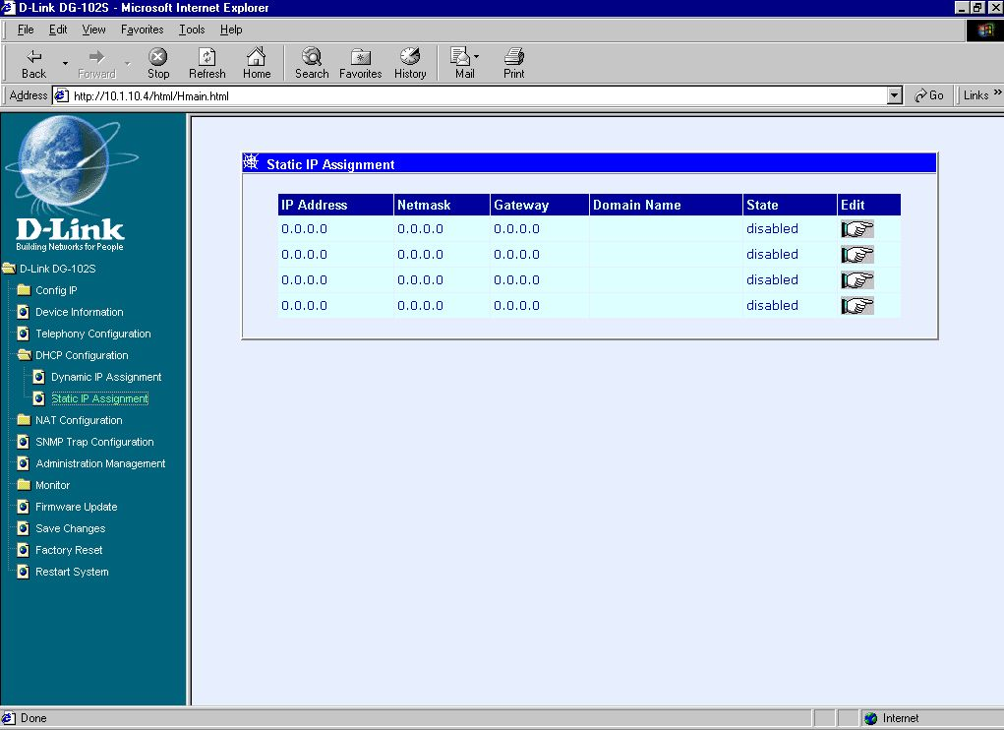
First Static IP Assignment window
Click the pointer icon on the window above to access the second Static IP Assignment window:
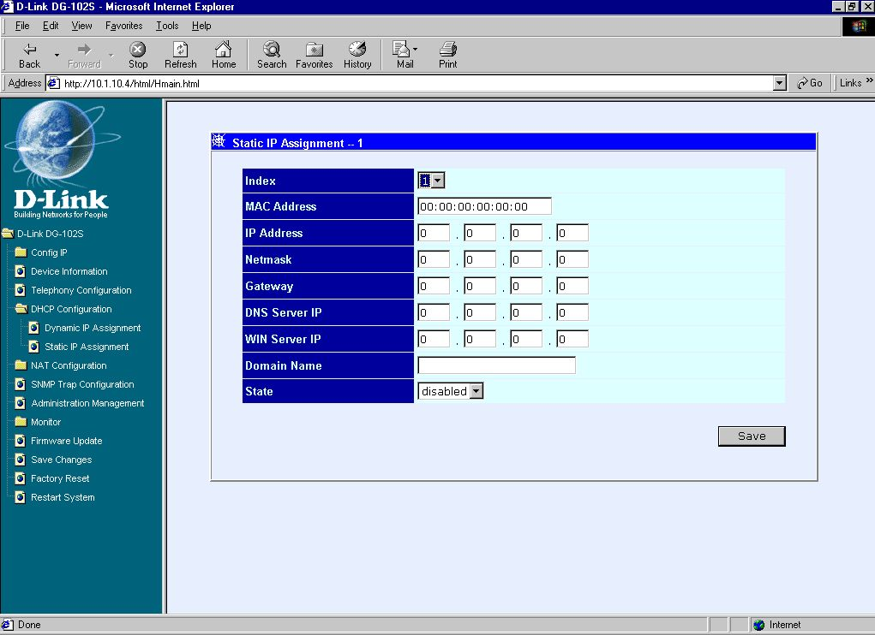
Second Static IP Assignment window
Enter the desired information on the window above and then click Save.

NAT Configuration
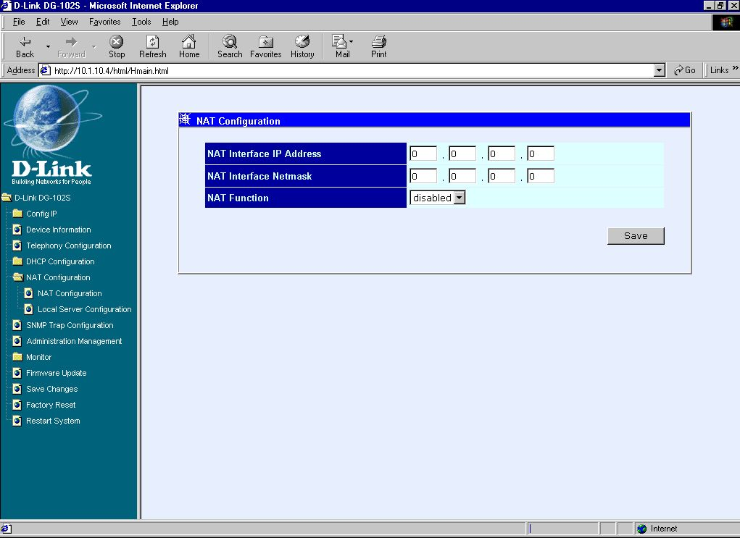
NAT Configuration window
After entering the desired information on the window above, enable or disable the NAT Function and then click Save.

Local Server Configuration
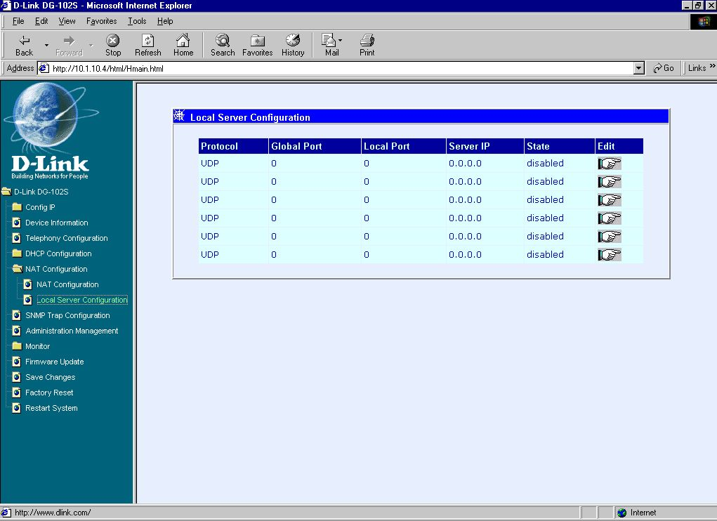
First Local Server Configuration window
This window allows you to view the current local server configuration settings.

Click the pointer icon on the window above to access the second Local Server Configuration window:
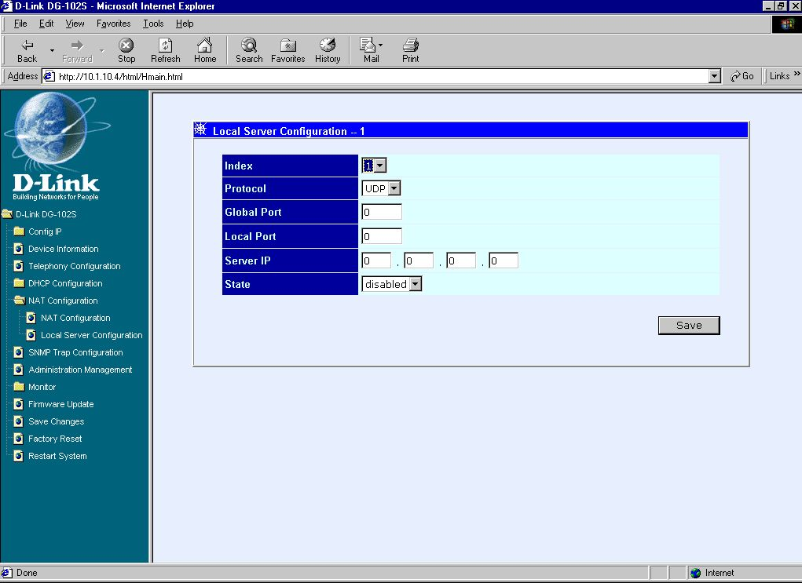
Second Local Server Configuration window
After completing the local server configuration settings on the window above, select enabled or disabled in the drop-down menu under State and then click Save.

SNMP Trap Configuration
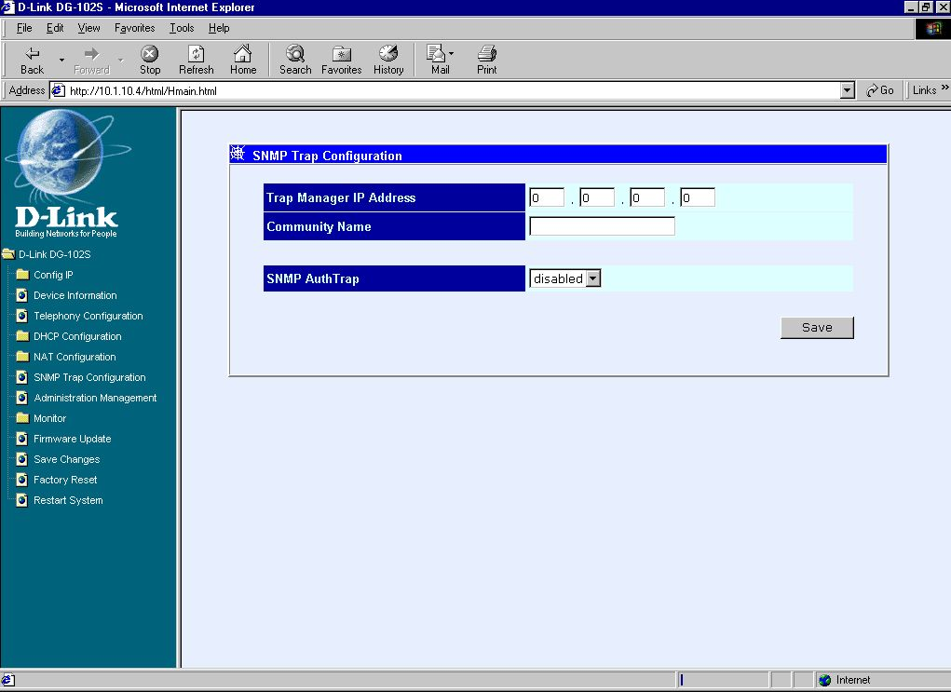
SNMP Trap Configuration window
The items on this window are described below:
- Trap Manager IP Address The IP address of the trap receiving station.
- Community Name A user-defined SNMP community name.
- SNMP AuthTrap Enable or disable the SNMP trap.
Click on the Save button at the bottom right of the window to save the settings.

Administration Management
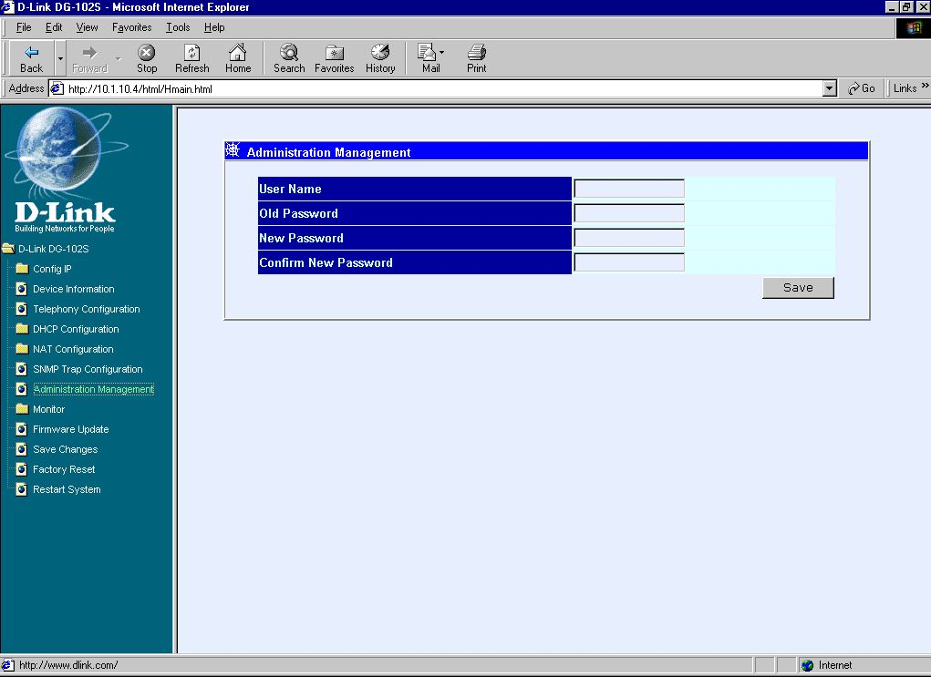
Administration Management window
To add or change a User Account, fill in the appropriate information in the User Name, Old Password (if applicable), New Password, and Confirm New Password fields. Click on the Save button to keep the settings.

Ethernet Statistics
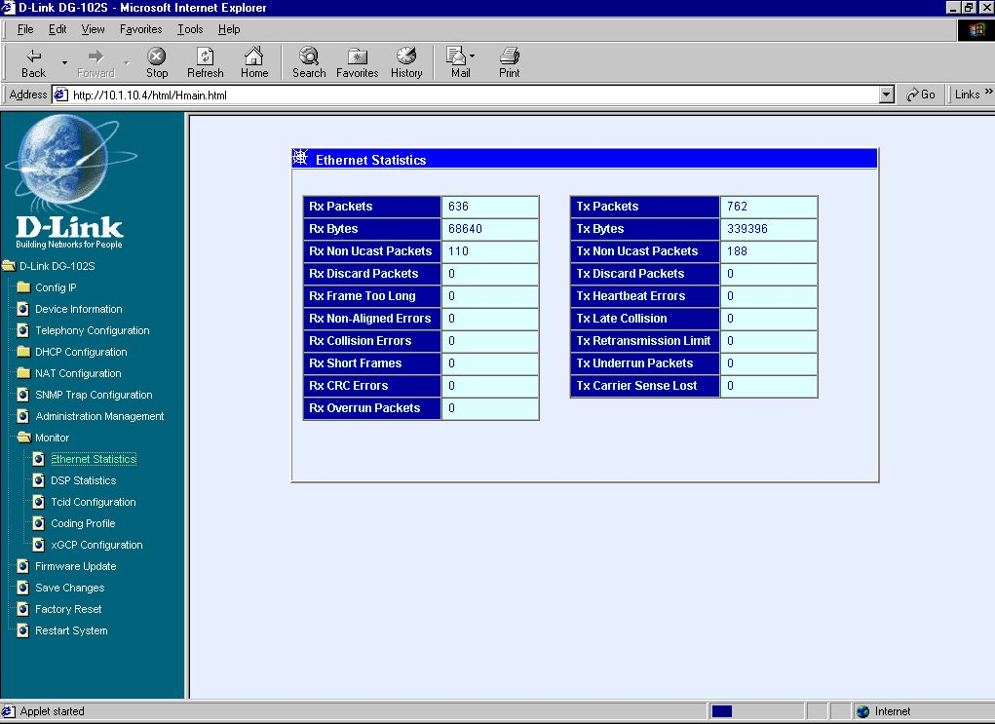
Ethernet Statistics window
Items in the window are described as follows:
- Rx Packets The total number of packets received by the device.
- Rx Bytes The total number of bytes contained in packets received by the device.
- Rx Non Ucast Packets The number of non-unicast packets received by the device.
- Rx Discard Packets The number of packets dropped by the device.
- Rx Frame Too Long The number of packets that are larger than the 1514 Ethernet packet limit.
- Rx Non-Aligned Errors The number of packets that are not aligned properly.
- Rx Collision Errors The number of collision errors.
- Rx Short Frames The number of packets smaller than the 64-octet minimum.
- Rx CRC Errors The number of packets received that failed the CRC checksum test.
- Rx Overrun Packets The number of packets received that exceed the 1518 octet maximum length imposed on Ethernet packets. Overrun packets are generated by some proprietary software applications.
- Tx Packets The total number of valid packets transmitted by the device since the last reset.
- Tx Bytes The total number of bytes transmitted by the device.
- Tx Non Ucast Packets The number of non-unicast packets sent.
- Tx Discard Packets The number of packets dropped by the device.
- Tx Heartbeat Errors The number of heartbeat errors. This relates to an internal timing function.
- Tx Late Collision The number of late collisions.
- Tx Retransmission Limit The number of times the device had to retransmit packets.
- Tx Underrun Packets This counter shows the number of runt packets transmitted by the device that are less than the allowed 64-octet minimum length. Underrun packets occur due to jam signals generated by collisions, backpressure, etc.
- Tx Carrier Sense Lost The number of times packets were lost due to carrier sense lost.

DSP Statistics
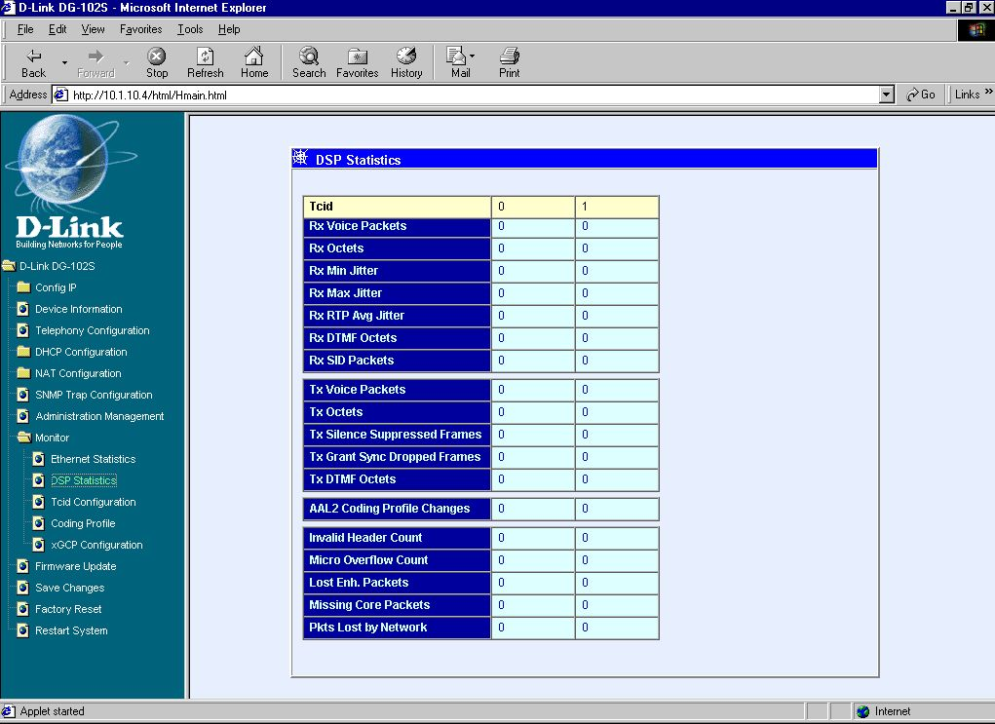
DSP Statistics window
This window displays a variety of DSP statistics.

Tcid Configuration
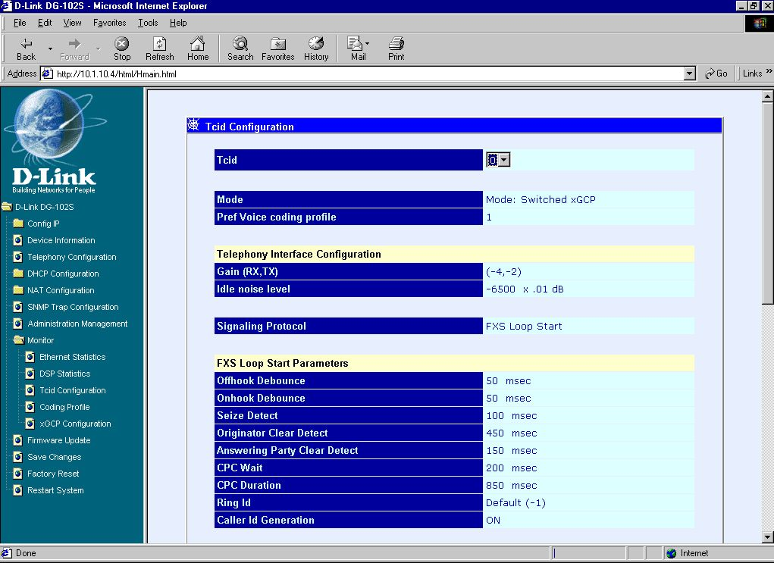
Tcid Configuration window
This read-only window displays a variety of Tcid configuration settings.

Coding Profile
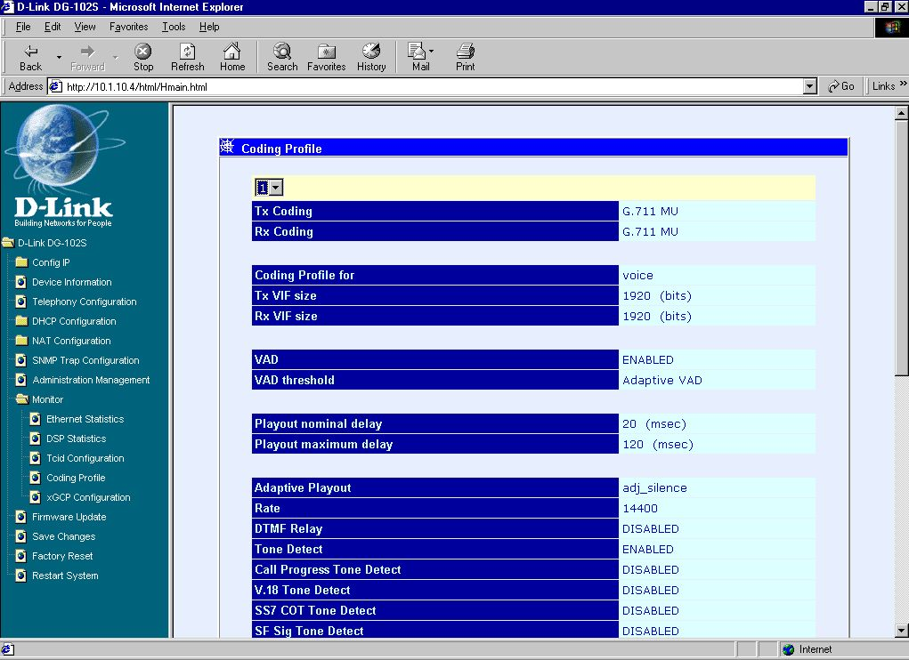
Coding Profile window
This read-only window displays various Coding Profile settings.

xGCP Configuration
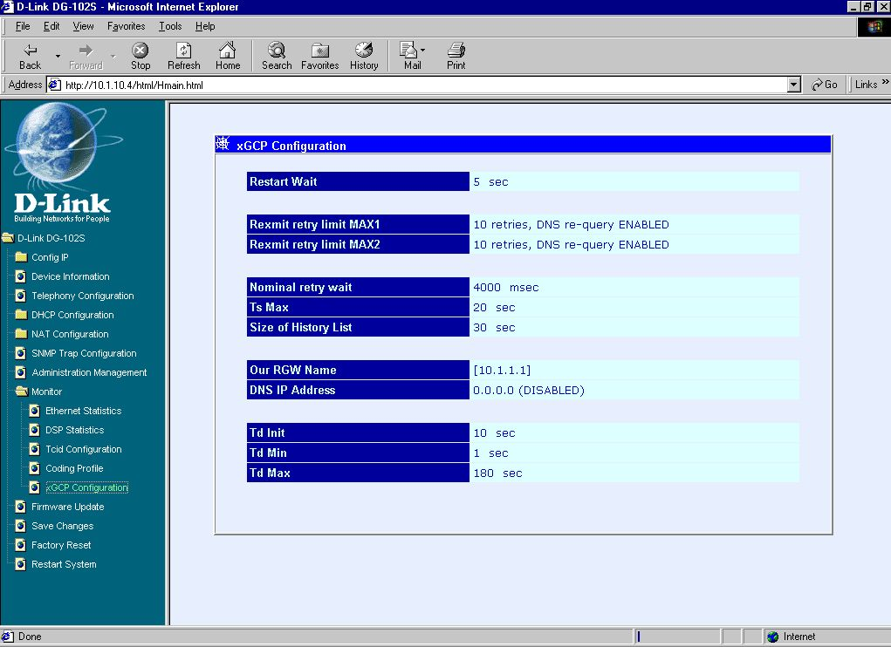
xGCP Configuration window
This read-only window displays settings related to xCGP Configuration.

Firmware and Configuration Update
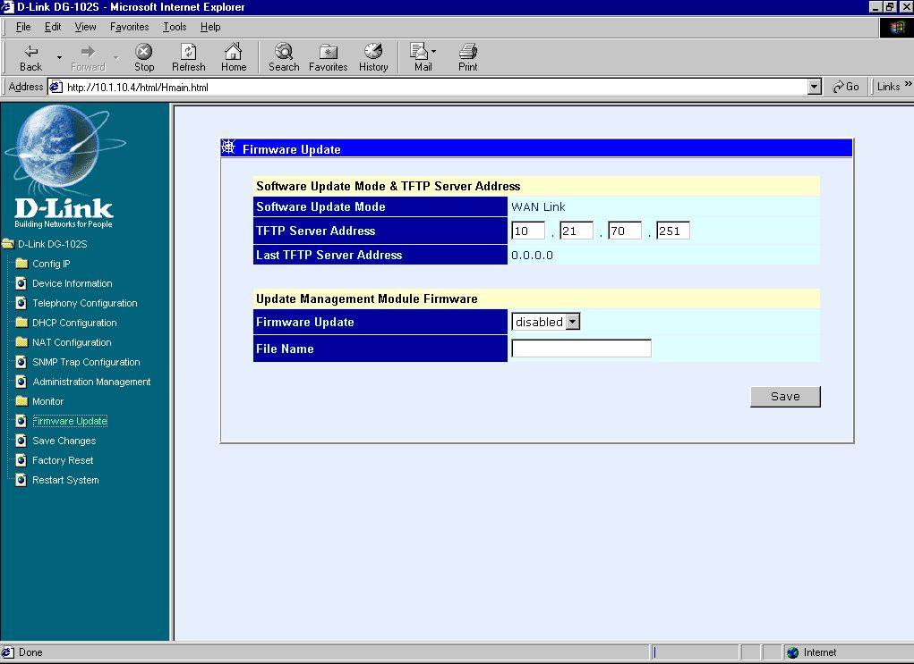
Update Firmware and Configuration Files window
The items on this window are described below:
- Software Update Mode This specifies downloading the image file through a WAN Link.
- TFTP Server Address The IP address of the TFTP server where the runtime or configuration file is located. This entry is used only if the Firmware Update is set to Enable.
- Last TFTP Server Address This is a read-only field that displays the IP address of the last TFTP server to be accessed.
- Firmware Update Determines whether or not the device will try to look for a runtime image file on the TFTP server.
- File Name The complete path and filename of the runtime image file on your TFTP server to be uploaded to the device.
Click on the Save button at the bottom right of the window to save the settings.

Save Changes
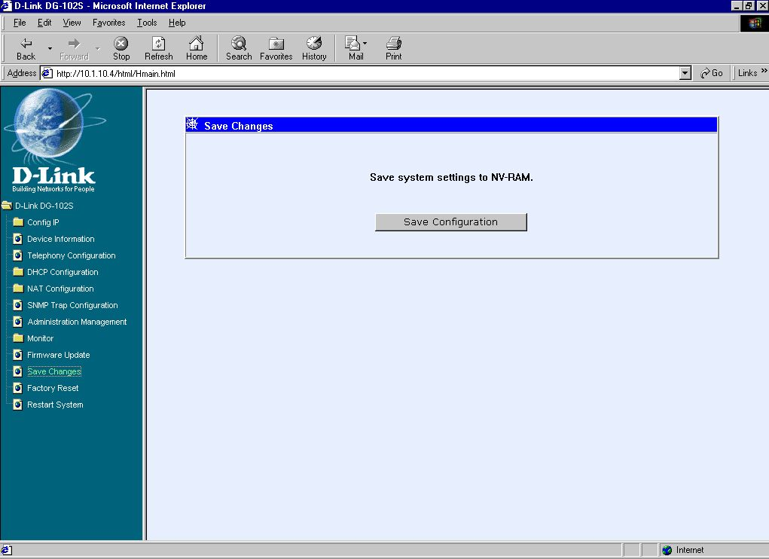
Save Changes window
After the settings have been saved to NV-RAM, they will become the default settings for the device, and they will be used every time it is powered on, reset or rebooted. The only exception to this is a factory reset, which will clear all settings and restore them to their initial values, which were present when the device was purchased.
Click on the Save Configuration button at the bottom of the window to save the system settings to NV-RAM.

Factory Reset
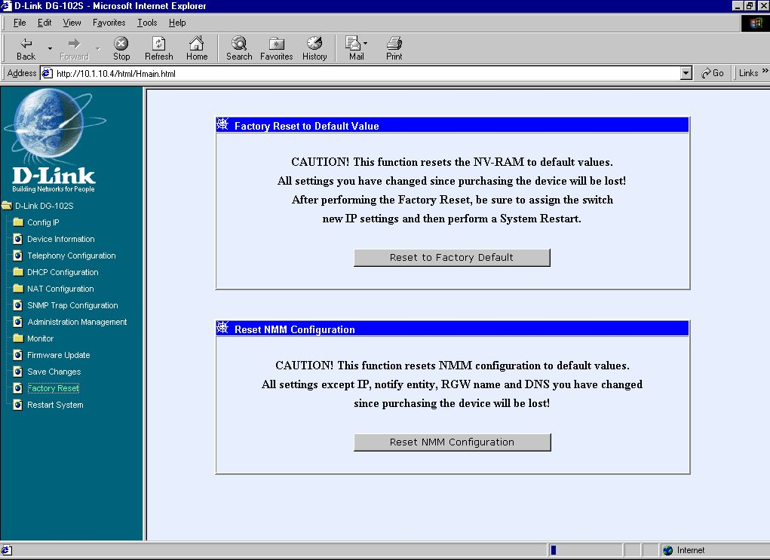
Factory Reset to Default Value window
Before performing a Factory Reset, be absolutely certain that this is what you want to do. Once the reset is done, all of the device’s settings stored in NV-RAM will be erased and restored to values present when the device was purchased.
Note: After performing the Factory Reset, make sure to redefine the IP settings for the device in the IP Configuration menu. Then perform a Restart System on the device. After these three procedures are performed, your Factory Reset is complete.
Click on the Reset to Factory Default button at the bottom of the window to reset the NV-RAM to the default values that were present when you purchased the device.

Restart System
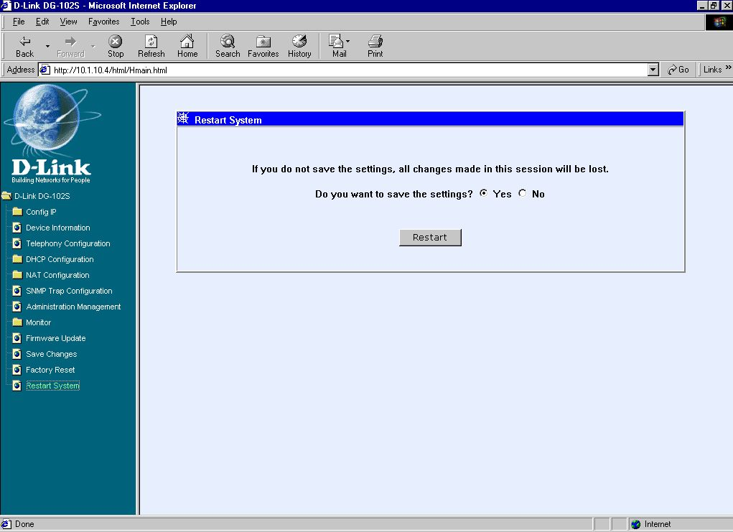
Restart System window
To perform a reboot of the device, which resets the system, click the Restart button.

7

Command Line Interface
The DG-102S VoIP gateway offers a line-at-a-time prompt and response scheme to execute various configuration instructions. The interface displays a single prompt character ggdbg> when it is ready to accept a command (ex. ggdbg>set or ggdbg>show).
Typing a question mark after the ggdbg> prompt will display a list of helpful user commands. Please note that all characters must be entered in lower case. For the sake of explanation, all command line examples in this chapter are in bold type.
See below for a list of some of the most commonly used commands, parameter(s), and examples of their usage.

General Setup Commands
nwdbg system reboot
Definition: This command is used to restart the device.
Parameter(s): None.
Example: nwdbg system reboot

nwdbg save changes
Definition: This command is used to save configuration changes into flash and then restart the device.
Parameter(s): None.
Example: nwdbg save changes

nwdbg factory reset
Definition: This command is used to change all of the configuration data to the default values, save the new configuration data into flash, and then restart the device.
Parameter(s): None.
Example: nwdbg factory reset

nwdbg un <USERNAME>
Definition: This command sets the username if there is a username string, or shows the username/password if only nwdbg un is typed.
Parameter(s): <USERNAME, maximum string length is 12 characters>
Example: nwdbg un 123456789012

nwdbg pw <PASSWORD>
Definition: This command sets the password if there is a password string, or shows the username/password if only nwdbg pw is typed.
Parameter(s): <PASSWORD, maximum string length is 12 characters>
Example: nwdbg pw

nwdbg slic <0|1>
Definition: This command changes the Subscriber Line Interface Circuit (SLIC) state to standby or active, or shows the SLIC state if only nwdbg slic is typed.
Parameter(s): <slic state, 0 : standby, 1 : active >
Example: nwdbg slic 0

nwdbg dtmf_relay <0|1>
Definition: This command turns the Dual Tone Multiple Frequency (DTMF) relay function on or off, or shows the DTMF relay state if only nwdbg dtmf_relay is typed.
Parameter(s): <0 : off, 1 : on>
Example: nwdbg dtmf_relay 0

nwdbg mac <MAC ADDRESS>
Definition: This command sets the MAC address of the voice link, or shows the MAC address if only nwdbg mac is typed.
Parameter(s): <MAC ADDRESS, the format is XX:XX:XX:XX:XX:XX>
Example: nwdbg mac 00:50:ba:08:24:56

nwdbg ip <dhcp|bootp|manual>
Definition: This command sets the software boot mode to DHCP or BOOTP or Manual mode.
If only nwdbg ip is typed, this command shows the IP configuration.
DHCP: While the system is booting, the system acts as a DHCP client.
BOOTP: While the system is booting, the system acts as a BOOTP client. This mode is used to set the device's IP address and upgrade the software.
Manual: While the system is booting, the system uses a fixed IP address. The fixed IP address can be set by nwdbg ip <IP ADDRESS>.
Parameter(s): <dhcp|bootp|manual>
Example: nwdbg ip dhcp

nwdbg ip <IP ADDRESS>
Definition: This command sets the fixed IP address, which is used as the system's IP address if the software boot mode is Manual mode.
If only nwdbg ip is typed, this command shows the IP configuration.
Parameter(s): <IP ADDRESS>
Example: nwdbg ip 10.1.1.120

nwdbg mask <SUBNET MASK>
Definition: This command sets the fixed subnet mask, which is used as the system's subnet mask if the software boot mode is Manual mode.
If only nwdbg mask is typed, this command shows the IP configuration.
Parameter(s): <SUBNET MASK>
Example: nwdbg mask 255.0.0.0

nwdbg gw <GATEWAY IP>
Definition: This command sets the fixed GW address, which is used as the system's GW address if the software boot mode is Manual mode.
If only nwdbg mask is typed, this command shows the IP configuration.
Parameter(s): <GATEWAY IP>
Example: nwdbg gw 10.1.1.254

nwdbg tftp <0|1>
Definition: This command sets the software download link to either a WAN link or a LAN link.
If only nwdbg tftp is typed, this command shows the download link.
Parameter(s): <0:WAN link, 1:LAN link>
Example: nwdbg tftp 0

nwdbg ca <NOTIFY ENTITY>
Definition: This command sets the address of notify entity.
If only nwdbg ca is typed, this command shows the address.
Parameter(s): <NOTIFY ENTITY, the format can be: localName@[domainName|ip]:port or
[domainName|ip]:port or [domainName|ip]>
Example: nwdbg ca 10.1.40.100:2427

nwdbg rgw <RGW NAME>
Definition: This command sets the Residential Gateway Name.
If only nwdbg rgw is typed, this command shows the RGW NAME.
Parameter(s): <RGW NAME>
Example: nwdbg rgw [RGW_1]

nwdbg dns <DNS IP>
Definition: This command sets the Domain Name Server's IP address.
If only nwdbg dns is typed, this command shows the DNS IP/STATE.
Parameter(s): <DNS IP>
Example: nwdbg dns 10.1.1.5

nwdbg dns <disable|enable>
Definition: This command turns on/off the DNS function.
If only nwdbg dns is typed, this command shows the DNS IP/STATE
Parameter(s): [disable | enable]
Example: nwdbg dns disable

nwdbg country <code>
Definition: This command provides country code setting interface to config the tone frequency for different country.
If only nwdbg country is typed, this command shows the COUNTRY CODE
Parameter(s): <0:USA (Default), 1:Japan, 2:Hong Kong, 3:Sweden>
Example: nwdbg country 1

nwdbg config
Definition: This command shows all the configuration settings made by nwdbg commands.
Parameter(s): None.
Example: nwdbg config

ping <DEST IP> <OPTIONS>
Definition: This command lets the user ping an IP address from the device.
Parameter(s): <DEST IP: The host ip address>
<OPTIONS, -t : Ping the specifed host until stopped (type SPACE).
-n count: Number of echo requests to send.
-w timeout: Timeout in seconds to wait for each reply.
-i interval: The interval in half-seconds between two echo requests.>
Example: ping 10.1.1.6 -n 100 -w 2 -i 1

TFTP Client Setup Commands
When the user enters tftp, the screen will show all commands about the TFTP client:
ggdbg>tftp
tftp srvip <IP ADDRESS> – set the IP address of TFTP server
tftp get <FILENAME> – get the remote image file
if <FILENMAE> is not specified, the
image file name in EEPROM will be
employed.
tftp update – update the image in flash
Current Settings :
TFTP Server IP Address : 172.16.6.245
Image File Name : 102nmm01.tfp

tftp srvip <IP ADDRESS>
Definition: This command sets the IP address of the TFTP server. The image must be resident on that TFTP server. If the IP address is invalid, the message ERROR will be displayed.
Example: ggdbg>tftp srvip 172.16.6.245
OK

tftp get <FILENAME>
Definition: Gets the image from the TFTP server. The <FILENAME> is the name of the image on the TFTP server. If any error happened during downloading image, the message ERROR will be displayed. When the user enters tftp get, the file name in EEPROM will be employed.
Example: ggdbg>tftp get c:\102nmm.tfp
Download d:\project\dg102\102nmm.tfp ...\
OK

tftp update
Definition: This command updates the image in FLASH. The image is downloaded for storage in DRAM. If any error happens during the update of the image, the message ERROR will be displayed.
Example: ggdbg>tftp update
.. Erase Runtime Flash Memory ... Done
.. Program Runtime Flash Memory ... Done
OK

A

Specifications
Call Control Protocols Compliance:
MGCP
Voice Compression:
G.711 (A-law and u-law), G.723.1, G.729a
Analog Voice Ports:
Type: Loop-Start FXS interfaces
DTMF tone detection/generation
V.21/V.25 Modem/Fax tone detection
Echo Cancellation: G.165/G.168

Ethernet Ports
WAN: NWay 10/100BASE-TX Fast Ethernet ports (MDI-II)
LAN: NWay 10/100BASE-TX Fast Ethernet ports (MDI-X)
IEEE 802.3 10BASE-T Ethernet compliance
IEEE 802.3u 100BASE-TX Fast Ethernet compliant
Quality of Service:
Voice service is prioritized over the data traffic
FAX Support:
V.21, V.27ter, V.29, V.17 Modulation/Demodulation.
Fax Relay Protocols: T.38
Network Protocols:
TCP/IP, UDP, ARP, ICMP, TFTP, Telnet, SNMP, HTTP
DHCP: Dynamic Host Configuration Protocol server and client
NAT: Network Address Translation
PPP over Ethernet Client
Network Management:
SNMP management agent base MIB II
Telnet provisioning
Manage functions through an intuitive web-based graphical user interface
Local management console
TFTP: The built–in Trivial File Transfer Protocol provides firmware upgrade
Security:
Password Authentication Protocol/Challenge Handshake Authentication Protocol (PAP/CHAP)
Administrative password through Telnet, Console, Web and SNMP
LEDs
General
Power
Status
Ethernet
WAN: 10/100M, Link/Act
LAN: 10/100M, Link/Act
Line
Hook/Ringing
Phone 1 to 2
Hook/Ringing
Dimensions
223.3(W) x 131.7(D) x 35(H) mm
Number of Ports
One 10/100BASE-TX Fast Ethernet port (WAN)
One 10/100BASE-TX Fast Ethernet port (LAN)
Two loop-start FXS RJ-11 ports
One PSTN POTS RJ-11 port for Life Line
One RS-232C, DB-9 Console port

Power Supply
AC-to-DC power adapter (provided)
DC Input: 12VDC/1A
Operating Temperature
0 - 50 °C
Storage Temperature
-10 - 55 °C
Humidity
5% - 95% non-condensing
Safety
CSA International (CSA 950, UL 1950, EN 60950, IEC 950)
Emission (EMI)
FCC Class B
VCCI Class B
BSMI Class B
CE Class B
C-Tick Class B
Offices

AUSTRALIA D-LINK AUSTRALASIA
Unit 16, 390 Eastern Valley Way Roseville, NSW 2069 Australia
TEL: 61-2-9417-7100 FAX: 61-2-9417-1077 TOLL FREE (Australia): 1800 177 100 TOLL FREE (New Zealand): 0800-900900
URL: www.dlink.com.au E-MAIL: support@dlink.com.au & info@dlink.com.au

CANADA D-LINK CANADA
2180 Winston Park Drive, Oakville, Ontario, L6H 5W1 Canada
TEL: 1-905-829-5033 FAX: 1-905-829-5223 BBS: 1-965-279-8732 TOLL FREE: 1-800-354-6522
URL: www.dlink.ca FTP: ftp.dlinknet.com E-MAIL: techsup@dlink.ca

DENMARK D-LINK DENMARK
Naverland 2 DK-2600 Glostrup Copenhagen, Denmark
TEL:45-43-969040 FAX:45-43-424347 URL: www.dlink.dk E-MAIL: info@dlink.dk

EGYPT D-LINK MIDDLE EAST
7 Assem Ben Sabet Street, Heliopolis Cairo, Egypt
TEL: 202-245-6176 FAX: 202-245-6192 URL: www.dlink-me.com E-MAIL: support@dlink-me.com & fateen@dlink-me.com

FRANCE D-LINK FRANCE
Le Florilege #2, Allee de la Fresnerie, 78330 Fontenay le Fleury, France
TEL: 33-1-3023-8688 FAX: 33-1-3023-8689 URL: www.dlink-france.com E-MAIL: info@dlink-france.fr

GERMANY D-LINK GERMANY
Bachstrae 22, D-65830 Kriftel, Germany
TEL: 49-(0)6192-97110 FAX: 49-(0)6192-9711-11 URL: www.dlink.de BBS: 49-(0)6192-971199 (analog)
BBS: 49-(0)6192-971198 (ISDN) INFO: 00800-7250-0000 (toll free) HELP: 00800-7250-4000 (toll free)
REPAIR: 00800-7250-8000 E-MAIL: mbischoff@dlink.de & mboerner@dlink.de

INDIA D-LINK INDIA
Plot No.5, Kurla-Bandra Complex Rd., Off Cst Rd., Santacruz (E) Bombay - 400 098 India
TEL: 91-22-652-6696 FAX: 91-22-652-8914 URL: www.dlink-india.com E-MAIL: service@dlink.india.com

ITALY D-LINK ITALY
Via Nino Bonnet n.6/b, 20154 Milano, Italy
TEL: 39-02-2900-0676 FAX: 39-02-2900-1723 URL: www.dlink.it E-MAIL: info@dlink.it

JAPAN D-LINK TOKYO
10F, 8-8-15 Nishi-Gotanda, Shinagawa-ku, Tokyo 141 Japan
TEL: 81-3-5434-9678 FAX: 81-3-5434-9868 URL: www.d-link.co.jp E-MAIL: kida@d-link.co.jp

SINGAPORE D-LINK INTERNATIONAL/D-LINK SINGAPORE
1 International Business Park, #03-12 The Synergy, Singapore 609917
TEL : 65-774-6233 FAX: 65-774-6322 E-MAIL: info@dlink.com.sg URL: www.dlink-intl.com

SWEDEN D-LINK SWEDEN
P. O. Box 15036, S-167 15 Bromma, Sweden
TEL: 46-(0)8564-61900 FAX: 46-(0)8564-61901 E-MAIL: info@dlink.se URL: www.dlink.dk

TAIWAN D-LINK TAIWAN
2F, No. 119 Pao-Chung Rd, Hsin-Tien, Taipei, Taiwan
TEL: 886-2-2910-2626 FAX: 886-2-2910-1515 URL: www.dlinktw.com.tw E-MAIL: dssqa@tsc.dlinktw.com.tw

U.K. D-LINK EUROPE/D-LINK U.K.
4th Floor, Merit House, Edgeware Road, Colindale, London NW9 5AB U.K.
TEL: 44 (0) 20-8731-5555 FAX: 44 (0) 20-8731-5511 URL: www.dlink.co.uk E-MAIL: info@dlink.co.uk

U.S.A. D-LINK U.S.A.
53 Discovery Drive, Irvine, CA 92618, USA
TEL: 1-949-788-0805 FAX: 1-949-753-7033 BBS: 1-949-455-1779 & 1-949-455-9616 INFO: 1-800-326-1688
URL: www.dlink.com E-MAIL: tech@dlink.com & support@dlink.com

Registration Card
Print, type or use block letters.
Your name: Mr./Ms_______________________________________________________________________
Organization:_____________________________ Dept. _________________________________________
Your title at organization: __________________________________________________________________
Telephone:__________________________ Fax:_______________________________________________
Organization's full address: ________________________________________________________________
______________________________________________________________________________________
Country:______________ Date of purchase (Month/Day/Year):____________________________________
Product Model | Product Serial No. | * Product installed in type of computer (e.g., Compaq 486) | * Product installed Computer serial No.
(* Applies to adapters only)
Product was purchased from:
Reseller's name: ________________________________________________________________________
Telephone:_______________________ Fax:__________________________________________________
Reseller's full address: ___________________________________________________________________
______________________________________________________________________________________
1. Where and how will the product primarily be used?
oHome oOffice oTravel oCompany Business oHome Business oPersonal
2. How many employees work at installation site?
o1 employee o2-9 o10-49 o50-99 o100-499 o500-999 o1000 or more
3. What network protocol(s) does your organization use ?
oXNS/IPX oTCP/IP oDECnet oOther_____________________________
4. What network operating system(s) does your organization use ?
oD-Link LANsmart oNovell NetWare oNetWare Lite oSCO Unix/Xenix
oPC NFS o3Com 3+Open oBanyan Vines oDECnet Pathwork
□Windows NT □Windows NTAS □Windows '95 □Other______________
5. What network management program does your organization use ?
□D-View □HP OpenView/Windows □HP OpenView/Unix □SunNet Manager □Novell NMS
□NetView 6000 □Other____________________
6. What network medium/media does your organization use ?
□Fiber-optics □Thick coax Ethernet □Thin coax Ethernet
□10BASE-T UTP/STP □100BASE-TX □100BASE-T4 □100VGAnyLAN □Other_________________
7. What applications are used on your network?
□Desktop publishing □Spreadsheet □Word processing □CAD/CAM
□Database management □Accounting □Other_____________________
8. What category best describes your company?
□Aerospace □Engineering □Education □Finance □Hospital □Legal □Insurance/Real Estate □Manufacturing
□Retail/Chainstore/Wholesale □Government □Transportation/Utilities/Communication □VAR
□Systemhouse/company□Other_____________
9. Would you recommend your D-Link product to a friend?
oYes oNo (why?) ______________________ oI don know yet
10. Your comments on this product:____________________________________________________________

