DPH-100 IP Phone
User’s Guide

First Edition (August 2001)
651DPH100015
Printed in Taiwan

Trademarks
Copyright © 2001 D-Link Corporation.
Contents subject to change without prior notice.
D-Link is a registered trademark of D-Link Corporation/D-Link Systems, Inc. All other trademarks belong to their respective proprietors.
Copyright Statement
No part of this publication may be reproduced in any form or by any means or used to make any derivative such as translation, transformation, or adaptation without permission from D-Link Corporation/D-Link Systems Inc., as stipulated by the United States Copyright Act of 1976.
Hardware:
D-Link warrants each of its hardware products to be free from defects in workmanship and materials under normal use and service for a period commencing on the date of purchase from D-Link or its Authorized Reseller and extending for the length of time stipulated by the Authorized Reseller or D-Link Branch Office nearest to the place of purchase.
This Warranty applies on the condition that the product Registration Card is filled out and returned to a D-Link office within ninety (90) days of purchase. A list of D-Link offices is provided at the back of this manual, together with a copy of the Registration Card.
If the product proves defective within the applicable warranty period, D-Link will provide repair or replacement of the product. D-Link shall have the sole discretion whether to repair or replace, and replacement product may be new or reconditioned. Replacement product shall be of equivalent or better specifications, relative to the defective product, but need not be identical. Any product or part repaired by D-Link pursuant to this warranty shall have a warranty period of not less than 90 days, from date of such repair, irrespective of any earlier expiration of original warranty period. When D-Link provides replacement, then the defective product becomes the property of D-Link.
Warranty service may be obtained by contacting a D-Link office within the applicable warranty period, and requesting a Return Material Authorization (RMA) number. If a Registration Card for the product in question has not been returned to D-Link, then a proof of purchase (such as a copy of the dated purchase invoice) must be provided. If Purchaser's circumstances require special handling of warranty correction, then at the time of requesting RMA number, Purchaser may also propose special procedure as may be suitable to the case.
After an RMA number is issued, the defective product must be packaged securely in the original or other suitable shipping package to ensure that it will not be damaged in transit, and the RMA number must be prominently marked on the outside of the package. The package must be mailed or otherwise shipped to D-Link with all costs of mailing/shipping/insurance prepaid. D-Link shall never be responsible for any software, firmware, information, or memory data of Purchaser contained in, stored on, or integrated with any product returned to D-Link pursuant to this warranty.
Any package returned to D-Link without an RMA number will be rejected and shipped back to Purchaser at Purchaser's expense, and D-Link reserves the right in such a case to levy a reasonable handling charge in addition mailing or shipping costs.
Software:
Warranty service for software products may be obtained by contacting a D-Link office within the applicable warranty period. A list of D-Link offices is provided at the back of this manual, together with a copy of the Registration Card. If a Registration Card for the product in question has not been returned to a D-Link office, then a proof of purchase (such as a copy of the dated purchase invoice) must be provided when requesting warranty service. The term "purchase" in this software warranty refers to the purchase transaction and resulting license to use such software.
D-Link warrants that its software products will perform in substantial conformance with the applicable product documentation provided by D-Link with such software product, for a period of ninety (90) days from the date of purchase from D-Link or its Authorized Reseller. D-Link warrants the magnetic media, on which D-Link provides its software product, against failure during the same warranty period. This warranty applies to purchased software, and to replacement software provided by D-Link pursuant to this warranty, but shall not apply to any update or replacement which may be provided for download via the Internet, or to any update which may otherwise be provided free of charge.
D-Link's sole obligation under this software warranty shall be to replace any defective software product with product which substantially conforms to D-Link's applicable product documentation. Purchaser assumes responsibility for the selection of appropriate application and system/platform software and associated reference materials. D-Link makes no warranty that its software products will work in combination with any hardware, or any application or system/platform software product provided by any third party, excepting only such products as are expressly represented, in D-Link's applicable product documentation as being compatible. D-Link's obligation under this warranty shall be a reasonable effort to provide compatibility, but D-Link shall have no obligation to provide compatibility when there is fault in the third-party hardware or software. D-Link makes no warranty that operation of its software products will be uninterrupted or absolutely error-free, and no warranty that all defects in the software product, within or without the scope of D-Link's applicable product documentation, will be corrected.
D-Link Offices for Registration and Warranty Service
The product's Registration Card, provided at the back of this manual, must be sent to a D-Link office. To obtain an RMA number for warranty service as to a hardware product, or to obtain warranty service as to a software product, contact the D-Link office nearest you. An addresses/telephone/fax list of D-Link offices is provided in the back of this manual.

LIMITATION OF WARRANTIES
IF THE D-LINK PRODUCT DOES NOT OPERATE AS WARRANTED ABOVE, THE CUSTOMER'S SOLE REMEDY SHALL BE, AT D-LINK'S OPTION, REPAIR OR REPLACEMENT. THE FOREGOING WARRANTIES AND REMEDIES ARE EXCLUSIVE AND ARE IN LIEU OF ALL OTHER WARRANTIES, EXPRESSED OR IMPLIED, EITHER IN FACT OR BY OPERATION OF LAW, STATUTORY OR OTHERWISE, INCLUDING WARRANTIES OF MERCHANTABILITY AND FITNESS FOR A PARTICULAR PURPOSE. D-LINK NEITHER ASSUMES NOR AUTHORIZES ANY OTHER PERSON TO ASSUME FOR IT ANY OTHER LIABILITY IN CONNECTION WITH THE SALE, INSTALLATION MAINTENANCE OR USE OF D-LINK'S PRODUCTS
D-LINK SHALL NOT BE LIABLE UNDER THIS WARRANTY IF ITS TESTING AND EXAMINATION DISCLOSE THAT THE ALLEGED DEFECT IN THE PRODUCT DOES NOT EXIST OR WAS CAUSED BY THE CUSTOMER'S OR ANY THIRD PERSON'S MISUSE, NEGLECT, IMPROPER INSTALLATION OR TESTING, UNAUTHORIZED ATTEMPTS TO REPAIR, OR ANY OTHER CAUSE BEYOND THE RANGE OF THE INTENDED USE, OR BY ACCIDENT, FIRE, LIGHTNING OR OTHER HAZARD.
LIMITATION OF LIABILITY
IN NO EVENT WILL D-LINK BE LIABLE FOR ANY DAMAGES, INCLUDING LOSS OF DATA, LOSS OF PROFITS, COST OF COVER OR OTHER INCIDENTAL, CONSEQUENTIAL OR INDIRECT DAMAGES ARISING OUT THE INSTALLATION, MAINTENANCE, USE, PERFORMANCE, FAILURE OR INTERRUPTION OF A D-LINK PRODUCT, HOWEVER CAUSED AND ON ANY THEORY OF LIABILITY. THIS LIMITATION WILL APPLY EVEN IF D-LINK HAS BEEN ADVISED OF THE POSSIBILITY OF SUCH DAMAGE.
IF YOU PURCHASED A D-LINK PRODUCT IN THE UNITED STATES, SOME STATES DO NOT ALLOW THE LIMITATION OR EXCLUSION OF LIABILITY FOR INCIDENTAL OR CONSEQUENTIAL DAMAGES, SO THE ABOVE LIMITATION MAY NOT APPLY TO YOU.
FCC Warning
This equipment has been tested and found to comply with the limits for a Class B digital device, pursuant to part 15 of the FCC Rules. These limits are designed to provide reasonable protection against harmful interference in a residential installation. This equipment generates, uses and can radiate radio frequency energy and, if not installed and used in accordance with the instructions, may cause harmful interference to radio communications. However, there is no guarantee that interference will not occur in a particular installation. If this equipment does cause harmful interference to radio or television reception, which can be determined by turning the equipment off and on, the user is encouraged to try to correct the interference by one or more of the following measures:
– Reorient or relocate the receiving antenna.
– Increase the separation between the equipment and receiver.
– Connect the equipment into an outlet on a circuit different from that to which the receiver is connected.
– Consult the dealer or an experienced radio/TV technician for help.
The device complies with part 15 of the FCC rules. Operation is subject to the following two conditions:
(1) This device may not cause harmful interface.
(2) This device must accept any interference received, including interference that may cause undesired operation.

Table of Contents
Introduction 1
Features 1
Unpacking 2
Operation Requirements 2
External Parts and Their Functions 3
Phone Installation and Indicator Functions 6
Installation Procedures 6
Configuration 7
Configuring the Phone Using a Web Browser 7
Setting Up the Connection 7
Configuring the Phone using the Keypad and LCD 18
Additional Features 21
REDIAL 21
MEMO 21
MUTE 23
FLASH 23
HOLD 23
Speakerphone 23
Specifications 24

1

Introduction
This manual describes the D-Link DPH-100 IP (Internet Protocol) telephone and explains how to configure and operate it.
The DPH-100 is a fully featured IP telephone that allows both business and residential customers to benefit from IP telephony services. It reduces costs by providing access to local and long-distance voice and data services over a single network connection.
This easy-to-use IP phone plugs directly into the local area network through a standard RJ-45 jack. The IP phone utilizes 10/100-Mbps Ethernet for connectivity and supports a full range of telephone network features. In addition, it provides access to a host of features for business applications, including hold, mute, and speakerphone operation. The DPH-100 is equipped with a 2x16 LCD panel for easy configuration and use.
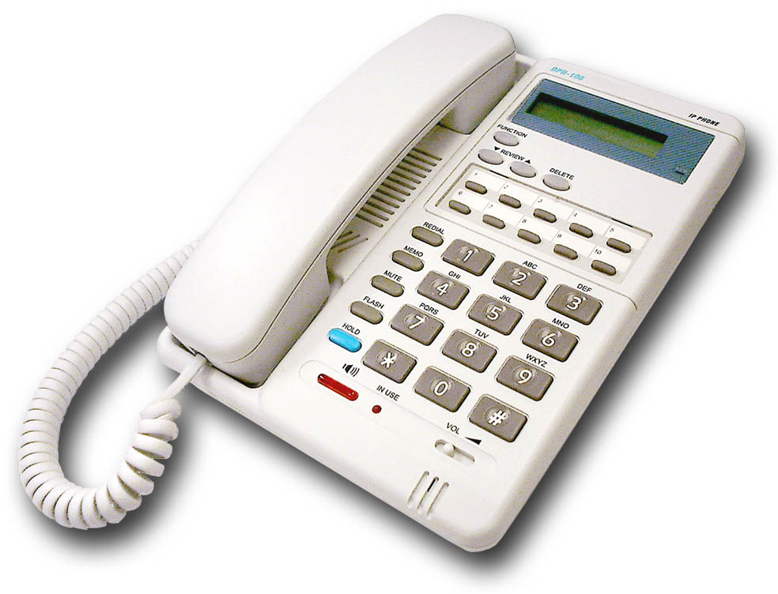

Features
- Operates as an Internet IP phone
- Compliant with MGCP 1.0 and NCS 1.0
- Compliant with H.323v2
- Connects directly to 10/100-Mbps Ethernet
- DHCP client or static IP addressing
- Large LCD panel (2 lines x 16 characters)
- Configurable through LCD-driven menu prompts
- Speakerphone function with automatic echo cancellation
- Silence suppression and comfort noise generation for a completely natural user experience
- DTMF tone generation
- Remote software upgrade support
- Visual status indicators
- Communication interface:
  - LAN jack: RJ-45 for Ethernet (MDI-II)
  - PC jack: RJ-45 for Ethernet (MDI-X)
- Communications protocols: TCP/IP, UDP
- Voice compression: complies with G.711 μ-law, G.711 A-law, G.723 and G.729
- User-adjustable volume control

Unpacking
Open the shipping carton and carefully remove all items. In addition to this user's guide, make sure you have received all of the following items:
- IP phone
- Handset
- Handset cord
- Power adapter (12V DC at 1A)
If any item appears to be missing or damaged, please contact your local reseller.

Operation Requirements
- Internet connection (via ISP)
- Local power outlet

External Parts and Their Functions
Figure 1 The Parts of the Phone
 | HOOK SWITCH | Switches the phone on/off hook.
 | LCD Screen | Presents on-line messages and configuration settings.
 | HOLD INDICATOR | ON when the HOLD function is in effect.
 | FUNCTION | Selects configuration menus.
 | REVIEW UP/DOWN | Move forward and backward through menu items; move the cursor up and down.
 | DELETE | Deletes the character to the left of the cursor.
 | REDIAL | Dials the last number you called.
 | MEMO | Shifts the state to editing the name and number of the Speed Dial and Address Book, or stores the configuration in non-volatile memory.
 | MUTE | Turns sound pickup off and on.
 | FLASH | Transfers the call or clears the input string.
 | HOLD | Turns sound transmission and reception off and on.
 | DIAL PAD | 0,1,2,3,4,5,6,7,8,9,*, #.
 | RING/ SPEAKER VOLUME CONTROL | Increases or decreases ring volume or speakerphone volume during a call.
 | SPEAKER PHONE | Enables/disables the speakerphone function.
 | ENTER | Confirms input or goes to the displayed submenu.
 | ESC | Cancels input or returns to the previous menu.

Figure 2 Handset Controls
 | HANDSET VOLUME CONTROL | Adjusts listening volume on a call to Low, Medium, or High (default setting is Medium)
 | HANDSET CONNECTOR | Connector for the handset cord.
Figure 3 Connectors

 | POWER | Power adapter receptacle.
 | LAN ETHERNET | 10/100BASE-TX LAN to ITSP Internet connection.
 | PC ETHERNET | 10/100BASE-TX connection to PC.

2

Phone Installation and Indicator Functions

Installation Procedures
The following are steps to install and power on your DPH-100 IP phone.
- Plug the RJ-45 Ethernet cable into the LAN jack.
- Plug the power adapter into the appropriate wall outlet.
- Plug the power adapter plug into the power jack (DC 12V/1A).
Figure 4 Installation Connections

LED Indicators

 | Condition | Color | Timing
LAN Port LED | Link OK | Green | Steady
LAN Port LED | Activity (Link in Use) | Green | Flashing
LAN Port LED | Speed 10/100 Mbps | Green | ON: 100 Mpbs  OFF: 10 Mbps
PC Port LED | Link OK | Green | Steady
PC Port LED | Activity (Link in Use) | Green | Flashing
PC Port LED | Speed 10/100 Mbps | Green | ON: 100 Mpbs  OFF: 10 Mbps

3

Configuration

Configuring the Phone Using a Web Browser

Setting Up the Connection
In order to use a Web browser to configure the DPH-100 IP phone, you must make sure the phone has a valid Ethernet connection to a PC or LAN via its Ethernet port. We recommend using a recent version of any widely used browser. The browser must have JavaScript enabled.
The phone comes with a default IP address of 10.1.1.100. You must make sure the PC is in the same IP domain as the IP phone. You can do this by changing the IP address of the PC as shown below.
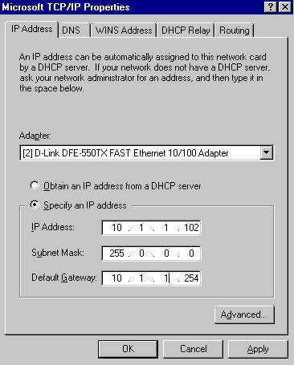

Once this is done, run any recent, JavaScript-enabled browser on the PC and point it to the default IP address of the phone as shown below:

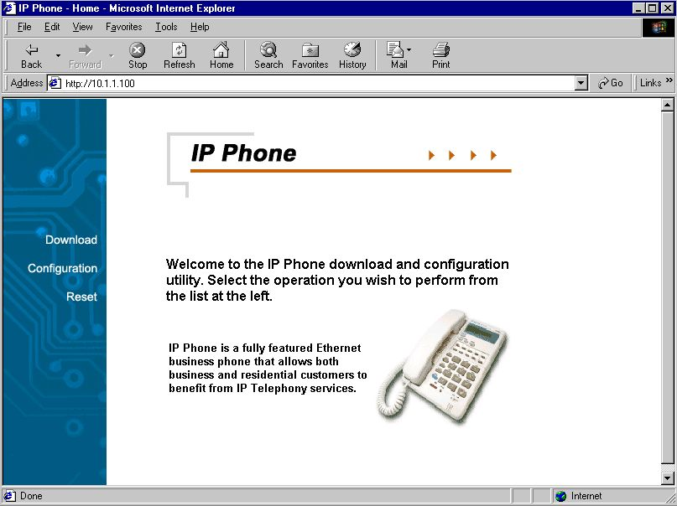

This is the main page of the phone's embedded Web-based configuration utility. This page shows you a welcome message and information about the phone for your reference. There are three choices for you on this page: Download, Configuration and Reset.

H.323 Configuration Page
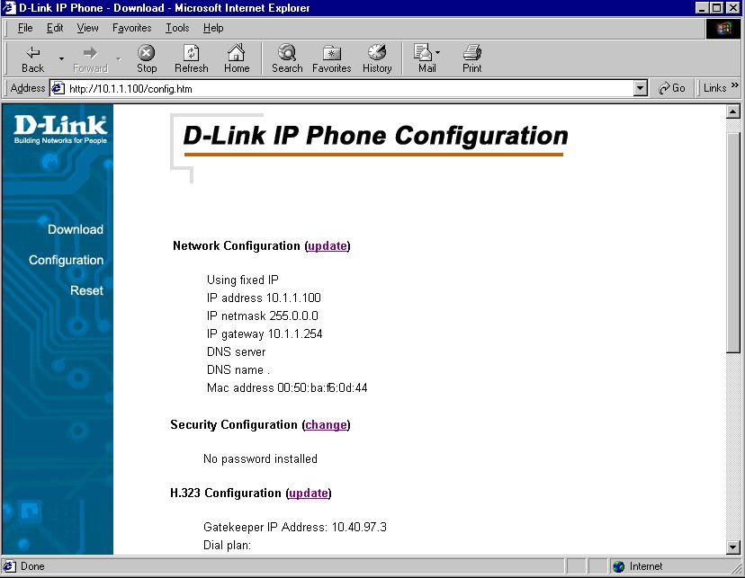
On this page you can set network, security, H.323, CODEC and clock configuration according to your requirements. After completing configuration, you must choose the Save button to store the settings in the phone's non-volatile memory, then reset the phone to activate the new configuration.

Network Configuration Page
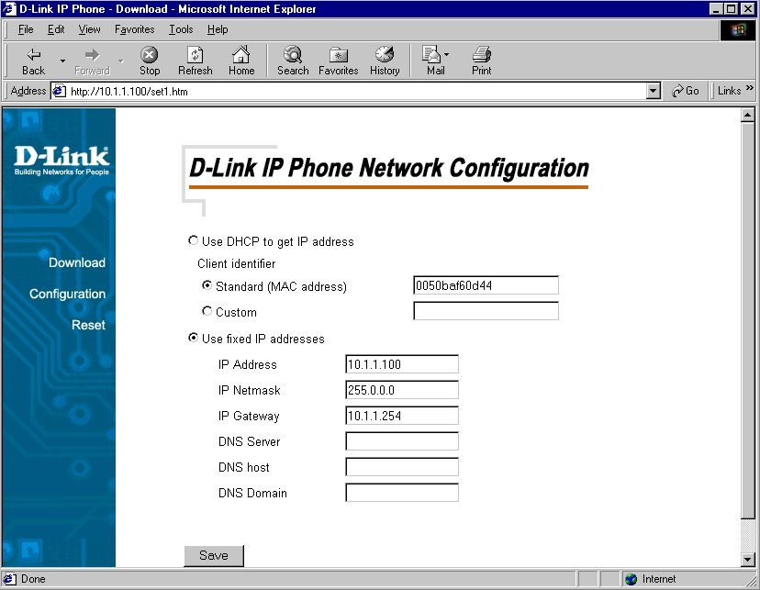
This is the IP phone network configuration web page. On this page, you can set the network parameters according to your network environment. These include the DHCP option and fixed-IP address/subnet/gateway settings. After adjusting the settings, you must click the Save button to save your new configuration.
You can set the phone to get its IP address from a DHCP server or to use a fixed IP address.
- Using DHCP to get an IP address: When DHCP is chosen, the IP phone will attempt to obtain its IP settings from a DHCP server.
- Using a fixed IP address:
  - IP Address: Enter a valid IP address for the phone.
  - IP Netmask: Enter the correct subnet mask for the phone.
  - IP Gateway: Enter an IP gateway for the phone.
  - DNS Server: Enter a DNS server IP address.
  - DNS Host: Enter a DNS server host name.
  - DNS Domain: Enter a DNS server domain name.

Security Configuration Page
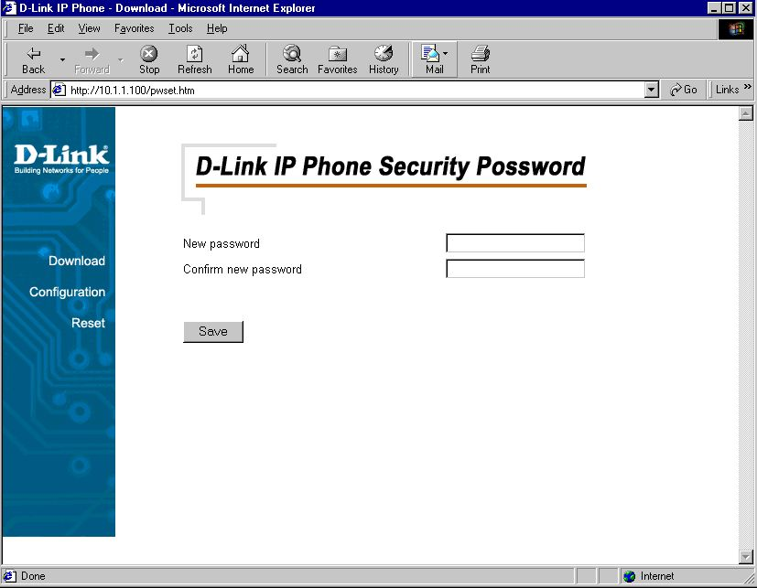
This is the IP phone's security password configuration page. You can set a password to protect your IP phone's configuration from unwanted tampering by other users. After changing the setting, you must click the Save button to save your new configuration. The default password setting is an "empty string," that is, nothing.

H.323 Parameter Configuration Page
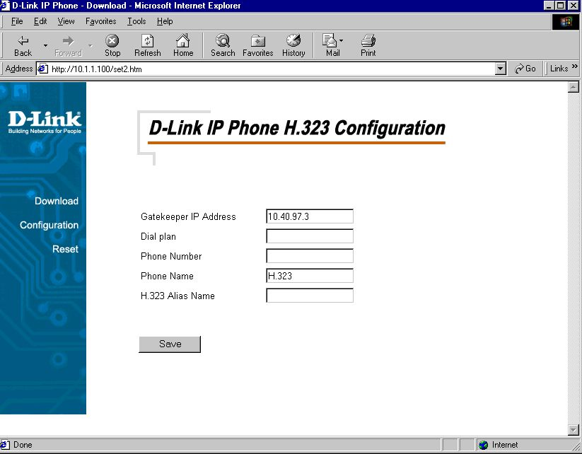
This is the H.323 configuration page. You can set the Gatekeeper IP address, dial plan, phone number, and phone name. After completing configuration, you must click the Save button to save your new configuration.
- Gatekeeper IP Address: Enter the IP address of the Gatekeeper for the phone.
- Dial Plan: The DPH-100 allows provisioning of the dial plan via a Web browser. A dial plan gives the unit a map to determine when a complete number has been entered and should be passed to the gatekeeper for resolution into an IP address. Dial plans are expressed using the syntax described in the MGCP NCS specification.
Example: A dial plan of (x.T|xxxxx) will match immediately if 5 digits are entered; it will also match after a four-second pause during which no digits are entered.
The Timer T is activated when it is all that is required to produce a match. The period of timer T defaults to four seconds.
- Phone Number: Enter the phone number for the IP phone.
- Phone Name: Enter the phone name for the IP phone.
- H.323 Alias Name: Enter the H.323 alias name for the IP phone.
AUDIO/CODEC Configuration Page
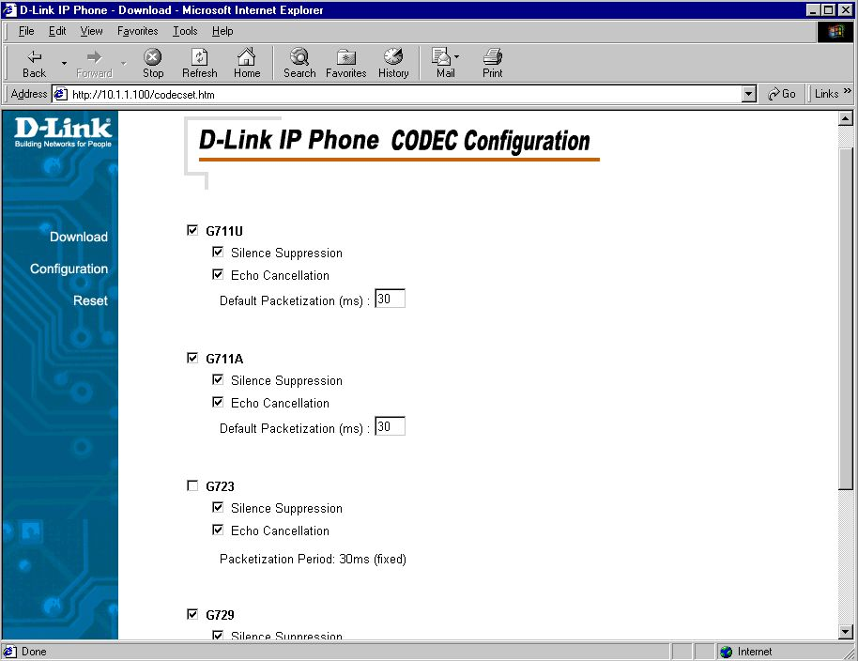
This is the codec (compression/decompression) configuration page. You can select the voice codecs G.711 μ-law, G.711 A-law, G.723 and G.729 on this page. After configuration, click the Save button.

Clock Configuration Page
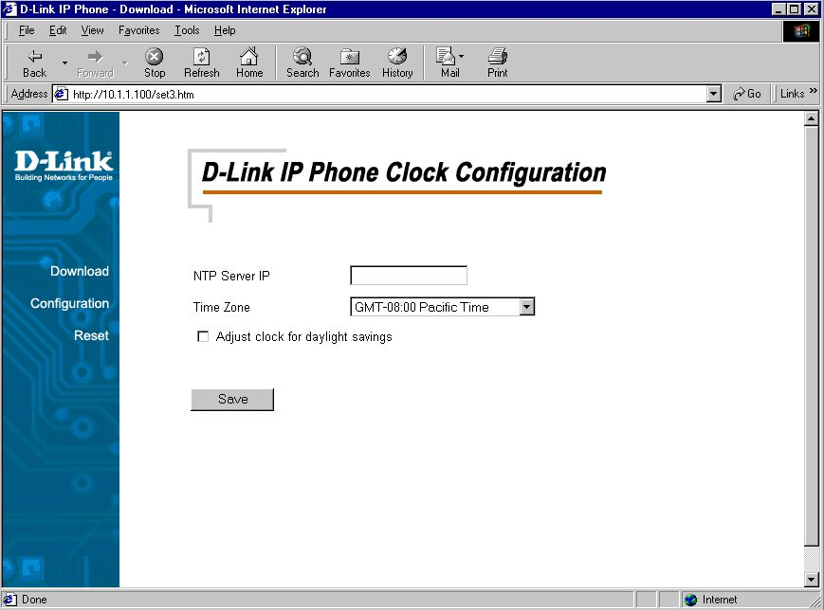
This is the clock configuration page. You can specify an NTP (Network Time Protocol) server, select the time zone of your region, and enable or disable adjustment for Daylight Savings Time to ensure that the phone displays the correct local time. After configuration, click the “Save” button.
- NTP Server IP: Enter the IP address of the NTP server for the phone.
- Time Zone: Select the appropriate time zone from the scrollable list.

Download Page
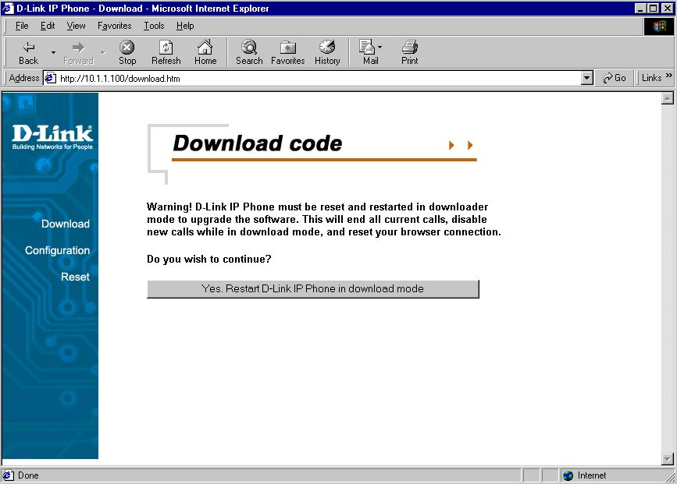
This page is used to upgrade the phone's H.323 application software image. When you click this page's single button, you will be taken to the TFTP download page, and the phone will be restarted in download mode (see below for details).

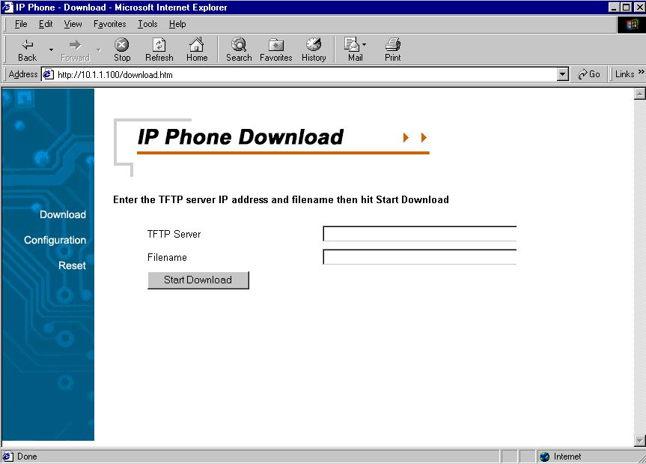
This is the TFTP download page. Both of the input boxes on this page must be filled in for the TFTP download function to work.
- TFTP Server: This is the IP address of the TFTP server where the application software image (also known as the "runtime file") is located.
- Filename: This is the complete name, including path, of the runtime image file on your TFTP server that is to be downloaded to the device.
Fill in the IP address of your TFTP server and the full path and name of the software image file to be downloaded to the phone. Click Start Download to make the phone request the file from the server. When the download is finished, click the Reset button on the Reset page.

Reset Page
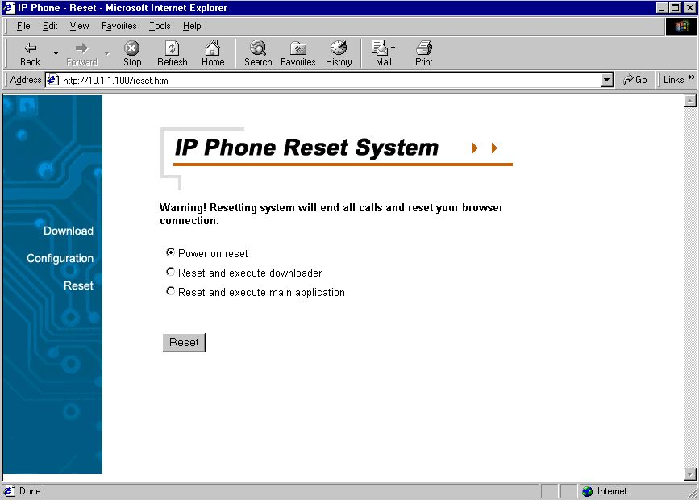
This is the IP phone reset system web page. You can reset the IP phone device through the web browser by clicking the “Reset” button.

Configuring the Phone using the Keypad and LCD
After power is applied, the LCD panel will display the time on the first line and the phone's name on the second line. To configure the phone, press the Function button, enter the password if one is set, and then press the Enter key. (The default password is Null <Empty>.) After successful password authentication, menu names will be displayed on the LCD panel, and you can step through them by pressing Review  or . Press the Enter button to access the named menu and modify the settings in it; press the ESC button to exit any menu but the main menu. The Function menu is hierarchical and similar to the Web page configuration, as shown below.

Keypad Configuration Menu
Main Menu | Sub-Menu
Password
 | <Enter Password> | <Enter number> | <1~8 digits>
IP Configuration
 | DHCP | <Enter ↓↑# *>
 | Fixed IP Address | IP Address | <Enter a.b.c.d>
 |  | Subnet Mask | <Enter a.b.c.d>
 |  | Gateway IP | <Enter a.b.c.d>
 |  | DNS Server IP | <Enter a.b.c.d>
 |  | DNS Host | <Enter string>
 |  | DNS Domain | <Enter string>
Security Configuration
 | New Password | <Enter number> | <1~8 digits>
 | Confirm Password | <Enter number> | <1~8 digits>
H.323 Configuration
 | Gatekeeper IP | <Enter a.b.c.d >
 | Dial Plan | <Enter string>
 | Phone Number | <Enter number> | <1~20 digits>
 | Phone Name | <Enter string>
 | Alias Name | <Enter string>
Codec Configuration
 | None (Use default G.711 codec) | <Enter>
 | G.723(G.711 +G.723) | <Enter>
 | G.729(G.711 +G.729) | <Enter>
Clock Configuration
 | NTP Server address | <Enter a.b.c.d>
 | Time Zone | <Enter ↓↑# *>
 | Daylight Saving | Enable | <Enter ↓↑# *>
 |  | Disable | <Enter ↓↑# *>

After change settings, press ”MEMO” to store the changes in the phone's non-volatile memory, or the changes will disappear after a power reset.
Note: The key buttons behave as shown below only when the configuration menu is active
(To activate the keypad configuration menu, press button <FUNCTION>.)
- FUNCTION: Inactivate configuration menu.
- MEMO: Store configuration back to the Flash.
- FLASH: Clear user input string and reset the cursor to the beginning.
- DELETE: Delete user input character; same as <Back Space>.
- REVIEW ✓: Scroll menu items or option items.
- Enter <#> : Go to the submenu or to confirm user input.
- ESC <*> : Return to the upper menu or to ignore user input.

4

Additional Features

REDIAL
- The IP phone remembers the last phone number dialed.
- To dial the same number again, off-hook the handset or press Speakerphone button, listen for a dial tone, and then press the REDIAL button.

MEMO
- Shift the state to editing the name and number of the Speed Dial & Address Book.
- Edit Speed Dial Address Book And Make a Call via Speed Dial:
Making a Call via Speed Dial

*
Calling
Key[1~10]
Redial
Key[1~10]
MEMO
Edit Name
Normal
Off hook
On hook
Display information For the Index
Making a Call via Speed Dial

Editing Speed Dial Addresses

Key[1~10]
Edit Name
[1~10] DEL
#
Edit Number
[1~10] DEL
MEMO
#
Select Index
*
*
Edit Speed Dial Address Book
On Hook
MEMO
*

MUTE
- Disables the voice packet transmission to the phone's network interface.
- To enable/disable MUTE, press the MUTE button during a call.

FLASH
- Flash to transfer the call
- To transfer the call, simply press the FLASH button.

HOLD
- Press HOLD button to hold a call and press again to release.

Speakerphone
- To dial or talk without picking up the handset.
- To take the advantage of the speakerphone, first press the Speakerphone button and make sure the IN USE LED lights up.
- Next, enter the destination phone number via the dialing pad.
- Press the Speakerphone button again when finished with the call.

A

Specifications
Call Control Protocol Compliance:
MGCP, H.323
Internet Protocol Compliance:
TCP/IP, UDP, ARP, TFTP, ICMP, Telnet, HTTP
Available Audio Compression Schemes
G.711 μ-law, G.711 A-law, G.723, G.729
Signal Format: DTMF
Echo Cancellation: G.165
DTMF tone detection/generation
IEEE 802.3 10BASE-T Ethernet compliant
IEEE 802.3u 100BASE-TX Ethernet compliant
LEDs
LAN: 10/100M, Link/Act
PC: 10/100M, Link/Act
Dimensions
162 mm (W) x 223 mm (D) x 82 mm (H)
Number of Ports
Two RJ-45 ports:
LAN: NWay 10/100BASE-TX Fast Ethernet port (MDI-II)
PC: NWay 10/100BASE-TX Fast Ethernet port (MDI-X)

Power Supply
AC-to-DC power adapter (provided)
DC Input: 12VDC/1A
Operating Temperature
0°–50° C
Storage Temperature
-10°–60° C
Humidity
5%–95% non-condensing
Safety
UL/CUL, CSA
Emissions (EMI)
FCC Class B
VCCI Class B
BSMI Class B
CE Class B
C-Tick Class B

Offices
AUSTRALIA D-LINK AUSTRALASIA
Unit 16, 390 Eastern Valley Way Roseville, NSW 2069 Australia
TEL: 61-2-9417-7100 FAX: 61-2-9417-1077 TOLL FREE (Australia): 1800 177 100 TOLL FREE (New Zealand): 0800-900900
URL: www.dlink.com.au E-MAIL: support@dlink.com.au & info@dlink.com.au

CANADA D-LINK CANADA
2180 Winston Park Drive, Oakville, Ontario, L6H 5W1 Canada
TEL: 1-905-829-5033 FAX: 1-905-829-5223 BBS: 1-965-279-8732 TOLL FREE: 1-800-354-6522
URL: www.dlink.ca FTP: ftp.dlinknet.com E-MAIL: techsup@dlink.ca

DENMARK D-LINK DENMARK
Naverland 2 DK-2600 Glostrup Copenhagen, Denmark
TEL:45-43-969040 FAX:45-43-424347 URL: www.dlink.dk E-MAIL: info@dlink.dk

EGYPT D-LINK MIDDLE EAST
7 Assem Ben Sabet Street, Heliopolis Cairo, Egypt
TEL: 202-245-6176 FAX: 202-245-6192 URL: www.dlink-me.com E-MAIL: support@dlink-me.com & fateen@dlink-me.com

FRANCE D-LINK FRANCE
Le Florilege #2, Allee de la Fresnerie, 78330 Fontenay le Fleury, France
TEL: 33-1-3023-8688 FAX: 33-1-3023-8689 URL: www.dlink-france.com E-MAIL: info@dlink-france.fr

GERMANY D-LINK GERMANY
Bachstrae 22, D-65830 Kriftel, Germany
TEL: 49-(0)6192-97110 FAX: 49-(0)6192-9711-11 URL: www.dlink.de BBS: 49-(0)6192-971199 (analog)
BBS: 49-(0)6192-971198 (ISDN) INFO: 00800-7250-0000 (toll free) HELP: 00800-7250-4000 (toll free)
REPAIR: 00800-7250-8000 E-MAIL: mbischoff@dlink.de & mboerner@dlink.de

INDIA D-LINK INDIA
Plot No.5, Kurla-Bandra Complex Rd., Off Cst Rd., Santacruz (E) Bombay - 400 098 India
TEL: 91-22-652-6696 FAX: 91-22-652-8914 URL: www.dlink-india.com E-MAIL: service@dlink.india.com

ITALY D-LINK ITALY
Via Nino Bonnet n.6/b, 20154 Milano, Italy
TEL: 39-02-2900-0676 FAX: 39-02-2900-1723 URL: www.dlink.it E-MAIL: info@dlink.it

JAPAN D-LINK TOKYO
10F, 8-8-15 Nishi-Gotanda, Shinagawa-ku, Tokyo 141 Japan
TEL: 81-3-5434-9678 FAX: 81-3-5434-9868 URL: www.d-link.co.jp E-MAIL: kida@d-link.co.jp

SINGAPORE D-LINK INTERNATIONAL/D-LINK SINGAPORE
1 International Business Park, #03-12 The Synergy, Singapore 609917
TEL : 65-774-6233 FAX: 65-774-6322 E-MAIL: info@dlink.com.sg URL: www.dlink-intl.com

SWEDEN D-LINK SWEDEN
P. O. Box 15036, S-167 15 Bromma, Sweden
TEL: 46-(0)8564-61900 FAX: 46-(0)8564-61901 E-MAIL: info@dlink.se URL: www.dlink.dk

TAIWAN D-LINK TAIWAN
2F, No. 119 Pao-Chung Rd, Hsin-Tien, Taipei, Taiwan
TEL: 886-2-2910-2626 FAX: 886-2-2910-1515 URL: www.dlinktw.com.tw E-MAIL: dssqa@tsc.dlinktw.com.tw

U.K. D-LINK EUROPE/D-LINK U.K.
4th Floor, Merit House, Edgeware Road, Colindale, London NW9 5AB U.K.
TEL: 44 (0) 20-8731-5555 FAX: 44 (0) 20-8731-5511 URL: www.dlink.co.uk E-MAIL: info@dlink.co.uk

U.S.A. D-LINK U.S.A.
53 Discovery Drive, Irvine, CA 92618, USA
TEL: 1-949-788-0805 FAX: 1-949-753-7033 BBS: 1-949-455-1779 & 1-949-455-9616 INFO: 1-800-326-1688
URL: www.dlink.com E-MAIL: tech@dlink.com & support@dlink.com

Registration Card
Print, type or use block letters.
Your name: Mr./Ms_______________________________________________________________________
Organization:_____________________________ Dept. _________________________________________
Your title at organization: __________________________________________________________________
Telephone:__________________________ Fax:_______________________________________________
Organization's full address: ________________________________________________________________
______________________________________________________________________________________
Country:______________ Date of purchase (Month/Day/Year):____________________________________
Product Model | Product Serial No. | * Product installed in type of computer (e.g., Compaq 486) | * Product installed Computer serial No.
(* Applies to adapters only)
Product was purchased from:
Reseller's name: ________________________________________________________________________
Telephone:_______________________ Fax:__________________________________________________
Reseller's full address: ___________________________________________________________________
______________________________________________________________________________________
1. Where and how will the product primarily be used?
oHome oOffice oTravel oCompany Business oHome Business oPersonal
2. How many employees work at installation site?
o1 employee o2-9 o10-49 o50-99 o100-499 o500-999 o1000 or more
3. What network protocol(s) does your organization use ?
oXNS/IPX oTCP/IP oDECnet oOther_____________________________
4. What network operating system(s) does your organization use ?
oD-Link LANsmart oNovell NetWare oNetWare Lite oSCO Unix/Xenix
oPC NFS o3Com 3+Open oBanyan Vines oDECnet Pathwork
□Windows NT □Windows NTAS □Windows '95 □Other______________
5. What network management program does your organization use ?
□D-View □HP OpenView/Windows □HP OpenView/Unix □SunNet Manager □Novell NMS
□NetView 6000 □Other____________________
6. What network medium/media does your organization use ?
□Fiber-optics □Thick coax Ethernet □Thin coax Ethernet
□10BASE-T UTP/STP □100BASE-TX □100BASE-T4 □100VGAnyLAN □Other_________________
7. What applications are used on your network?
□Desktop publishing □Spreadsheet □Word processing □CAD/CAM
□Database management □Accounting □Other_____________________
8. What category best describes your company?
□Aerospace □Engineering □Education □Finance □Hospital □Legal □Insurance/Real Estate □Manufacturing
□Retail/Chainstore/Wholesale □Government □Transportation/Utilities/Communication □VAR
□Systemhouse/company□Other_____________
9. Would you recommend your D-Link product to a friend?
oYes oNo (why?) ______________________ oI don know yet
10. Your comments on this product:____________________________________________________________

