DPH-120S

Date: March 9, 2005

Product name: | VoIP Phone
Revision: | A1
Available: | E/ Mar. 2005
Picture: | 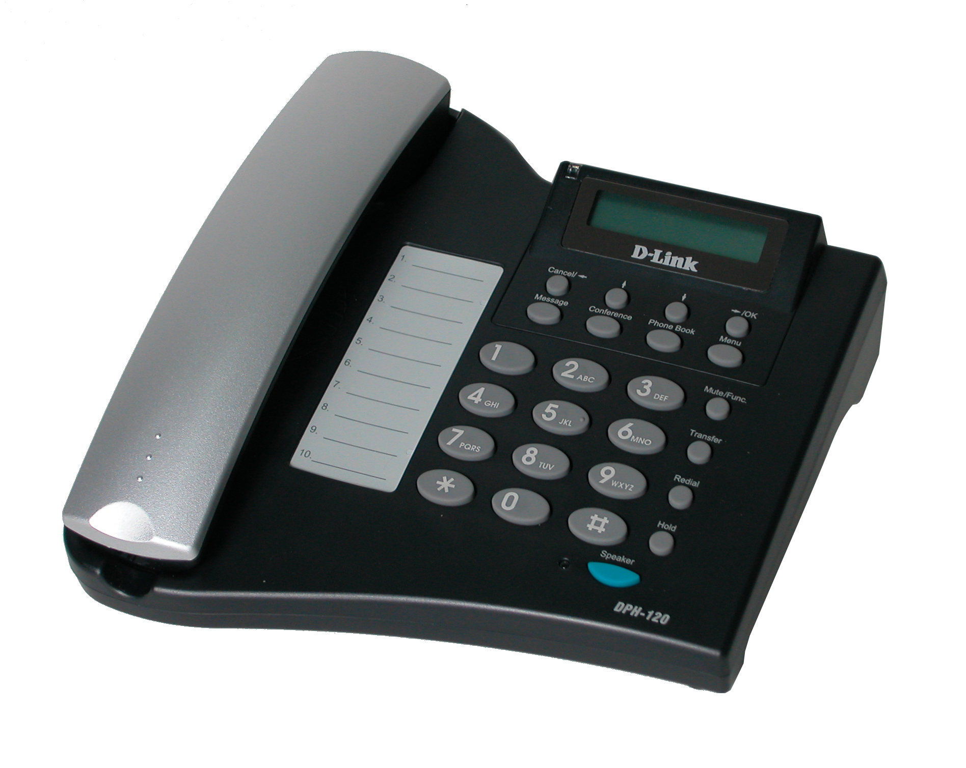
Why Sell This Product: | - This Internet telephone supplements our recently released DPH-140S Internet telephone. It has just a fewer keyboard functions than the DPH-140S, but otherwise, all the main functions and Internet telephone protocols are the same.  - The new DPH-120S is slightly smaller, lighter and cheaper than the DPH-140S. With this new Internet telephone added to your product range, you should have more flexible options to offer to your service providers.  - Target users: home and business users wishing to make broadband Internet phone calls directly from a telephone set rather than from a computer.  - The older DPH-80 and DPH-100 IP phones will eventually be phased out and replaced by this new Internet telephone.  Selling Points  - Most complete call function support from a telephone keyboard.  - Fully tested and available now.  - The D-Link name as an established supplier of Internet phone equipment.  - Excellent price/function ratio.
Key Features: | - IP Telephone for broadband Internet or IP networks  - SIP protocol support  - Connects to Internet through LAN or directly to DSL or cable modem  - Second connection to PC  - IP address assignment using PPPoE, DHCP or static configuration  - Voice activity detection/comfort noise generation  - Adaptive jitter buffer  - Acoustic echo cancellation  - DTMF tone generation  - Easy-to-use setup/programming interface  - Remote software update support  - 2 x 16 LCD display  - Adjustable speaker/ringer volume control
Technical Details: | General  WAN Connection Support  Through 10/100BASE-TX Ethernet port  Internet Support  - IP, TCP, UDP, ARP, HTTP protocols  - DHCP client  - DNS  VoIP Protocol Support  SIP  Echo Cancellation  Ethernet  - IEEE 802.3 10BASE-T Ethernet  - IEEE 802.3u 100BASE-TX Fast Ethernet  - ANSI/IEEE 802.3 NWay auto-negotiation  Number of Ethernet Ports  - 1 RJ-45 auto-sensing 10/100Mbps to DSL/cable modem or LAN with Internet connection  - 1 RJ-45 auto-sensing 10/100Mbps to PC  Audio Code  - G.7.11u-law/a-law  - G.723.1  - G.729a/b  AEC (Acoustic Echo Cancellation) G.168  Phone Set  Function Support  - Redial  - Menu  - Mute  - Transfer  - Hold  - Voice mail  - 3-way conference  - Speaker  - Address book (200 records)  - Special dial (10 records)  - Review address records  - Speaker/ringer volume adjust  Tone  - DTMF  - Ring tone (4 selectable ring tones)  - Ring back tone  - Dial tone  - Busy tone  Key Pad  - 0 to 9 keys, * key, # key  - Function keys: mute, transfer, redial, hold, 3-way conference, voice mail  - Others: speed dial setting, phone book, menu, OK, Cancel and Navigation keys  Network Assignment  - PPPoE  - DHCP  - Static IP  Firmware Upgrade  - TFTP  - Auto/manual provisioning system  Configuration Support  - Keypad & LCD  - Web browser  - Auto/manual provisioning system  Physical & Environmental  LED Indicators  - Line status  - Incoming call  - Speaker status  Power Input  5V DC 2A AC power adapter  Power Consumption  5 watts (max.)  Dimensions  210 (L) x 208 (W) x 38 (H) mm  Weight  635grams  Operating Temperature  0 to 40 ℃  Storage Temperature  -20 to 60 ℃  Operating Humidity  20% to 80% non-condensing  EMI  - FCC Class B  - CE Class B  Safety  CB (IEC60950)
EMI/EMC Report | ☑FCC No. ☑ CE No. ☑ VCCI No.  ◻ CTR-21 No. ◻ C-Tick No. ◻ A-Tick No.  ◻ FDA No. ◻ R&TTE No. ◻ BSMI No.  ◻ Others
Safety | ◻ TUV No. ◻ UL No. ◻ CSA No.  ◻ Others
Packaging Style | ◻ Clamshell ◻ White Box ◻ Gift Box ◻ Bulk ☑ White Box with D-Link Logo  ◻ Others
Packaging Contents: | - DPH-120S Device X 1  - Power Adapter X 1  - CD X 1  - Quick Installation Guide x 1  - CAT5 Ethernet cable x 1
UPC Code:
  NPH120SC..A1 | 790069 274770
  IPH120SN..A1 | 790069 274787
  IPH120SE..A1 | 790069 274794
  IPH120SB..A1 | 790069 274800
  EPH120SE..A1 | 790069 274817
  EPH120SB..A1 | 790069 274824
  DPH120SA..A1 | 790069 274138
Units Per Carton: | 10
Cartons Per Pallet: | For WW Air: 12, Sea: 20 | For USA Air: 12, Sea: 20
Dimensions and Weight: | Box:  ,Others , 1.3586 kg  Carton: 515x378x336 mm, 14.588 kg  Pallet: (by Air) 1200 x 1100 x 1133 mm, 190 kg (for WW)  1220 x 1020 x 1133 mm, 191 kg (for USA)  (by Sea) 1200 x 1100 x 1805 mm, 307 kg (for WW)  1220 x 1020 x 1805 mm, 308 kg (for USA)  INTRASTAT weight: 1.0973 kg (Box)  Packing material weight (Box):  - Paper: 0.2445 kg  - Plastic: 0.0162 kg  - Mixed: 0.0006 kg

