
This product can be set up using Keypad and Web browser, such as IE (Internet Explorer).

DPH-140S
IP Phone
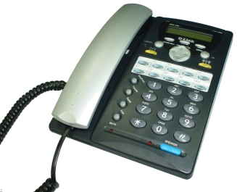

Check Your Package Contents
These are the items included with your DPH-140S IP Phone purchase：
• DPH-140S VoIP Phone

• CD-ROM (containing Manual and Installation program)

• Ethernet cable

• Power cord






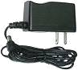
Using a power
supply with a different voltage rating will damage and void the warranty for this product.

If any of the above items are missing, please contact your reseller.

©2003 D-Link Systems, Inc. All rights reserved. Trademarks or registered trademarks are the property of their respective holders. Software and specifications subject to change without notice. DVG-1104TH.01242003

The Appearance of Product
Front view and keypad function:

(1) 2 x 16 Characters LCD Display
(10) Phone Book

(11) Speed Dial

(2) Menu
(12) Cancel
(3) OK
(5) 3-Way Conference
(17) Redial/Call History
(6) Local MultiLine
(7) Numeric Keypad
(4) Control Pad
(9) Speaker Phone Indicator
(8) Speaker Phone
(18) Hold
(16) Transfer
(14) Voice Message
(19) Mute Indicator
(13) Voice Message Indicator
(15) Mute/Func.

Keys | Functions
(1) LCD Display | Displays menu, time, clock, name, phone number, call status
(2) Menu | Access the phone menu
(3) OK | Confirm setting change, exit menu, dial, save changes
(4) Control Pad | Backspace, scroll up or down, select enable or disable
(5) 3-Way Conference | Enable 3-way conference
(6) Local Multiline | Switch to different lines
(7) Numeric Keypad | Input IP/phone number/alphabet characters
(8) Speaker Phone | Enable user to use the phone without using the handset
(9) Speaker Phone Indicator | Indicates that phone is currently in speaker phone mode
(10) Phonebook | Access the phonebook
(11) Speed Dial | Access the speed dial menu
(12) Cancel | Deny changes, cancel phone calls, ignore phone calls
(13) Voice Message Indicator | Indicates that there is a voice message
(14) Voice Message | Check voice message
(15) Mute | Disable user’s handset microphone so that the person on the other line can not hear anything
(16) Transfer | Transfer the person on the other line to another number
(17) Redial/Call History | Redial last dialed number, access redial menu
(18) Hold | Place the person on the other line on hold
(19) On Hold Indicator | Indicates that the person on the other line is currently placed on hold

Text entry

You use alphanumeric characters to enter details in to the ADSL ID and ADSL Password from phone as your ISP provide. This text entry is also available for phone book setting.

 | Text Mode |  |  | Text Mode
Key | Normal (ABC) | Numeric (0-9) | Key | Normal (ABC) | Numeric (0-9)
 |  | 1 |  | PQRSpqrs | 7
 | ABCabc | 2 |  | TUVtuv | 8
 | DEFdef | 3 |  | WXYZwxyz | 9
 | GHIghi | 4 |  | @ . _ － * # ( ) % & + / $ , | 0
 | JKLjkl | 5 |  |  | *
 | MNOmno | 6 |  |  | #

Connector:

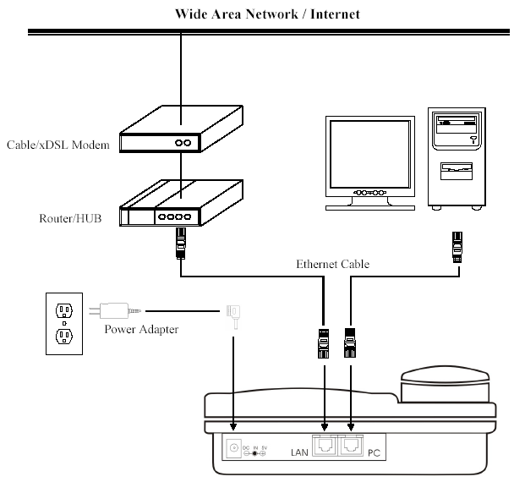

IP Phone Setup Menu

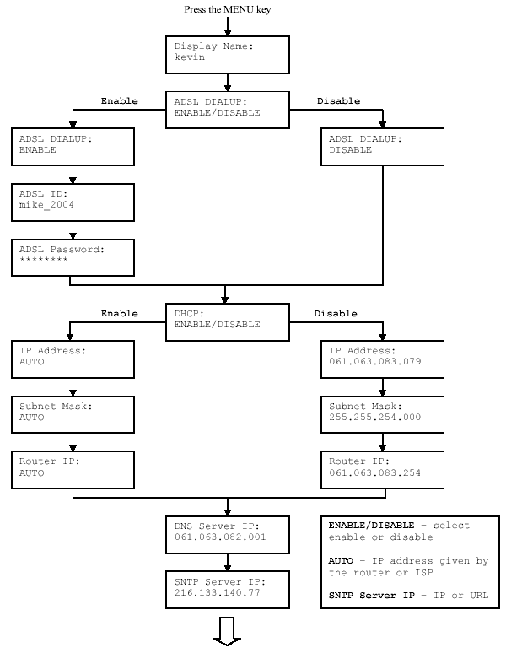

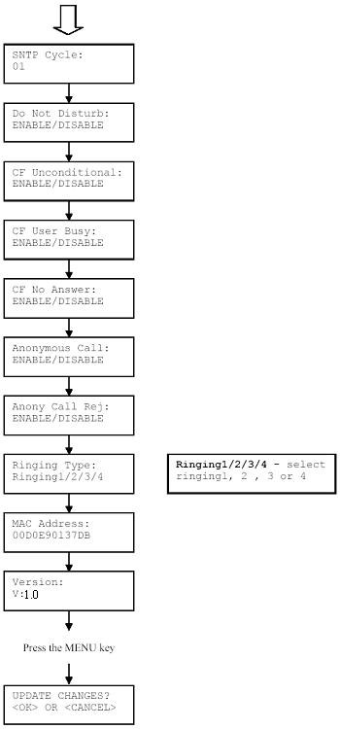
NOTE 1: If you made any modifications, you may quit setup at any time by pressing + save and exit or + to quit without saving. The phone will automatically exit the menu screen if there are no inputs from the user.
NOTE 2: Use up and down arrow on the direction pad to switch among stages.
NOTE 3: Use left and right arrow on the direction pad to select ENABLE or DISABLE.
NOTE 4: Left arrow key can be used as Backspace key.

