D-Link
DVA-G3340S
High-Speed 2.4 GHz
Wireless ADSL VOIP Router
Manual

Building Networks for People

Ver 1.00
Contents
UNFINISHED FIRST DRAFT 1
Using the Configuration Menu 9
PPPoE and PPPoA Connection for WAN 11
Dynamic IP Address Connection for WAN 15
Bridged Connection for WAN 18
Static IP Address for Connection WAN 20
ATM Traffic Shaping 22
ATM Traffic Shaping 24
LAN IP Settings 26
DHCP Settings 27
Use the Router for DHCP 28
Disable the DHCP Server 28
DNS Settings 30
VOIP Settings − Server 31
VOIP Settings − User Agent 33
VOIP Settings − Telephony 34
Wireless Settings 36
Configure Basic Wireless Settings 36
Wireless Settings − WEP 37
Security Options for Wireless 37
WEP Encryption 37
Setup Encryption Keys 38
Wireless Settings − WPA 39
Configure WPA Settings 39
Wireless Settings − WPA-PSK 40
Configure WPA-PSK Security for WLAN 40
Multiple Virtual Connections 41
Configure Multiple PVCs 41
Advanced Router Management 42
UPnP 44
Virtual Server 45
Filters 48
Filters 48
Static Routing 50
DMZ 51
Firewall 52
RIP Dynamic Routing 53
PPP Connection State 54
ADSL 55
ATM VC 56
Wireless Management 57
Wireless Performance 58
Tools 60
Change System Password 61
Remote Web Management and Telnet Access 61
Time 62
Save or Load Configuration File 63
Restore Factory Default Settings 63
Firmware 64
Ping Test 65
Ping Test 65
IGMP Proxy 65
Test 66
Status Information 67
Device Information Display 67
Log 68
Traffic 69
ADSL 70
Description 71

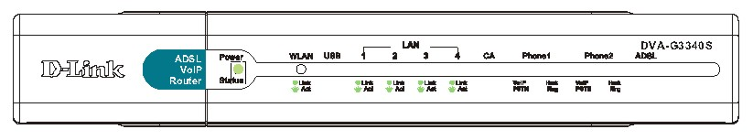
Contents of Package:
- D-Link DVA-G3340S High-Speed 2.4GHz Wireless ADSL VOIP Router
- Power Adapter-DC 12V, 1200 mA
- Manual and Warranty on CD
- Quick Installation Guide
- Ethernet Cable (All the DVA-G3340S’s Ethernet ports are Auto-MDIX)
- RJ-11 Cable
- RJ-45 Cable
- USB Cable

Note: Using a power supply with a different voltage rating than the one included with the DVA-G3340S will cause damage and void the warranty for this product.
If any of the above items are missing, please contact your reseller.
System Requirements for Configuration:
- Ethernet-Based Cable or DSL Modem
- Computers with Windows, Macintosh, or Linux-based operating systems with an installed Ethernet adapter
- Internet Explorer Version 6.0 or Netscape Navigator Version 6.0 and Above

Introduction
The D-Link DVA-G3340S High-Speed Wireless Router is an 802.11g high-performance, wireless router that supports high-speed wireless networking at home, at work or in public places.

Unlike most routers, the DVA-G3340S provides data transfers at up to 8X (compared to the standard 11 Mbps) when used with other D-Link AirPlus G products. The 802.11 g standard is backwards compatible with 802.11 b products. This means that you do not need to change your entire network to maintain connectivity. You may sacrifice some of 802.11 g’s speed when you mix 802.11 b and 802.11 g devices, but you will not lose the ability to communicate when you incorporate the 802.11g standard into your 802.11 b network. You may choose to slowly change your network by gradually replacing the 802.11 b devices with 802.11 g devices .

In addition to offering faster data transfer speeds when used with other 802.11g products, the DVA-G3340S has the newest, strongest, most advanced security features available today. When used with other 802.11 g WPA (WiFi Protected Access) and 802.1x compatible products in a network with a RADIUS server, the security features include:
WPA *Available around Q4/2003 as a free download.: Wi-Fi Protected Access authorizes and identifies users based on a secret key that changes automatically at a regular interval. WPA uses TKIP (Temporal Key Integrity Protocol) to change the temporal key every 10,000 packets (a packet is a kind of message transmitted over a network.) This insures much greater security than the standard WEP security. (By contrast, the older WEP encryption required the keys to be changed manually.)

For home users that will not incorporate a RADIUS server in their network, the security for the DVA-G3340S, used in conjunction with other 802.11g products, will still be much stronger than ever before. Utilizing the Pre Shared Key mode of WPA, the DVA-G3340S will obtain a new security key every time it connects to the 802.11g network. You only need to input your encryption information once in the configuration menu. No longer will you have to manually input a new WEP key frequently to ensure security, with the DVA-G3340S, you will automatically receive a new key every time you connect, vastly increasing the safety of your communications.
Connections
LEDs
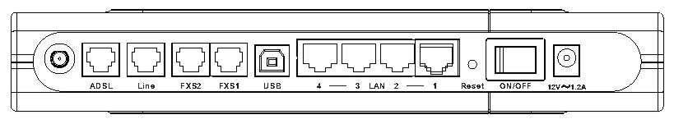

Features

- Fully compatible with the 802.11 g standard to provide a wireless data rate of up to 54Mbps
- Backwards compatible with the 802.11 b standard to provide a wireless data rate of up to 11 Mbps
- WPA (Wi Fi Protected Access) authorizes and identifies users based on a secret key that changes automatically at a regular interval, for example:
- Pre Shared Key mode means that the home user, without a RADIUS server, will obtain a new security key every time the he or she connects to the network, vastly improving the safety of communications on the network.
- 802.1x *Available around Q4/2003 as a free download. Authentication in conjunction with the RADIUS server verifies the identity of would be clients
- Utilizes OFDM technology (Orthogonal Frequency Division Multiplexing)
- User-friendly configuration and diagnostic utilities
- Operates in the 2.4GHz frequency range
- Connects multiple computers to a Broadband (Cable or DSL) modem to share the Internet connection
- Advanced Firewall features
- Supports NAT with VPN pass-through, providing added security
- MAC Filtering
- IP Filtering
- URL Filtering
- Domain Blocking
- Scheduling
- DHCP server supported enables all networked computers to automatically receive IP addresses
- Web-based interface for Managing and Configuring
- Access Control to manage users on the network

- Supports special applications that require multiple connections
- Equipped with 4 10/100Mbps Ethernet ports, 1 WAN port, Auto MDI/MDIX

Using the Configuration Menu
The Home>Wizard screen will appear. Please refer to the Quick Installation Guide for more information regarding the Setup Wizard.

These buttons appear on most of the configuration screens in this section. Please click on the appropriate button at the bottom of each screen after you have made a configuration change.
Whenever you want to configure your network or the DVA-G3340S, you can access the Configuration Menu by opening the web-browser and typing in the IP Address of the DVA-G3340S. The DVA-G3340S default IP Address is
shown at right:
- Open your web browser
- Type in the IP Address of the Router (http://192.168.1.1)
Note: if you have changed the default IP Address assigned to the DVA-G3340S, make sure to enter the correct IP Address.
- Type admin in the User Name field
- Type admin in the Password field
- Click OK

Home > Wizard

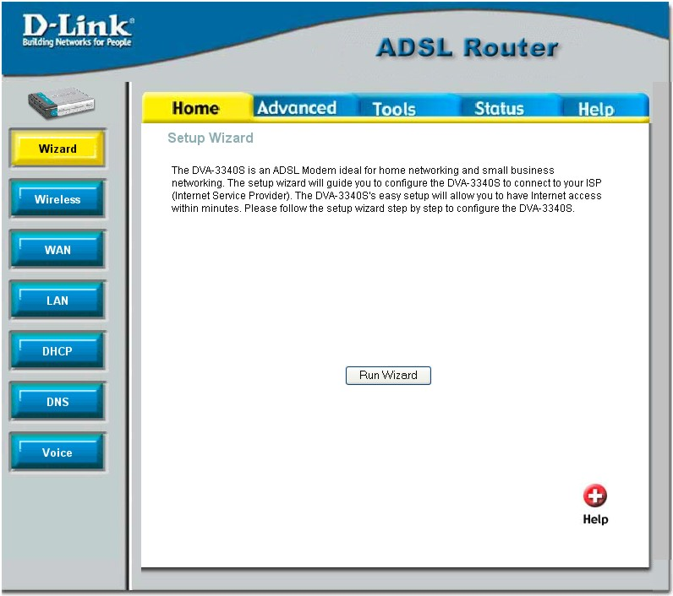
Home > WAN > PPPoE/PPPoA
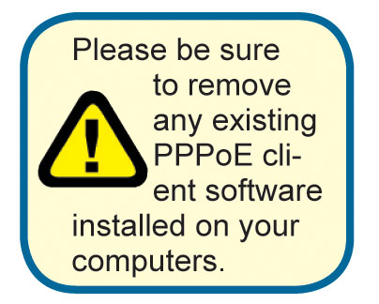
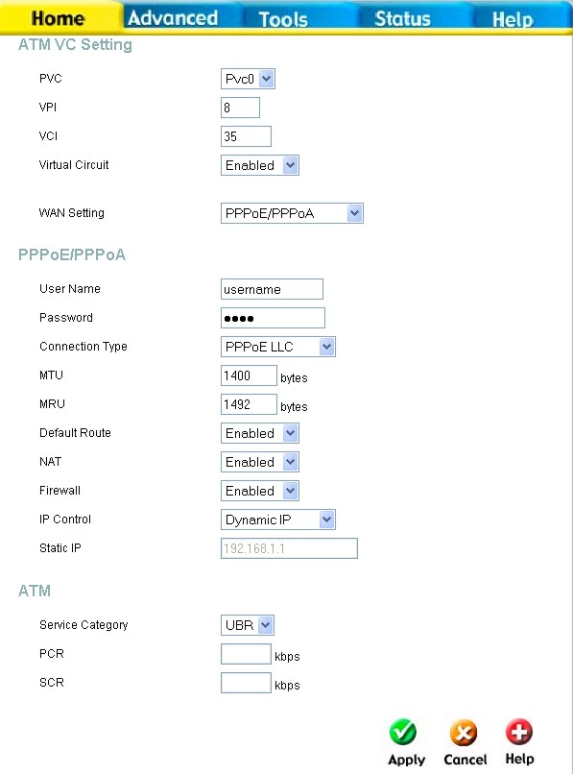
Configure WAN Connection
To configure the Router’s basic configuration settings without running the Setup Wizard, you can access the menus used to configure WAN, LAN, DHCP and DNS settings directly from the Home directory. To access the WAN Settings menu, click on the WAN link button on the left side of the first window that appears when you successfully access the web manager.
The WAN Settings menu is also used to configure the Router for multiple virtual connections (Multiple PVCs).

WAN Settings Menu – PPPoE / PPPoA

Select the connection type used for your account. The menu will display settings that are appropriate for the connection type you select. Follow the instruction below according to the type of connection you select in the WAN Settings menu.
The new settings must be saved and the Router must be restarted for the settings to go into effect. To save the new settings and restart the Router, click on the Tools directory tab and then click the System menu button. Click the Reboot button under Force the DVA-G3340S to system restart. The Router will save the new WAN settings, restart and attempt to establish the WAN connection.

PPPoE and PPPoA Connection for WAN
Follow the instructions below to configure the Router to use a PPPoE or PPPoA for the Internet connection. Make sure you have all the necessary information before you configure the WAN connection.
- If not already selected, choose the PPPoE/PPPoA option from the WAN Settings pull-down menu. PPPoE/PPPoA is selected by default if you are configuring the Router for the first time.
- Under the ATM VC Settings at the top of the menu should not be changed unless you have been instructed to change them. However, if you are instructed to change the VPI or VCI values, type in the values assigned for your account. Leave the PVC and Virtual Circuit setting at the default (Pcv0 and Enabled) values for now. This can be used later if you are configuring multiple virtual circuits for your ADSL service. For more information on ATM VC Settings, see the table on page 24 below.
- Under the PPPoE/PPPoA heading, type the User Name and Password used for your ADSL account. A typical User Name will be in the form user1234@isp.co.uk, the Password may be assigned to you by your ISP or you may have selected it when you set up the account with your ISP.
- Choose the Connection Type from the pull-down menu located under the User Name and Password entry fields. This defines both the connection protocol and encapsulation method used for your ADSL service. The available options are PPPoA VC-MUX, PPPoA LLC and PPPoE LLC. If have not been provided specific information for the Connection Type setting, leave the default setting.
- Leave the MTU value at the default setting (default = 1400) unless you have specific reasons to change this (see table below).
- Leave the MRU value at the default setting (default = 1492) unless you have specific reasons to change this (see table below).
- Leave the Default Route enabled if you want to use the Router as the default route to the Internet for your LAN. Whenever a computer on the LAN attempts to access the Internet, the Router becomes the Internet gateway to the computer. If you have an alternative route for Internet traffic you may disable this without effecting the Router’s connection.
- NAT should remain enabled. If you disable NAT, you not be able to use more than one computer for Internet connections. NAT is enabled and disabled system-wide, therefore if you are using multiple virtual connections, NAT will disabled on all connections.
- The Firewall should remain enabled for most users. If you choose to disable this you will not be able to use the features configured in the Firewall and Filters menus located in the Advanced directory. See the next chapter for more details on these menus.
- Typically the globally IP settings (i.e. IP address for the WAN interface) for a PPPoA or PPPoA connection will use Dynamic IP assignment from the ISP. Some accounts may be assigned a specific global IP address. If you have been give an IP address for you PPPoE/PPPoA connection, select the Static IP option from the IP Control pull-down menu. This menu can be used to configure the WAN port as an Unnumbered IP interface. (See table below for Unnumbered IP)
- Most users will not need to change ATM settings. If this is the first time you are setting up the ADSL connection it is recommended that you leave the Service Category settings at the default values until you have established the connection. See the table on page 22 for a description of the parameters available for ATM traffic shaping.
- When you are satisfied that all the WAN settings are configured correctly, click on the Apply button.
- The new settings must be saved and the Router must be restarted for the settings to go into effect. To Save & Reboot the Router, click on the Tools directory tab and then click the Save & Reboot menu button. In the Save and Reboot menu, click the Reboot button under Force the DVA-G3340S to system restart. The Router will save the new settings and restart. Upon restarting the Router will automatically establish the WAN connection.
Additional settings for PPPoE/PPPoA connections:
PPPoE/PPPoA Parameters Description
User Name | For PPP connections, a User Name and Password are used to identify and verify your account to the ISP. Enter the User Name for your ADSL service account. User names and passwords are case-sensitive, so enter this information exactly as given to you by your ISP.
Password | Together with the User Name, this is used to verify your account to the ISP. Enter the Password exactly as given to you by your ISP.
Connection Type | This specifies the protocol (PPPoE or PPPoA) and the encapsulation method (LLC or VC-MUX) used for your connection. The options available are PPPoE LLC, PPPoA LLC or PPPoA VC-MUX.
MTU | The Maximum Transmission Unit size may be changed if you want to optimize efficiency for uploading data through the WAN interface. The default setting (1400 bytes) should be suitable for most users. Some user may want to adjust the setting to optimize performance for wireless traffic or when low latency is desired (such as with Internet gaming). It is highly recommended that the user research how adjusting the MTU may effect network traffic for better or worse.
MRU | Similar to the MTU, except this applies to Maximum Received Unit size for downloading data. Most users will be happy with the default setting (1492 bytes). However this may also be optimized for fast downloads of general bulk Internet traffic, for low latency or for downloading to computers on the Wireless LAN. As with the MTU setting, the user should carefully consider how changing the MRU may effect Internet downloads for all systems on your LAN.
Default Route | When this is enabled, the Router will be considered to be the primary gateway to the Internet and WAN for systems on your network. If you are using the Router on a network with one or more alternative gateway routers, you may prefer to disable this if you will use another router as the primary gateway.
NAT | Network Address Translation may be enabled or disabled with the pull-down menu. Keep in mind that disabling NAT allows on a single computer to be used for Internet access through the Router. NAT is enabled and disable for the Router on all connections (i.e. Pvc0 – Pvc7) if your Router is set up for multiple virtual connections.
Firewall | Use this to universally enable or disable the Firewall and Filter features available in the Router. If you disable this you will not be able to configure settings in the Firewall or Filters menus in the Advanced directory.
IP Control | This is used to determine how global IP settings are handled for the WAN interface. Typically PPPoE or PPPoA connections will use the default setting for Dynamic IP. Some users will be given a specific IP address for the WAN interface. In this case you need to change this setting to Static IP. When Static IP is selected in the IP Control menu, you need to type in the global IP address provided to you by your ISP. The IP Unnumbered option is used if you want to set up a non-TCP/IP port protocol link through the WAN interface. An IP Unnumbered interface does not have an IP address and therefore cannot be managed via Telnet or any other TCP/IP application.
Static IP | If you have selected the Static IP option in the IP Control menu, type in the global IP address used for your WAN interface. This should be given to you by your ISP.

Dynamic IP Address Connection for WAN
Home > WAN > Dynamic IP Address
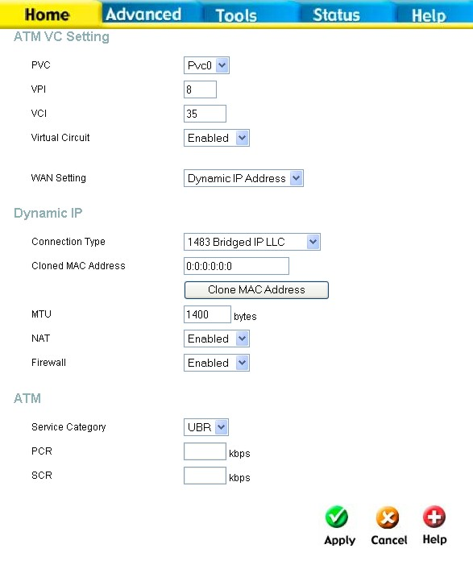
A Dynamic IP Address connection configures the Router to automatically obtain its global IP address from a DHCP server on the ISP’s network. The service provider assigns a global IP address from a pool of addresses available to the service provider. Typically the IP address assigned has a long lease time, so it will likely be the same address each time the Router requests an IP address.
To configure a Dynamic IP Address connection, perform the steps listed below. Some of the settings do not need to be changed the first time the device is set up, but can be changed later if you choose. See the table below for a description of all the settings available in this menu.
WAN Settings for Dynamic IP Address Connection

- Choose the Dynamic IP Address option from the WAN Settings pull-down menu.
- Under the ATM VC Settings at the top of the menu should not be changed unless you have been instructed to change them. However, if you are instructed to change the VPI or VCI values, type in the values assigned for your account. Leave the PVC and Virtual Circuit setting at the default (Pcv0 and Enabled) values for now. This can be used later if you are configuring multiple virtual circuits for your ADSL service. For more information on ATM VC Settings, see the table on page 24 below.
- Under the Dynamic IP heading, choose the Connection Type from the pull-down menu. This defines both the connection type and encapsulation method used for your ADSL service. The available options are 1483 Bridged IP LLC and 1483 Bridged IP VC-Mux. If have not been provided specific information for the Connection Type setting, leave the default setting.
- Some ISPs record the unique MAC address of your computer’s Ethernet adapter when you first access their network. This can prevent the Router (which has a different MAC address) from being allowed access to the ISPs network (and the Internet). To clone the MAC address of your computer’s Ethernet adapter, type in the MAC address in the Cloned MAC Address field and click the Clone MAC Address button.
- Leave the MTU value at the default setting (default = 1400) unless you have specific reasons to change this (see table below).
- NAT should remain enabled. If you disable NAT, you not be able to use more than one computer for Internet connections. NAT is enabled and disabled system-wide, therefore if you are using multiple virtual connections, NAT will disabled on all connections.
- The Firewall should remain enabled for most users. If you choose to disable this you will not be able to use the features configured in the Firewall and Filters menus located in the Advanced directory. See the next chapter for more details on these menus.
- Most users will not need to change ATM settings. If this is the first time you are setting up the ADSL connection it is recommended that you leave the Service Category settings at the default values until you have established the connection. See the table on page 22 for a description of the parameters available for ATM traffic shaping.
- When you are satisfied that all the WAN settings are configured correctly, click on the Apply button.
- The new settings must be saved and the Router must be restarted for the settings to go into effect. To Save & Reboot the Router, click on the Tools directory tab and then click the Save & Reboot menu button. In the Save and Reboot menu, click the Reboot button under Force the DVA-G3340S to system restart. The Router will save the new settings and restart. Upon restarting the Router will automatically establish the WAN connection.
Additional settings for Dynamic IP Address connections:
Dynamic IP Parameters Description
Connection Type | This specifies the connection type and encapsulation method used for your Dynamic IP Address connection. The options available are Bridged IP LLC or Bridged IP VC-MUX.
Cloned MAC Address | This is not always necessary, but may be required for some ISPs. Type in the MAC address of your computer’s Ethernet adapter in the Cloned MAC Address field and click the Clone MAC Address button. This will copy the information to a file used by the Router to present to the ISP’s server used for DHCP. Some ISPs record the unique MAC address of your computer’s Ethernet adapter when you first access their network. If you want to later replace the cloned MAC address with the factory default setting, type in all zeros - 0:0:0:0:0:0 - and click the Clone MAC Address button.
MTU | The Maximum Transmission Unit size may be changed if you want to optimize efficiency for uploading data through the WAN interface. The default setting (1400 bytes) should be suitable for most users. Some user may want to adjust the setting to optimize performance for wireless traffic or when low latency is desired (such as with Internet gaming). It is highly recommended that the user research how adjusting the MTU may effect network traffic for better or worse.
NAT | Network Address Translation may be enabled or disabled with the pull-down menu. Keep in mind that disabling NAT allows on a single computer to be used for Internet access through the Router. NAT is enabled and disable for the Router on all connections (i.e. Pvc0 – Pvc7) if your Router is set up for multiple virtual connections.
Firewall | Use this to universally enable or disable the Firewall and Filter features available in the Router. If you disable this you will not be able to configure settings in the Firewall or Filters menus in the Advanced directory.

Bridged Connection for WAN
Home > WAN > Dynamic IP Address
For Bridged connections it will be necessary for most users to install additional software on any computer that will the Router for Internet access. The additional software is used for the purpose of identifying and verifying your account, and then granting Internet access to the computer requesting the connection. The connection software requires the user to enter the User Name and Password for the ISP account. This information is stored on the computer, not in the Router.
Follow the instructions below to configure a Bridged connection for the WAN interface.

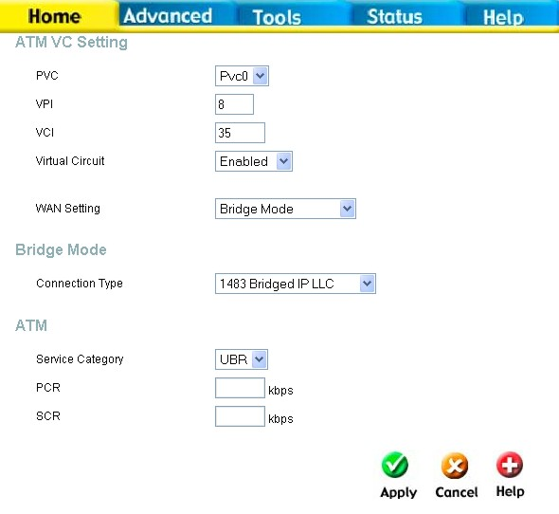
WAN Settings Menu – Bridge Mode

To configure a Dynamic IP Address connection, perform the steps listed below. Some of the settings do not need to be changed the first time the device is set up, but can be changed later if you choose. See the table below for a description of all the settings available in this menu.
- Choose the Bridge Mode option from the WAN Settings pull-down menu.
- Under the ATM VC Settings at the top of the menu should not be changed unless you have been instructed to change them. However, if you are instructed to change the VPI or VCI values, type in the values assigned for your account. Leave the PVC and Virtual Circuit setting at the default (Pcv0 and Enabled) values for now. This can be used later if you are configuring multiple virtual circuits for your ADSL service. For more information on ATM VC Settings, see the table on page 24 below.
- Under the Bridge Mode heading, choose the Connection Type from the pull-down menu. This defines both the connection type and encapsulation method used for your ADSL service. The available options are 1483 Bridged IP LLC and 1483 Bridged IP VC-Mux. If have not been provided specific information for the Connection Type setting, leave the default setting.
- Most users will not need to change ATM settings. If this is the first time you are setting up the ADSL connection it is recommended that you leave the Service Category settings at the default values until you have established the connection. See the table on page 22 for a description of the parameters available for ATM traffic shaping.
- When you are satisfied that all the WAN settings are configured correctly, click on the Apply button.
- The new settings must be saved and the Router must be restarted for the settings to go into effect. To Save & Reboot the Router, click on the Tools directory tab and then click the Save & Reboot menu button. In the Save and Reboot menu, click the Reboot button under Force the DVA-G3340S to system restart. The Router will save the new settings and restart. Upon restarting the Router will automatically establish the WAN connection.

Static IP Address for Connection WAN
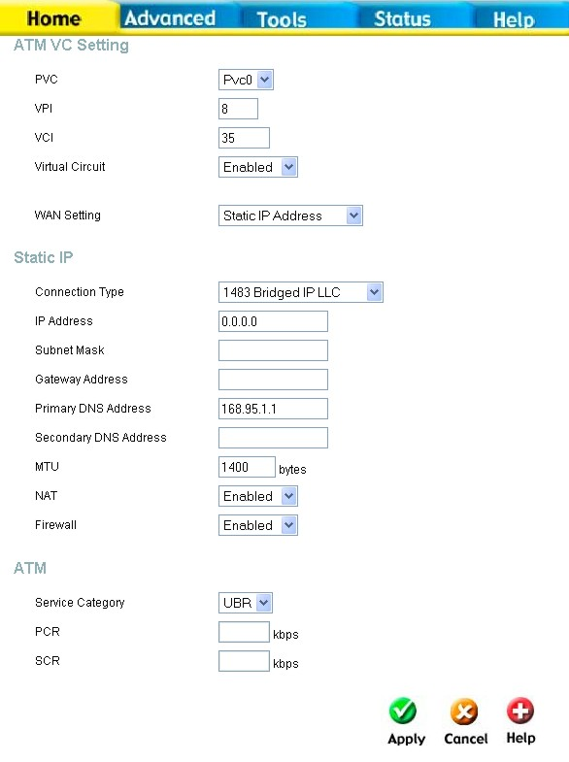
Home > WAN > Static IP Address
When the Router is configured to use Static IP Address assignment for the WAN connection, you must manually assign a global IP Address, Subnet Mask and Gateway IP Address used for the WAN connection. Most users will also need to configure DNS server IP settings in the DNS Settings configuration menu (see below). Follow the instruction below to configure the Router to use Static IP Address assignment for the WAN connection.
To configure a Dynamic IP Address connection, perform the steps listed below. Some of the settings do not need to be changed the first time the device is set up, but can be changed later if you choose. See the table below for a description of all the settings available in this menu.
WAN Settings - Static IP
Additional settings for Static IP Address connections:
Static IP Parameters Description
Connection Type | This specifies the connection type and the encapsulation method used for your Static IP Address connection. The options available are Bridged IP LLC, Bridged IP VC-MUX, Routed IP LLC, Routed IP VC-MUX or IPoA.
IP Address | This is the permanent global IP address for your account. This is the address that is visible outside your private network. Get this from your ISP.
Subnet Mask | This is the Subnet mask for the WAN interface. Get this from your ISP.
Gateway Address | This is the IP address of your ISP’s Gateway router. It provides the connection to the Router for IP routed traffic that is outside your ISP’s network. That is, this will be the primary connection from the Router to most of the Internet. Get this IP address from your ISP.
ARP Server Address  (for IPoA connection only) | This is not required for all IPoA connections. Check with your ISP for an ARP server IP address if this is necessary for your IPoA connection.
Primary DNS Address | This is the IP address of the first choice for Domain Name Service (DNS) used to match the named URL web address used by most browsers with the actual global IP address used for a web server. Usually this will be a server owned by the ISP. Get this IP address from your ISP.
Secondary DNS Address | This is the second choice for a DNS server. Get this IP address from your ISP.
MTU | The Maximum Transmission Unit size may be changed if you want to optimize efficiency for uploading data through the WAN interface. The default setting (1400 bytes) should be suitable for most users. Some user may want to adjust the setting to optimize performance for wireless traffic or when low latency is desired (such as with Internet gaming). It is highly recommended that the user research how adjusting the MTU may effect network traffic for better or worse.
MRU | Similar to the MTU, except this applies to Maximum Received Unit size for downloading data. Most users will be happy with the default setting (1492 bytes). However this may also be optimized for fast downloads of general bulk Internet traffic, for low latency or for downloading to computers on the Wireless LAN. As with the MTU setting, the user should carefully consider how changing the MRU may effect Internet downloads for all systems on your LAN.
Firewall | Use this to universally enable or disable the Firewall and Filter features available in the Router. If you disable this you will not be able to configure settings in the Firewall or Filters menus in the Advanced directory.

ATM Traffic Shaping

Home > WAN
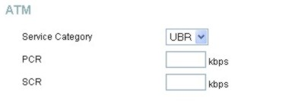
The ATM settings in the WAN configuration menus for the different connection types can be used to adjust QoS parameters for ADSL clients. This may not be available to all ADSL accounts. Ask your ISP if ATM Traffic Shaping is available for your account.
ATM Settings for WAN connection (PPPoE/PPPoA menu)

Additional ATM settings for PPPoE or PPPoA connections:
ATM QoS Parameters Description
Service Category | The ATM settings allows the user to adjust ATM Quality of Service (QoS) or traffic parameters to suit specific traffic requirements. For applications or circumstances where packet loss or packet delay are a concern, ATM QoS can be adjusted to minimize problems. For most accounts, it will not be necessary to change these settings. Altering QoS settings can adversely affect performance of some commonly used Internet applications.  If you plan to change QoS or traffic parameters, contact your ISP or network services provider for information on what types of adjustment are available or possible for your account. Your ISP may not support the class of service you want to use.  To adjust ATM QoS parameters, select one of the Service Categories listed here and type in the PCR value in the entry field below. For the VBR service category, an additional parameter (SCR) must also be defined.  UBR – Unspecified Bit Rate, this is the default category used for general-purpose Internet traffic where normal levels of packet loss and delay are acceptable. For some applications or for multiple connection accounts, it may be desirable to specify the PCR.  CBR – Constant Bit Rate, usually used in circumstances where very low packet loss and very low Cell Delay Variable (CDV) are desirable.  VBR – Variable Bit Rate, usually used when network traffic is characterized by bursts of packets at variable intervals, and some moderate packet loss and delay is acceptable. This category is typically used for audio and video applications such as teleconferencing. The network must support QoS Class 2 to use VBR.
PCR | Peak Cell Rate – The PCR is inversely related to the time interval between ATM cells. It is specified for all three service categories (UBR, CBR and VBR) in Kbps.
SCR | Sustainable Cell Rate – The SCR is defined for the VBR service category. This is the rate that can be sustained for “bursty”, on-off traffic sources. It is a function of Maximum Burst Size (MBS) and the time interval (between cells).

ATM Traffic Shaping

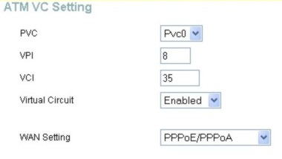
Home > WAN

The ATM settings in the WAN configuration menus for the different connection types can be used to adjust QoS parameters for ADSL clients. This may not be available to all ADSL accounts. Ask your ISP if ATM Traffic Shaping is available for your account.
ATM VC Settings in WAN connection menu

The table below describes the ATM VC settings used to configure a connection for an ADSL account.
ATM VC Parameters Description
PVC | The Router supports using up to eight multiple virtual connections. This menu allows the user to configure WAN settings for all the available connections (see instructions below on how to set up Multiple Virtual Connections). Use the PVC menu to select the connection (Pvc0 to Pvc7) you want to configure. Since most users will use only a single connection, the default setting Pvc0 can be used for any changes made to the WAN settings.
VPI | The Virtual Path Identifier is used with the VCI to define a dedicated circuit on the ATM network portion of the connection to the Internet and WAN. Most users will not need to change this setting.
VCI | The Virtual Channel Identifier is used with the VPI to define a dedicated circuit on the ATM network portion of the connection to the Internet and WAN. Most users will not need to change this setting.
Virtual Circuit | As with the PVC setting, this is mainly for use by clients who are configuring the Router for multiple virtual connections. Use this to enable or disable the PVC you are currently configuring. By default, the Pvc0 is enabled and the remaining PVCs are disabled.
WAN Setting | Use this to change the type of connection used. The options are: PPPoE/PPPoA, Dynamic IP Address, Static IP Address and Bridge Mode. Each option will offer a different settings for configuration.

LAN IP Settings

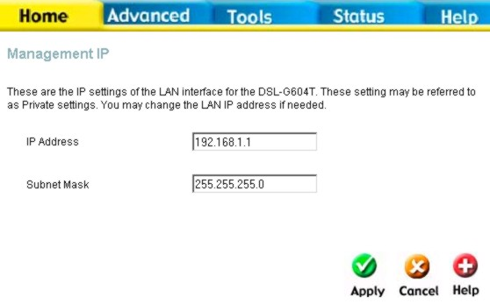
Home > LAN
You can configure the LAN IP address to suit your preference. Many users will find it convenient to use the default settings together with DHCP service to manage the IP settings for their private network. The IP address of the Router is the base address used for DHCP. In order to use the Router for DHCP on your LAN, the IP address pool used for DHCP must be compatible with the IP address of the Router. The IP addresses available in the DHCP IP address pool will change automatically if you change the IP address of the Router. See the next section for information on DHCP setup.

Configure LAN IP settings

To change the LAN IP Address or LAN Network Mask, type in the desired values and click the Apply button. Your web browser should automatically be redirected to the new IP address. You will asked to login again to the Router’s web manager.

DHCP Settings
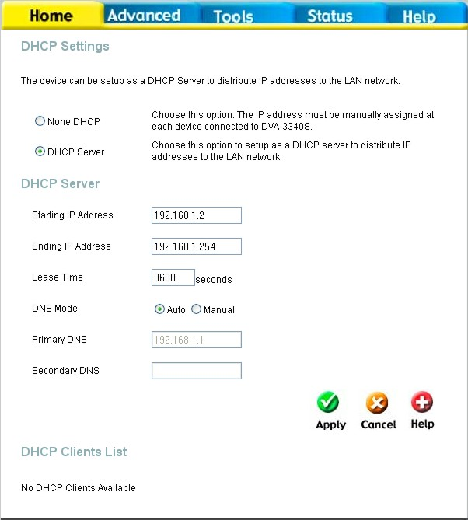
Home > DHCP
The DHCP server is enabled by default for the Router’s Ethernet LAN interface. DHCP service will supply IP settings to workstations configured to automatically obtain IP settings that are connected to the Router though an Ethernet port. When the Router is used for DHCP it becomes the default gateway for DHCP client connected to it. Keep in mind that if you change the IP address of the Router the range of IP addresses in the pool used for DHCP on the LAN will also be changed. The IP address pool can be up to 253 IP addresses.
To display the DHCP Server menu, click the DHCP button in the Home directory. Any active DHCP Clients appear listed in the DHCP Client List below the configuration menu. The IP address and MAC address for active DHCP clients are displayed in the list.

Configure DHCP server settings for the LAN

The two options for DHCP service are as follows:
- You may use the Router as a DHCP server for your LAN.
- You can disable DHCP service and manually configure IP settings for workstations.
You may also configure DNS settings for the LAN when using the Router in DHCP mode. In Auto DNS Mode, the Router will automatically relay DNS settings to properly configured DHCP clients. To manually enter DNS IP addresses, select the Manual DNS Mode option and type in a Primary and Secondary DNS IP Address in the field provided. The manually configured DNS settings will be supplied to clients that are configured to request them from the Router.
Follow the instructions below according to which of the above DHCP options you want to use. When you have configured the DHCP Settings as you want them, click the Apply button to commit the new settings. The new settings must be saved and the Router must be restarted for the settings to go into effect. To save the new settings and restart the Router, click on the Tools directory tab and then click the System menu button. Click the Reboot button under Force the DVA-G3340S to system restart. The Router will save the new DHCP settings and restart.

Use the Router for DHCP
To use the built-in DHCP server, click to select the DHCP Server option if it is not already selected. The IP Address Pool settings can be adjusted. The Starting IP Address is the lowest available IP address (default = 192.168.1.2). If you change the IP address of the Router this will change automatically to be 1 more that the IP address of the Router. The Ending IP Address is the highest IP address number in the pool. Type in the Lease Time in the entry field provided. This is the amount of time in seconds that a workstation is allowed to reserve an IP address in the pool if the workstation is disconnected from the network or powered off.

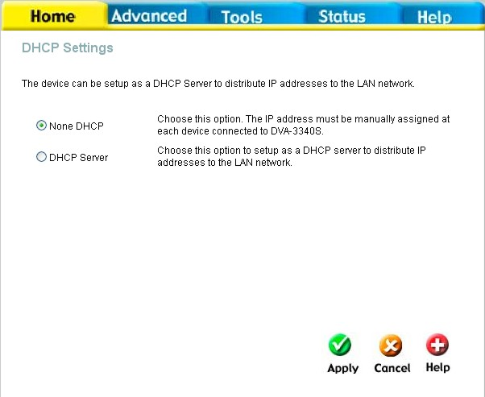
Disable the DHCP Server
To disable DHCP, click to select the None DHCP option and click on the Apply button. Choosing this option requires that workstations on the local network must be configured manually or use another DHCP server to obtain IP settings.
If you configure IP settings manually, make sure to use IP addresses in the subnet of the Router. You will need to use the Router’s IP address as the Default Gateway for the workstation in order to provide Internet access.

DHCP Settings menu with DHCP disabled
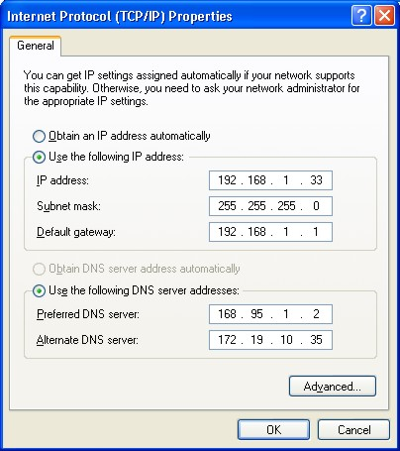
To manually configure IP settings on Windows workstations, open the TCP/IP Properties menu and select the “Use the following IP address” option. You will need to supply the IP address, Subnet mask and Default gateway for each workstation. The example here also uses manually configured DNS settings.

DNS Settings
Home > DNS
The Router can be configured to relay DNS settings from your ISP or another available service to workstations on your LAN. When using DNS relay, the Router will accept DNS requests from hosts on the LAN and forward them to the ISP’s, or alternative DNS servers. DNS relay can use auto discovery or the DNS IP address can be manually entered by the user. Alternatively, you may also disable the DNS relay and configure hosts on your LAN to use DNS servers directly. Most users who are using the Router for DHCP service on the LAN and are using DNS servers on the ISP’s network, will leave DNS relay enabled (either auto discovery or user configured).

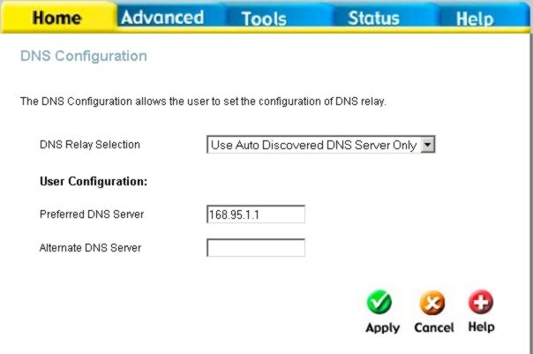
Configure DNS Settings

In the DNS Relay Selection pull-down menu, choose to Use Auto Discovery, Use User Configured or Disable DNS relay.
If you have not been given specific DNS server IP addresses or if the Router is not pre-configured with DNS server information, select the Auto Discover option for DNS relay. Auto discovery DNS instructs the Router to automatically obtain the DNS IP address from the ISP through DHCP. If your WAN connection uses a Static IP address, auto discovery for DNS cannot be used.
If you have DNS IP addresses provided by your ISP, enter these IP addresses in the available entry fields for the Preferred DNS Server and the Alternative DNS Server.
If you choose to disable DNS relay, it will be necessary to configure DNS settings for hosts on the LAN since they will not be depending on the Router to forward the DNS requests.
When you have configured the DNS settings as desired, click the Apply button.

VOIP Settings − Server
Home > Voice > Server
The Router can be configured to handle voice signals over the Internet Protocol (Voice Over IP − VOIP).
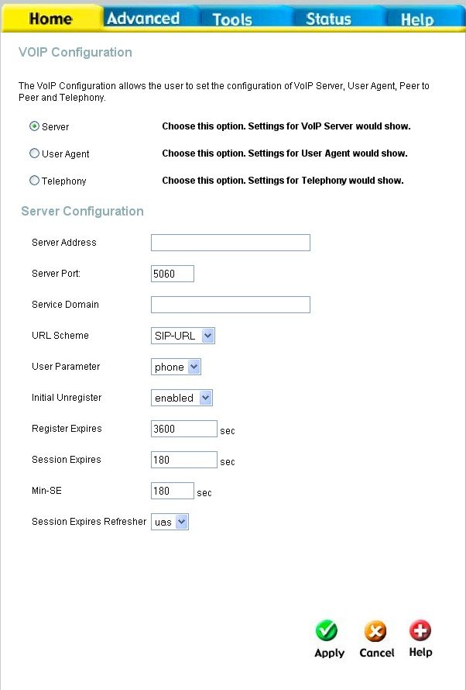

Configure VOIP Server Settings

The table below describes the VOIP Server settings.
VOIP Server Parameters Description
Server Address | Enter the IP address of the SIP Server in this field.
Server Port | Enter the SIP server’s listening port for the SIP in this field. Leave this field set to the default if your VoIP service provider did not give you a server port number for SIP.
Service Domain | Enter the SIP service domain name in this field.
URL Scheme | Select SIP-URL to have the router include the domain name with the SIP number in the SIP messages that it sends. Select TEL-URL to have the router use the SIP number without a domain name in the SIP messages that it send.
User Parameter | You can set this to phone or none. This determines whether or not the phone number is appended to the information forwarded to your SIP server. Your VoIP service provider will instruct you which setting to use.
Initial Unregister | You can set this to enabled or disabled. Some SIP servers can become unstable if you are registered more than once (due to a power outage and subsequent reboot of the router, for example). This setting allows your router to “unregister” itself when it is rebooted, removing the previously sent registration information.
Register Expires | Use this field to set how long the router will wait before sending a repeat registration request if a registration attempt fails or there is no response from the registration server.
Session Expires | This field will set the longest time that the router will allow a SIP session to remain idle (without traffic) before dropping it.
Min-SE | When two SIP devices negotiate a SIP session, they must negotiate a common expiration time for idle SIP sessions. this field sets the shortest expiration time that the router will accept. The router checks the session expiration values of incoming SIP INVITE requests against the minimum session expiration value that you enter here. If the session expiration of an incoming INVITE request is less than this value, the router negotiates with the other SIP device to increase the session expiration value to match the minimum session expiration value.
Session Expires Refresher | This determines which side of an expired call session will initiate the session refresh. uac – specifies the Caller side will initiate the session refresh. uas – specifies the Call receiver (the “Callee”) will initiate the session refresh.

VOIP Settings − User Agent
Home > Voice > User Agent
The Router can be configured to handle voice signals over the Internet Protocol (Voice Over IP − VOIP).
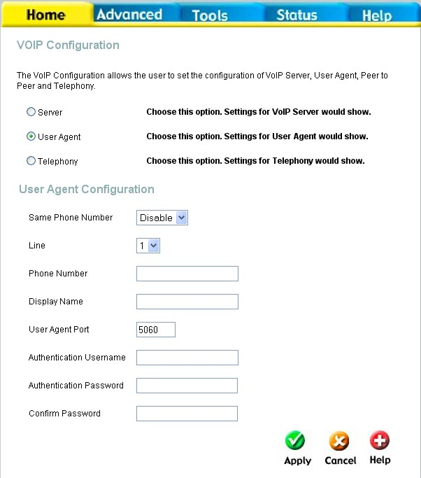
Configure VOIP User Agent Settings

The table below describes the VOIP Server settings.
VOIP User Agent Parameters Description
Same Phone Number | Use this field to Enable or Disable the use of the same telephone number for the User Agent as for the Server Agent.
Line | Use this field to assign line 1 or line 2 telephone sockets (on the back of the router) to the information entered in the User Agent.
Phone Number | The telephone number assigned to the User Agent.
Display Name | The name that will be displayed when the User Agent is in use.
User Agent Port | This selects the port number the router will listen to when determining when calls are being made.
Authentication Username | The Username used to access your SIP server and your VoIP service provider.
Authentication Password | The Password used to access your SIP server and your VoIP service provider.
Confirm Password | Retype your password to confirm.

VOIP Settings − Telephony
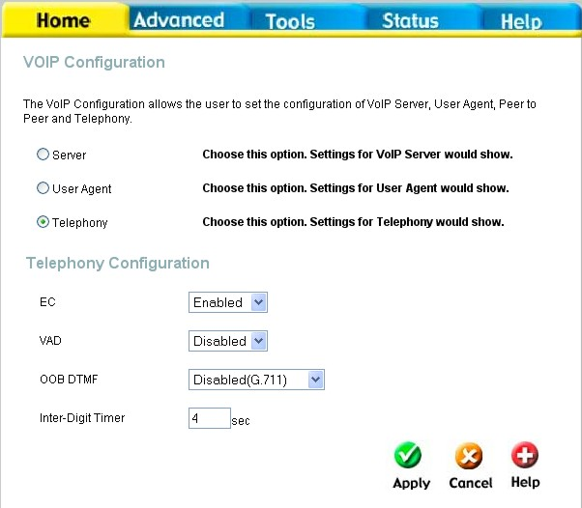
Home > Voice > Telephony
The Router can be configured to handle voice signals over the Internet Protocol (Voice Over IP − VOIP).
Configure VOIP User Agent Settings

The table below describes the VOIP Server settings.
VOIP Telephony Parameters Description
EC | Echo Cancellation (EC) – G.168 is an ITU standard for eliminating echo. Select Enabled to cancel the echo caused by the sound of your voice reverberating in the telephone receiver when you speak.
VAD | Voice Activity Detection (VAD) – detects whether or not speech is present. This lets the router reduce the bandwidth that a call uses by not transmitting “silent Packets” when you are not speaking.
OOB DTMF | Out-of band Dual Tone Multi-frequency – The Dual Tone Multi-frequency (DTMF) mode sets how the router will handle the tones that your telephone makes when you push its buttons. It is recommended that you use the same mode that your VoIP service provider uses. Select Enabled (RFC 2833) to send the DTMF tones in RTP packets. Select Disabled (G.711) to include the DTMF tones in the voice date stream. This method works best when you are using a codec that does not use compression (like G.711).
Inter-Digit Timer | determines the amount of time that will elapse between sending dialed digits when making a VoIP telephone call.

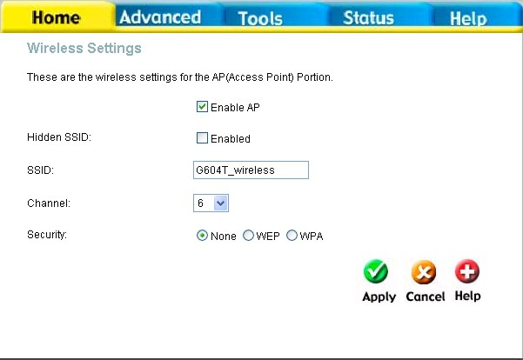
Wireless Settings
Home > Wireless
The two essential settings for wireless LAN operation are the SSID and Channel Number. The SSID (Service Set Identifier) is used to identify a group of wireless LAN components. The SSID can be broadcast or can be hidden (not broadcast). Use the Wireless Settings menu to configure these basic settings. Wireless security using encryption (WEP) or access limitation (WPA) are also configured with the Wireless Settings method. Read more below about setting up security for Wireless LAN.
Wireless Settings menu

Configure Basic Wireless Settings
Follow the instructions below to change basic wireless settings.
- To disable the wireless interface: click in the Enable AP check box to remove the check mark and click the Apply button. This will immediately disable the wireless access point, it is not necessary to restart the access point to make this change.
- If the wireless interface has been disabled: click the Enable AP check box to place a check mark in it. Click the Apply button. It is not necessary to restart the access point unless you have also changed the channel or SSID.
- The SSID can be changed to suit your wireless network. Remember that any wireless device using the access point must have the same SSID and use the same channel. The SSID can be a continuous character string (i.e. no spaces) of up to 16 characters in length. To disable SSID sharing (SSID broadcast), click to slect the Hidden SSID box. Click the Apply button to save any change to the SSID. A hidden SSID makes it more difficult for wireless clients to join or leave the SSID as they must be manually configured to join.
- The Channel: may be changed to channels that are available in your region. Channels available for wireless LAN communication are subject to regional and national regulation. Click the Apply button to save any change to the Channel.
- Make sure you save the new wireless settings. Use the System Settings menu to save the new settings.

Wireless Settings − WEP
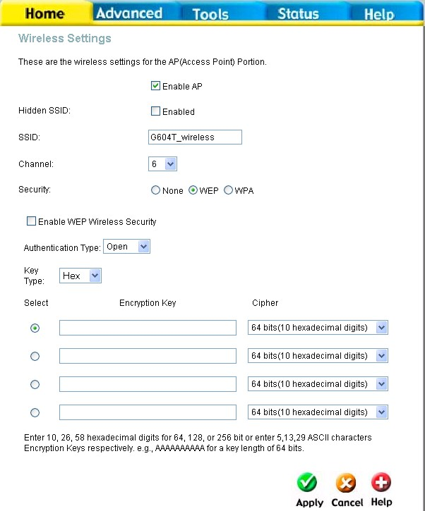
Home > Wireless > WEP
The wireless LAN interface of the DVA-G3340S has various security features used to limit access to the device or to encrypt data and shared information. The available standardized security for wireless LAN includes WEP and WPA Wireless security is configured with the Wireless Settings menu located in the Home directory.
Wireless Security − WEP

Security Options for Wireless
In the Wireless Settings menu, select the type of security you want to configure. The menu will change to present the settings specific to the method being configured. The Router’s wireless security options include three levels of WEP encryption and WPA for IEEE 802.1x network authentication or WPA with a user configured Pre Shared Key (PSK).

WEP Encryption
WEP (Wireless Encryption Protocol or Wired Equivalent Privacy) encryption can be enabled for security and privacy.. WEP encrypts the data portion of each frame transmitted from the wireless adapter using one of the predefined keys. Decryption of the data contained in each packet can only be done if the both the receiver and transmitter have the correct key.
WEP is disabled by default. To enable WEP, select the Enable option. Configure the Encryption Keys as desired and click the Apply button. The encryption key setup is described below.
WEP can use open or shared keys, or may be configured to allow the clients to use either type of key. Use the Authentication Type: drop-down menu to choose Open, Shared or Both.
- Select Open to allow any wireless station to associate with each other through the access point. Wireless devices will be able to communicate with all devices on a network unless they require the a Shared key.
- Select Shared to only allow stations using a shared key encryption to associate with each other through the access point. That is, only devices with the same key are allowed to communicate over a network with devices that share the same key. Shared key requires additional configuration of the keys to be used. Follow the instructions below to configure the Shared Keys.
- Select Both if you want to allow Wireless clients to specify using a shared or open key.

Setup Encryption Keys
WEP Keys may be configured using Hex or ASCII characters. In addition there are three levels of encryption available, each level requires a different number of characters. Select Hex or ASCII from the Key Type drop-down menu. Hex or Hexadecimal digits are defined as the numerical digits 0 – 9 and the letters A – F (upper and lower case are recognized as the same digit). ASCII characters include numbers and letters but no spaces. An upper case ASCII character is NOT recognized as the same lower case character, and therefore must be configured exactly as typed for all wireless nodes using the access point. The length of the key depends on the level of encryption used.
Select the Key Length from the drop-down menu. The available key lengths are 64, 128 or 256-bit encryption. In the spaces provided, type in Key 1, Key 2, Key 3 and Key 4. The length of the character string used of the keys depends on the level (Key Length) of encryption selected. Only one key can be active. The active key is selected by clicking the radio button for the key you want to use.
Click the Apply button when you have configured WEP as desired to put the changes into effect.

Wireless Settings − WPA
Home > Wireless > WPA
WPA security for wireless communication has been developed to overcome some of the shortcomings of WEP. WPA uses an improved encryption method combined with an authentication procedure.
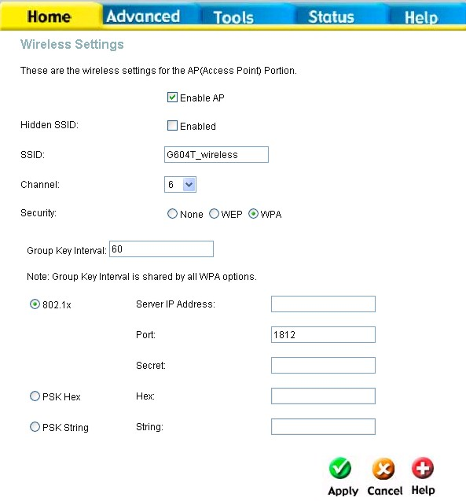
Wireless Security − WPA

Configure WPA Settings
To configure WPA settings, select the WPA option. The menu will change to offer the appropriate settings.
WPA can be configured to work with 802.1x network authentication, or to use a PSK Hex or PSK String key. Follow the instruction below according to the authentication method used. All the WPA methods require the Group Key Interval update. The default is 60 seconds. To change this type in the desired number of seconds to define the time interval between key changes foe WPA clients.
To use WPA with 802.1x:
- Select the 802.1x option.
- Type in the Server IP Address field for the RADIUS server used for authentication.
- Change the Port: if necessary, type in the password in the shared Secret field and change the Group Key Interval as desired.
- Click the Apply button to put the changes into effect. Remember to save the settings using the System Settings menu.

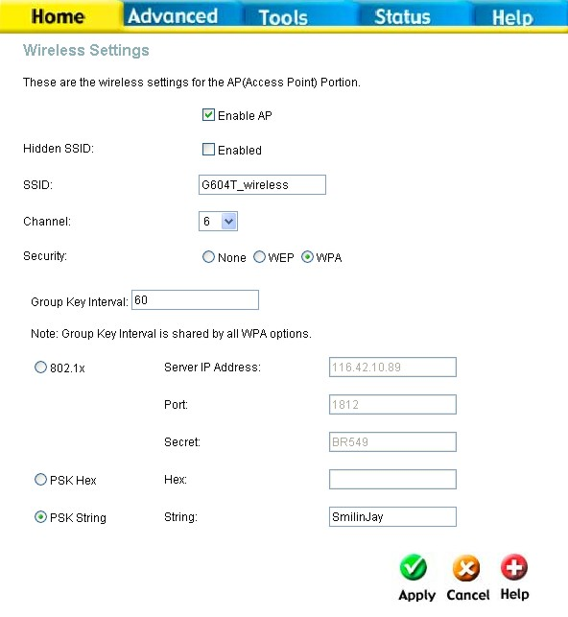
Wireless Settings − WPA-PSK
Home > Wireless > WPA > PSK
WPA-PSK requires a shared key but does not use a separate server for authentication. PSK keys can be ASCII or Hex type.
Wireless Security − WPA-PSK

Configure WPA-PSK Security for WLAN
To use WPA with a PSK key:
- Select the PSK Hex (Hexadecimal key) or PSK String (ASCII key) option.
- Type in the Hex: or String: key in the appropriate entry field.
- Click the Apply button to put the changes into effect. Remember to save the settings using the System Settings menu.

Multiple Virtual Connections
Home > WAN > ATM VC Setting

The Router supports multiple virtual connections. Up to eight PVCs to eight separate destinations can be created and operated simultaneously utilizing the same bandwidth. Additional PVC connections can be added for various purposes. For example, you may want to establish a private connection to remote office in order to create an extended LAN, or setup a server on a separate connection. Provisioning for additional PVC profiles must be done through your telecommunications services provider. Extended LAN operations employing multiple virtual connections require ADSL routers or modems at the remote site for a successful connection. Contact your ISP or telecommunications service provider if you are interested in setting up multiple virtual connections.
After the necessary arrangements have been made to use the Router with multiple virtual connections, follow the instructions below to setup the Router using the VPI/VCI settings given to you by your server provider.
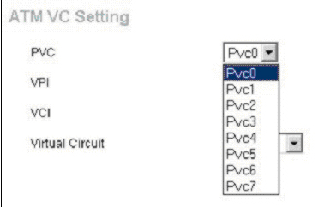

Configure Multiple PVCs

Additional PVCs can be configured by first accessing the WAN configuration menu in the Home directory.

Select new PVC to configure in the WAN menu
The PVC pull-down menu offers 8 virtual connections available for configuration. The default PVC used by the Router is labeled Pvc0. Any additional connections that are configured must have a VPI/VCI combination that is unique to the Router. These numbers will have been already been established by your service provider on their network.
To add a new virtual connection:
- Select the new PVC to configure from the pull-down menu.
- Enter the values for the VPI and VCI given to you by your service provider.
- To activate the VC, select Enabled from the Virtual Circuit pull-down menu.
- Configure the WAN Settings and Connection Type as desired.

In the example below, a new PVC (Pvc1) has been added using the WAN Settings menu. The connection is setup as a bridged connection.

Advanced Router Management
Advanced > UPnP
This chapter introduces and describes the management features that have not been presented in the previous chapter. These include the more advanced features used for network management and security as well as administrative tools to manage the Router, view statistics and other information used to examine performance and for troubleshooting.
Use your mouse to click the directory tabs and menu buttons in order to display the various configuration and read-only menus discussed below.
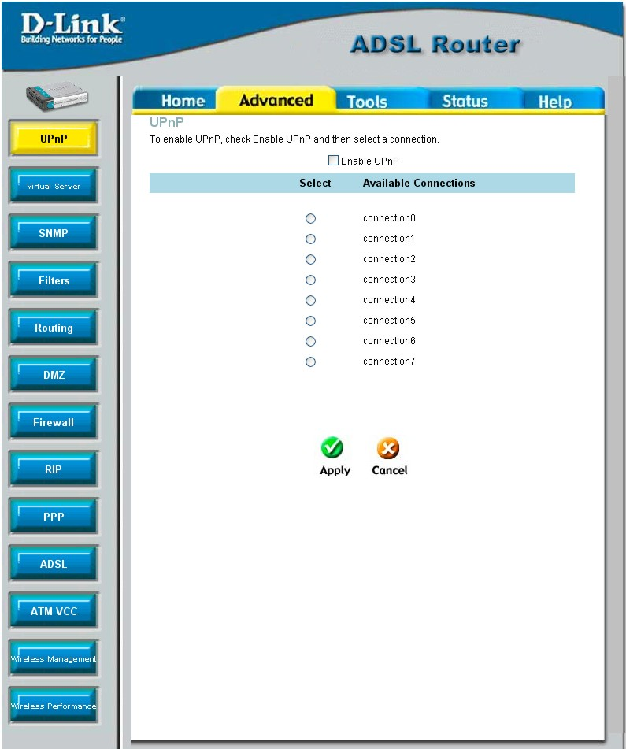
Advanced UPnP menu
The table below summarizes again the directories and menus available in the management web interface. In this chapter you will find descriptions for the menus located in the Advanced, Tools and Status directories.

Directory Configuration and Read-only Menus
Home | Click the Home tab to access the Setup Wizard, Wireless Settings, WAN Configuration, LAN IP Configuration, DHCP for the LAN Setup and DNS Configuration menus. See the previous chapter for a description of the Home directory menus.
Advanced | Click the Advanced tab to access the UPnP, Virtual Server, Filters, (Static) Routing, DMZ, Firewall, RIP, PPP, ADSL, ATM VCC, Wireless Management and Wireless Performance menus.
Tools | Click the Tools tab to access the Administrator Settings (used to set the system user name and password, backup and load settings), System Time Configuration, Firmware Upgrade, Diagnostic Test and Save & Reboot menus.
Status | Click the Status tab to view the Device Information, DHCP Clients, Event Log, Traffic Statistics and ADSL Status information windows.
Help | The Help menu presents links to pages that explain various functions and services provided by the Router.

UPnP
Advanced > UPnP
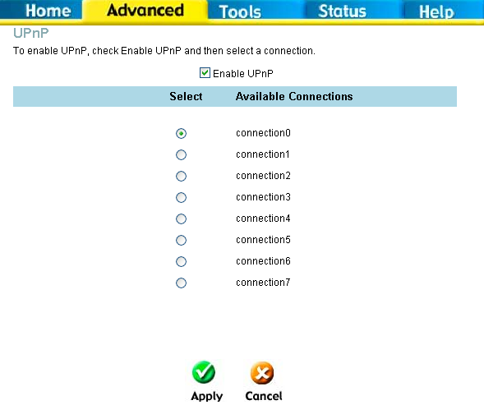
UPnP supports zero-configuration networking and automatic discovery for many types of networked devices. When enabled, it allows other devices that support UPnP to dynamically join a network, obtain an IP address, convey its capabilities, and learn about the presence and capabilities of other devices. DHCP and DNS service can also be used if available on the network. UPnP also allows supported devices to leave a network automatically without adverse effects to the device or other devices on the network.
UPnP can be supported by diverse networking media including Ethernet, Firewire, phone line and power line networking.

Enable UPnP Menu

To enable UPnP for any available connection, click to check the Enable UPnP selection box, select the connection or connections on which you will enable UPnP listed under Available Connections and click the Apply button.

Virtual Server
Advanced > Virtual Server

Use the Virtual Server menu to set up port forwarding rules in the Router. The Virtual Server function allows remote users to access services on your LAN such as FTP for file transfers or SMTP and POP3 for e-mail. The DVA-G3340S will accept remote requests for these services at your Global IP Address, using the specified TCP or UDP protocol and port number, and then redirect these requests to the server on your LAN with the Private IP address you specify.
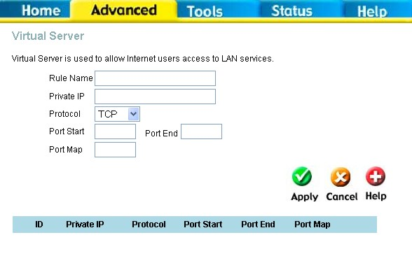
Virtual Server Menu and List

Remember that the specified Private IP Address must be within the useable range of the subnet occupied by the Router.
UDP/TCP port redirection is used to direct traffic through the WAN port to the specified servers or workstations on your private network. Port redirection can also be used to direct potentially hazardous packets to a proxy server outside your firewall. For example, you can configure the Router to direct HTTP packets to a designated HTTP server in the DMZ. You can define a set of instructions for a specific incoming port or for a range of incoming ports. Each set of instructions or rule is indexed and can be modified or deleted later as needed.
Virtual server rules can be set up with complimentary features such as Firewall Rules, DMZ devices and IP Filters to improve efficiency and security. Be sure to consider how these other functions will effect the virtual server rules you have configured and enabled.

To modify virtual server settings for any previously created rule, click on the note pad icon in the right hand column of the list for the set you want to configure. The parameters that have been configured for the rule appear in the settings fields above the list. Adjust the settings as desired and click the Apply button to put them into effect. To delete a rule from the list, click on the trash can icon and confirm that you want to delete the rule in the pop-up dialog box that appears.

The table below describes the configuration settings presented in the Virtual Server menu.
To configure a virtual server set, define the following settings in the Virtual Server configuration menu located in the top half of the browser window.
Parameter Description
Rule Name | Provide a name for the rule. This name will not appear in the list below, however it may be useful if you later need to edit the settings for the rule. Rule names are optional.
Private IP | This is the IP address of the server on your LAN that will provide the service to remote users. The Private IP address is used to direct the service to a specific computer on your private network such as an FTP, Email or public web server. Type in the IP address of the server used for the service being configured here.
Protocol | You can select the transport protocol (TCP or UDP) that the application on the virtual server will use for its connections. Select one of the following options from the pull-down menu to define a TCP, UDP or Both. The choice of this protocol is dependent on the application that is providing the service. If you do not know which protocol to choose, check your application’s documentation.
Port Start /Port End | Configure a range of ports for forwarding. Type the lowest numbered port in the range in the Port Start space. Type the highest numbered port in the Port End space. For a single port, just enter the same number in both spaces.  Virtual server port redirection must be used with a specified server or computer on the LAN (identified by the Private IP address).
Port Map | This is the local port being forwarded to from the Port Start/Port End port(s). Keep in mind that if you use a non-standard port number for an application with a reserved UDP/TCP port, some additional configuration may be required for the servers or workstations using the application on the LAN side.

Click the Apply button to put the new virtual server configuration set or modification into effect. Any server sets configured in the menu will appear in the Virtual Server List with the new settings. The Router must save the new settings and reboot before the new virtual server configurations are applied.
To remove any configuration set from the Virtual Server List, click on the trashcan icon for set you want to delete.

Filters
Filter rules in the Router are put in place to allow or block specified traffic. The Filter Rules however can be used in a single direction to examine and then Allow or Deny traffic for Inbound (WAN to LAN) or Outbound (LAN to WAN) routed data. The rules based on IP address and TCP/UDP port.
Configure the filter rules as desired and click the Apply button to create the rule. The newly created rule appears listed in the Outbound Filter List at the bottom of the menu. The table below describes the various parameters that are configured for the filter rules.
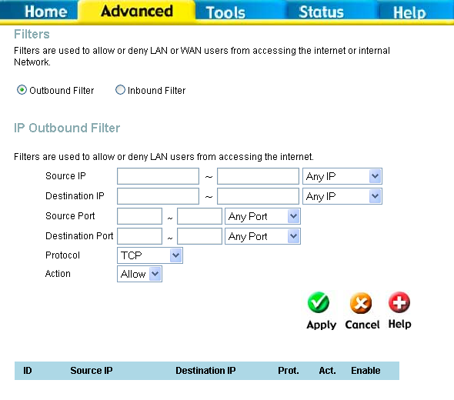
Filters Configuration Menu
To modify any previously created filter rule, click on the note pad icon in the right hand column of the Filter List for the set you want to configure. Adjust the settings as desired and click the Apply button to put the new settings into effect.
First determine the direction of the traffic you want the rule to filter. To filter WAN to LAN traffic, select the Inbound Filter option. Any new Inbound Filter rules created will appear in the list. Likewise, should you to filter LAN to WAN traffic, create an Outbound Filter rule.

The parameters described below are used to set up filter rules.
Parameter Description
Source IP | For an Outbound Filter, this is the IP address or IP addresses on your LAN for which you are creating the filter rule. For an Inbound Filter, this is the IP address or IP addresses for which you are creating the filter rule. You can opt to indicate a Mask Range, a Single IP, an IP Range or Any IP from the pull-down menu. Choosing Any IP will apply the rule to all WAN or all LAN IP addresses depending on which type of rule (Inbound or Outbound) is being configured.
Destination IP | Where the Destination IP address resides also depends on if you are configuring an Inbound or Outbound filter rule. You can opt to indicate a Mask Range, a Single IP, an IP Range or Any IP from the pull-down menu.
Source Port | The Source Port is the TCP/UDP port on either the LAN or WAN depending on if you are configuring an Outbound or Inbound Filter rule. Select one of the following options from the pull-down menu to define a Any Port, Single Port, Port Range or Safe Range (ports above 1024).
Destination Port | The Destination Port is the TCP/UDP port on either the LAN or WAN depending on if you are configuring an Outbound or Inbound Filter rule. Select one of the following options from the pull-down menu to define a Any Port, Single Port, Port Range or Safe Range (ports above 1024).
Protocol | Select the transport protocol (TCP, UDP or All) that will be used for the filter rule.
Action | Select to Allow or Deny transport of the data packets according to the criteria defined in the rule. Packets that are allowed are routed to their destination; packets that are denied are blocked.

Click the Apply button to put the new rule into effect. Any filter rule configured in the menu will appear in the Filters List with the new settings. The Router must save the new settings and reboot before the new rules are applied.

Static Routing
Use Static Routing to specify a route used for data traffic within your Ethernet LAN or to route data on the WAN. This is used to specify that all packets destined for a particular network or subnet use a predetermined gateway.
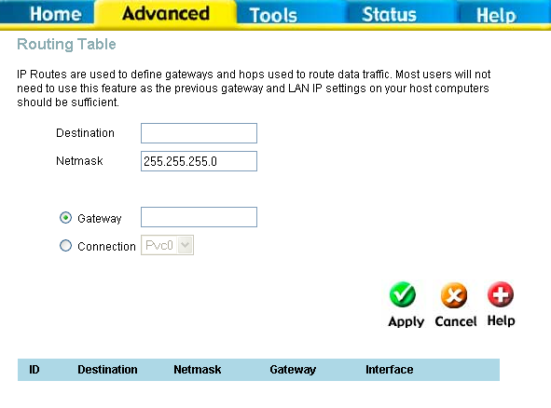
Static Routing menu
To add a static route to a specific destination IP on the local network, enter a Destination IP address, Netmask, then click the Gateway radio button and type in the Gateway’s IP address. Click Apply to enter the new static route in the table below. The route becomes active immediately upon creation.
To add a static route to a specific destination IP on the WAN, click the Connection radio button and choose a connection from the pull-down menu, then enter a Destination IP address and Netmask. Click Apply to enter the new static route in the table below. The route becomes active immediately upon creation
To remove a static route from the table in the bottom half of the window, choose to Delete it from the table and click the Apply button. Remember to save the configuration changes.

DMZ
Since some applications are not compatible with NAT, the Router supports use of a DMZ IP address for a single host on the LAN. This IP address is not protected by NAT and will therefore be visible to agents on the Internet with the right type of software. Keep in mind that any client PC in the DMZ will be exposed to various types of security risks. If you use the DMZ, take measures (such as client-based virus protection) to protect the remaining client PCs on your LAN from possible contamination through the DMZ.
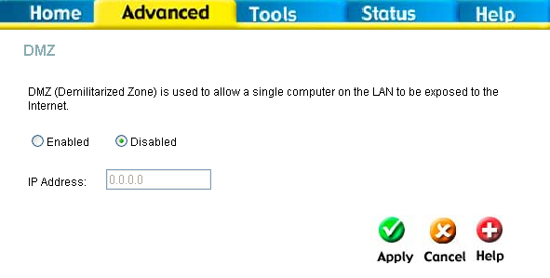
DMZ IP address configuration
To designate a DMZ IP address, select the Enabled radio button, type in the IP Address of the server or device on your LAN, and click the Apply button. To remove DMZ status from the designated IP address, select the Disabled radio button and click Apply. It will be necessary to save the settings and reboot the Router before the DMZ is activated.

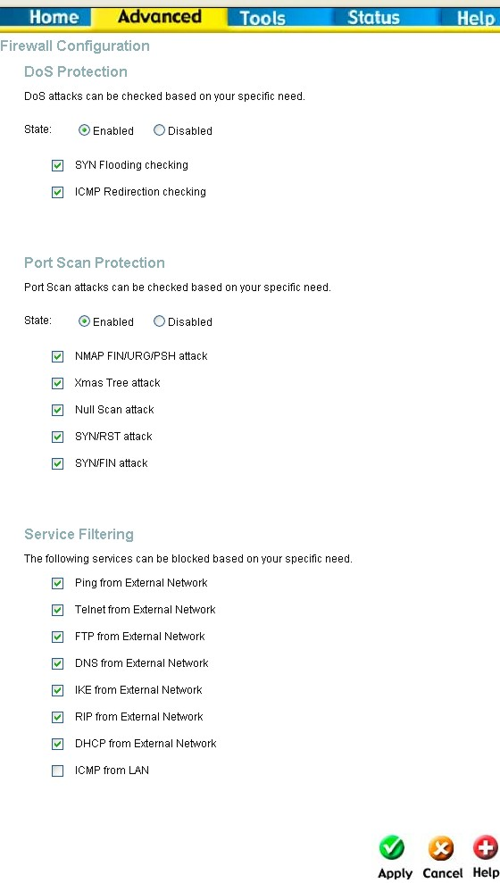
Firewall
The Firewall Configuration menu allows the Router to enforce specific predefined policies intended to protect against certain common types of attacks. There are two general types of protection (DoS, Port Scan) that can be enabled on the Router, as well as filtering for specific packet types sometimes used by hackers.
You can choose to Enable or Disable protection against a customized basket of attack and scan types. To enable DoS Protection or Port Scan Protection, select the Enable radio button for the protection type and click in the selection boxes for the various types of protection listed under each.

Firewall Configuration Menu
When DoS, Port Scan, or Service Filtering Protection is enabled, it will create a firewall policy to protect your network against the following:

Dos Protection | Port Scan Protection | Service Filtering
SYN Flood check  ICMP Redirection check | Nmap/FIN attack  URG/PSH attack  Xmas Tree Scan  Null Scan attack  SYN/RST attack  SYN/FIN Scan | Ping from WAN  Telnet from WAN  FTP from WAN  DNS from WAN  IKE from WAN  RIP from WAN  DHCP from WAN

A DoS "denial-of-service" attack is characterized by an explicit attempt by attackers to prevent legitimate users of a service from using that service. Examples include: attempts to "flood" a network, thereby preventing legitimate network traffic, attempts to disrupt connections between two machines, thereby preventing access to a service, attempts to prevent a particular individual from accessing a service, or, attempts to disrupt service to a specific system or person.
Port scan protection is designed to block attempts to discover vulnerable ports or services that might be exploited in an attack from the WAN.
The Service Filtering options allow you to block FTP, Telnet response, Pings, etc, from the external network. Check the category you want to block to enable filtering of that type of packet.
When you have selected the desired Firewall policies, click the Apply button to enforce the policies. Remember to save any configuration changes.

RIP Dynamic Routing
The Router supports RIP v1 and RIP v2 used to share routing tables with other Layer 3 routing devices on your local network or remote LAN.

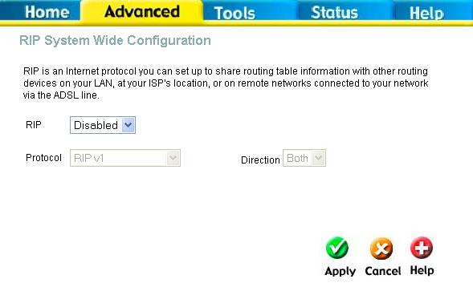
Dynamic Routing (RIP) menu
To enable RIP, select Enabled from the RIP pull-down menu, select the Protocol (RIPv1 and RIPv1 Compatible) and Direction (In, Out, or Both), and click Apply.
The RIPv1 Compatible option will transmit RIPv2 broadcast packets and receive both RIP v1 and RIP v2 packets.
The direction configuration refers to the RIP request. Select In to allow RIP requests from other devices. Select Out to instruct the Router to make RIP requests for routing tables from other devices. Select Both to share routing tables in both directions.

PPP Connection State
When the WAN connection is configured for either PPPoA or PPPoE, you can configure the Router’s PPP session to remain on all the time, or to disconnect after some period of no activity. You may also choose to instruct the Router to connect each time you want to access the WAN or the Internet.

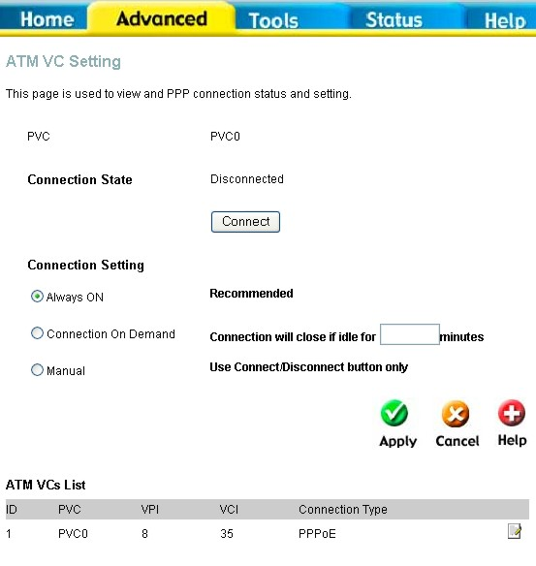
PPP Connection settings menu

If you want the Internet or WAN connection to be available any time a host on your LAN requests access, select the Always On option.
If your ISP account is billed according to the amount of time the Router is connected, choose the Connection On Demand option. You can configure an idle time in minutes to disconnect the PPP connection after a period of inactivity. This will discontinue the PPP session and require a few seconds to reconnect when a host requests access to the WAN. Alternatively you can choose the Manual option and use the Connect button to initiate a PPP connection each time you want to use the Router to access the WAN. If you use the Manual option, you must return to this menu and click the Disconnect button to terminate the PPP session.

ADSL
The ADSL Configuration page allows the user to set the configuration for ADSL protocols. For most ADSL accounts the default settings Multi-mode will work. This configuration works with all ADSL implementations. If you have been given instructions to change the Modulation method used, select the desired option T1.413, G.dmt, or G.lite and click the Apply button.

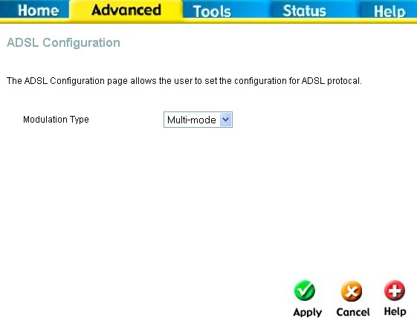
ADSL Modulation Configuration

ATM VC
The ATM Virtual Circuit connection menu is used to configure the WAN connection. If you are using multiple PVCs, you can change the configuration of any PVC in this menu. To create new or additional PVCs, read the section below on Multiple PVCs.
This menu can be used as an alternative menu to configure the same settings found on the WAN menu in the Home directory.
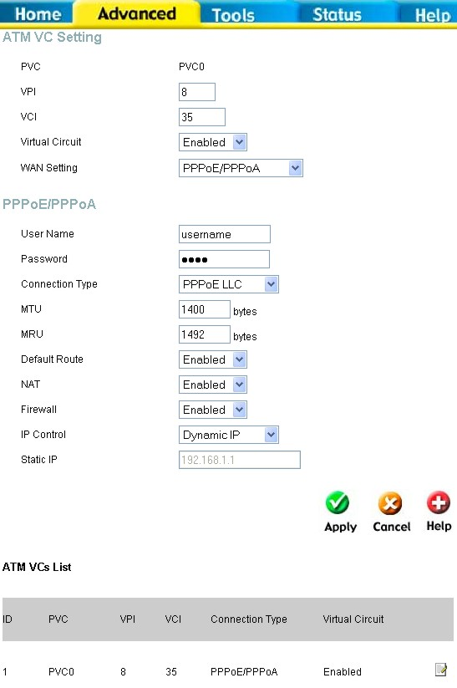
ATM Virtual Circuit configuration menu
To configure an existing PVC configuration set, click the corresponding notepad icon in the right-hand column of the ATM VCs List. The PVCs current settings appear above in the entry fields of the ATM VC Settings menu. Configure the appropriate settings and click the Apply button to put the new settings into effect.

Wireless Management
The Wireless Management menu located in the Advanced directory is used to control MAC address access to the wireless access point and to view a list of MAC addresses that are currently associated with the access point. This menu is also be used to enable and configure use of multiple SSIDs. To use more than one SSID, WEP and WPA security must first be disabled (see below).

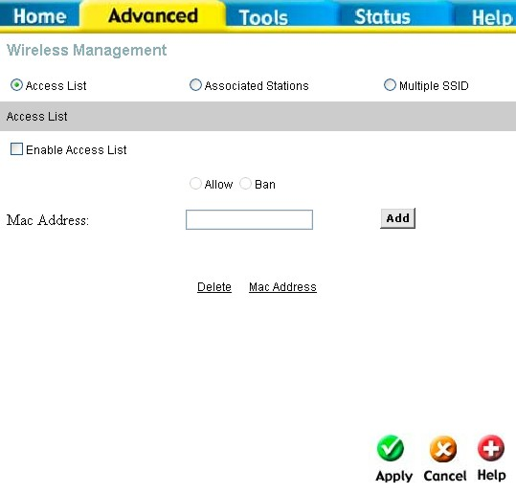
Wireless Management Access List
To view a list of stations currently associated with the access point, click the Associated Stations radio button.

Configure Wireless Access Control
To create a list of MAC addresses that are banned or allowed association with the wireless access point:
- Click in the Enable Access List option box to select it.
- Select the action to perform on the MAC address to be specified. Choose to Allow or Ban association.
- Type in the MAC Address in the entry field provided.
- Click the Add button to add the MAC address to the list. The AMC address will appear listed in the table below.
- After compiling the list of MAC addresses as desired, click the Apply button to enforce access control for the MAC addresses in the list.
To remove any MAC address from the list, click the radio button in the left column of the list for the MAC address to be removed and click the Apply button.

Configure Multiple SSID
Multiple SSID cannot be used if the access point has either WPE or WPA enabled. This must first be disabled in the Wireless menu located in the Home directory.
To configure multiple SSID:
- Disable WEP or WPA in the Wireless menu of the Home directory.
- Click in the Enable Multiple SSID option box to select it.
- Enter the SSID you want to add.
- Click the Add button to add the SSID to the list.
- Click the Apply button to enable the listed SSIDs.
To remove an SSID from the list, click the radio button in the left column of the list for the SSID to be removed and click the Apply button.

Wireless Performance
If you want to tweek wireless settings, click the Wireless Performance menu button in the Advanced directory

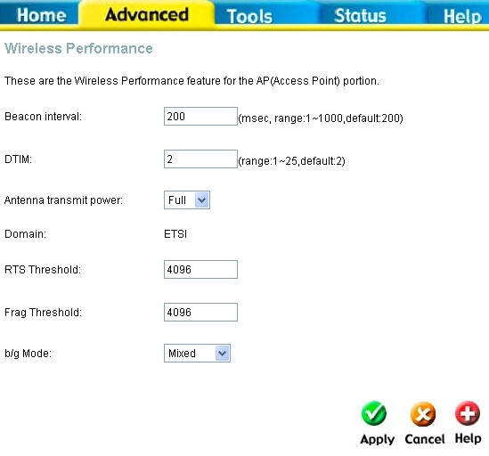
Wireless LAN Performance settings

Tools
Click the Tools tab to reveal the menu buttons for various functions located in this directory. The Administrator Settings is the first menu that appears in the Tools directory. This menu is used to change the system password used to access the web manager, to save or load Router configuration settings and to restore default settings. The functions in this and the other Tools menus are described below.

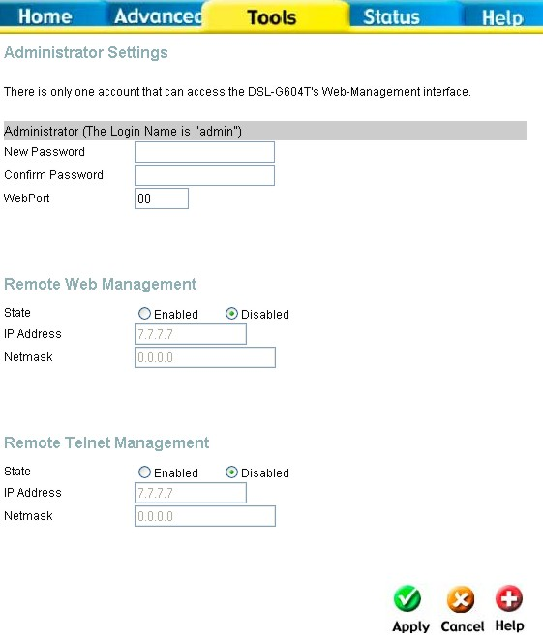
System Tools administrative functions

Change System Password
To change the password used to access the Router web manager, click the Admin button in the Tools directory to display the Administrator Settings menu. Under the Administrator heading, type the New Password and Confirm Password to be certain you have typed it correctly. Click the Apply button to activate the new password. The System User Name remains “admin”, this cannot be changed using the web manager interface. Be sure to save the new setting.
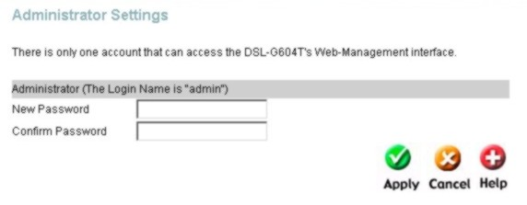
Administrator Settings change password menu

Remote Web Management and Telnet Access
The Administrator Settings menu is also used to enable remote Telnet management and remote web management access to the Router. To enable remote management of the Router, select the Enabled radio button for either Remote Web or Remote Telnet Management and type the IP Address and Netmask of the remote network or system used for management. Click the Apply button to activate remote management from the chosen IP address. Be sure to save the new setting.

Time
The Router provides a number of options to maintain current date and time including SNTP.

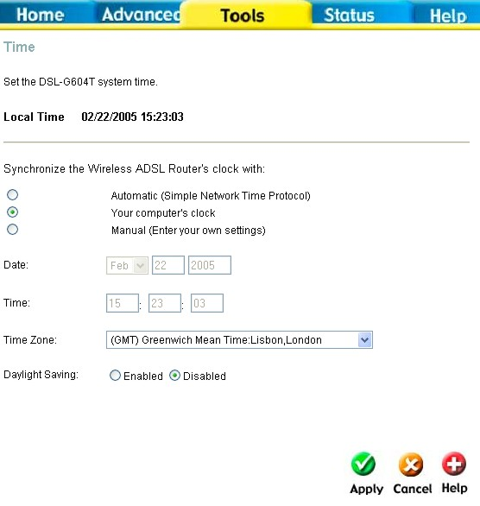
Time & Date Configuration
To configure system time on the Router, select the method used to maintain time. The options available include SNTP, using your computer’s system clock (default) or set the time and date manually. If you opt to use SNTP, you must enter the SNTP server URL or IP address. Click the Apply button to set the system time.

Save or Load Configuration File
Once you have configured the Router to your satisfaction, it is a good idea to back up the configuration file to your computer. To save the current configuration settings to your computer, click the Admin button in the Tools directory to display the Administrator Settings menu. Click the Save button to Save Settings to Local Hard Drive. You will be prompted to select a location on your computer to put the file. The file type is .xml (HTML) and may be named anything you wish.
To load a previously saved configuration file, click the Browse button and locate the file on your computer. Click the Load button to Load Settings From Local Hard Drive. Confirm that you want to load the file when prompted and the process is completed automatically. The Router will reboot and begin operating with the configuration settings that have just been loaded.

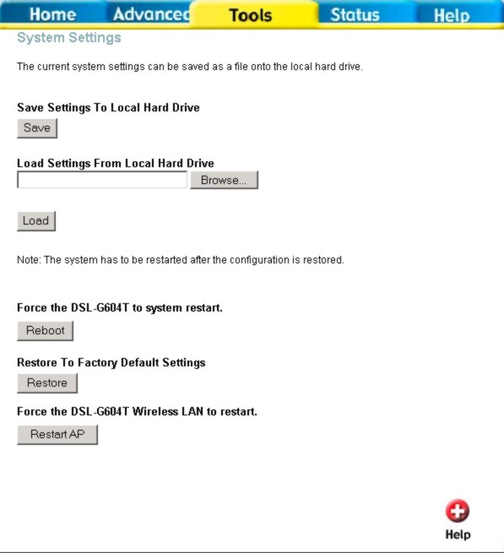
Save System Settings and Restore Defaults

Restore Factory Default Settings
To reset the Router to its factory default settings, click the Restore button in the Administrator Settings menu. You will be prompted to confirm your decision to reset the Router. The Router will reboot with the factory default settings including IP settings and Administrator password.

Firmware
Use the Firmware Upgrade menu to load the latest firmware for the device. Note that the device configuration settings may return to the factory default settings, so make sure you save the configuration settings with the System Settings menu described above.

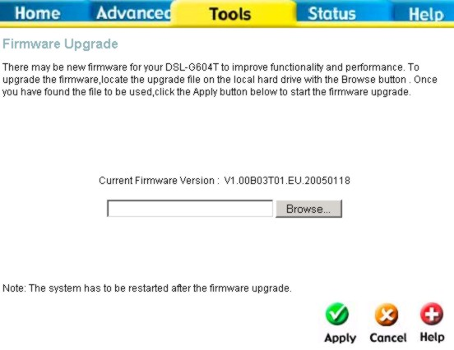
Firmware Upgrade
To upgrade firmware, type in the name and path of the file or click on the Browse button to search for the file. Click the Apply button to begin copying the file. The file will load and restart the Router automatically.

Ping Test
To perform a statndard Ping test for network connectivity, click the Misc. menu button in the Tools directory to view the Miscellaneous Configuration menu.

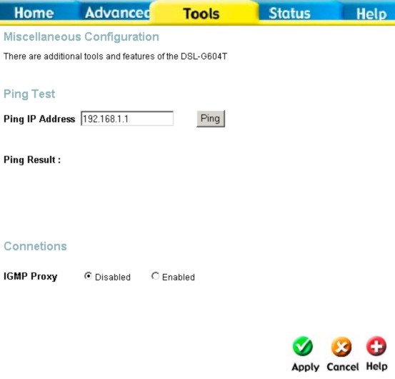
Miscellaneous Configuration menu
Other functions available in Miscellaneous Configuration menu are a Ping test and IGMP enable/disable.

Ping Test
The Ping test functions on the WAN and LAN interfaces. Type the IP address you want to check in the space provided and click the Ping button. Read the Ping test result in the space immediately below.

IGMP Proxy
The Miscellaneous Configuration menu also allows you to enable IGMP forwarding.
This is Disabled by default. This setting will not allow IGMP (Internet Group Management Protocol) packets to be forwarded to the LAN. IGMP is used to manage multicasting on TCP/IP networks, most users will not need to enable this. Some ISPs use IGMP to perform remote configuration for client devices, such as the Router. If you are unsure, check with your ISP. To enable IGMP service to the LAN interface, select Enabled and click the Apply button.

Test
The Test menus are used to test connectivity of the Router. A Ping test may be done through the local or external interface to test connectivity to known IP addresses. The diagnostics feature executes a series of test of your system software and hardware connections. Use this Test menu when working with your ISP to troubleshoot problems.

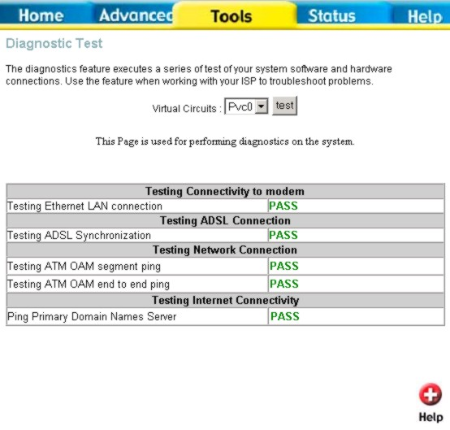
Diagnostics Test Menu

Status Information
Use the various read-only menus to view system information and monitor performance.

Device Information Display
Use the Device Information window to quickly view basic current information about the LAN and WAN interfaces and device information including Firmware Version and MAC address.

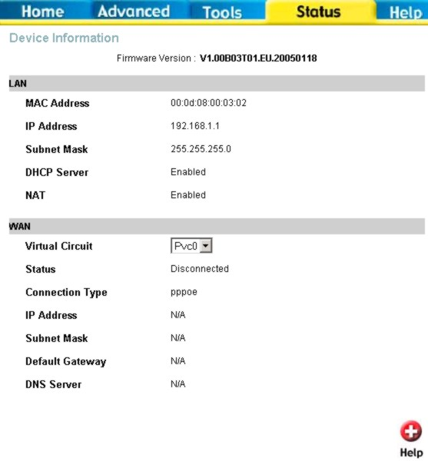
Device Information display

Log
The system log displays chronological event log data. Use the navigation buttons to view or scroll log pages. You may also save a simple text file containing the log to your computer. Click the Save Log button and follow the prompts to save the file.

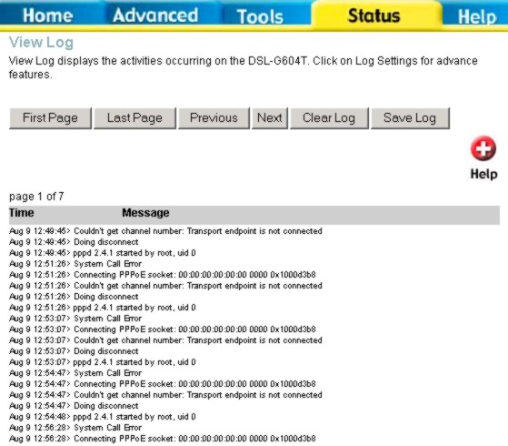
Log display
Click Clear Log delete the current log information.

Traffic
Use the Traffic Statistics window to monitor traffic on the Ethernet or ADSL Internet connection. When the Wireless Select the interface for which you want to view packet statistics and the information will appear below.

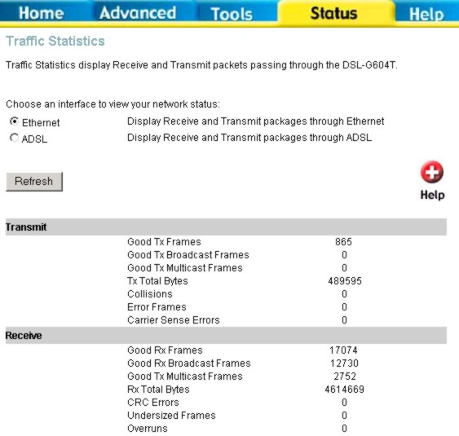
Traffic Statistics information
Click Refresh to view traffic information.

ADSL
Use the ADSL Status information and the Test page for troubleshooting the ADSL connection.

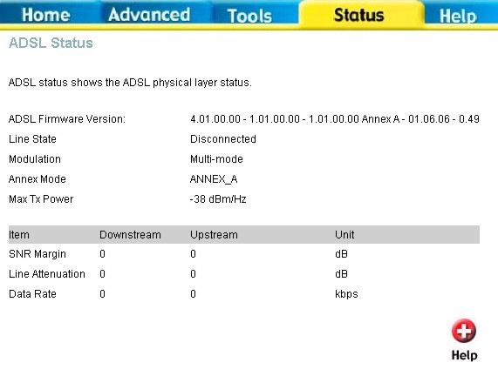
ADSL Status information

Technical Specifications

Key Component | Description
Network Processor and ADSL Chipset | TI AR7VWi
Voice Chipset | TI TNETV901
Product Feature | Description
Network Interface
One ADSL port | RJ-11, inner pair (pin 2,3)
Standard Compliance | ADSL Standards:  ANSI T1.413 Issue 2  ITU G.992.1 (G.dmt) AnnexA  ITU G.992.2 (G.lite) Annex A  ITU G.994.1 (G.hs)
Standard Compliance | ADSL2 Standards:  ITU G.992.3 (G.dmt.bis) Annex A  ITU G.992.4 (G.lite.bis) Annex A
Standard Compliance | ADSL2+ Standards:  ITU G.992.5 Annex A
Line Rate | Downstream: up to 24Mbps
Line Rate | Upstream : up to 1Mbps
Performance | Pass DSL Forum TR-067 Performance Criteria
LAN Interface
Four Fast Ethernet ports | RJ-45, 10/100Mbps, MDI/MDIX Auto-sesnsing
Standard Compliance | IEEE802.3, IEEEE802.3u
USB Interface
One USB port | Type B connector
Standard Compliance | USB Implementation Forum USB 1.1 Specification
Voice Interface
Two ports for POTS connection | RJ-11, FXS interface
Two ports for POTS connection | Loop Start
One port for PSTN connection | RJ-11, FXO interface
Telephone dialing mode support | DTMF
Telephone dialing mode support | Dial Pulse (20pps/10pps)
Ringer Equivalency Number | REN=5
Line Impedance | 600ohm
Wireless Access Point Embedded
Standard Compliance | IEEE 802.11
Standard Compliance | IEEE 802.11b
Standard Compliance | IEEE 802.11g
Radio and Modulation Type | IEEE 802.11b: DQPSK, DBPSK, DSSS, and CCK
Radio and Modulation Type | IEEE 802.11g: BPSK, QPSK, 16QAM, 64QAM, OFDM
Operating Frequency | 2400 ~ 2484.5MHz ISM band
Channel Numbers | 11 channels for United States
Channel Numbers | 13 channels for European Countries
Channel Numbers | 13 channels for Japan
Data Rate | IEEE 802.11b: 11, 5.5, 2, and 1Mbps
Data Rate | IEEE 802.11g: 6, 9, 12, 18, 24, 36, 48, 54Mbps
Media Access Protocol | CSMA/CA with ACK
Form Factor and Interface | mini-PCI interface
Antenna type | One Built-in Diversity Antenna
Power
External Linear Power Adapter | Input: Depends on specific country requirements
External Linear Power Adapter | Output: 12V AC, 1.6A
Device Power consumption | Maximum 12 watt
Reset Button | Reset to factory default
Product Feature | Description
Bridging/Routing
Transparent bridging
Dynamic Learning | Up to 1024 MAC addresses
Encapsulation | Bridged/Routed Ethernet over ATM (RFC1483/2684)
Encapsulation | Classical IP over ATM (RFC1577)
IPv4 | TCP/UDP
IPv4 | ARP
IPv4 | ICMP
IP Routing | RIP v1 (RFC 1058), RIP v2 (RFC 1389)
IP Routing | IP Static Routing
DHCP | DHCP Server (RFC2131)
DHCP | DHCP Client (RFC2131)
DNS | DNS Cache
DNS | Dynamic DNS
IP multicast | IGMP Proxy
IP multicast | IGMP Snooping
ATM/ADSL
Multiple PVC | Support 8 PVCs
ATM Cell format | ITU-T Rec. I.361
ATM Adaptation Layer | AAL5
ATM signaling | ATM Forum UNI3.1/4.0
OAM support | F4/F5 Loopback
ATM QoS (Traffic Shaping) | UBR, CBR, VBR
PPP Support
Point-to-Point Protocol | RFC1661
PPP over ATM | RFC2364
PPP over Ethernet | RFC2516
PPP Encapsulation | VC
PPP Encapsulation | LLC
User Authentication | PAP (RFC 1334)
User Authentication | CHAP (RFC 1994)
User Authentication | Auto-detection of PAP/CHAP
NAT
NAT/NAPT
Port Forwarding | Static IP masquerade(1~65535)
Port Forwarding | Entry Number: 32 entries
Port Forwarding | Port Number Setting:- Possible to assign the range- Possible to set TCP/UDP/Both as the protocol
Pass Through | IPSec/L2TP/PPTP pass through
NAT ALGs | MSN MSGR
NAT ALGs | FTP
NAT ALGs | SIP (Video/ Audio/ White Board/ Remote Control)
NAT ALGs | ICQ for File and Audio transfer
NAT ALGs | NetMeeting 3/ 2.0 Video/Audio receive
NAT ALGs | CUSEEME
Security
MAC Filtering | Over 16 entries
MAC Filtering | Only ARP Pass-through
MAC Filtering | MAC Address and Ethernet type are configurable
IP Filtering | 32 records
IP Filtering | Range Setting (IP Address, Port Number)
IP Filtering | In-bound/Out-bound Setting
SPI | Detection of Known Attacks
QoS
Priority Queue | Voice over data
Wireless AP Functions
ESS-ID Support
MAC Address Filtering | Support Access Control List (ACL)
WEP Support | 64/128/256 bits
WPA Support
VoIP
Call Control Protocol | SIP (RFC3261)
Codec | G.711μ-law/A-law
Codec | G.726
Codec | G.729A
Echo Canceller | G.168
Fax Relay | G.711
DTMF Relay | RFC2833
Country Tone Support | DT , RBT , BT，Howler／HST(future support)
Tone Detection | DTMF
Tone Detection | Modem/Fax: V.21,V.25
PSTN Life-line Function | Automatic fall back to PSTN in case of power failure
PSTN Life-line Function | PSTN line automatic selection (e.g. emergency Call 911)
PSTN Life-line Function | PSTN routing table support base on prefix number
Caller ID | BellCore, ETSI complaint
Life-line Backup | Making call to PSTN
Life-line Backup | Receiving call from PSTN
RTP/RTCP
Configuration/Management
Access Administration | Username/Password control for Telnet, WEB configuration
WEB-based management | HTTP server
Ping | Support Ping test from Modem
SNTP | Simple Network Time Protocol
Factory Reset | Reset to factory default
UPnP 1.0
Diagnostics
Configuration Backup/Restore
Product Feature | Description
Safety Requirement
CSA International Mark | Including CSA950, UL1950, IEC60950, EN60950
EMC Specification
FCC part15 class B
PTT Test
FCC part68
Wireless Certification
Wi-Fi certified
Environmental Requirement
Operating Temperature | 0 °C to 40 °C
Storage Temperature | -20 °C to 70 °C
Operating Humidity Range | 5% to 95% Non-condensing
Product Feature | Description
IP Address/Mask | 192.168.1.1/255.255.255.0
VPI/VCI | 0/35
ADSL Mode | Multi-mode
Connection Mode | PPPoE LLC
User Name/Password | admin/admin

Technical Support
You can find software updates and user documentation on the D-Link website.

D-Link provides free technical support for customers within the United States and within Canada for the duration of the warranty period on this product.

U.S. and Canadian customers can contact D-Link technical support through our website, or by phone.
Tech Support for customers within the United States:
D-Link Technical Support over the Telephone:
(877) 453-5465
24 hours a day, seven days a week
D-Link Technical Support over the Internet:
http://support.dlink.com
email:support@dlink.com

Tech Support for customers within Canada:
D-Link Technical Support over the Telephone:
(800) 361-5265
Monday to Friday 7:30am to 12:00am EST
D-Link Technical Support over the Internet:
http://support.dlink.ca
email:support@dlink.ca



