
This product can be set up using Remote IP configuration tool and Web browser, such as IE (Internet Explorer).

DVG-2004S
Gateway

Check Your Package Contents
These are the items included with your DVG-2004S VoIP Gateway purchase：
• DVG-2004S VoIP Gateway

• CD-ROM (containing Manual and Installation program)

• Ethernet cable

• Phone cable

• Power cord



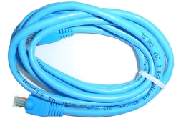

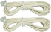


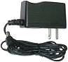
Using a power
supply with a different voltage rating will damage and void the warranty for this product.

If any of the above items are missing, please contact your reseller.
©2005 D-Link Systems, Inc. All rights reserved. Trademarks or registered trademarks are the property of their respective holders. Software and specifications subject to change without notice. DVG-2004S

Connecting DVG-2004S to Your Network

A. First, connect the power adapter to the receptor at the front panel of the DVG-2004S and then plug the other end of the power adapter to a wall outlet or power strip. The “ready” LED will turn ON to indicate proper operation.

B. 1. Connect an Ethernet cable to the Ethernet jack located on the Cable / DSL modem.

2. Insert the other end of the Ethernet cable to the LAN PORT on the front panel of DVG-2004S. The LAN LED light will illuminate to indicate proper connection. If the LAN LED is not illuminated, please go back and step B and repeat its instructions.
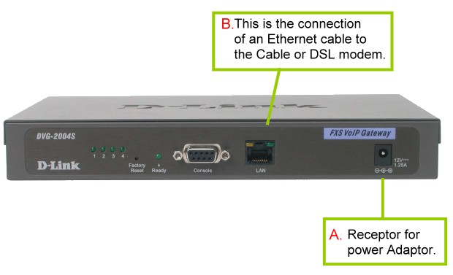

C. Insert a phone cord to FXS port on the back panel of the DVG-2004S.


LED Light Display

The LED lights show the status of the DVG-2004S where list on the front panel.

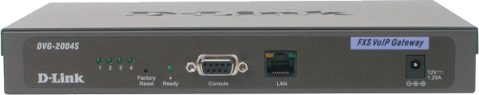
(1) (2) (3) (4)
No. | Label | Color | Display | Status
(1) | FXS 1-4 | Green | On | The phone line is active
(2) | Ready | Green | On | Power on
(2) | Ready | Green | Flash | System is rebooting
(2) | Ready | Green | Off | Power off
(3) | LAN- Left (100M) | Amber | On | Network connected
(3) | LAN- Left (100M) | Amber | Flash | Packet is through this port
(4) | LAN- Right (10M) | Green | On | Network connected
(4) | LAN- Right (10M) | Green | Flash | Packet is through this port

When you have connected all the line to the DVG-2004S, it will look similar to this:

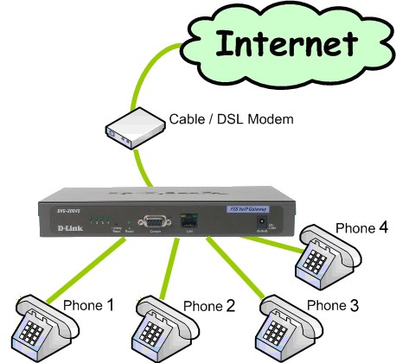


VoIP Remote Configuration

DVG-2004S you purchased comes with an installation Insert the CD into your PC or laptop and double click the file name “Setup VoIP-Remote-Config ”. VoIP-Remote config software will be installed on your computer.

Setup with VoIP-Remoteconfig.exe
Once you finish installing, a new icon is created on your desktop.
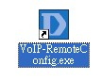
Double click this icon.
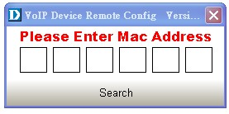
Click on the empty field and enter the MAC address (printed on the back of DVG-2004S). If you cannot find the MAC address, click “Search” to view all the available MAC addresses in the LAN. You will see the following window.
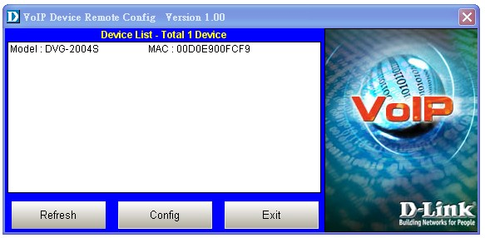
Device list: List all the devices installed in the LAN.

This window contains 3 buttons -
- Refresh: Refresh the information on the Device List.
- Config: Configure the device.
- Exit: Exit VoIP Device Remote Config.

After you click the Config button, you will see the following window.
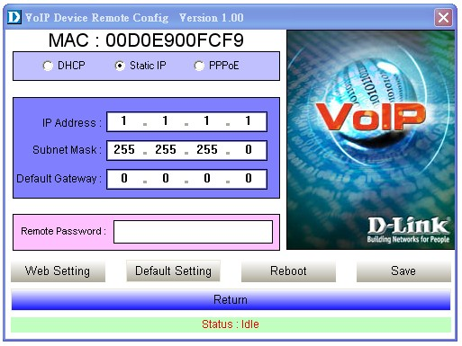
There are 3 ways to setup the IP address: DHCP, PPPoE, and Static IP. Select your Network settings. These are the most common setup:
- For LAN, please choose Static IP
- For xDSL, please chose PPPoE
- For cable internet, please choose DHCP
- For other Network setup, please consult your Network Administrator.

Before you can save these settings, please enter the password on the Remote Password field.
- Remote Password: Default password is “1234”. After you enter the correct password, you may select “Default Setting”, “Reboot” or “Save”.
- Web Setting: Link user directly to the web setting interface.
- Default setting: Restore to factory default settings.
- Reboot: Restart the system.
- Save: Save any changes and restart the system.
- Status: Displays the device’s current status (Idle, Rebooting etc).
- Return: Return to the “Device List” window.


Login to the Browser

After choosing your Network environment, click “Web Setting”.
Click Web Setting

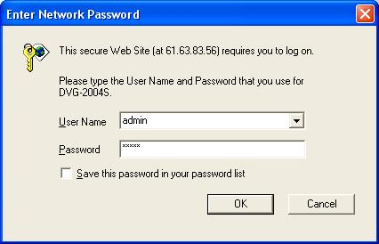
Type “admin” for the username and password.
Click OK

You will see the following screen.

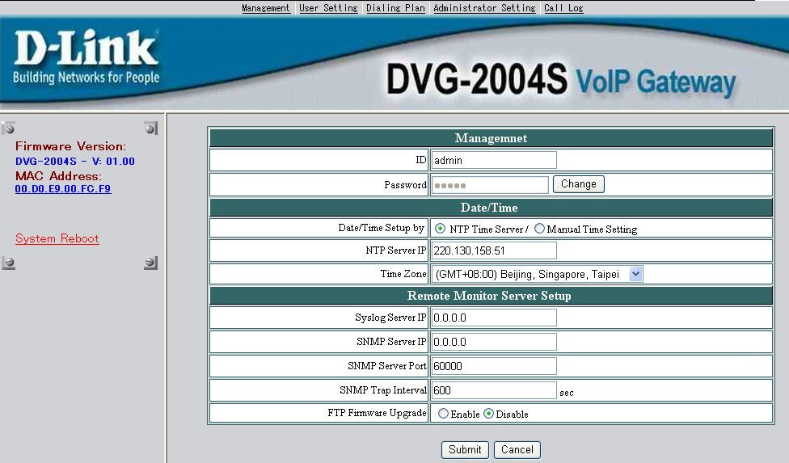

Select General Setting from the Dialing Plan menu.

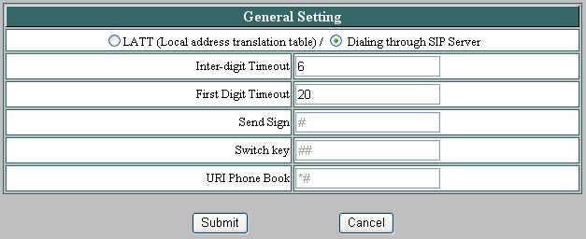
Select Dialing through SIP Server

Click Submit
Select SIP Setting from the Administrator Setting menu. The following fields with “ ” are required. Then click submit.

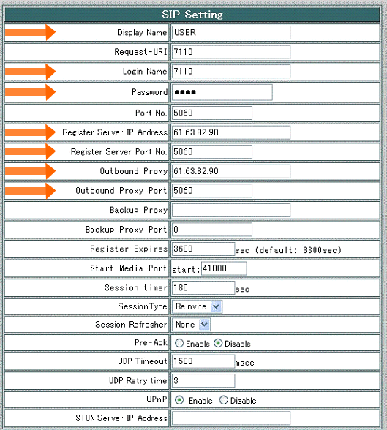
Display Name | Name displayed on the LCD for the caller.
Login Name | User name to log in the SIP server.
Password | User password to log in to the SIP server.
Register Server IP Address | SIP Register Server IP address.
Register Server IP Address Port | Port number of SIP Register Server.
Outbound Proxy | Outbound Proxy server IP address.
Outbound Proxy Port | Port number of Outbound Proxy Server.
Please click the hyperlink character System Reboot on the bottom left of the menu to reboot.
Your setup is complete!!

