ANT24-0501

Date: February 3, 2005

Product name: | Wireless 2.4GHz 5dBi omni-directional indoor antenna
Product Group & Type: | Wireless
Revision: | A1
Available: | Jan. M / 2005
Picture: | 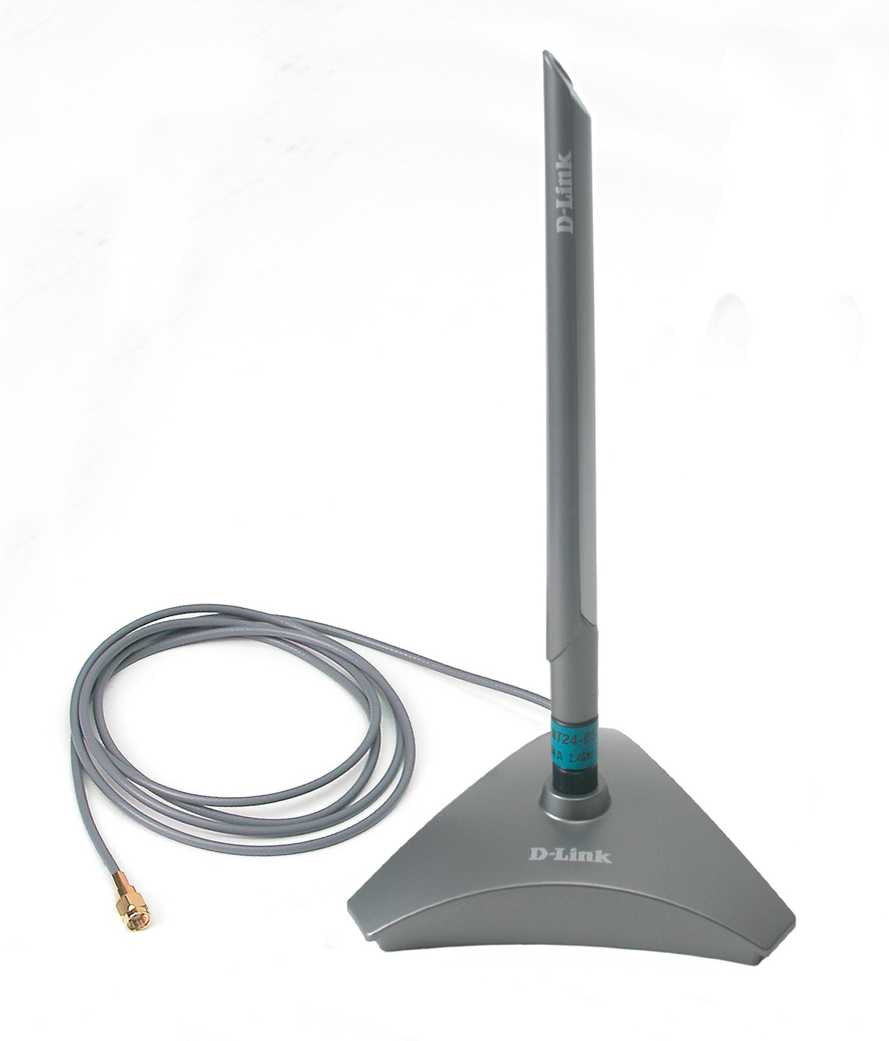
Why Sell This Product: | - Optional indoor antenna for 2.4GHz wireless devices, offering higher Gain for wider operation range and flexible options for wireless users.  - Expand your product line with antennas supporting D-Link and third-party vendor wireless devices.  - Supports both RP-SMA and RP-TNC types of connectors, can work with a wide variety of wireless devices.  Selling Points  - Supports popular 802.11b and 802.11g standards.  - Flexible installation options.  - Adjustable antenna.
Key Features: | - 5dBi Gain omni-directional antenna  - Compliant with 2.4GHz ISM band  - For indoors use with 802.11b/g wireless devices  - Extends and expands wireless networking environment range to 360 degree coverage in open space and office environment  - Perfect pattern and adjustable angle for best performance result  - 4 flexible installation options: desktop on flat surface, magnetic attached, wall-mounting and direct attachment on wireless device  - Stylish, unique housing design  - Works with 2.4GHz wireless antennas equipped with RPSMA or RP-TNC connector  - Extension cable provided for flexible and extendable antenna working environment
Technical Details: | Electrical Properties  Frequency Range  2.4GHz to 2.5GHz  Directivity  Omni-directional  Impedance  50 ohm (normal)  VSWR  1.92 (max.)  Return Loss  -10dB (max.)  Antenna Structure  Collinear  Peak Gain  5dBi(without cable loss)  Admitted Power  1 watt  Cable Loss (1.5m)  2.1dB at 2.45GHz  HPBW/E-Plane (Vertical)  36 degrees  HPBW/H-Plane (Horizontal)  360 degrees  Physical & Environmental  Extension Cable  - RG-178 50-ohm  - 1.5-meter length, gray color  Connector  - RP-SMA  - RP-SMA to RP-TNC adapter provided  Antenna Material  ABS, ABS+PC  Color  - Antenna: metallic gray and silver  - Antenna base: metallic gray  Dimensions  230 (H) x 120 (W) x 120 (D) mm (antenna base included)  9 mm (diameter) (antenna pole)  Weight  217 grams (antenna base and extension cable included)  Operating Temperature  -20 to +65 C  Storage Temperature  -30 to +75 C  Operating Humidity  5% to 95% RH non-condensing  Storage Temperature  5% to 95% RH non-condensing
EMI/EMC Report | ☑FCC No. ☑ CE No. ◻ VCCI No.  ◻ CTR-21 No. ◻ C-Tick No. ◻ A-Tick No.  ◻ FDA No. ◻ R&TTE No. ◻ BSMI No.  ◻ Others
Safety | ◻ TUV No. ◻ UL No. ◻ CSA No.  ◻ Others
Packaging Style | ◻ Clamshell ◻ White Box ☑ Gift Box ◻ Bulk ◻ White Box with D-Link Logo  ◻ Others
Packaging Contents: | - One ANT24-0501 2.4GHz indoor 5dBi omni-directional Antenna with 1.5M extension cable and RP-SMA Jack connector  - One RP-SMA/ RP-TNC adapter  - One registration card and international office guide  - Mounting kit includes:  Two crews  Two plastic fixings  One sticker
UPC Code:
  BANT240501A1 | 790069275197
  CANT240501A1 | 790069275197
  ANT240501.A1 | 790069275241
  TANT240501A1 | 790069275203
  NANT240501A1 | 790069275210
  EANT240501A1 | 790069275227
Units Per Carton: | 12
Cartons Per Pallet: | For USA Air:24, Sea: 36 | For WW Air:24, Sea: 36
Dimensions and Weight: | Box:  , Others 265x148x145 mm, 0.338 kg  Carton: 559x335x331 mm, 4.006 kg  Pallet: (by Air) 1220x1020x1370 mm, 100.6 kg (for USA)  1200x1100x1390 mm, 100.6 kg (for WW)  (by Sea) 1220x1020x1990 mm, 148.7 kg (for USA)  1200x1100x2010 mm, 148.7 kg (for WW)  INTRASTAT weight: 0.134 kg (Box)  Packing material weight (Box):  - Paper: 0.17 kg  - Plastic: 0.02 kg  - Mixed: 0.01 kg
