ANT24-0501C

Date: August 2, 2005

Product Description: | Wireless 802.11b/g 5dBi indoor omni-directional antenna
Revision: | A1
Availability: | Now
Picture: | 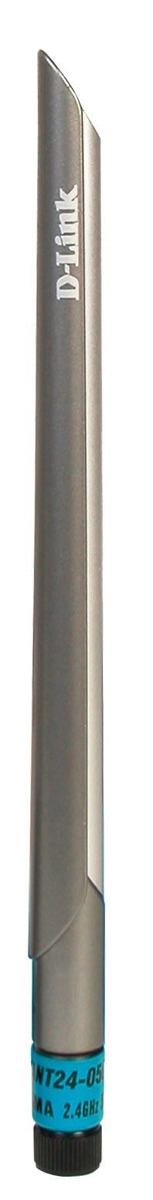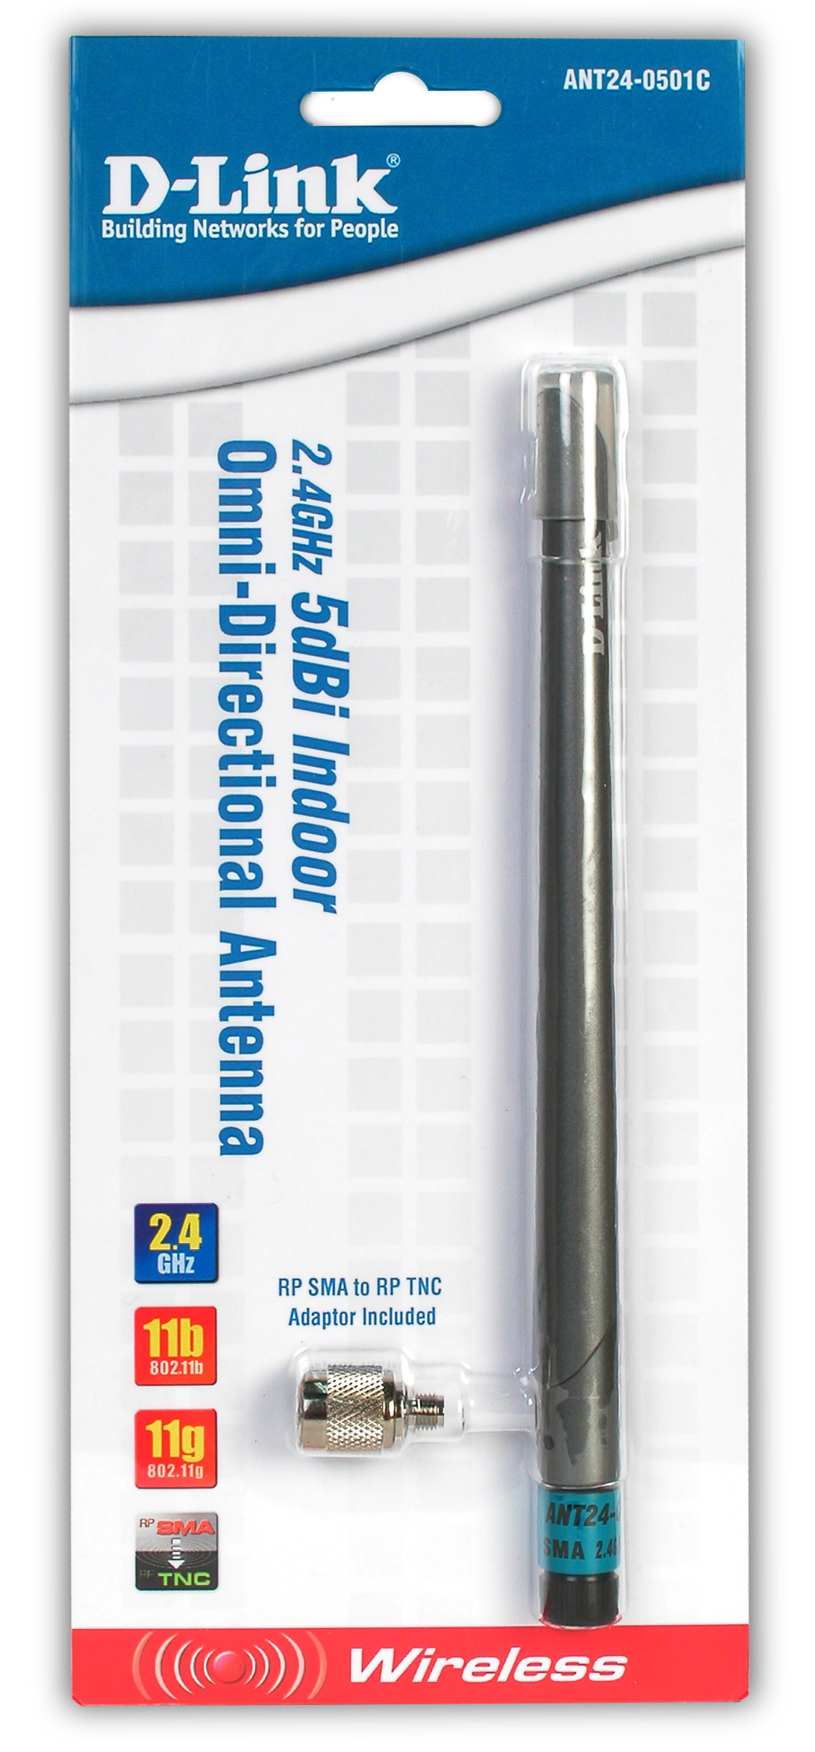
Why Sell This Product: | This external antenna is part of D-Link’s wireless LAN peripheral product line designed to supplement your sales of wireless LAN. It’s targeted at wireless users already having wireless access points or routers equipped with detachable low Gain external antennas.  Selling Points  - Simple to install, no technical support required.  - Standard RP-SMA plug.  - Works with access points and routers equipped with RP-SMA or RP-TNC connectors (RP-SMA to RP-TNC adapter provided).
Key Features: | - Complies to IEEE 802.11b/g 2.4GHz Standard  - 5dBi Peak Gain  - Expands Wireless Operation Range to 360 Degrees Coverage  - Antenna Angle Can Be Adjusted for Best Signal Transmission/ Reception  - RP-SMA Plug Connector  - RP-SMA to RP-TNC Adapter Provided
Technical Details: | - Frequency Range: 2.4GHz to 2.5GHz  - Impedance: 50 ohm (normal)  - VSWR: 1.92 (max.)  - Peak Gain: 5dBi  - Admitted Power: 1 watt  - E-Plane: 36 degrees  - H-Plane: 360 degrees  - Color: Metallic gray and silver  - Connector: Reverse SMA plug (built into antenna)  - RP-SMA to RP-TNC adapter (externally provided)  - Antenna Material: ABS, ABS+PC
EMI/EMC Report | ☑FCC No. ☑ CE No. ◻ VCCI No.  ◻ CTR-21 No. ☑ C-Tick No. ◻ A-Tick No.  ◻ FDA No. ◻ R&TTE No. ◻ BSMI No.  ◻ IC No. ◻ Others
Safety | ◻ TUV No. ◻ UL No. ◻ CSA No.  ◻ CB No. ◻ Others
Packaging Style | ☑ Clamshell ◻ White Box ◻ Gift Box ◻ Bulk ◻ Brown Box ◻ Others
Packaging Contents: | - One ANT24-0501C 2.4GHz 5dBi indoor omni-directional antenna with a RP-SMA plug connector  - One RP SMA/ RP TNC adapter  - One registration card and company contact guide
UPC Code:
  UPC code |  | Part Number
  790069 | 283345 | ANT240501CA1
  790069 | 283352 | TANT24050CA1
  790069 | 283369 | BANT24050CA1
  790069 | 283369 | CANT24050CA1
  790069 | 283383 | NANT24050CA1
Units Per Carton: | For USA | For EU | For WW
Units Per Carton: | 40 | 40 | 40
Cartons Per Pallet: | For USA | For EU | For WW
Cartons Per Pallet: | Air:24, Sea: 36 | Air:36, Sea: 36 | Air:24, Sea: 36
Dimensions and Weight: | Box: ◻ 237x168x36mm (Type A) ◻ 225x150x75mm (Type B)  ◻ 269x162x65mm (Type C) ◻ 274x208x68mm (Type D)  ◻ 274x208x118mm (Type D1) ◻ 274x208x138mm (Type D2)  ◻ 288x245x66mm (Type E)  , Others 360x110x12 mm, 0.33 kg  Carton: 314x346x270 mm, 4 kg  Pallet: (by Air) 942x984x1480 mm, 260 kg (for USA)  942x984x1750 mm, 308 kg (for EU)  942x984x1500 mm, 260 kg (for WW)  (by Sea) 942x984x1750 mm, 308 kg (for USA)  942x984x1750 mm, 308 kg (for EU)  942x984x1770 mm, 308kg (for WW)  INTRASTAT weight: 0.29 kg (Box)  Packing material weight (Box):  - Paper: 0.02 g  - Plastic: 0.02 kg  - Mixed: 0 kg

