ANT24-0600

Date: July 21, 2004

Product name: | 2.4GHz 6dBi directional indoor antenna
Product Group & Type: | Antenna
Revision: | A1
Available:
Picture: | 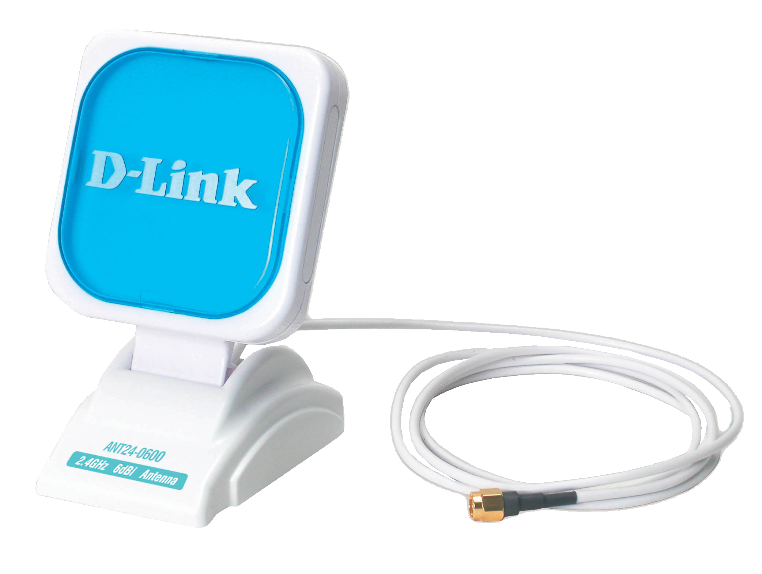
Why Sell This Product: | - Optional antenna for 2.4GHz wireless devices, offering higher Gain for wider operation range and flexible options for wireless users.  - Expand your product line with antennas supporting D-Link and third-party vendor wireless devices.  - Supports both RP-SMA and RP-TNC types of connectors, can work with a wide variety of wireless devices  Selling Points  - Supports popular 802.11b and 802.11g standards.  - Flexible installation options.  - Adjustable antenna panel.
Key Features: | - Extends 2.4GHz 802.11 b/g wireless network operation range  - Adjustable angle for best signal transmission result  - 3 flexible installation options: placing on flat surface, mounting on wall, magnetic attachment  - Works with all 2.4GHz wireless devices equipped with RP-SMA or RP-TNC antenna connector  - Simple installation  - 150-cm extension cable provided  - Compact, lightweight
Technical Details: | Electrical Properties  Frequency Range  2.4GHz to 2.5GHz  Impedance  50 ohm normal  VSWR  1.92 max.  Return Loss  -10 dB max.  Antenna Structure  1/2 dipole array reflector  Peak Gain (without cable loss)  6.0 dBi @ 2.45GHz (typical)  Admitted Power  1 watt  Cable Loss (1.5m)  2.1dB @ 2.45GHz  H-Plane  -3dBi, 68  E-Plane  -3dBi, 80  Physical Properties  Extension Cable  Filotex 50 ohm  Antenna Cover  ABS  Antenna Base  PC  Color  White  Physical & Environmental  Dimensions  Panel: 80 x 80 x 15.6 mm  Base: 85 x 65 x 34 mm  Weight  202 grams (antenna only)  Operating Temperature  -20 to 65 ℃  Storage Temperature  -30 to 75 ℃  Package Includes  - ANT24-0600 antenna with  - 1.5m Filotex extension cable  - RP-SMA jack connector  - RP-SMA to RP-TNC adapter  - User's Quick Installation Guide  - 2 screws  - 2 plastic fixings  - Sticker
EMI/EMC Report | ◻FCC No. ◻ CE No. ◻ VCCI No.  ◻ CTR-21 No. ◻ C-Tick No. ◻ A-Tick No.  ◻ FDA No. ◻ R&TTE No. ◻ BSMI No.  ◻ Others
Safety | ◻ TUV No. ◻ UL No. ◻ CSA No.  ◻ Others
Packaging Style | ◻ Clamshell ◻ White Box ☑ Gift Box ◻ Bulk ◻ Others
Packaging Contents: | Antenna, QIG, sticker, anchors, screws
UPC Code:
  ANT240600.A1, | 790069 270154
  BANT240600A1 | 790069 270161
Units Per Carton: | 10
Cartons Per Pallet: | Air: 36, Sea: 48
Dimensions and Weight: | Box: 220 x 145 x 71 mm, 0.4133 kg  Carton: 340 x 260 x 430 mm, 4.20 kg  Pallet: (by Air) 1020 x 1040 x 1440 mm, 170 kg  (by Sea) 1020 x 1040 x 1870 mm, 220 kg  INTRASTAT weight: 0.4133 kg (Box)  Packing material weight (Box):  - Paper: 0.015 kg  - Plastic: 0.003 kg  - Mixed: 0.005 kg

