ANT24 Antenna cable kits

Date: March 2, 2005

Product name: | Wireless antenna cable kits
Revision: | A1
Available: | E/ Dec.
Picture: | ANT24-DLK3M ANT24-ODU03M  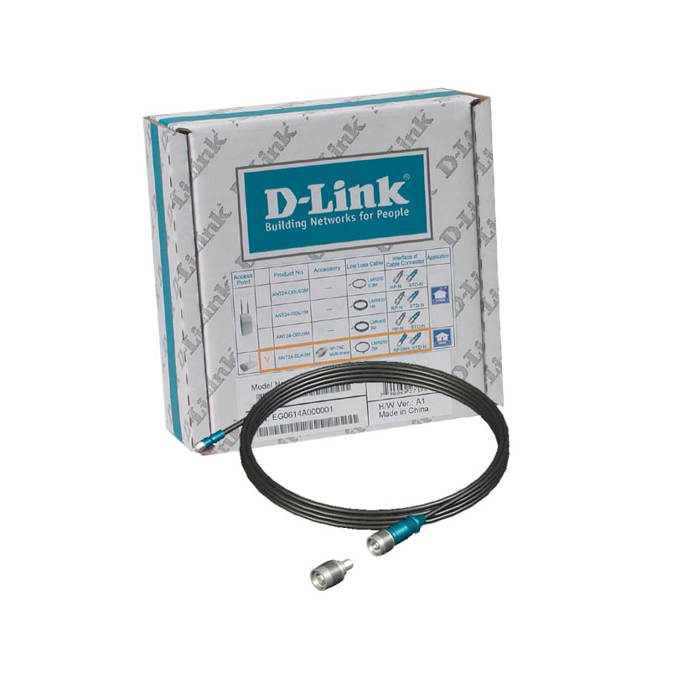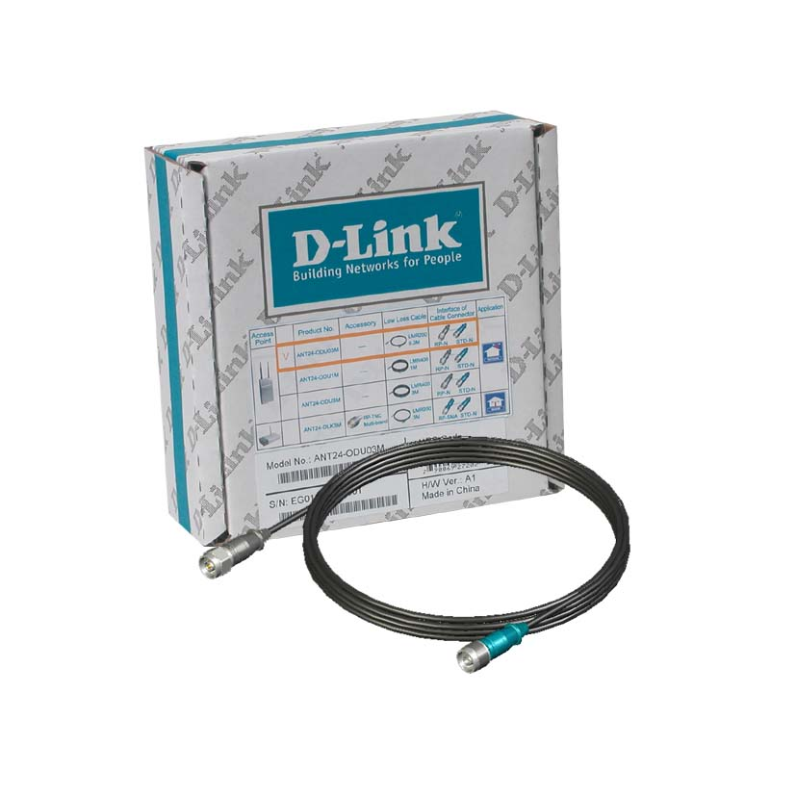  ANT24-ODU1M ANT24-ODU3M  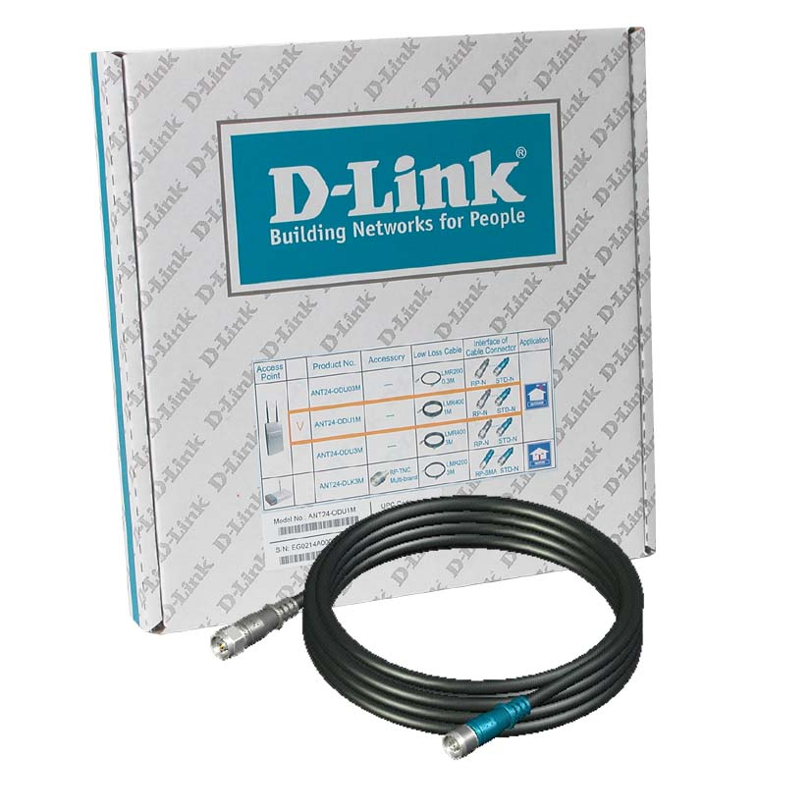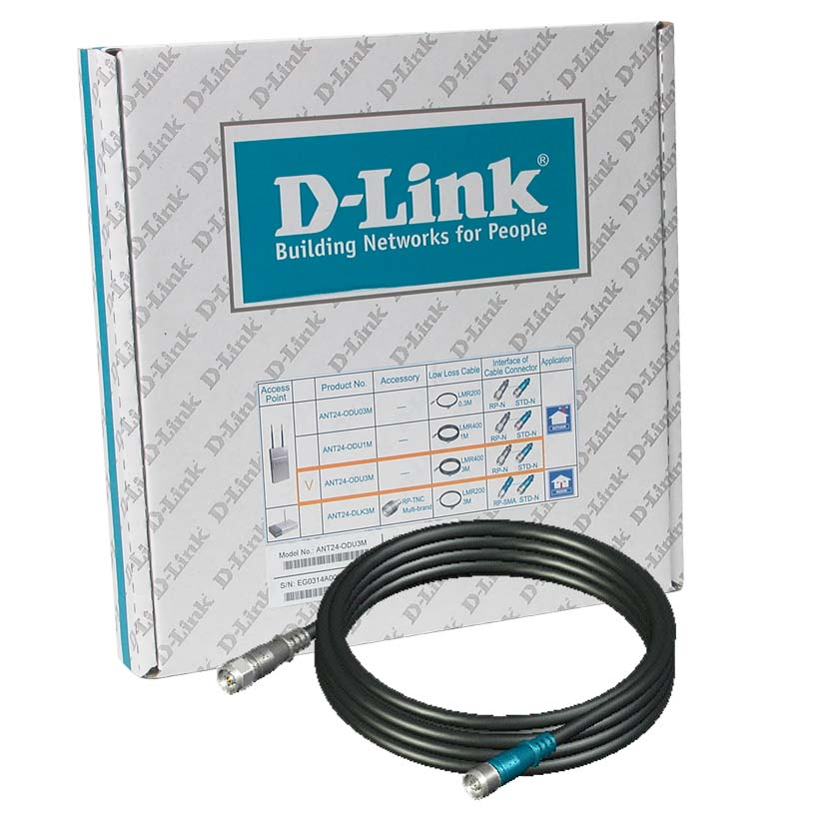
Why Sell This Product: | - These are optional cables kits for outdoor antennas. These kits allow you to provide a complete solution and the one-stop shopping convenience for your users and SI.  - D-Link already has a very extensive range of antenna offerings (it’s well publicized in the industry’s press). These antenna kits will allow you to expand your antenna product line even further.  - These kits support RP-SMA and RP-TNC types of connectors, and can work with a wide variety of antennas.  Selling Points  - Support both 2.4GHz and 5GHz frequency bands’ antennas.  - Flexible cable lengths to meet different requirements.  - Industry-standard weatherproof cables with 5 years guaranteed UV ratings.  - Cables support wide temperature range.  - Fit perfectly with connectors on D-Link wireless access points and D-Link optional antennas, eliminating the need to add connector adapters, which might result with some cable signal loss.
Key Features:
Technical Details: | Please refer to Antenna Cable Kit catalog
EMI/EMC Report | ◻ FCC No. ◻ CE No. ◻ VCCI No.  ◻ CTR-21 No. ◻ C-Tick No. ◻ A-Tick No.  ◻ FDA No. ◻ R&TTE No. ◻ BSMI No.  ◻ Others
Safety | ◻ TUV No. ☑ UL No. 1581 ◻ CSA No.  ◻ Others
Packaging Style | ◻ Clamshell ◻ White Box ◻ Gift Box ◻ Bulk ☑ White Box with D-Link Logo  ◻ Others
Packaging Contents:
  ANT24ODU03M | 30cm cable x 1, QIG
  ANT24ODU1MA1 | 1m cable x 1, QIG
  ANT24ODU3MA1 | 1m cable x 1, QIG
  ANT24DLK3MA1 | 3 m cable x1, QIG, RP-TNC/ RP-SMA adaptor x 1
UPC Code:
  ANT24ODU03A1 | 790069269530
  ANT24ODU1MA1 | 790069270437
  ANT24ODU3MA1 | 790069270444
  ANT24DLK3MA1 | 790069270451
Units Per Carton: | ANT24-ODU03M, ANT24-DLK3M: 24  ANT24-ODU1M, ANT24ODU3M: 8
Cartons Per Pallet: | For USA Air:  ANT24-ODU03M, ANTDLK3M:36  ANT24-ODU1M, ANT24ODU3M: 36  For USA Sea:  ANT24-ODU03M, ANTDLK3M: 54  ANT24-ODU1M, ANT24ODU3M: 54 | For WW Air:  ANT24-ODU03M, ANTDLK3M: 27  ANT24-ODU1M, ANT24ODU3M: 27  For WW Sea:  ANT24-ODU03M, ANTDLK3M: 54  ANT24-ODU1M, ANT24ODU3M: 54
Dimensions and Weight: | Box:  mm, Others,  ANT24-ODU03M: 150x150x53 mm, 0.21Kg  ANT24-ODU1M: 305x300x40 mm, 0.48Kg  ANT24-ODU3M, 305x300x40 mm,0.70Kg  ANT24DLK3M: 150x150x53 mm,0.28Kg  Carton:  ANT24-ODU03M: 340x320x34 mm, 5.8Kg  ANT24-ODU1M: 340x320x34 mm, 4.6Kg  ANT24-ODU3M, 340x320x34 mm, 6.4Kg  ANT24DLK3M: 340x320x34 mm, 7.5Kg  Pallet: (by Air) (USA)  ANT24-ODU03M: 1200x1020x1650 mm, 222.24Kg  ANT24-ODU1M: 1200x1020x1650 mm, 179.04Kg  ANT24-ODU3M, 1200x1020x1650 mm, 242.40Kg  ANT24DLK3M: 1200x1020x1650 mm, 282.72Kg  (by Air) (WW)  ANT24-ODU03M: 1200x1100x1500 mm, 169.68Kg  ANT24-ODU1M: 1200x1100x1500 mm, 137.28Kg  ANT24-ODU3M, 1200x1100x1500 mm, 184.80Kg  ANT24DLK3M: 1200x1100x1500 mm,215.04Kg  (by Sea) (WW), (USA)  ANT24-ODU03M: 1200x1020x2200 mm, 327.36Kg  ANT24-ODU1M: 1200x1020x2200 mm, 262.56Kg  ANT24-ODU3M, 1200x1020x2200 mm, 357.60Kg  ANT24DLK3M: 1200x1020x2200 mm, 418.08Kg  INTRASTAT weight: kg (Box)  ANT24-ODU03M, ANT24-DLK3M: 0.23Kg (Box)  ANT24-ODU1M, ANT24ODU3M: 0.65Kg (Box)  Packing material weight (Box):  ANT24-ODU1M, ANT24ODU3M:  - Paper: 0.2 kg  - Plastic: 0.02 kg  - Mixed: 0.01 kg  ANT24-ODU1M, ANT24ODU3M:  - Paper: 0.62 kg  - Plastic: 0.02 kg  - Mixed: 0.01 kg

