ANT24-1500

ANTENNA TYPE | GP-ANTENNA
MODEL NO. | 1GP-24002
FREQUENCY | 2.45GHz±50MHz
V.S.W.R. | ≦1.5
IMPEDANCE | 50 ±5Ω
GAIN | 15 dBi
WITHSTANDING POWER | MAX50W
WEIGT | APPROX 1000g±20g
LENGTH | 1600 m/m±10
H-PLANE FIELD PATTERNS | 360 ⁰
E-PLANE FIELD PATTERNS | 5 ⁰

MECHANICAL SPECIFICATION

APPEARANCE
CONNECTOR TYPE | N TYPE FEMALE

REMARK

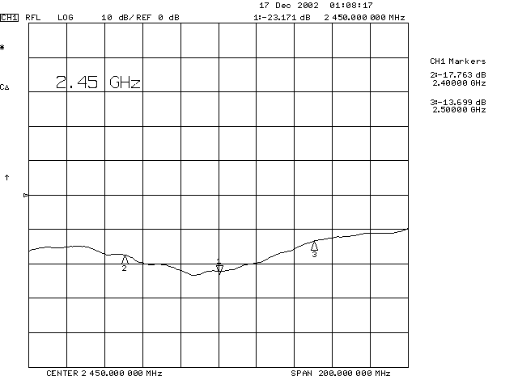

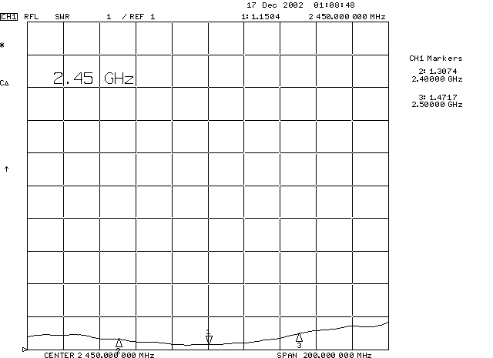

H-PLANE FIELD PATTERNS

E-PLANE FIELD PATTERNS

