ANT24-2100

ANTENNA TYPE | CONNER ANTENNA
MODEL NO. | ANT24-2100
FREQUENCY | 2.45GHz±50MHz
V.S.W.R. | ≦1.5
IMPEDANCE | 50 OHMS ±5Ω
GAIN | 21 dBi
WITHSTANDING POWER | MAX 50W
WEIGT | APPROX 2700g±10g
LENGTH | 610 m/m±5
H-PLANE FIELD PATTERNS | 18 ⁰
E-PLANE FIELD PATTERNS | 12 ⁰

MECHANICAL SPECIFICATION

APPEARANCE
CONNECTOR TYPE | N TYPE FEMALE

REMARK

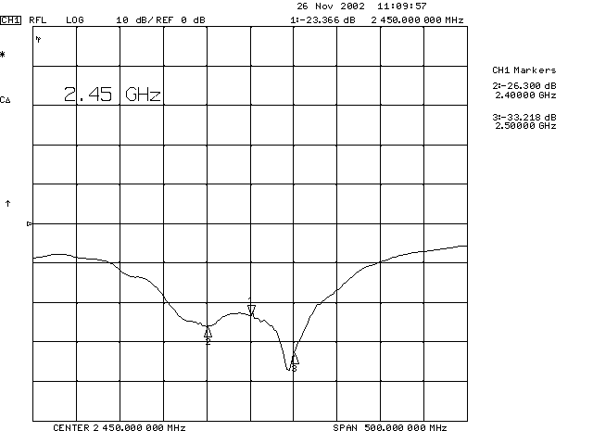

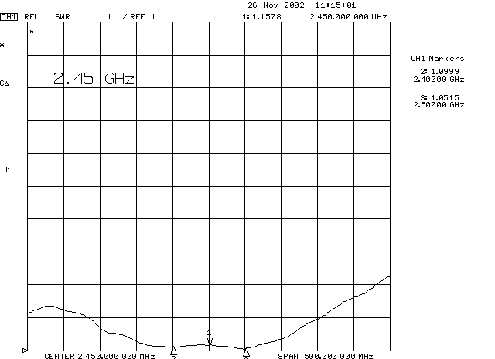

H-PLANE FIELD PATTERNS

E-PLANE FIELD PATTERNS

