

Firmware Version: | 3.10rc066
Published Date: | 2010/09/23

Content:
Upgrading Instructions: 2
Upgrading by using Web-UI 2
New Features: 2
Changes of MIB & D-View Module: 2
Problems Fixed: 2
Known Issues: 3
Related Documentation: 3

Revision History and System Requirement:
Firmware Version | Date | Model | Hardware Version
3.10rc066 | 2010/09/23 | DAP-1353 | B1

Upgrading Instructions:
D-Link AP supports firmware upgrading via Web-UI. You may download the firmware from D-Link web site http://tsd.dlink.com.tw.

Upgrading by using Web-UI
- Connect a work station to the LAN port of Access Point.
- Open the web browser of work station and entering the IP address of the AP. The system
default IP address is 192.168.0.50.
- Enter administrator’s username and password, user name is “admin” and leave
the password field blank by default.
To update the AP's firmware, click Maintenance > Firmware and SSL Certification Upload
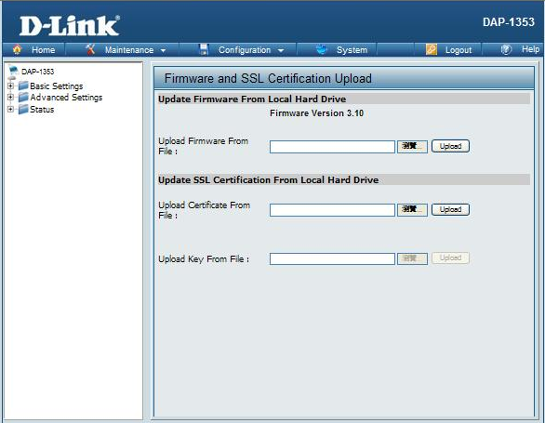

New Features:
- Add AP Repeater Mode function
- Add AP Array function

Changes of MIB & D-View Module:
None

Problems Fixed:
Firmware Version | Problems Fixed
V3.10 | - The time interval of wireless setting which does not have default value.  - Time Zone should not support "copy computer time"  - When set APR+ Use APC's Cloned MAC to send beacon will cause Root AP deauth APR forever.  - When set APR connect with root AP, root AP will deauth APR contiunally

Known Issues:
Firmware Version | Known Issues
V3.10 | None

Related Documentation:
- DAP-2553 User Manual v3.10

