

Firmware Version: | 3.15rc012
Published Date: | 2011/05/19

Content:
Upgrading Instructions: 2
Upgrading by using Web-UI 2
New Features: 2
Changes of MIB & D-View Module: 2
Problems Fixed: 2
Known Issues: 3
Related Documentation: 3

Revision History and System Requirement:
Firmware Version | Date | Model | Hardware Version
3.15rc012 | 2011/05/19 | DAP-1353 | B1

Upgrading Instructions:
D-Link AP supports firmware upgrading via Web-UI. You may download the firmware from D-Link web site http://tsd.dlink.com.tw.

Upgrading by using Web-UI
- Connect a work station to the LAN port of Access Point.
- Open the web browser of work station and entering the IP address of the AP. The system default IP address is 192.168.0.50.
- Enter administrator’s username and password, user name is “admin” and leave the password field blank by default.
To update the AP's firmware, click Maintenance > Firmware and SSL Certification Upload
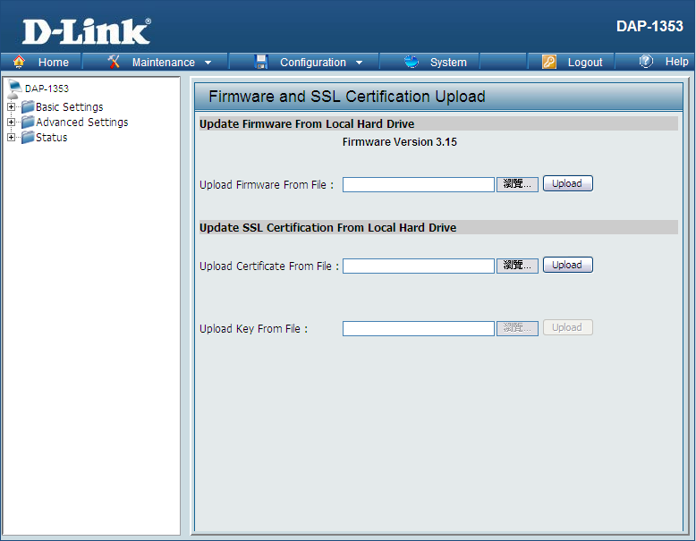

New Features:
- Support AP Array Setup tool
- Support APMII v2.15 SNMP enable function
- Upload/Download ACL file

Changes of MIB & D-View Module:
- AP Manager II: v3.15
- D-View: v3.15

Problems Fixed:
Firmware Version | Problems Fixed
V3.15 | - Fix 20 clients issue  - Hide the password when login from CLI & web security

Known Issues:
Firmware Version | Known Issues
V3.15 | None

Related Documentation:
None

