

Firmware Version: | 1.10rc009
Published Date: | 2012/04/20

Content:
Upgrading Instructions: 2
Upgrading by using Web-UI 2
New Features: 2
Changes of MIB & D-View Module: 2
Problems Fixed: 2
Known Issues: 3
Related Documentation: 3

Revision History and System Requirement:
Firmware Version | Date | Model | Hardware Version
1.10rc009 | 2012/04/20 | DAP-2310 | A1

Upgrading Instructions:
D-Link AP supports firmware upgrading via Web-UI. You may download the firmware from D-Link web site http://tsd.dlink.com.tw.

Upgrading by using Web-UI
- Connect a work station to the LAN port of Access Point.
- Open the web browser of work station and entering the IP address of the AP. The system
default IP address is 192.168.0.50.
- Enter administrator’s username and password, user name is “admin” and leave
the password field blank by default.
To update the AP's firmware, click Maintenance > Firmware and SSL Certification Upload
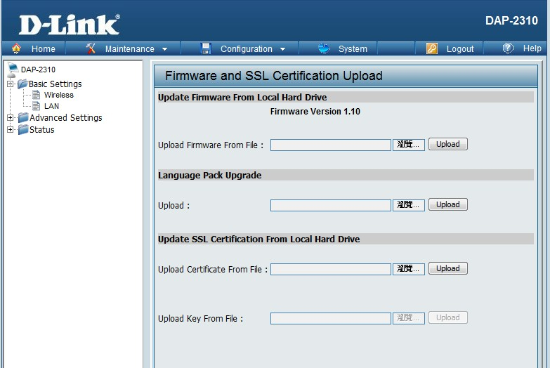

New Features:
- Add repeater mode function.

Changes of MIB & D-View Module:
None

Problems Fixed:
Firmware Version | Problems Fixed
V1.10 | F/W：When Authentication is 802.1x, wireless station can't connect with AP  F/W：Time zones for Russia increased at one hour.  AP Array：Slave or backup master can't Synchronized with the master.

Known Issues:
Firmware Version | Known Issues
V1.10 | None

Related Documentation:
- DAP-2310 User Manual v1.1

