

Firmware Version: | 1.16rc028
Published Date: | 2014/01/06

Content:
Upgrading Instructions: 2
Upgrading by using Web-UI 2
New Features: 2
Changes of MIB & D-View Module: 2
Problems Fixed: 2
Known Issues: 3
Related Documentation: 3

Revision History and System Requirement:
Firmware Version | Date | Model | Hardware Version
1.15rc014 | 2012/08/13 | DAP-2310 | A1

Upgrading Instructions:
D-Link AP supports firmware upgrading via Web-UI. You may download the firmware from D-Link web site http://tsd.dlink.com.tw.

Upgrading by using Web-UI
- Connect a work station to the LAN port of Access Point.
- Open the web browser of work station and entering the IP address of the AP. The system
default IP address is 192.168.0.50.
- Enter administrator’s username and password, user name is “admin” and leave
the password field blank by default.
To update the AP's firmware, click Maintenance > Firmware and SSL Certification
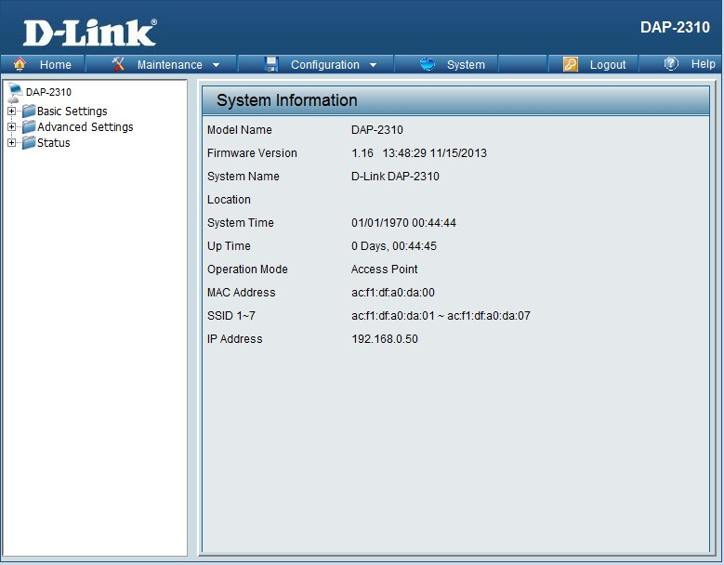

New Features:
Security enhancement
- The setting key will be saved as encryption characters
- encrypt some sensitive info of WEB & SNMP

Changes of MIB & D-View Module:
None

Problems Fixed:
Firmware Version | Problems Fixed
V1.16 | - Fix in open system can be save success without network key  - Fix in Repeater mode when SSID Visibility disabled ,Repeater can't connect to the root AP  - Fix in APC mode when SSID Visibility disabled ,APC can't connect to the root AP  - Fix in MultiSSID setting when only change the WEP Key Index, will pop up the warning message  - Fix “Periodical Key Change” function doesn't work  - Fix “MAC Clone Manual” function doesn't work  - Fix “MultiSSID+WEP Spec Character” STA can't be connect to  - Fix security can't be sync in AP Array  - Fix in WPA-PSK 64 hex doesn't work normally  - Fix in “Limit Administrator IP” for set IP in CLI and WEB  - Fix in “MultiSSID's Priority” function doesn’t work  - Fix WPA Authentication cannot work  - Fix WDS connect issue  - Fix in WDS->WPA-Personal security can't be scan  - Fix in VLAN -> Disable the Multi-SSID but VLAN auto disable  - Fix when set authentication to WPA-PSK and select autokey then use station to connect, it will show none.  - Fix password support ASCII when the length less than 64  - Add MIB for “clientinfo tx rx byte”

Known Issues:
Firmware Version | Known Issues
V1.16 | None

Related Documentation:
- DAP-2310 User Manual v1.15

