

Firmware Version: | 1.10rc041
Published Date: | 2012/08/28

Content:
Upgrading Instructions: 2
Upgrading by using Web-UI 2
New Features: 2
Changes of MIB & D-View Module: 2
Problems Fixed: 2
Known Issues: 3
Related Documentation: 3

Revision History and System Requirement:
Firmware Version | Date | Model | Hardware Version
1.00rc016 | 2010/12/06 | DAP-2360 | A1

Upgrading Instructions:
D-Link AP supports firmware upgrading via Web-UI. You may download the firmware from D-Link web site http://tsd.dlink.com.tw.

Upgrading by using Web-UI
- Connect a work station to the LAN port of Access Point.
- Open the web browser of work station and entering the IP address of the AP. The system
default IP address is 192.168.0.50.
- Enter administrator’s username and password, user name is “admin” and leave
the password field blank by default.
To update the AP's firmware, click Maintenance > Firmware and SSL Certification
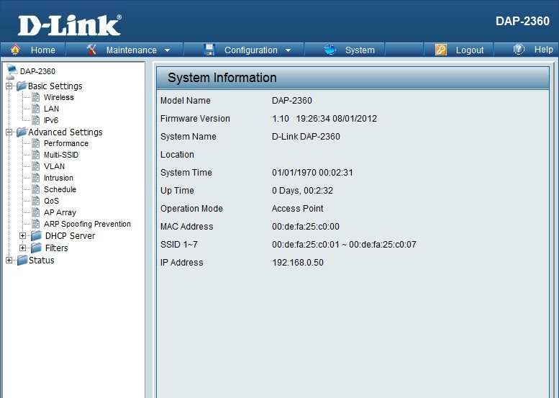

New Features:
- Update new Wireless driver.
- Support IPv6
- Support DNS client for SNTP.
- Add Config file and F/W transfer status in MIB module.
- Add HT20/40 coexistent mechanism “Enable/Disable” in the Web UI.

Changes of MIB & D-View Module:
None

Problems Fixed:
Firmware Version | Problems Fixed
V1.10 | - Adjust TX power base on D-Link WiFi Frequency table  - Fix MSSID missed too many beacons in WPA+OPEN security  - Fix auto channel selection work failed in Multi-SSID  - Fix WDS scanning caused data link break in WDS mode  - Fix APC scanning caused data link break in AP client mode  - Fix AP array endurance issue  - Fix AP client mode low throughput issue.  - Fix Low throughput issue in noise environment.  - Fix AP can't switch to HT20 mode when detect leagcy 11g device.  - Fix kernel panic caused by DHCP pkts forwarding in bridge.  - Fix Hostapd crash issue when authentication type as 802.1X.  - Fix a compatibility issue with Moto MC50 WinCE device in WPA/PSK mode.  - Fix a Static IP assignment issue in WEBUI.  - Fix WLAN module restart frequently when set as dynamic IP.  - Fix memory leak issue in SNMP module.  - Modify output power table (follow D-Link WiFi Frequency table)

Known Issues:
Firmware Version | Known Issues
V1.10 | None

Related Documentation:
- DAP-2360 User Manual v1.10

