

Firmware Version: | 1.11rc062
Published Date: | 2014/01/07

Content:
Upgrading Instructions: 2
Upgrading by using Web-UI 2
New Features: 2
Changes of MIB & D-View Module: 2
Problems Fixed: 2
Known Issues: 3
Related Documentation: 3

Revision History and System Requirement:
Firmware Version | Date | Model | Hardware Version
1.10rc041 | 2012/08/28 | DAP-2360 | A1

Upgrading Instructions:
D-Link AP supports firmware upgrading via Web-UI. You may download the firmware from D-Link web site http://tsd.dlink.com.tw.

Upgrading by using Web-UI
- Connect a work station to the LAN port of Access Point.
- Open the web browser of work station and entering the IP address of the AP. The system
default IP address is 192.168.0.50.
- Enter administrator’s username and password, user name is “admin” and leave
the password field blank by default.
To update the AP's firmware, click Maintenance > Firmware and SSL Certification
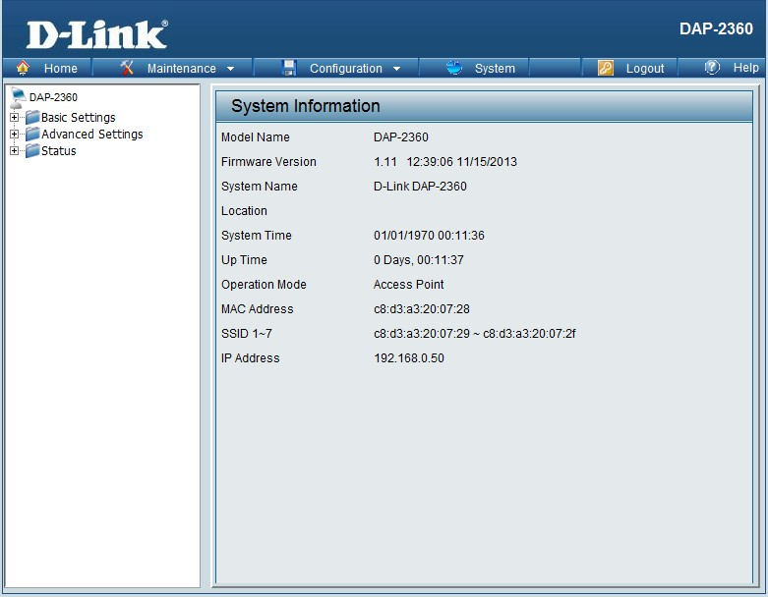

New Features:
- Update new Wireless driver.
- Enhance Web security issue,
- Add TX/RX bytes in client info
- Support APMII v3.0

Changes of MIB & D-View Module:
- Add dot11ClientTxBytesCount and dot11ClientRxBytesCount in MIB.

Problems Fixed:
Firmware Version | Problems Fixed
V1.11 | - Fix wireless LED doesn't work normal  - Fix WPA-PassPhrase should support 64 hex  - Fix WDS can't connect by the WPA Security  - Fix Enable Daylight Saving function doesn't work normal  - Fix ARP Spoofing Prevention can input the Null IP address  - Fix some AP’s band shoe null in Intrusion when detect  - Fix can't connect by the WPA-PSK in WDS mode  - Fix when use Periodical Key Change the authentication will change to none  - Fix can input invalid string in user limit  - Fix when set WPA password with 64hex in Multi-SSID fail from AP module  - Fix when set authentication to WPA-PSK and select autokey then use station to connect, it will show none.  - Fix password support ASCII when length less than 64  - Fix the bug about VLan can’t be enable

Known Issues:
Firmware Version | Known Issues
V1.11 | None

Related Documentation:
- DAP-2360 User Manual v1.10

