

Firmware Version: | 1.12rc073
Published Date: | 2015/04/13

Content:
Upgrading Instructions: 2
Upgrading by using Web-UI 2
New Features: 2
Changes of MIB & D-View Module: 2
Problems Fixed: 2
Known Issues: 3
Related Documentation: 3

Revision History and System Requirement:
Firmware Version | Date | Model | Hardware Version
1. 1.11rc062 | 2014/01/07 | DAP-2360 | A1

Upgrading Instructions:
D-Link AP supports firmware upgrading via Web-UI. You may download the firmware from D-Link web site http://tsd.dlink.com.tw.

Upgrading by using Web-UI
- Connect a work station to the LAN port of Access Point.
- Open the web browser of work station and entering the IP address of the AP. The system
default IP address is 192.168.0.50.
- Enter administrator’s username and password, user name is “admin” and leave
the password field blank by default.
To update the AP's firmware, click Maintenance > Firmware and SSL Certification
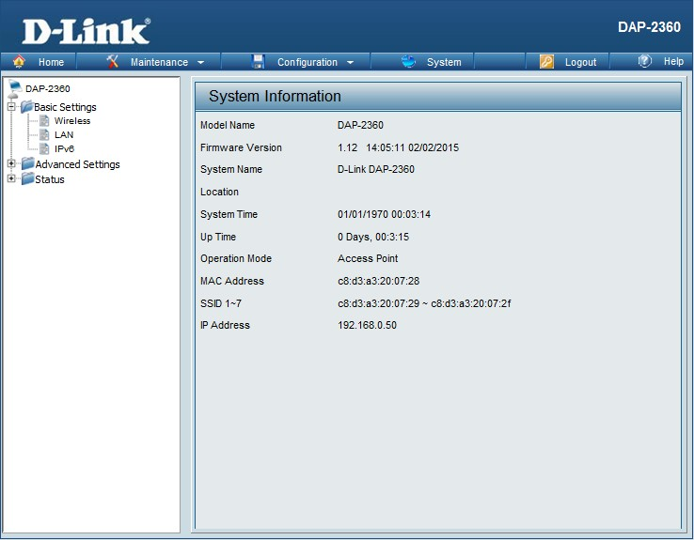

New Features:
- Update OpenSSL from 0.9.8g to 0.9.8za.

Changes of MIB & D-View Module:
None

Problems Fixed:
Firmware Version | Problems Fixed
V1.12 | - APC mode can’t connect to AP and hides its SSID  - New FW can’t match the old config, it cause WPA-PSK will change to OPEN.  - AP array does not sync WPA-PSK information for MSSID and cause MSSID change to OPEN.

Known Issues:
Firmware Version | Known Issues
V1.12 | None

Related Documentation:
- DAP-2360 User Manual v1.10

