

Firmware Version: | 1.25rc016
Published Date: | 2011/11/21

Content:
Upgrading Instructions: 2
Upgrading by using Web-UI 2
New Features: 2
Changes of MIB & D-View Module: 2
Problems Fixed: 2
Known Issues: 3
Related Documentation: 3

Revision History and System Requirement:
Firmware Version | Date | Model | Hardware Version
1.21rc012 | 2010/11/30 | DAP-2553 | A1

Upgrading Instructions:
D-Link AP supports firmware upgrading via Web-UI. You may download the firmware from D-Link web site http://tsd.dlink.com.tw.

Upgrading by using Web-UI
- Connect a work station to the LAN port of Access Point.
- Open the web browser of work station and entering the IP address of the AP. The system
default IP address is 192.168.0.50.
- Enter administrator’s username and password, user name is “admin” and leave
the password field blank by default.
To update the AP's firmware, click Maintenance > Firmware and SSL Certification Upload

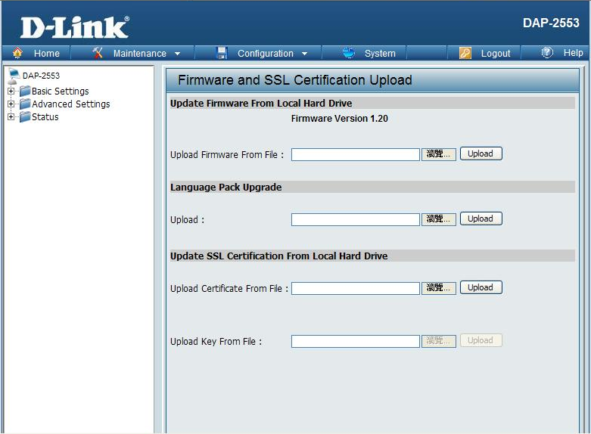

New Features:
- Update wireless driver to new version 7.3.0.449
- Support AP Array Setup Tool

Changes of MIB & D-View Module:
None

Problems Fixed:
Firmware Version | Problems Fixed
V1.25 | F/W：When IGMP enabled, should let LLMNR packet pass  F/W：User can't mangement AP when enable wirelss schedule  F/W：Daylight Saving does no work when the Time Zone set as GMT.  F/W：Periodical Key Change -> Items of Activated Form sometimes show blank

Known Issues:
Firmware Version | Known Issues
V1.25 | None

Related Documentation:
- DAP-2553 User Manual v1.3

