

Firmware Version: | 1.20rc039
Published Date: | 2011/8/17

Content:
Upgrading Instructions: 2
Upgrading by using Web-UI 2
New Features: 2
Changes of MIB & D-View Module: 2
Problems Fixed: 2
Known Issues: 3
Related Documentation: 3

Revision History and System Requirement:
Firmware Version | Date | Model | Hardware Version
1.15rc029 | 2010/11/30 | DAP-2590 | A1/2
1.20rc039 | 2011/08/17 | DAP-2590 | A1/2

Upgrading Instructions:
D-Link AP supports firmware upgrading via Web-UI. You may download the firmware from D-Link web site http://tsd.dlink.com.tw.

Upgrading by using Web-UI
- Connect a work station to the LAN port of Access Point.
- Open the web browser of work station and entering the IP address of the AP. The system
default IP address is 192.168.0.50.
- Enter administrator’s username and password, user name is “admin” and leave
the password field blank by default.
To update the AP's firmware, click Maintenance > Firmware and SSL Certification Upload
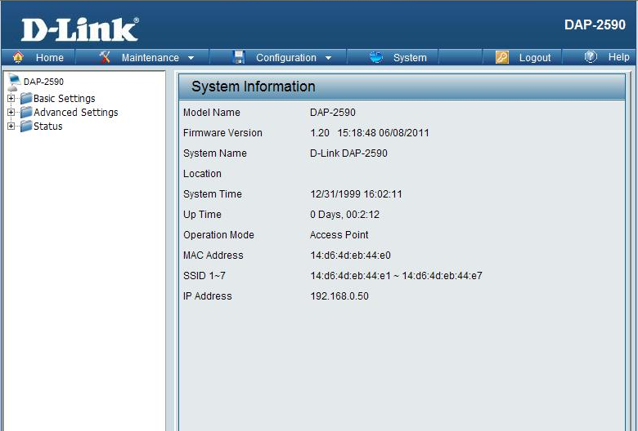

New Features:
Firmware Version | New Features
V1.20 | - Upload/download ACL file  - Hide the password when login from CLI  - Support APMII v2.15  - Support AP Array Tool  - Web Redirection  - Add PCI error, beacon stuck, cold/warm start into syslog  - Reboot when meet PCI error problem  - Web redirection phase 2  - Firewall on TCP/IP stack of AP itself  - Multicast packet control

Changes of MIB & D-View Module:
None

Problems Fixed:
Firmware Version | Problems Fixed
V1.20 | [IGMP Snooping] AP should not block LLMNR packet when IGMP snooping is enabled  [ Help+ Multicast bandwidth] Add Multicast bandwidth part to Help file.  [NTP] After disable NTP function, APUT still sends NTP packets.  [F/W] Fix SNMP/LLTD caused memory leak  [SNMP] Fix emailNotificationTable use wrong RGDB address  [WDS with AP]: Remote WDS AP can't get IP address from wired.  [WDS with AP]: Open/enable can built WDS with shared key.  [Schedule] In schedule rule list, the name will show blank  [APC]: Client AP can't get IP address from root ap.  Fix when set WDS mode DAP-2590 can't forward LACP packs.  [Client Information]: When Multi-SSID disable need to clear client information which connect to guest SSID.  [VLAN->PVID auto assign]:Fix when add or del a Vlan in CLI, port's pvid doesn't change.  [Traffic Control]: The uplink/downlink bandwidth can set to >150Mbps  [WPA2-PSK+WDS WITH AP]: WDS AP always deauthent remote AP because of reason 6.  [Trap Categorize Function]: The trap server use "MG-soft MIB Browser 10.0b", it can not receive any trap information.  WDS throughput issue (HQ20100813000007--Australia)  AP drops clients and stops accepting new connections [DEUR20100819000007-UKI]  The password can be changed remotely by sending POST request.  Modify Time Zone behavior

Known Issues:
Firmware Version | Known Issues
V1.20 | None

Related Documentation:
- DAP-2590 User Manual v1.2

