

Firmware Version: | 1.25rc056
Published Date: | 2012/09/07

Content:
Upgrading Instructions: 2
Upgrading by using Web-UI 2
New Features: 2
Changes of MIB & D-View Module: 2
Problems Fixed: 2
Known Issues: 3
Related Documentation: 3

Revision History and System Requirement:
Firmware Version | Date | Model | Hardware Version
1.20rc039 | 2011/06/13 | DAP-2590 | A1/2

Upgrading Instructions:
D-Link AP supports firmware upgrading via Web-UI. You may download the firmware from D-Link web site http://tsd.dlink.com.tw.

Upgrading by using Web-UI
- Connect a work station to the LAN port of Access Point.
- Open the web browser of work station and entering the IP address of the AP. The system
default IP address is 192.168.0.50.
- Enter administrator’s username and password, user name is “admin” and leave
the password field blank by default.
To update the AP's firmware, click Maintenance > Firmware and SSL Certification Upload
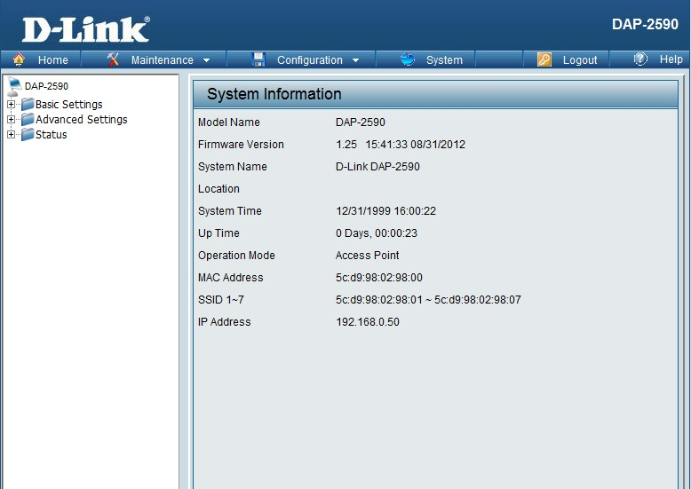

New Features:
- Enable ht20/40 coexistence in 2.4Ghz
- Support DNS client for SNTP

Changes of MIB & D-View Module:
None

Problems Fixed:
Firmware Version | Problems Fixed
V1.25 | - Fix LAN Led still light on after LAN cable remove  - Fix ARP table overflow issue.  - Fix Wireless stop service when too much interference in user environment.  - Fix internal radius does not support IPHONE/IPAD  - Fix slave or backup master can't synchronized with the master for AP Array  - Fix AP client mode stop running when use chariot with DAP-2553 2553  - Fix web site display error in Web Redirection

Known Issues:
Firmware Version | Known Issues
V1.25 | None

Related Documentation:
- DAP-2590 User Manual v1.3

