

Firmware Version: | v1.00
Published Date: | 2009/12/1

Content:
Revision History and System Requirement: 2
Upgrading Instructions: 2
Upgrading by using Web-UI 2
New Features: 2
Changes of MIB & D-View Module: 3
Problems Fixed: 3
Known Issues: 3
Related Documentation: 3

Revision History and System Requirement:
Firmware Version | Date | Model | Hardware Version
V1.00rc011 | 2009/12/1 | DAP-2690 | A1

Upgrading Instructions:
D-Link AP supports firmware upgrading via Web-UI. You may download the firmware from D-Link web site http://tsd.dlink.com.tw.

Upgrading by using Web-UI
- Connect a work station to the LAN port of Access Point.
- Open the web browser of work station and entering the IP address of the AP. The system
default IP address is 192.168.0.50.
- Enter administrator’s username and password, user name is “admin” and leave
the password field blank by default.
To update the AP's firmware, click Tool > Firmware and SSL Certification Upload.

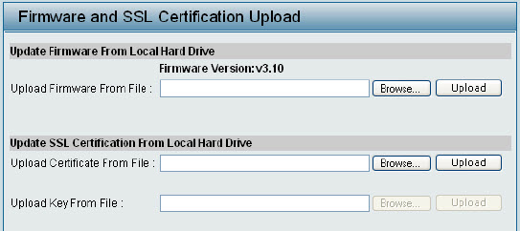

v1.00

New Features:
Fireware Version | New Features
v1.00rc011 | None

Changes of MIB & D-View Module:
None

Problems Fixed:
Firmware Version | Problems Fixed
v1.00rc011 | First Release.

Known Issues:
Firmware Version | Known Issues
v1.00rc011 | None

Related Documentation:
- None

