

Firmware Version: | 1.11rc040
Published Date: | 2012/04/23

Content:
Upgrading Instructions: 2
Upgrading by using Web-UI 2
New Features: 2
Changes of MIB & D-View Module: 2
Problems Fixed: 2
Known Issues: 3
Related Documentation: 3

Revision History and System Requirement:
Firmware Version | Date | Model | Hardware Version
1.11rc040 | 2012/04/23 | DAP-2690 | A1

Upgrading Instructions:
D-Link AP supports firmware upgrading via Web-UI. You may download the firmware from D-Link web site http://tsd.dlink.com.tw.

Upgrading by using Web-UI
- Connect a work station to the LAN port of Access Point.
- Open the web browser of work station and entering the IP address of the AP. The system
default IP address is 192.168.0.50.
- Enter administrator’s username and password, user name is “admin” and leave
the password field blank by default.
To update the AP's firmware, click Maintenance > Firmware and SSL Certification Upload
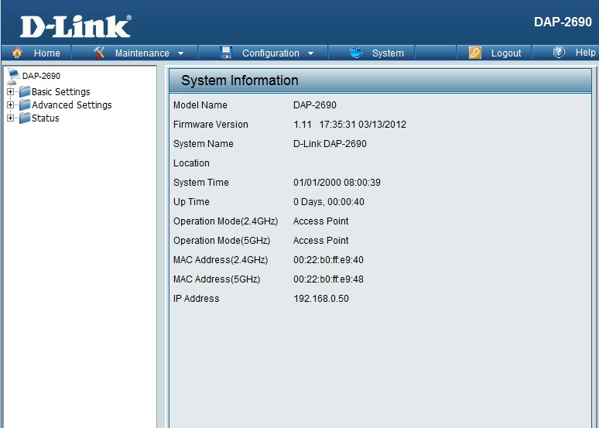

New Features:
- Update Web Redirection behavior

Changes of MIB & D-View Module:
None

Problems Fixed:
Firmware Version | Problems Fixed
V1.11 | - Fix Wireless stop service when too much interference in user environment.  - Fix ARP table overflow issue.  - WDS x 2 has Low throughput  - Fix when enable the limit administrator vlan id but the web redirection doesn't disable  - Fix downlink interface can't save success in traffic control  - Fix when IGMP Snooping enable it don't block 224.0.0.252 in Multicast Bandwidth Control & IGMP Snooping  - Add & Modify the commands of Multicast Bandwidth control.  - Fix the AP hang up when running pressure test in Web Redirect. ( about 120~150 web sessions)  - Fix Web authentication fail  - Fix Web redirect + Web authentication fail  - Fix LLTD packet will let br0 enter promiscuous mode, and cause memory leak.  - Fix in 5G band, when set the WPA/WPA2-auto-Enterprise-TKIP,the channel width should be 20MHz and gray  - Fix when delete the Static IP Pool, but the STA will always get the same static IP.  - Fix when set the wireless mode is the mixed 802.11g and 802.11b, the channel width should be the gray to 20MHz at all times.  - When set 802.11n only, the security-TKIP and WEP UI should be gray or would not have this item.  - When build the APC mode, the signal is show error.  - Fix in Time and Date Settings some TimeZone can't get the correct time.  - Fix when enable the Multi SSID and modify it, the page will show error.  - Fix when the HEX encrypt, set a~f, it will match upper/lower case. but when connect AP use STA, it will not match upper/lower case  - Fix in 11a band/WPA-PSK/Periodical Key Change :it can't show time interval in email log info  - Fix in 5Ghz Multi-SSID+Periodical Key Change when save and active, PassPhrase show null.  - Fix 20 clients connect with AP, endurance test fail.

Known Issues:
Firmware Version | Known Issues
V1.11 | None

Related Documentation:
- DAP-2690 User Manual v1.0

