

Firmware Version: | 1.15rc049
Published Date: | 2012/08/31

Content:
Upgrading Instructions: 2
Upgrading by using Web-UI 2
New Features: 2
Changes of MIB & D-View Module: 2
Problems Fixed: 2
Known Issues: 3
Related Documentation: 3

Revision History and System Requirement:
Firmware Version | Date | Model | Hardware Version
1.11rc040 | 2012/04/23 | DAP-2690 | A1

Upgrading Instructions:
D-Link AP supports firmware upgrading via Web-UI. You may download the firmware from D-Link web site http://tsd.dlink.com.tw.

Upgrading by using Web-UI
- Connect a work station to the LAN port of Access Point.
- Open the web browser of work station and entering the IP address of the AP. The system
default IP address is 192.168.0.50.
- Enter administrator’s username and password, user name is “admin” and leave
the password field blank by default.
To update the AP's firmware, click Maintenance > Firmware and SSL Certification Upload
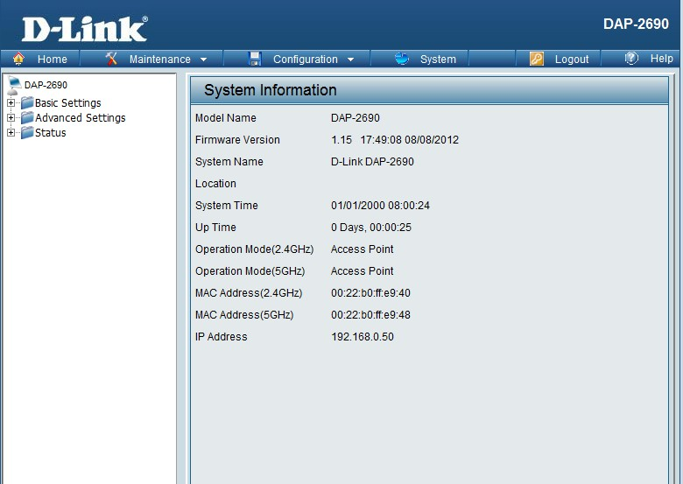

New Features:
- Enable ht20/40 coexistence in 2.4Ghz
- Support DNS client for SNTP

Changes of MIB & D-View Module:
None

Problems Fixed:
Firmware Version | Problems Fixed
V1.15 | - Fix the stuck beacon issue by chipset vender’s patch  - Replace the IP address to domain name in Log setting  - Add MIB support for HT20/40 coexistence and DNS, SNTP, Log settings  - Fix some authentication can not support short GI  - Fix the ping packet will be drop when packet size larger than 1469 in WDS mode  - Fix VLAN only can add 15 entries.  - Fix AP Array slave or backup master can’t Synchronized with the master.

Known Issues:
Firmware Version | Known Issues
V1.15 | None

Related Documentation:
- DAP-2690 User Manual v1.15

