

Firmware Version: | 3.11rc078
Published Date: | 2015/01/20

Content:
Upgrading Instructions: 2
Upgrading by using Web-UI 2
New Features: 2
Changes of MIB & D-View Module: 2
Problems Fixed: 2
Known Issues: 3
Related Documentation: 3

Revision History and System Requirement:
Firmware Version | Date | Model | Hardware Version
3.01rc053 | 2014/01/29 | DAP-2690 | B1

Upgrading Instructions:
D-Link AP supports firmware upgrading via Web-UI. You may download the firmware from D-Link web site http://tsd.dlink.com.tw.

Upgrading by using Web-UI
- Connect a work station to the LAN port of Access Point.
- Open the web browser of work station and entering the IP address of the AP. The system
default IP address is 192.168.0.50.
- Enter administrator’s username and password, user name is “admin” and leave
the password field blank by default.
To update the AP's firmware, click Maintenance > Firmware and SSL Certification Upload

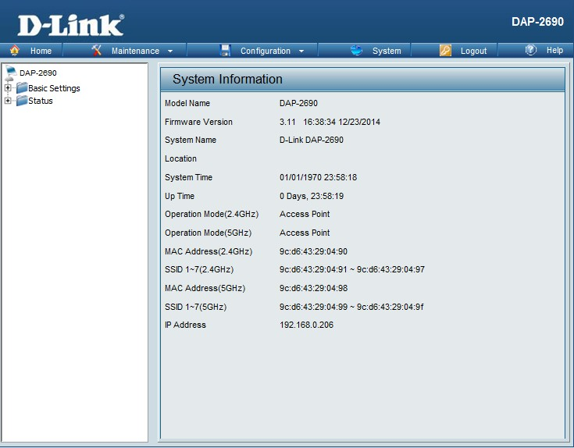

New Features:
Support CWM v1.00+v1.01
1. Session timeout customization for Captive Portal (10 to 1440 minutes)
2. Support external syslog server for EU directive
3. Dashboard display site and network name at each connected device
4. Dashboard display the current SSID instead of Primary SSID

Changes of MIB & D-View Module:
CWM_DAP2690B v3.11-R29

Problems Fixed:
Firmware Version | Problems Fixed
V3.11 | - Clear text for captive portal login  - Fix Rogue AP scan cause the sorted result reset  - Upgrade Openssl from 0.9.8g to 0.9.8za.  - BTD2014110085-CPU usage reach 100%, cannot login Web UI.  - BTD2014110088-IPv6 packets cause AP kernel panic.  - BTD2014110090-STA cannot associate with AP.  - BTD2014110091-AP stop sending syslog to syslog server  - BTD2014110092-Bandwidth control cannot control VLAN upload traffic

Known Issues:
Firmware Version | Known Issues
V3.11 | None

Related Documentation:
- DAP-2690 User Manual v3.10

