

Firmware Version: | 3.15rc091
Published Date: | 2015/07/09

Content:
Upgrading Instructions: 2
Upgrading by using Web-UI 2
New Features: 2
Changes of MIB & D-View Module: 2
Problems Fixed: 2
Known Issues: 3
Related Documentation: 3

Revision History and System Requirement:
Firmware Version | Date | Model | Hardware Version
3.11rc078 | 2015/01/20 | DAP-2690 | B1

Upgrading Instructions:
D-Link AP supports firmware upgrading via Web-UI. You may download the firmware from D-Link web site http://tsd.dlink.com.tw.

Upgrading by using Web-UI
- Connect a work station to the LAN port of Access Point.
- Open the web browser of work station and entering the IP address of the AP. The system
default IP address is 192.168.0.50.
- Enter administrator’s username and password, user name is “admin” and leave
the password field blank by default.
To update the AP's firmware, click Maintenance > Firmware and SSL Certification Upload
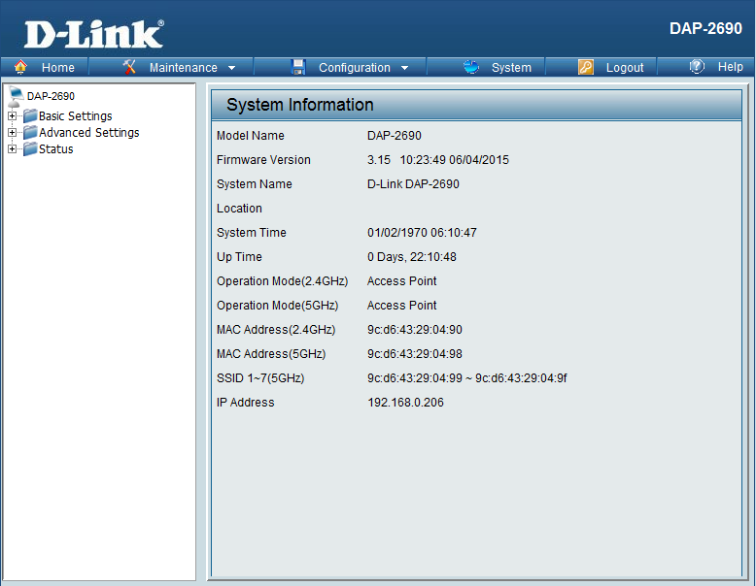

New Features:
Support CWM v1.02
1. Disassociation supported on multi-SSID
2. Support Captive portal customization
3. Support config file upload from CWM

Changes of MIB & D-View Module:
CWM_DAP2690B v3.15-R34

Problems Fixed:
Firmware Version | Problems Fixed
V3.15 | - Fixed issue of client can’t access the Internet when Ethernet to WLAN disable  - Fixed users can’t access https sites with IE8/IE11 browsers  - Fixed daylight saving issue  - Fixed disconnect issue after wireless clients are connected for few weeks  - Fixed WLAN statistic page display issue  - Fixed 5Ghz wireless client can’t connect to the Internet via IPv6  - Modify timezone.  - Showing current channel after DFS function worked [DI20150521000002-Japan].  - Fixed DFS on W53 channel does not work [DI20150325000003-Japan]  - Fixed Enable IPv6 cause high utilization of CPU [DI20150220000004-Japan]  - Fixed Cannot set AP Array Enable via WebUI after enabling IPv6  - Fix captive portal on other SSID(including 5G primary and MSSID) will not work when captive portal on 2.4G primary SSID is not enabled

Known Issues:
Firmware Version | Known Issues
V3.15 | None

Related Documentation:
- DAP-2690 User Manual v3.11

