

Firmware Version: | 1.10rc035
Published Date: | 2014/09/05

Content:
Upgrading Instructions: 2
Upgrading by using Web-UI 2
New Features: 2
Changes of MIB & D-View Module: 2
Problems Fixed: 2
Known Issues: 3
Related Documentation: 3

Revision History and System Requirement:
Firmware Version | Date | Model | Hardware Version
v1.00 | 2013/11 | DAP-2695 | A1

Upgrading Instructions:
D-Link AP supports firmware upgrading via Web-UI. You may download the firmware from D-Link web site http://tsd.dlink.com.tw.

Upgrading by using Web-UI
- Connect a work station to the LAN port of Access Point.
- Open the web browser of work station and entering the IP address of the AP. The system
default IP address is 192.168.0.50.
- Enter administrator’s username and password, user name is “admin” and leave
the password field blank by default.
To update the AP's firmware, click Maintenance > Firmware and SSL Certification Upload
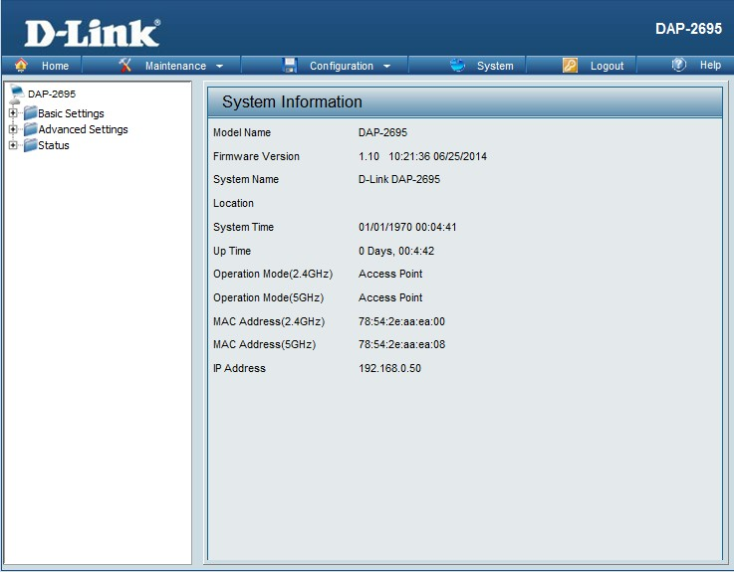

New Features:
- Update wireless driver to 10.2.85
- Support CWM phase 1 feature

Changes of MIB & D-View Module:
None

Problems Fixed:
Firmware Version | Problems Fixed
V1.10 | - [AP Array] : Fix the Signal Band AP set to Master, After sync, 5G band sync issue.  - [Login Page Upload] : Fix after set settings the image will disappear  - [Help] : Add help of MAC By Pass function.  - [AP Array] : Fix the bug when set one Master AP to Backup Master role  - [AP Array] : Fix one member leave and then add into the group again, the config can't sync  - [Network Utilization] : Fix this function doesn't work in 5G band  - [Throughput] : Fix WDS with WPA2-AES can't run over 5 minutes in 5G  - [LED] : Fix 5G LED not off when 5G radio off  - Fix client info does not correct when 11AC when connected

Known Issues:
Firmware Version | Known Issues

Related Documentation:
- DAP-2695 User Manual v1.10

