

Firmware Version: | 1.16rc053
Published Date: | 2015/07/8

Content:
Upgrading Instructions: 2
Upgrading by using Web-UI 2
New Features: 2
Changes of MIB & D-View Module: 2
Problems Fixed: 2
Known Issues: 3
Related Documentation: 3

Revision History and System Requirement:
Firmware Version | Date | Model | Hardware Version
1.11rc044 | 2015/01/20 | DAP-2695 | A1

Upgrading Instructions:
D-Link AP supports firmware upgrading via Web-UI. You may download the firmware from D-Link web site http://tsd.dlink.com.tw.

Upgrading by using Web-UI
- Connect a work station to the LAN port of Access Point.
- Open the web browser of work station and entering the IP address of the AP. The system
default IP address is 192.168.0.50.
- Enter administrator’s username and password, user name is “admin” and leave
the password field blank by default.
To update the AP's firmware, click Maintenance > Firmware and SSL Certification Upload
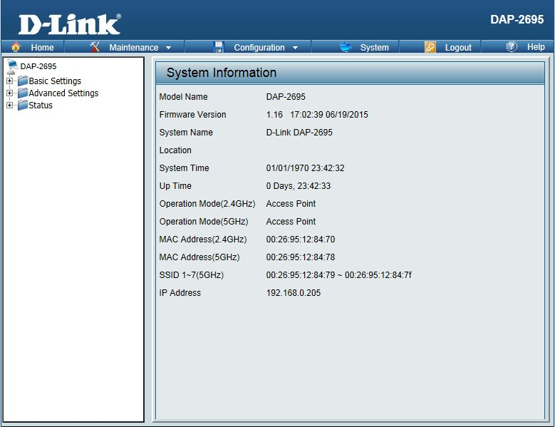

New Features:
Support CWM v1.02
- Disassociation supported on multi-SSID
- Support Captive portal customization
- Support config file upload from CWM

Changes of MIB & D-View Module:
CWM_DAP2695 v1.16-R38

Problems Fixed:
Firmware Version | Problems Fixed
V1.16 | - Fixed QoS configuration issue  - Fixed 5GHz WLAN connection issue  - Fixed backup AP Array master didn’t take control after the master went down  - Modify timezone.  - Fix captive portal on other SSID(including 5G primary and MSSID) will not work when captive portal on 2.4G primary SSID is not enabled

Known Issues:
Firmware Version | Known Issues
V1.16 | None

Related Documentation:
- DAP-2695 User Manual v1.11

