

Firmware Version: | 1.20rc075
Published Date: | 2016/09/14

Content:
Upgrading Instructions: 2
Upgrading by using Web-UI 2
New Features: 2
Changes of MIB & D-View Module: 2
Problems Fixed: 2
Known Issues: 3
Related Documentation: 3

Revision History and System Requirement:
Firmware Version | Date | Model | Hardware Version
1.11rc044  1.16rc053  1.17rc063 | 2015/01/20  2016/03/18  2016/03/18 | DAP-2695 | A1

Upgrading Instructions:
D-Link AP supports firmware upgrading via Web-UI. You may download the firmware from D-Link web site http://tsd.dlink.com.tw.

Upgrading by using Web-UI
- Connect a work station to the LAN port of Access Point.
- Open the web browser of work station and entering the IP address of the AP. The system
default IP address is 192.168.0.50.
- Enter administrator’s username and password, user name is “admin” and leave
the password field blank by default.
To update the AP's firmware, click Maintenance > Firmware and SSL Certification Upload
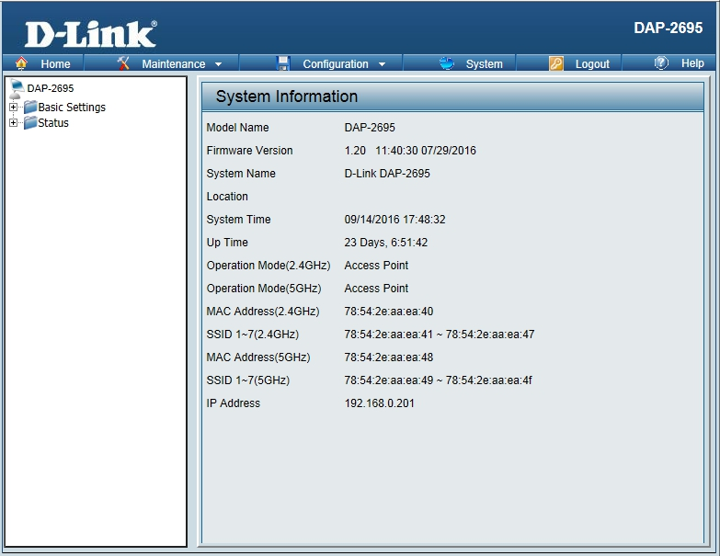

New Features:
- Support CWM v1.03
- Support Captive portal with Multiple SSID and VLAN
- Captive portal support https URL redirect
- Display station’s OS in client information for Captive portal client
- One SSID with multiple schedule settings
- MAC ACL from per SSID 64 to per radio share 512
- Support External captive portal in CWM mode
- Country selection for specific country code
- Add language pack upload and remove function
- Enable/disable STP

Changes of MIB & D-View Module:
None

Problems Fixed:
Firmware Version | Problems Fixed
V1.20 | - Fix if enable wlan partition, blocking access from lan to wlan, clients does not get ip address and not have network access.  - Fix DBG16060127->Disable aparry if cwm is enabled.  - Fix DBG16070013->IPv6 without need authentication could connect to internet  - Fix DBG16070073->In WDS ping failed when configured 5G WDS with WPA/AES encryption

Known Issues:
Firmware Version | Known Issues
V1.20 | None

Related Documentation:
- DAP-2695 User Manual v1.12(DI)/v1.13(US)/v1.13(EU)

