

Firmware Version: | 1.05rc019
Published Date: | 2016/10/03

Content:
Upgrading Instructions: 2
Upgrading by using Web-UI 2
New Features: 2
Changes of MIB & D-View Module: 2
Problems Fixed: 2
Known Issues: 3
Related Documentation: 3

Revision History and System Requirement:
Firmware Version | Date | Model | Hardware Version
1.00rc011  1.01rc014 | 2015/08/13  2016/04/19 | DAP-3320 | A1

Upgrading Instructions:
D-Link AP supports firmware upgrading via Web-UI. You may download the firmware from D-Link web site http://tsd.dlink.com.tw.

Upgrading by using Web-UI
- Connect a work station to the LAN port of Access Point.
- Open the web browser of work station and entering the IP address of the AP. The system default IP address is 192.168.0.50.
- Enter administrator’s username and password, user name is “admin” and leave the password field blank by default.
To update the AP's firmware, click Maintenance > Firmware and SSL Certification Upload
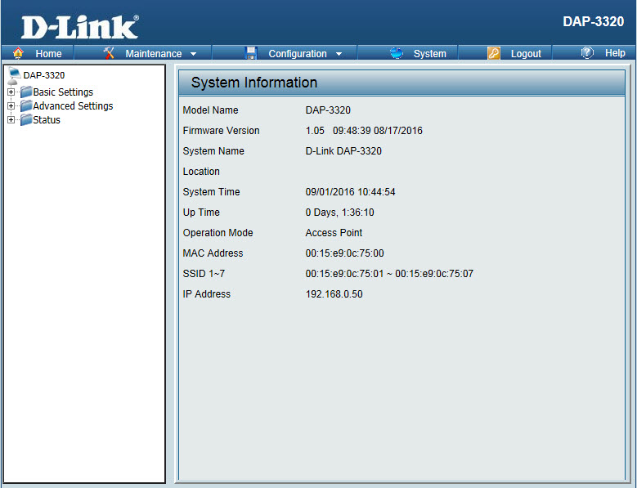

New Features:
1. Support CWM v1.03
2. Support Captive portal with Multiple SSID and VLAN
3. Captive portal support https URL redirect
4. Display station’s OS in client information for Captive portal client
5. One SSID with multiple schedule settings
6. MAC ACL from per SSID 64 to per radio share 512
7. Support External captive portal in CWM mode
8. Country selection for specific country code

Changes of MIB & D-View Module:
None

Problems Fixed:
Firmware Version | Problems Fixed
V1.05 | - Fix if enable WLAN partition, blocking access from LAN to WLAN, clients does not get IP address and not have network access.  - Fix DBG16060127->Disable AP array if cwm is enabled.  - Fix DBG16070013->IPv6 without need authentication could connect to internet  - Fix DBG160800015->IGMP snooping that client can't get IPv6 address if enable IGMP snooping

Known Issues:
Firmware Version | Known Issues
V1.05 | None

Related Documentation:
DAP-3320 User Manual v1.10

