

Firmware Version: | 1.15rc039
Published Date: | 2013/03/08

Content:
Upgrading Instructions: 2
Upgrading by using Web-UI 2
New Features: 2
Changes of MIB & D-View Module: 2
Problems Fixed: 2
Known Issues: 3
Related Documentation: 3

Revision History and System Requirement:
Firmware Version | Date | Model | Hardware Version
1.03rc004 | 2010/12/14 | DAP-3520 | A1
1.02rc003 | 2010/04/01 | DAP-3520 | A1

Upgrading Instructions:
D-Link AP supports firmware upgrading via Web-UI. You may download the firmware from D-Link web site http://tsd.dlink.com.tw.

Upgrading by using Web-UI
- Connect a work station to the LAN port of Access Point.
- Open the web browser of work station and entering the IP address of the AP. The system
default IP address is 192.168.0.50.
- Enter administrator’s username and password, user name is “admin” and leave
the password field blank by default.
To update the AP's firmware, click Maintenance > Firmware and SSL Certification Upload
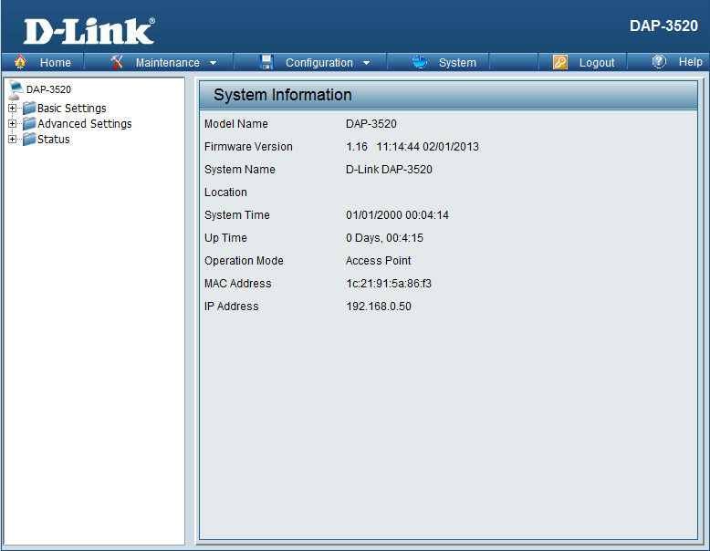

New Features:
Firmware Version | New Features
V1.15 | - Support AP Array Setup Utility  - Upgrade Wireless driver to version 7.3.0.449  - Support “ping control” function  - Add DNS setting on LAN Setting web page  - Add HT20/40 coexistence enable/disable

Changes of MIB & D-View Module:
None

Problems Fixed:
Firmware Version | Problems Fixed
V1.15 | - Fix the error for ACL file upload in D-View and APM2  - Fix the error info in the console log when running WDS endurance  - Fix the when select year then day cannot be select in Time and Date  - Correct the EG country code range  - Fix when enable wireless schedule and vlan function the AP cannot be manage  - Fix ”get multicastrate” always display 11Mbps in CLI  - Fix ping through fail when MAC clone enabled for APC mode  - Fix fail to manage AP caused by MAC confusion  - Fix memory leak caused by SNMP module,  - Fix bug when country as Israel, 5Ghz can be work  - Fix when the current time is out of the range of the time, station still can associate to AP  - Fix when AP Array Master AP leave and come back the role of Master AP issue  - Fix when enable AP Array, the Limit Administrator IP range still worked  - Fix application (indoor/outdoor) function bug when country code is JP in WEB and CLI and MIB  - Fix set community didn't take effect when using CLI SNMP set host command  - Fixe web page SNMP trap version bug.  - Fixe ping delay issue when Ethernet port link down  - Fixe memory leak issue caused by SNMP  - Fixe that the WEB can’t disable VLan setup for Ethernet port when enable limit admin VLan id and save-active  - Fix abnormal UI display in 5GHz and wireless setting cannot be saved anymore after pressing Scan button to site survey as 5GHz wireless client  - Fix that DHCP discover packets without taged after save and active  - Fix APMII update config fail  - Fix ath0 mode setting, the invalid parameter value will be set as ath0 mode  - Fix the bug that the device reset to factory default when update configuration file using APMII or D-View  - Fix the bug about auto channel selection function for 2.4GHz  - Fix the bug that No WDS/WDS with AP selections when wireless band as 2.4GHz  - Fix 11n client disconnect issue when transfer big size file(WEP+AES)  - Fix ifTable ifindex for Multi-SSID  - Fix the scheduling bug when F/W upgrade from v103 to v115  - Fix the wrong IP address table in AP Array UI

Known Issues:
Firmware Version | Known Issues
V1.15 | None

Related Documentation:
- DAP-3520 User Manual v1.10

