

Firmware Version: | 1.10r027
Published Date: | 2022/02/16

Content:
Upgrading Instructions: 2
Upgrading by using Web-UI 2
New Features: 2
Changes of MIB & D-View Module: 2
Problems Fixed: 3
Known Issues: 3
Related Documentation: 3
Revision History and System Requirement:
Firmware Version | Date | Model | Hardware Version
v1.00r015  v1.01r018 | 2021/02/03  2021/05/18 | DAP-X2850 | A1

Upgrading Instructions:
D-Link AP supports firmware upgrading via Web-UI. You may download the firmware from D-Link web site http://tsd.dlink.com.tw.
Please also
- Make sure your DAP-X2850 has to manually assign a valid static IPv4 address or get a valid IPv4 address from DHCP server before upgrade FW.
- Do not power off your DAP-X2850 when FW upgrading.

Upgrading by using Web-UI
- Connect a work station to the LAN port of Access Point.
- Open the web browser of work station and entering the IP address of the AP. The system default IP address setting is dynamic ip, and you can enter http://dapx2850.local to login, if it cannot get ip address from DHCP server, it’s ip address will back to 192.168.0.50.
- Enter administrator’s username and password, user name and password are “admin” by default.
To update the AP's firmware, click Maintenance > Firmware and SSL Certification Upload
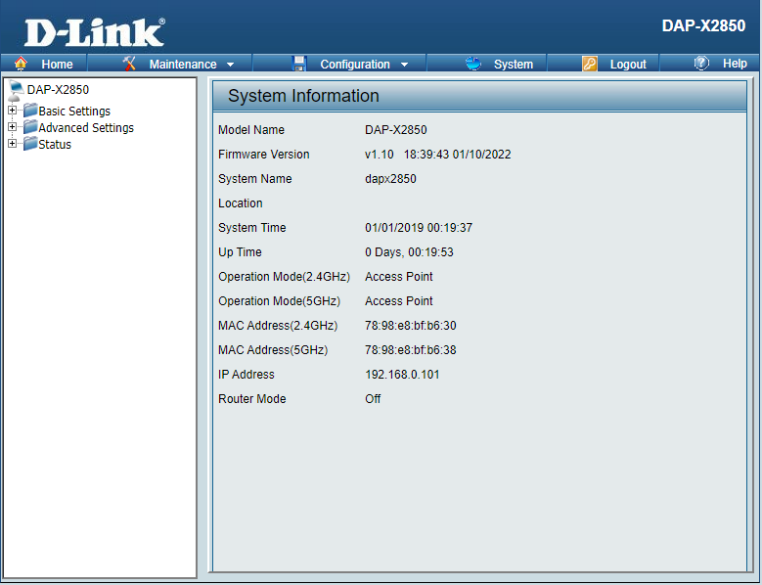

New Features:
- Upgrade SDK to SPF11.4
- Upgrade Openssl
- Support DNC 1.2.0.6 new feature
- Add channel 165 for KR country code
- Add Slovenia and Kosovo in country selection table

Changes of MIB & D-View Module:
None

Problems Fixed:
Firmware Version | Problems Fixed
V1.10 | - Fix DBG21020140 - Captive Portal (MAC address authentication) UI shows incorrectly.  - Fix HQ20210129000004 - Misspelling on Client Information  - Fix DI20211129000009 - IPv6 setting issue  - Fix DI20211130000007 - VHT Operation - Channel Width: 20 MHz or 40 MHz (0x00)  - Fix DI20211202000003 – Doesn't restart udhcpc after enabling Limit Administrator VLAN.  - Fix DI20211210000002 - Doesn't record "Captive portal, Client (MAC=) is in white list  - Fix DI20211213000002 – Accepts W52/53 in outdoor mode w/o any error message via its CLI for JP country code  - Fix DEUR20211208000005 - WLAN clients don't get IP-address

Known Issues:
Firmware Version | Known Issues
V1.10 | None

Related Documentation:

