DBT-122

Date: March 14, 2005

Product name: | USB Bluetooth Adapter
Revision: | A1
Available: | M/ Feb. 2005
Picture: | 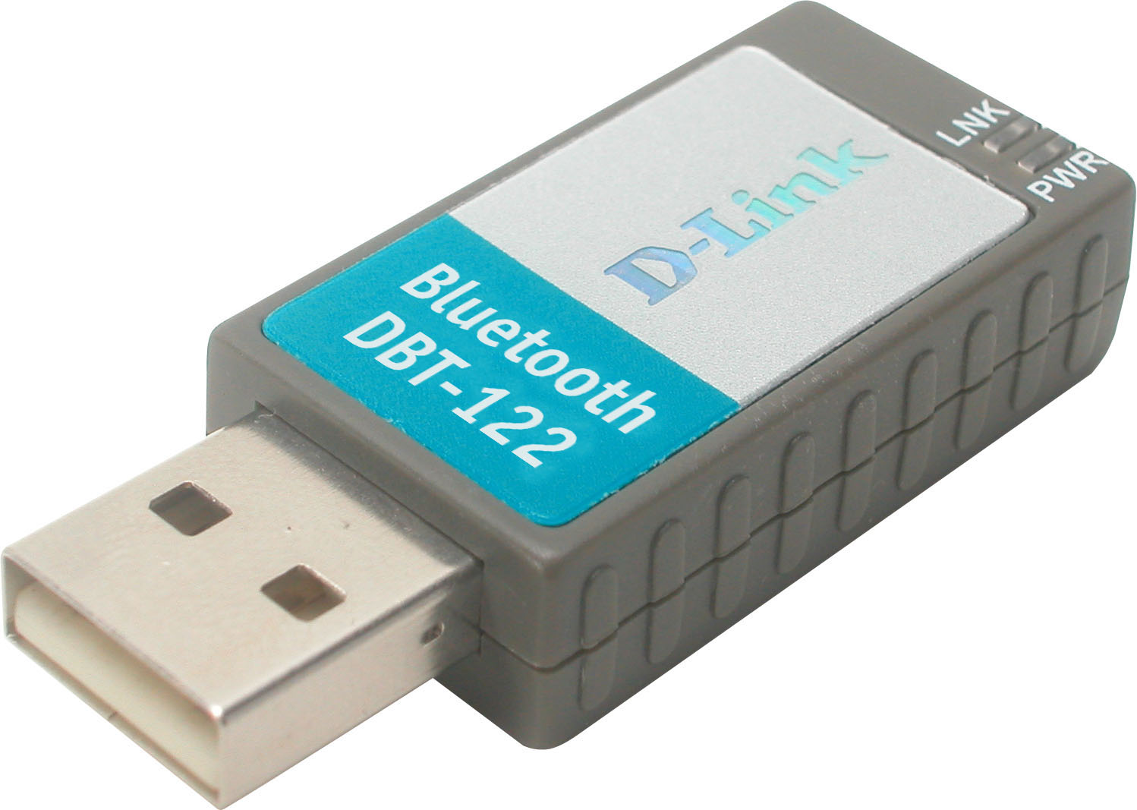
Why Sell This Product: | - We’re releasing this new Bluetooth adapter to supplement our current DBT-120 Bluetooth adapter. The new DBT-122 adapter complies with the newer 1.2 Bluetooth standard, supports the Adaptive Frequency Hopping (AFH) function that resolves all channel utilization conflicts with any Wi-Fi equipment operating in the same area, and is targeted at the main Bluetooth markets such as Europe. The current DBT-120 will continue to sell in the U.S., where it has been popular.  - The new DBT-122 will eventually replace the DBT-120 in the future.  Selling Points  - Works with Windows-based PCs, including Win2000 and XP.  - Supports Adaptive Frequency Hopping (AFH) function that automatically selects to use channels not utilized by nearby operating Wi-Fi equipment.  - Supports more Bluetooth profiles.
Key Features: | - USB connection to PC  - Up to 723Kbps asymmetrical, 433.9Kbps symmetrical data transfer rate  - Bluetooth SIG 1.2 compliant  - Supports Adaptive Frequency Hopping (AFH) function  - RF wireless frequency 2400to 2483.5 MHz for USA, Europe, Japan, 2446.5 to 2483.5 MHz for France  - 128-bit data encryption  - 2dBi on-board antenna  - Up to 10 meters (33 ft.) wireless operation range*  * Environmental factors may adversely affect operation range.
Technical Details: | System Requirements  - PC equipped with 300MHz processor or above  - 64 MB RAM or more  - USB 1.1 or 2.0 port  - Microsoft Windows XP, 2000, ME or 98SE with USB 1.1/2.0 support  - CD-ROM drive (for device driver installation)  Bluetooth Standard  Bluetooth SIG 1.2  Host Interface  USB 1.1  Bluetooth Profile  - DUN: DT/GW  - Fax: DT/GW  - FTP: client/server  - HCRP: client  - Headset: AG/HS  - HID: host  - OPP: client/server  - PAN: AP/group/user  - SPP: Dev A/Dev B  - Sync: client /server  - LAN: DT/GW  - Generic Access  - Basic Image  RF Emission Type  Frequency Hopping Spread Spectrum (FHSS)  RF Modulation Type  GFSK  RF Frequency  - 2400 to 2483.5MHz for USA, Europe, Japan  - 2446.5 to 2483.5 MHz for France  Transmit Output Power  -6 to +4dBm (Class 2)  Receive Sensitivity  -83 dBm typical across pass band under high interference environments  Antenna  2dBi on-board  General Function  Supports up to 7 slave devices  Transfer Rates  - Up to 723 Kbps asymmetrical  - Up to 433.9 Kbps symmetrical  Data Encryption  128-bit  Wireless Operation Range  Up to 10 meters (33 feet) peer-to-peer *  * Environmental factors may adversely affect operation range.  Physical & Environmental  Power Supply  USB powered (derived from PC)  Dimensions  47 x 19 x 10 mm  Weight  78 grams  Operating Temperature  0 to 50 ℃  Storage Temperature  -20 to 65 ℃  Operating Humidity  5% to 95% non-condensing  Emission Certification  - FCC Class B  - CE  - C-Tick  - VCCI  - BSMI  O.S. Driver Support  Windows XP, 2000, ME, 98 SE  Package Includes  - DBT-122 USB adapter  - USB extension cable  - CD (containing User's Manual)  - Quick Installation Guide
EMI/EMC Report | ☑FCC No. ☑ CE No. ☑ VCCI No.  ◻ CTR-21 No. ☑ C-Tick No. ◻ A-Tick No.  ◻ FDA No. ☑ R&TTE No. ☑ BSMI No.  ◻ Others
Safety | ◻ TUV No. ◻ UL No. ◻ CSA No.  ◻ Others
Packaging Style | ◻ Clamshell ◻ White Box ☑ Gift Box ◻ Bulk ◻ White Box with D-Link Logo  ◻ Others
Packaging Contents: | - DBT-122 Device  - USB Extension Cable  - CD-ROM with Mannual  - QIG
UPC Code:
  BBT122….A1 | 790069 276040
  IBT122….A1 | 790069 276057
  IBT122SG..A1 | 790069 276064
  EBT122….A1 | 790069 276071
  NBT122….A1 | 790069 276088
  TBT122….A1 | 790069 276095
Units Per Carton: | 40
Cartons Per Pallet: | For USA Air: , Sea: | For WW Air:12, Sea: 20
Dimensions and Weight: | Box:  ,Others , 0.27 kg  Carton: 495 x 410 x 360 mm, 11.7 kg  Pallet: (by Air) mm, kg (for USA)  1200 X 1100 X1230 mm, 162 kg (for WW)  (by Sea) mm, kg (for USA)  1200 x 1100 x 1950 mm, 255 kg (for WW)  INTRASTAT weight: 0.126 kg (Box)  Packing material weight (Box):  - Paper: 0.098 kg  - Plastic: 0.044 kg  - Mixed: 0.004 kg

