DBT-320

Date: June 1, 2004

Product name: | Bluetooth USB Printer Adapter
Product Group & Type:
Revision: | A1
Available:
Picture: | 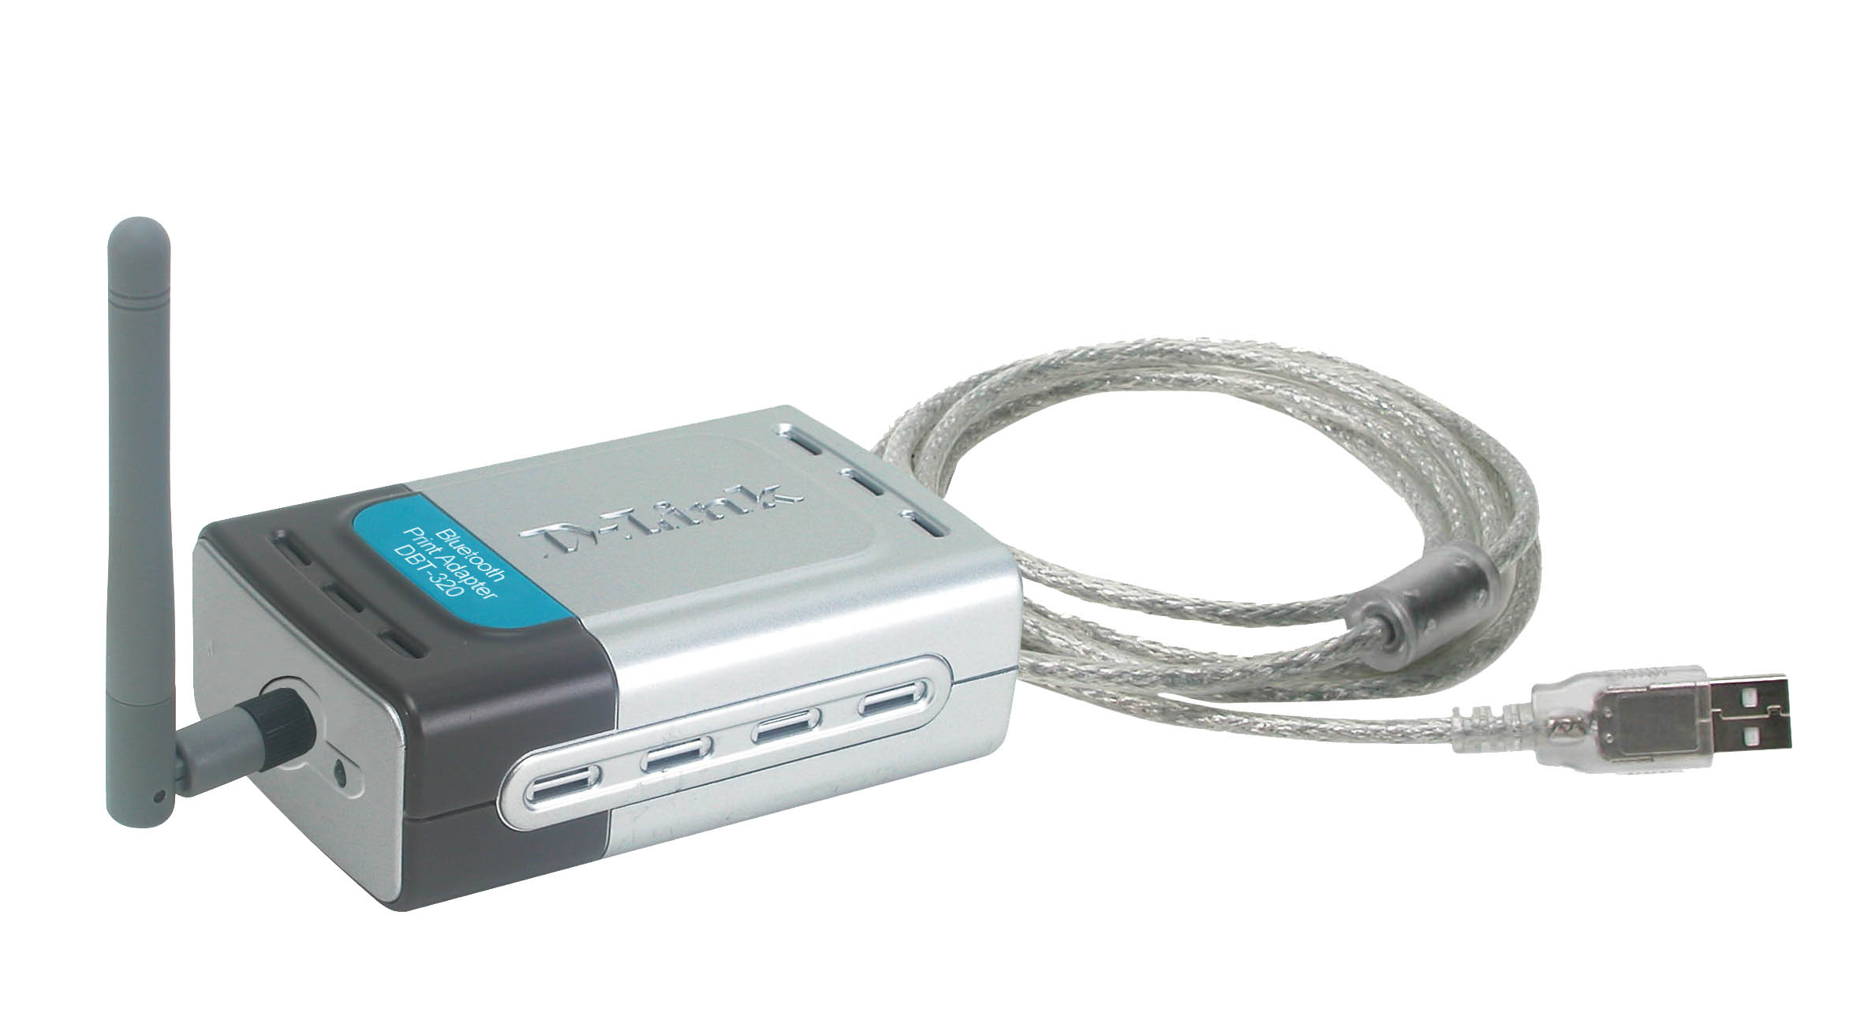
Why Sell This Product: | - Emerging demand for Bluetooth connection, especially in Europe.  - Emerging demand for Bluetooth connection to the Internet and wireless printing of web pages.  - Supplement your current Bluetooth product line.  - Plug and play product, requires little aftersale technical support.  Selling Points  - No driver program required.  - Works with all popular USB printers.  - Standard Bluetooth profiles for printing (Hardcopy Cable Replacement Profile (HCRP), Serial Port Profile (SPP), Object Push Profile (OPP).  - Printing compatibility with virtually all Bluetooth-enabled mobile devices.
Keyfeatures: | - Wireless printing from laptop computers, PDAs, mobile phones  - Enables upgrading of USB printers to Bluetooth-enabled  - Simply plugs to printer s USB port, no driver program required  - Works with all popular USB printers  - Works with all popular Bluetooth-enabled mobile phones such as Sony Ericsson & PDAs with OPP support  - Works with Windows 98SE, 2000, ME, XP computers with Bluetooth HCRP support  - Supports HCRP and OPP Profile to provide wireless  - printing for Bluetooth-enabled computers, notebooks, Mac  - USB1.1 and Bluetooth 1.1 compliant  - Wireless range 10 meters *  ** Environmental factors may adversely affection operation range.
Technical Details: | Standards  - Bluetooth: v1.1  - USB: 1.1  USB Port  Type B  Bluetooth Profile Support  - HCRP (Hardcopy Cable Replacement Profile)  - SPP (Serial Port Profile)  - OPP (Object Push Profile)  O.S. Support  Microsoft Windows 98, 2000, ME, XP  System Requirements  - Bluetooth Enabled PC, Mobile Phone, or PDA*  - Printing Software for PDA Printing  - Printer with USB Type B Port  * PCL3 printer required for PDA and mobile phone printing. PDA printing software required depending on your PDA model.  Radio Class  Class 2  Spread Spectrum  FHSS (Frequency Hopping Spread Spectrum)  Modulation Type  GFSK (Gaussian Frequency Shift Keying)  Frequency Band  2400 to 2483.5 MHz USA & Europe (except France)  Frequency Hopping  1600hops/sec (or 625 nanosecond/hop)  Receiving Sensitivity  -76 to -82 dBm  RF Output Power  -6 to +4 dBm (Class 2)  Receiving Signal Range  Better than -76 dBm @ 0.1% FER  Antenna  1.8 dBi Gain  Antenna Type  Dipole Antenna  Operating Distance  Up to 10 meters *  * Environmental factors may adversely affection operation range.  Physical & Environmental  Supply Voltage  5V/2A  Operation Current  80mA (max.)  Input Power  AC 100 to 240VAC, 50/60Hz (through external AC power adapter)  Output Power  DC +5V, 2.1A  Power Consumption  0.7 watts @ 5V DC  Dimensions  89 x 52 x 28 mm (device only, without Antenna and USB cable)  Operating Temperature  0 to 55 °C  Storage Temperature  -10 to 85 °C  Box Includes  - DBT-320 device  - External power adapter  - Quick Installation Guide
EMI/EMC Report | ☑FCC No. KA2DBT320A1 ☑ CE No. EM/2004/20065, ELC/2004/20034 ◻ VCCI No. ◻ CTR-21 No. ◻ C-Tick No. ◻ A-Tick No. ◻ FDA No. ◻ R&TTE No. ◻ BSMI No. ◻ Others
Safety | ◻ TUV No. ◻ UL No. ◻ CSA No.  ◻ Others
Packaging Style | ◻ Clamshell ☑ White Box ☑ Gift Box ◻ Bulk ◻ Others
Packaging Contents: | - DBT-320 x1,  - Quick Installation Guide x1  - Power Adapter x1  - Wall mount cradle x1  - Wall mount screw x1  - Warranty Card*1  - Wall mount crade QIG*1
UPC Code:
  DBT320A…A1 | 790069266515
  DBT320B…A1 | 790069266522
  DBT320E…A1 | 790069266539
  DBT320N…A1 | 790069266546
  TDBT320…A1 | 790069268564
  BDBT320…A1 | 790069266553
  NDBT320…A1 | 790069268571
Units Per Carton: | 20
Cartons Per Pallet: | Air: 400, Sea: 560
Dimensions and Weight: | Box: 224 x 147 x 77 mm, 0.5 kg  Carton: 614 x 400 x 245 mm, 11 kg  Pallet: (by Air) 1200 x 1100 x 1570 mm, 200 kg  (by Sea) 1200 x 1100 x 1900 mm, 280 kg  INTRASTAT weight: kg (Box)  Packing material weight (Box):  - Paper: 0.228 kg  - Plastic: 0.0152 kg  - Mixed: 0 kg

