DBT-900AP

Date: March 23, 2004

Product name: | Bluetooth-to-LAN Access Point
Product Group & Type:
Revision: | A1
Available:
Picture: | 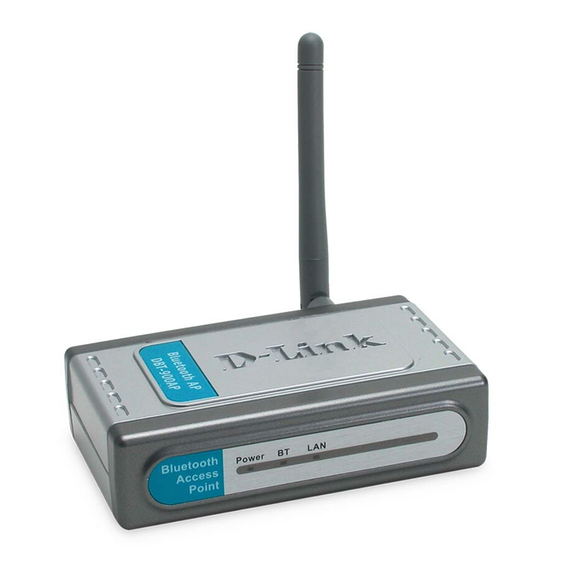
Why Sell This Product: | - Emerging demand for Bluetooth connection, especially in Europe.  - Emerging demand for Bluetooth connection to the Internet.  - Boost sale of Bluetooth adapters: you can also sell more DBT-120 and DCF-650BT while selling this DBT-900AP.  - More complete Bluetooth product line for you to offer.  - Plug and play product, no need for aftersale technical support.  Selling Points  - PAN Profile support, the latest Bluetooth technology.
Keyfeatures: | - Bluetooth specification v1.1 (PAN Profile) compliant  - Ethernet connection with DHCP assignment  - 10/100BASE-TX Ethernet LAN port with auto-sensing  - 10/100Mbps speeds, auto MDI/MDIX plug-and-play connection  - Plug-and-play installation, no driver required  - LED indicators for Power, Bluetooth Connection and LAN Connectivity status  - Security function for user access authorization/authentication  - Simultaneous access to Internet/Intranet for up to 7 Bluetooth users  - Operation range up to 20 meters (Class 2)  - Works seamlessly with desktop/laptop computers and PDAs *  * Computers, PDAs and other devices connecting to the DBT-900AP access point must be  Bluetooth-enabled with PAN Profile support.
Technical Details: | Emission Type  Frequency Hopping Spread Spectrum (FHSS)  RF Frequency  2400 to 2483.5MHz (Europe & USA, except France)  Output Power  -6 to +4dBm (Class 2)  Modulation Type  Gaussian Frequency Shift Keying (GFSK)  Frequency Hopping  1600hops/sec. (625us/hop)  Receiving Sensitivity  -80dBm (Class 2) BER 10E-3  Antenna  2dBi Gain dipole antenna  LED Indicators  - Power  - BT (Bluetooth)  - LAN  Connectors  - Power jack  - RJ-45 LAN jack  Configuration Reset  Reset button  Physical & Environmental  Power Input  Through external power adapter  Power Adapter  - Auto-switching 100 to 240 VAC, 50/60Hz  - 5VDC, 2A  Dimensions  104 (L) x 63 (W) x 29 (H) mm (device only)  Weight  100 grams (device only)  Operation Temperature  5 to 50 °C  Storage Temperature  -25 to 50 °C  Humidity  5% to 95% non-condensing  Emission  - FCC Class B  - CE Class B  Safety  LVD (EN60950)
EMI/EMC Report | ☑FCC No. ☑ CE No. ◻ VCCI No.  ◻ CTR-21 No. ◻ C-Tick No. ◻ A-Tick No.  ◻ FDA No. ◻ R&TTE No. ◻ BSMI No.  ◻ Others
Safety | ◻ TUV No. ◻ UL No. ◻ CSA No.  ◻ Others
Packaging Style | ◻ Clamshell ☑ White Box ☑ Gift Box ◻ Bulk ◻ Others
Packaging Contents: | - DBT-900AP x1,  - Quick Installation Guide x1  - Cat. 5 UTP cable x1  - Switch Power Adapter x1  - Mounting cradle x1
UPC Code:
  DBT900APA.A1 | 790069 26313
  DBT900APB.A1 | 790069 26314
  DBT900APE.A1 | 790069 26315
  DBT900APN.A1 | 790069 26316
Units Per Carton: | 20
Cartons Per Pallet: | Air: 20, Sea: 28
Dimensions and Weight: | Box: 224 x 147 x 77 mm, 0.615 kg  Carton: 598 x 384 x 245 mm, 15 kg  Pallet: (by Air) 1200 x 1100 x 1570 mm, 315 kg  (by Sea) 1200 x 1100 x 1900 mm, 435 kg  INTRASTAT weight: kg (Box)  Packing material weight (Box):  - Paper: kg  - Plastic: kg  - Mixed: kg

