Bluetooth Modem

Quick Installation Guide

CONTENTS

Chapter 1 Introduction 4

Chapter 2 Hardware Installation 4

Chapter 3 Start using the DFM-562BT 5

Chapter 1 Introduction

This Bluetooth Modem allows you connect your bluetooth-enabled computers to the Internet and use fax service wirelessly.

Package Contents
The box includes the following items:
- One 56K Bluetooth Modem
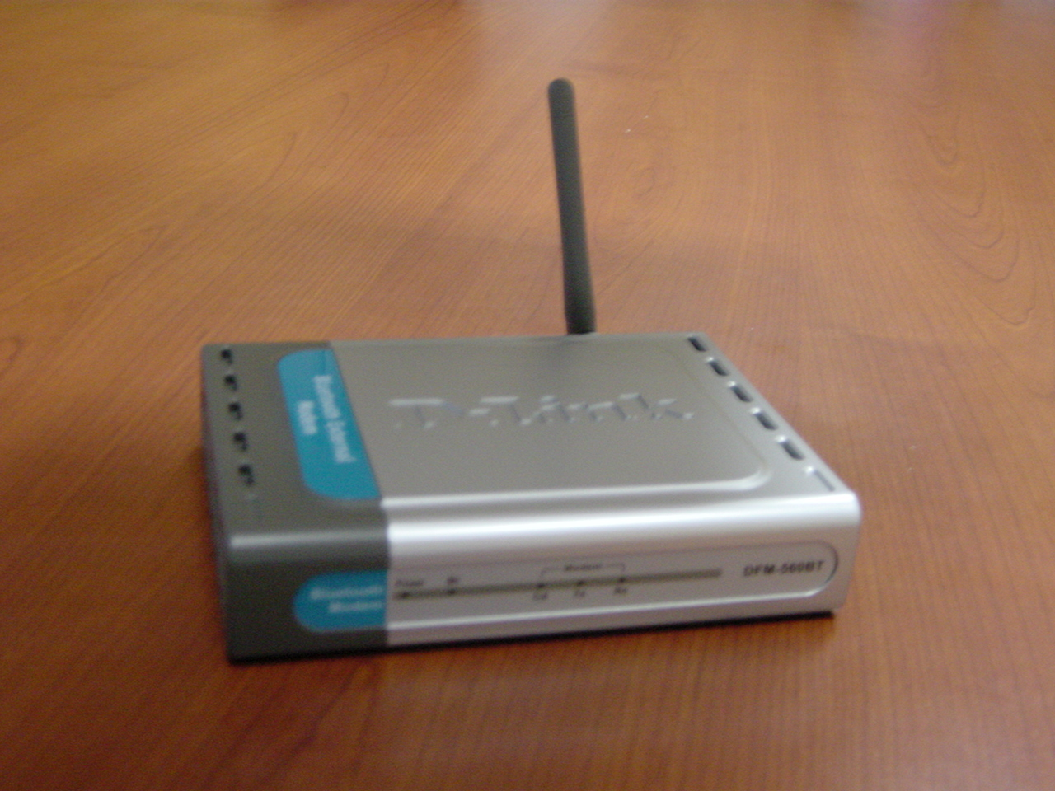

- Power Adapter
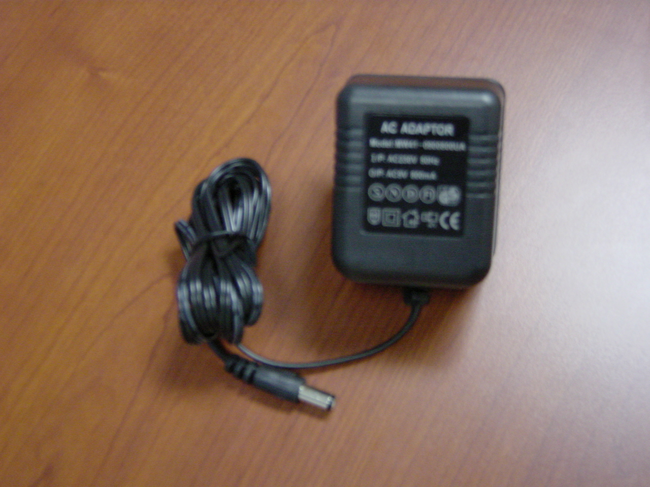

- One Phone Cable
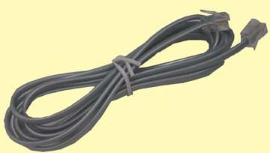

- One “Quick Installation Guide”

Chapter 2 Hardware Installation
- Straight up the antenna of the DFM-562BT.
(You may need to adjust the direction of the antenna to get better signal strength.)
- Plug the supplied phone cable into the jack on the back of the DFM-562BT marked “LINE”.
- Plug the other end of the phone cable into the wall socket.
- Plug the power cord of the supplied power adapter into the jack on the back of the DFM-562BT marked “POWER”.
- Plug the power adapter into the power socket.
- Push the power switch to turn on the power of the DFM-562BT. And the “Power” LED Indicator on the front of the DFM-562BT will be light then.
Note: Push the power switch again to turn off the DFM-562BT.

Once properly installed, the DFM-562BT Bluetooth Modem will be able to be connected to other Bluetooth wireless adapters. And your connected Personal Air networks should look similar to this:
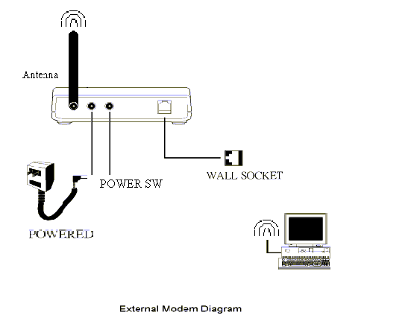
Computers with DBT-120

Chapter 3 Start Using DFM-562BT
This modem does not need to install any specific driver; it requires the Bluetooth adapter (for example: D-Link DBT-120 USB Bluetooth Adapter) to be installed on the PC or laptop computer in order to access to the DFM-562BT via Bluetooth.
The step-by-step instructions that follow are shown with Widcom Bluetooth Software that included with D-Link DBT-120 USB Bluetooth Adapter under Windows 98SE/ME/2000.

- Right-click to the “B” logo on the system tray and choose “Explorer” or double click “My Bluetooth Places” to open Bluetooth Adapter.
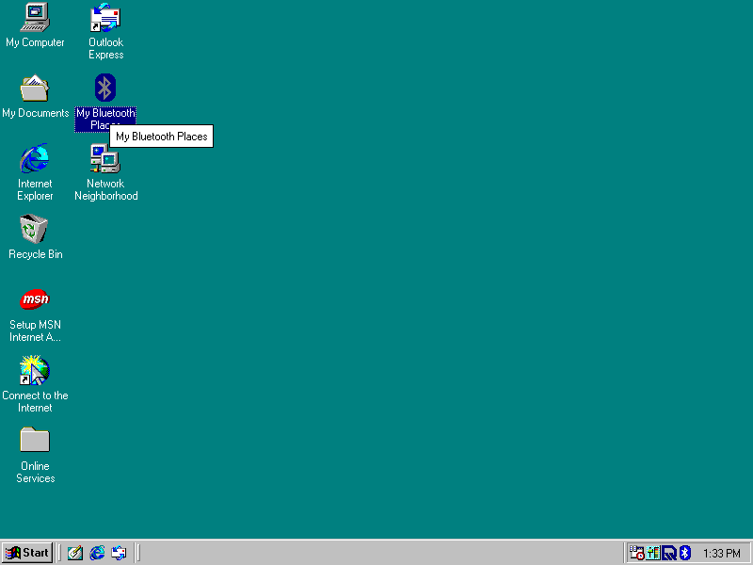

- Double-Click the “Find Bluetooth Devices” to have USB Bluetooth Adapter to find the DFM-562BT.
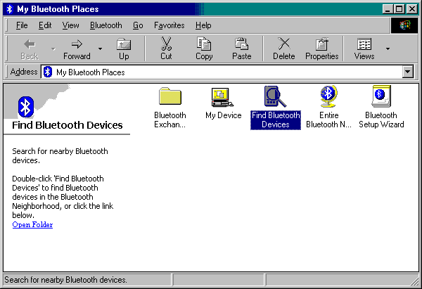

Note: Before searching, please make sure the DFM-562BT is in the range, up to 10 meter, from DBT-120 D-Link USB Bluetooth Adapter.

- Once the DFM-562BT is found by USB Bluetooth Adapter, double-click the icon of “DFM-562BT”.
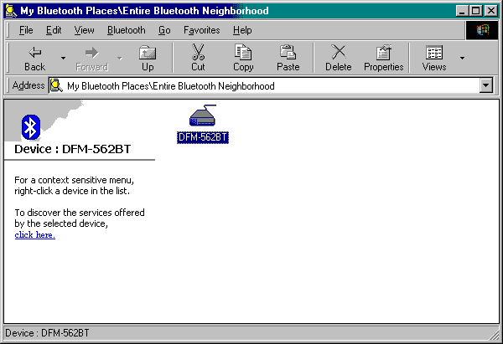

- Right-click the “Dial-up Networking” and choose “Connect Dial-up Networking”.
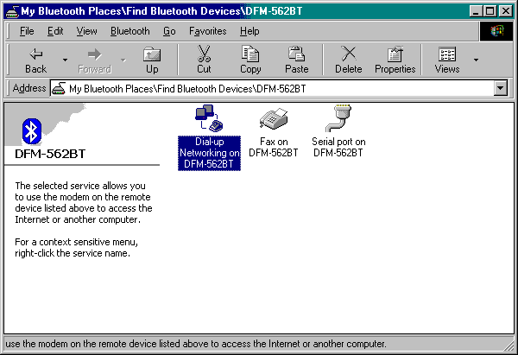

- A “Connection Wizard” will be shown for you to setup your own Internet connection account. Please refer to your ISP to setup this Connection Wizard and click “Connect” then.
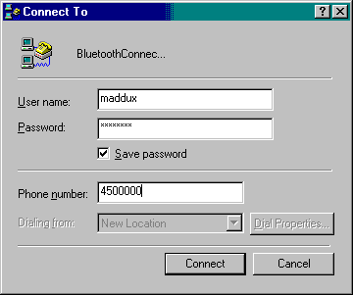

- Once the “Connected” icon is shown on the system tray, you’re ready to surf Internet from now!

