DWL-3200AP

Date: May 13, 2005

Product name: | 802.11g/2.4GHz AirPremier Managed Access Point
Revision: | A1
Available: | M/May 2005
Picture: | 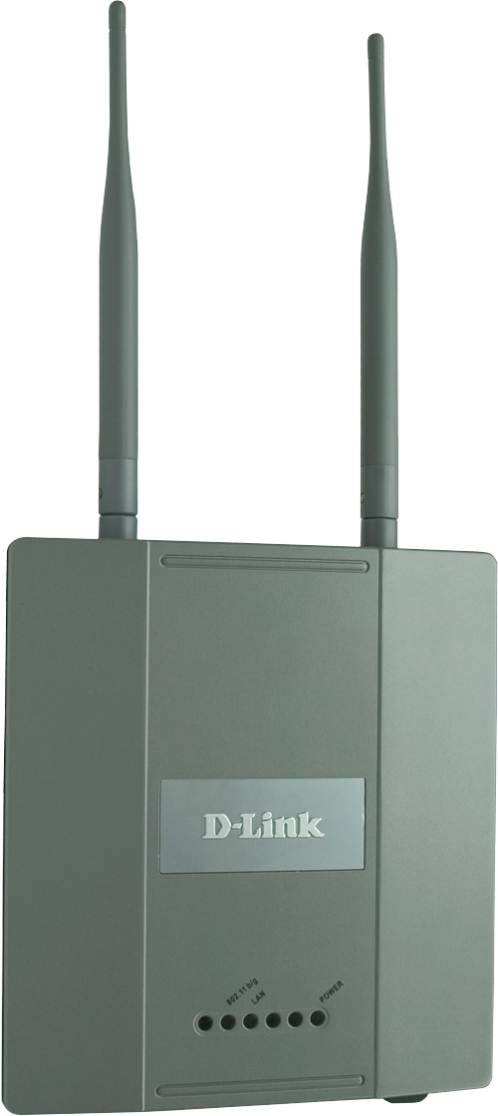
Why Sell This Product: | We’re introducing this wireless product as the first enterprise-class AP from D-Link to expand our current AirPremier product line. Its aim is to improve your products’ margin and to supplement your other wireless product sales. This product includes advanced management functions and is targeted at business users, hospitals, schools, convention centers and public hot spots. This AP is used for indoor installation.  Selling Points  - High 108Mbps wireless speed and high Gain antennas.  - Full wireless security and management functions, including PoE, 802.1Q VLAN (multiple SSID) and WPA2 support.  - Manageable from SNMP D-View (available later).  - Can also be installed as a wireless bridge.
Key Features: | For Business-Class Environments  - Sturdy Metal Chassis  - Ideal for Indoor Deployments  - Plenum-Rated Housing  - Two 5dBi High-Gain Antennas  Multiple Operation Modes  - Access Point  - Point-to-Point (PtP) Bridge  - Point-to-Multipoint (PtMP) Bridge  High Performance Connectivity  - 802.11g Wireless Speeds  - Up to 54Mbps Wireless Data Transfer Rates*  - D-Link 108G Technology 108Mbps Wireless Speed  Trusted Security Features  - 64/128/152-bit WEP Data Encryption  - WPA Personal  - WPA Enterprise  - 802.1x User Authentication  - AES  - 802.1Q Multiple SSIDs/Network Segmentation  - MAC Address Filtering  - 802.11i-Ready  Convenient Installation  - Built-in 802.3af Power over Ethernet  - Locking Brackets Included  Advanced Management  - AP Manager  - Web Browser (HTTP)  - Telnet  - SNMP v.3  * Maximum wireless signal rate based on IEEE standard 802.11g specifications. Actual data throughput will vary. Network conditions and environmental factors lower actual data throughput rate.
Technical Details: | Standards  - IEEE 802.11b  - IEEE 802.11g  - IEEE 802.3  - IEEE 802.3u  - IEEE 802.3af  Data Rates  - For 802.11g:  108, 54, 48, 36, 24, 18, 12, 9 and 6Mbps  - For 802.11b:  11, 5.5, 2 and 1Mbps  Wireless Frequency Range  2.4GHz to 2.4835GHz  Antennas  Dual 5dBi Gain detachable diversity dipole antennas with reverse SMA connectors  Operation Modes  - Access Point  - Point-to-Point (PtP) Bridge  - Point-to-Multipoint (PtMP) Bridge  Security  - 64-, 128-, 152-bit WEP data encryption  - MAC address filtering  - WPA/WPA2 EAP  - WPA/WPA2 PSK  - 802.1x User Authentication  - AES  - 802.11i-ready  - 802.1Q SSID broadcast enable/disable  - Multiple SSIDs (maximum 4)  Device Management  - Web-based: Internet Explorer v.6 or later; Netscape Navigator v.7 or later; or other Java-enabled browsers.  - Telnet  - AP Manager  - SNMP v.3  Certifications  - FCC Class B  - CE  - Wi-Fi
EMI/EMC Report | ☑FCC No. KA2DWL3200APA1 ☑ CE No. ◻ VCCI No.  ◻ CTR-21 No. ☑ C-Tick No. ◻ A-Tick No.  ◻ FDA No. ◻ R&TTE No. ◻ BSMI No.  ◻ Others
Safety | ◻ TUV No. ☑ UL No. E164374 ◻ CSA No.  ◻ Others
Packaging Style | ◻ Clamshell ◻ White Box ◻ Gift Box ◻ Bulk ◻ White Box with D-Link Logo  ☑ Others (BROWN BOX)
Packaging Contents: | - DWL-3200AP Device  - CAT5 Ethernet cable  - Power Adapter/Cord  - Two detachable antennas  - CD-ROM with Mannual  - QIG  - Wall mounted kit
UPC Code:
  BWL3200ANAA1 | 790069 273544
  TWL3200ANAA1 | 790069 273476
  CWL3200ANAA1 | 790069 273544
  EWL3200BEUA1 | 790069 273568
  EWL3200EEUA1 | 790069 273575
  IWL3200ANAA1 | 790069 273582
  IWL3200EEUA1 | 790069 273599
  IWL3200ENAA1 | 790069 273421
  IWL3200NEUA1 | 790069 273438
  IWL3200IS.A1 | 790069 281341
  NWL3200CEUA1 | 790069 273452
Units Per Carton: | 5
Cartons Per Pallet: | For USA Air: 30, Sea:48 | For WW Air:30, Sea:48  For UK Air: 48, Sea:48
Dimensions and Weight: | Box:  ,Others , 1.843 kg  Carton: 620*300*250 mm, 9.50 kg  Pallet: (by Air) 1220*1020*1380 mm, 290.5 kg (for USA)  _1100*1200*1380 mm, 305 kg (for WW)  _1100*1200*2140 mm, 497 kg (for UK/EU)  (by Sea)1220*1020*2130 mm, 455.2 kg (for USA)  _1100*1200*2140 mm, 497 kg (for WW)  _1100*1200*2140 mm, 497 kg (for UK/EU)  INTRASTAT weight: 1.498 kg (Box)  Packing material weight (Box):  - Paper: 0.320 kg  - Plastic: 0.0214 kg  - Mixed: 0.0034 kg

PMA
Product Class
Item Group
Sub Group
Intelligence
Tech.(Features)
Layer
Application
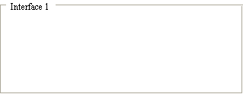
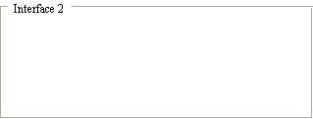
Q'ty

Interface
Net Interface
Port NO.
Interface
Net Interface
Port NO.

