Product External Spec
For
802.11b/g Ceiling Mount Access Point with PoE
Model Name: DWL-3260AP

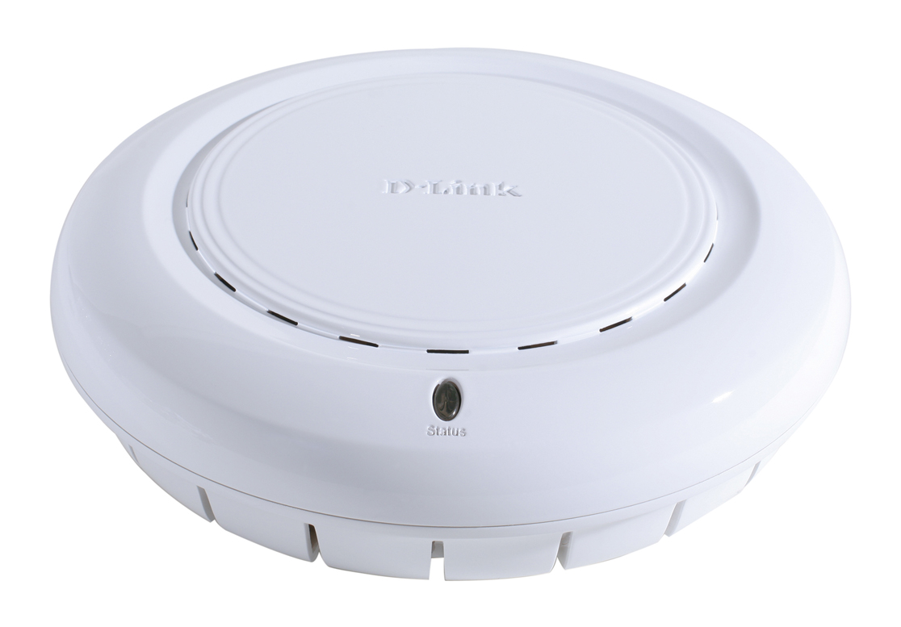

Version: 1.03

Revision History

Rev. | Date | Author | Reason for Changes
1.00 | Aug 18,2006 | Ares Ding | - New released
1.01 | Jan 9,2007 | Ares Ding | - Change SDRAM size : 32MB
1.02 | Mar 16,2007 | Ares Ding | - Add performance section
1.03 | June 15,2007 | Ares Ding | - Revise the embedded antenna gain value

Contents
Revision History ii
1.0 Scope 1
1.1 Document 1
1.2 Product Features 1
2.0 Requirements 2
2.1 Functional Block Diagram 2
2.2 General Requirements 2
2.2.1 IEEE 802.11b Section 2
2.2.2 IEEE 802.11g Section 2
2.2.3 General Section 3
2.3 Software Requirements 3
2.3.1 Network Setting 3
2.3.2 Wireless Setting 3
2.3.3 Security Setting 4
2.3.4 Multiple SSID 4
2.3.5 Performance 4
2.3.6 Management 5
2.3.7 Others 5
2.4 Mechanical Requirements 5
2.5 Compatibility Requirements 5
2.6 Regulatory Requirements 6
2.7 Requirements of Reliability, Maintainability and Quality 6
2.8 Environmental Requirements 6

1.0 Scope

1.1 Document
This document provides an overview of the requirements for the DWL-3260AP. The DWL-3260AP is an 802.11 b/g AP.

1.2 Product Features
- Provide Ethernet to Wireless LAN bridge fully IEEE 802.3 compatible on the Ethernet side and fully interoperable with IEEE 802.11b/g compliant equipment.
- Compatible with IEEE 802.11b high rate standard to provide wireless 11Mbps data rate.
- Compatible with IEEE 802.11g higher speed standard to provide wireless 54Mbps data rate, and the turbo mode of 108Mbps.
- Supports Power Over Ethernet (802.3af)
- Operation at 2.4~2.5GHz to meet worldwide regulations.
- Allows auto fallback data rate for reliability, optimized throughput and transmission range.
- Supports IEEE 802.11 b/g wireless data encryption with 64/128/152-bit WEP for security.
- Web-based configuration and management.
- Supports enhanced security – WPA and WPA2, RADIUS client, and Cipher negotiation
- Supports multiple SSID – 1 Primary SSID and 7 Multi-SSID
- Supports 10/100M Ethernet port.
- Type approval compliant with Europe regulation.

2.0 Requirements
The following sections identify the detailed requirements of the 802.11 g/b Access Point.

2.1 Functional Block Diagram

Processor
802.11g
RF
SDRAM
32MB
802.3
PHY

2.4GHz
Antennas

Flash
4MB

2.2 General Requirements

2.2.1 IEEE 802.11b Section
# | Feature | Detailed Description
2.2.1.1 | Standard | - IEEE 802.11b
2.2.1.2 | Radio and Modulation Schemes | - DQPSK, DBPSK and CCK
2.2.1.3 | Operating Frequency | - 2400 ~ 2497MHz ISM band
2.2.1.4 | Channel Numbers | - 13 channels for Europe Countries
2.2.1.5 | Data Rate | - 11, 5.5, 2, and 1Mbps
2.2.1.6 | Media Access Protocol | - CSMA/CA with ACK
2.2.1.7 | Transmitter Output Power | - Typical 18dBm at 11, 5.5, 2 and 1Mbps
2.2.1.8 | Receiver Sensitivity | - Typical –83dBm for 11Mbps @ 8% PER(Packet Error Rate)  - Typical –89dBm for 2Mbps @ 8% PER(Packet Error Rate)

2.2.2 IEEE 802.11g Section
# | Feature | Detailed Description
2.2.2.1 | Standard | - IEEE 802.11g
2.2.2.2 | Radio and Modulation Type | - BPSK, QPSK, 16QAM, 64QAM, OFDM
2.2.2.3 | Operating Frequency | - 2400 ~ 2483.5MHz ISM band
2.2.2.4 | Channel Numbers | - 13 channels for Europe Countries
2.2.2.5 | Data Rate | - 108, 54, 48, 36, 24, 18, 12, 9 and 6Mbps
2.2.2.6 | Media Access Protocol | - CSMA/CA with ACK
2.2.2.7 | Transmitter Output Power | - Typical RF Output Power at each Data Rate  - +14 ~ 15dBm at 54Mbps and 108Mbps  - +14 ~ 16dBm at 48Mbps  - +16 ~ 18dBm at 36, 24, 18, 12, 9, and 6Mbps
2.2.2.8 | Receiver Sensitivity | - Typical Sensitivity at Which Frame (1000-byte PDUs) Error Rate = 10%  - –87dBm at 6Mbps  - –86dBm at 9Mbps  - –85dBm at 12Mbps  - –83dBm at 18Mbps  - –80dBm at 24Mbps  - –76dBm at 36Mbps  - –71dBm at 48Mbps  - –66dBm at 54Mbps

2.2.3 General Section
# | Feature | Detailed Description
2.2.3.1 | Interface | - Power Jack (Bottom of the chassis)  - Factory Reset Button (Bottom of the chassis)  - 10/100M Base-T (UTP) (Bottom of the chassis)  - Internal antenna  - External Antenna Connector  - DIP Switch (for external antenna)
2.2.3.2 | Antenna Type | - Embedded antennas with 1dBi gain for 2.4GH
2.2.3.3 | Ethernet Standard | - IEEE 802.3, IEEE 802.3u, IEEE 802.3x
2.2.3.4 | Operating Voltage | - 48V DC +/- 10% for PoE
2.2.3.5 | Current Consumption | - Max. 7W
2.2.3.6 | LEDs | (Side of the chassis)  - Status

2.3 Software Requirements
The configuration of AP can be done through the Ethernet port by using the Web based application.

2.3.1 Network Setting
# | Feature | Detailed Description
2.3.1.1 | Get IP From | - Dynamic (DHCP)  - Static (Manual)
2.3.1.2 | IP Address | - The IP address of the AP can be viewed and set
2.3.1.3 | Subnet Mask | - The Ethernet station and the AP is on the same subnet. The IP address for the AP is correspond to the Subnet Mask
2.3.1.4 | Default Gateway | - The Ethernet station and the AP is on the same Gateway. The IP address for the AP is correspond to the Gateway

2.3.2 Wireless Setting
# | Feature | Detailed Description
2.3.2.1 | Wireless Band | - The Wireless Band of the AP can be viewed.
2.3.2.2 | Mode | - Access Point, WDS with AP, WDS, AP Repeater, AP Client
2.3.2.3 | SSID | - SSID is a group of AP. SSID is the name of the WLAN used for identifying the WLAN
2.3.2.4 | SSID Broadcast | - Indicates whether the SSID of your wireless network will be broadcasted.
2.3.2.5 | Channel | - Can select the radio channel. The permissible channels dependent on the Wireless Band
2.3.2.6 | Auto Channel Scan | - If you check Auto Channel Scan, the AP will automatically find the best channel to use.

2.3.3 Security Setting
# | Feature | Detailed Description
2.3.3.1 | Authentication Type | - For added security on a wireless network, data encryption can be enabled. There are nine available Authentications type can be selected.  - Open System, Shared Key, or both enabled  - WPA-Enterprise, WPA-2-Enterprise, WPA-AUTO-Enterprise  - WPA-Personal, WPA2-Personal, WPA-AUTO-Personal
2.3.3.2 | WEP Key Type | - WEP Key Format: Option for both Hex and ASCII
2.3.3.3 | WEP Key Size | - Four WEP keys can be selected for 64-bit, 128-bit and 152-bit WEP encryption for 802.11g
2.3.3.4 | WPA-Enterprise, WPA-2-Enterprise, WPA-AUTO-Enterprise | - Wi-Fi Protected Access authorizes and authenticates users onto the wireless network. It requires a RADIUS server in the network. WPA and WPA2 uses different algorithm. WPA-Auto allows both WPA and WPA2.
2.3.3.5 | WPA-Personal, WPA2-Personal, WPA-AUTO-Personal | - Wi-Fi Protected Access authorizes and authenticates users onto the wireless network. It protects the network through the use of a pre-shared key. WPA and WPA2 uses different algorithm. WPA-Auto allows both WPA and WPA2.
2.3.3.6 | ACL | - WLAN STA Mac address access control.
2.3.3.7 | Internal Station Connection | - Allows stations to inter-communicate by connecting to target AP. By disabling this function, wireless stations cannot exchange data through AP.
2.3.3.8 | Ethernet to WLAN Access | - Allows data flow from the Ethernet to wireless stations connected to the AP. By disabling this function, all Broadcast packet from the Ethernet to associated wireless devices is blocked while wireless stations can still send data to the Ethernet through the AP.

2.3.4 Multiple SSID
# | Feature | Detailed Description
2.3.4.1 | Behavior | - Single SSID/Beacon, Multiple Beacons, Multiple BSSIDs
2.3.4.2 | Multi-SSID | - One primary SSID and seven secondary SSIDs can be configured.
2.3.4.3 | VLAN supported | - VLAN function can be enabled for primary SSID and secondary SSIDs
2.3.4.4 | Security Supported | - Open System, Shared Key, WPA and WPA2 for Multi-SSID.

2.3.5 Performance
# | Feature | Detailed Description
2.3.5.1 | Data Rate | The Data Rates are Auto, 1Mbps, 2Mbps, 5.5Mbps, 6Mbps, 9Mbps, 11Mbps, 12Mbps, 18Mbps, 24Mbps, 36Mbps, 48Mbps, 54Mbps.Default is set to Auto
2.3.5.2 | Beacon Interval (20~1000) | Beacons are packets sent by an access point to synchronize a network. Default is set to 100
2.3.5.3 | DTIM (1~255) | (Delivery Traffic Indication Message) DTIM is a countdown informing clients of the next window for listening to broadcast and multicast messages. Default is set to 1.
2.3.5.4 | Fragment Length (256~2436) | The fragmentation threshold, which is specified in bytes, determines whether packets will be fragmented. Packets exceeding the 2346 byte setting will be fragmented before transmission. 2346 is the default setting
2.3.5.5 | RTS Length: | This value should remain at its default setting of 2346. If you encounter inconsistent data flow, only minor modifications to the value range between 256 and 2346 are recommended.
2.3.5.6 | Transmit Power: | Choose full, 50%, 25%, 12.5% minimum power.
2.3.5.7 | Super G mode | Super G is a group of performance enhancement features that  increase end user application throughput in an 802.11g network. Super G is backwards compatible to standard 802.11g devices. For top performance, all wirelss devices on the network should be Super G capable. Select either Disabled, Super G without Turbo, or Super G with Dynamic Turbo.
2.3.5.8 | Wireless B/G | Select Mixed for both 802.11b and 802.11g, 11b for 802.11b only, or 11g for 802.11g only.
2.3.5.9 | WMM | Select Enable or Disable, Disable is selected by default. WMM stands for Wi-Fi Multimedia, by enabling this feature it will improve the user experience for audio and video applications over a Wi-Fi network.
2.3.5.10 | Radio Wave | Select ON or OFF.
2.3.5.11 | Preamble | Select the default value Short and Long, or Long Only.

2.3.6 Management
# | Feature | Detailed Description
2.3.6.1 | WEB | - Configuration via WEB
2.3.6.2 | Telnet | - Configuration via Telnet. Telnet time out supported.
2.3.6.3 | SSH | - Secure Shell provides strong authentication and secure communications
2.3.6.4 | Remote upgrade | - You can use WEB or Telnet to remote upgrade f/w via Ethernet or Wireless
2.3.6.5 | SNMP | - Support SNMP v3( Release II).
2.3.6.6 | Station status | - Display associated STA status, like Mac address…etc
2.3.6.7 | System status | - Display Device system status, like f/w version, device Mac address, UP time, etc.
2.3.6.8 | Download/Upload configuration data | - You can use WEB or Telnet to download/upload configuration data via Ethernet or Wireless
2.3.6.9 | Administrator | - One user name/password.
2.3.6.10 | AP statistic | - Display AP Tx/Rx counter, error counter
2.3.6.11 | AP Manager (2) | - Management Tool
2.3.6.12 | D-View | - D-Link D-View module

2.3.7 Others
# | Feature | Detailed Description
2.3.7.1 | AP hidden | - The STA can’t found the AP when enable.
2.3.7.2 | WLAN STA partition | - The WLAN STA can’t access each other when enable.
2.3.7.3 | Bridge Forwarding | - Support TCP/IP, IPX, and AppleTalk.

2.4 Mechanical Requirements
# | Feature | Detailed Description
2.4.1 | Diamter | - 171.97mm
2.4.2 | High | - 48.16mm

2.5 Compatibility Requirements
The Wireless Access Point will pass the following compatibility requirements.
# | Feature | Detailed Description
2.5.1 | Wi-Fi | - Conform with Wi-Fi certification
2.5.2 | Physical Layer and  Functionality | - Pass D-Link Engineering Test Plan and Test Report

2.6 Regulatory Requirements
# | Feature | Detailed Description
2.6.1 | USA | IEEE 802.11b/g:  - FCC part 15.247, 15.205, 15.209  Safety:  - UL1950-3 for CSA mark
2.6.2 | European Countries | IEEE 802.11b/g:  - EMC: EN 300 328, EN 300 826, EN 60950
2.6.3 | Japan | IEEE 802.11b/g:  - ARIB STD-T66 and RCR STD-33A  EMI:  - VCCI
2.6.4 | Canada | IEEE 802.11 b/g:  - Power Limits: RSS-210 6.2.2 (91)  Safety:  - CSA
2.6.5 | Australia (C-Tick) | IEEE 802.11b/g:  - AS/NZS 4771: 2000+A1 2003, EN300 328,  CISRP 22

2.7 Requirements of Reliability, Maintainability and Quality
# | Feature | Detailed Description
2.7.1 | MTBF | - Mean Time Between Failure > 30,000 hours
2.7.2 | Maintainability | - There is no scheduled preventive maintenance required
2.7.3 | Quality | - The product quality followed D-Link factory quality control system

2.8 Environmental Requirements
# | Feature | Detailed Description
2.8.1 | Operating Temperature Conditions | - The product is capable of continuous reliable operation when operating in ambient temperature of 0 ℃ to +40℃.
2.8.2 | Non-Operating Temperature Conditions | - Neither subassemblies is damaged nor the operational performance be degraded when restored to the operating temperature after exposing to storage temperature in the range of -20 ℃ to +65 ℃.
2.8.3 | Operating Humidity conditions | - The product is capable of continuous reliable operation when subjected to relative humidity in the range of 10% and 90% non-condensing.
2.8.4 | Non-Operating Humidity Conditions | - The product is not be damaged nor the performance be degraded after exposure to relative humidity ranging from 5% to 95% non-condensing

