



DWL-6500

D-Link AirPro™ 2.4GHz/5GHZ
Wireless Access Point
Wireless Access Point

Before You Begin
This product can be set up using any current web browser, i.e., Internet Explorer 5x, Netscape Navigator 4x.
It’s best to use a computer with an Ethernet adapter for configuring the DWL-6500. The default IP address for the DWL-6500 is 192.168.0.50 with a Subnet Mask of 255.255.255.0. You will need to assign your computer a Static IP address within the same range as the DWL-6500’s IP address for the purpose of configuring the DWL-6500. See the Appendix if you need assistance in assigning a Static IP address for your network adapter.
Check Your Package Contents
These are the items included with your DWL-6500 purchase:

• DWL-6500 Wireless Access Point

• CD-ROM (containing
Manual and Warranty)

• Ethernet (CAT5 UTP/
Straight Through) Cable


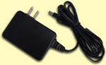
• 48V DC, 0.4A Power Adapter

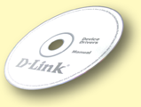
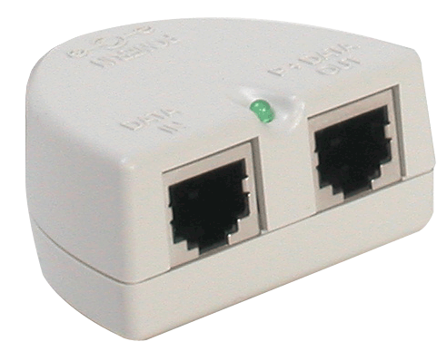
- PoE (Power over Ethernet) Base Unit

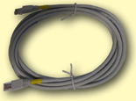

Using a power
supply with a different voltage rating will damage and void the warranty for this product.

If any of the above items are missing, please contact your reseller.
©2002 D-Link Systems, Inc. All rights reserved. Trademarks or registered trademarks are the property of their respective holders. Software and specifications subject to change without notice. DWL-6500.08062002

Connecting The DWL-6500 Multimode Wireless Access Point To Your Network
A. First, connect the power adapter to the receptor at the back panel of the DWL-6500 and then plug the other end of the power adapter to a wall outlet or power strip. The Power LED will turn ON to indicate proper operation. Alternatively you may use the Power over Ethernet functionality of the device to supply power to the device.
B. Using a Straight-Through Ethernet cable, insert one end of the cable to the Ethernet port on the back panel of the DWL-6500 and the other end of the cable to an Ethernet Broadband Router (i.e., D-Link DI-604) or Switch (i.e., D-Link DSS-5+). Note: The computer used to configure the DWL-6500 must also be connected to the same Ethernet router or switch.
When connecting
the DWL-6500 Wireless Access Point to an Ethernet Adapter in a computer, use a Cross-Over Ethernet cable.
C. Computers with 802.11b and 802.11a wireless adapters can connect to the DWL-6500. The DWL-650+ AirPlus Wireless Cardbus Adapter or the DWL-A650 AirPro and the DWL-520+ AirPlus Wireless PCI Adapter or the DWL-A520 AirPro will connect out of the box to the DWL-6500, using their default wireless settings.
C. Antenna
Used to wirelessly connect to 802.11b and 802.11a adapters.
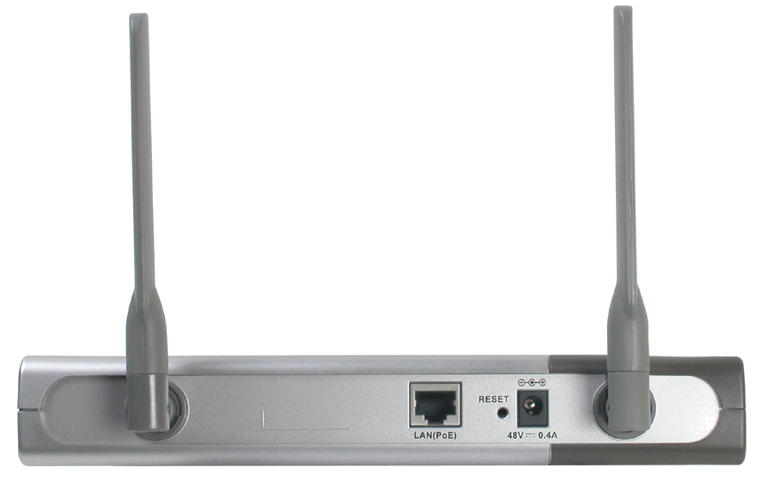

Reset Button
Pressing this button restores the DWL-6500 to its original factory default settings.

B. LAN Port
For connecting to a switch on a local network with an Ethernet cable.
Has PoE capability.
A. Receptor for Power Adapter

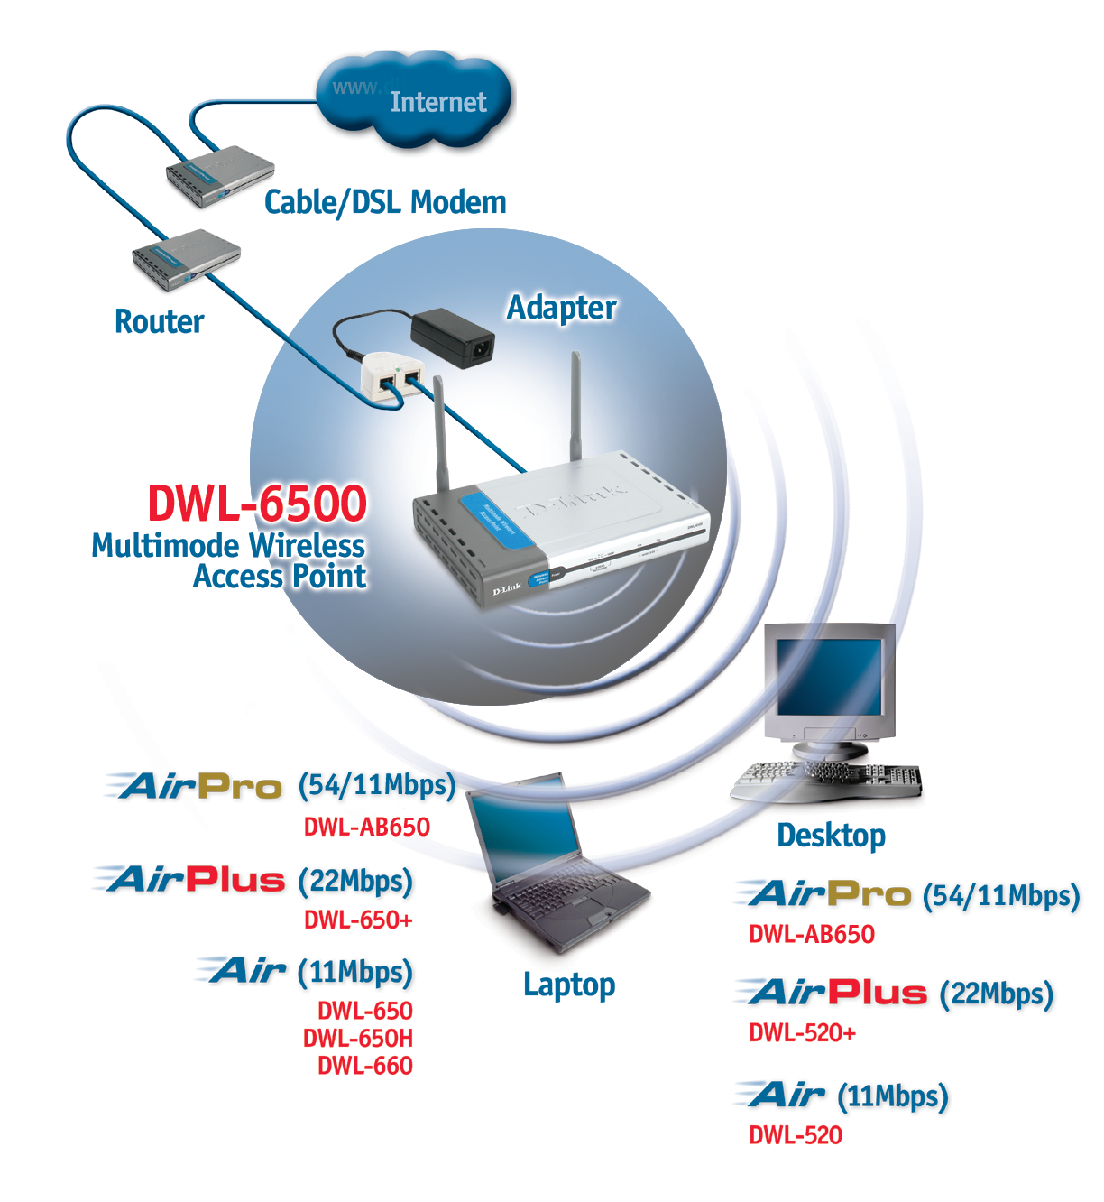
When you have completed the steps in this Quick Installation Guide, your connected network should look similar to this:

PoE Module
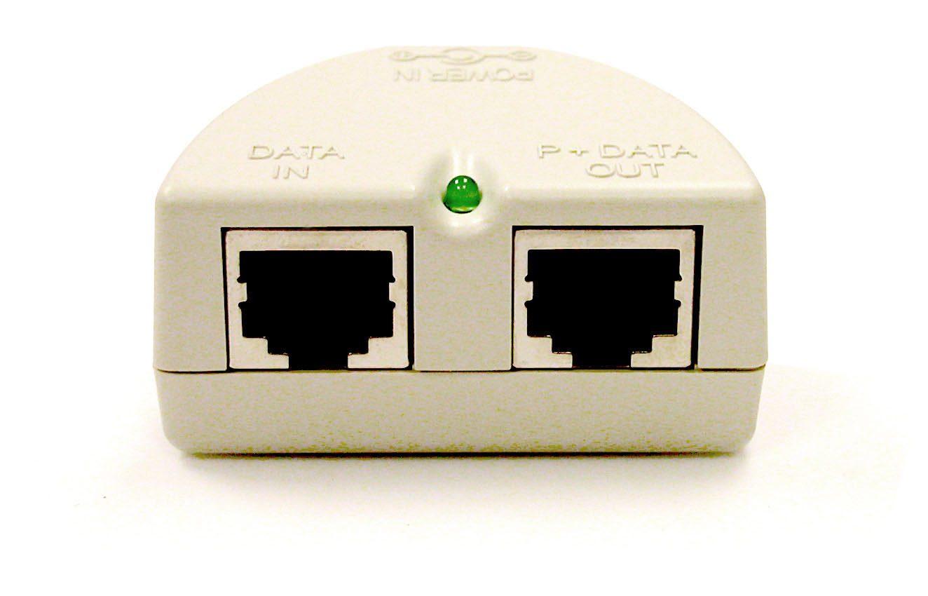
You can use the Power over Ethernet functionality to power the device.
Connect cable from Data In jack to the LAN.
Connect cable from P+Data Out jack to the device.

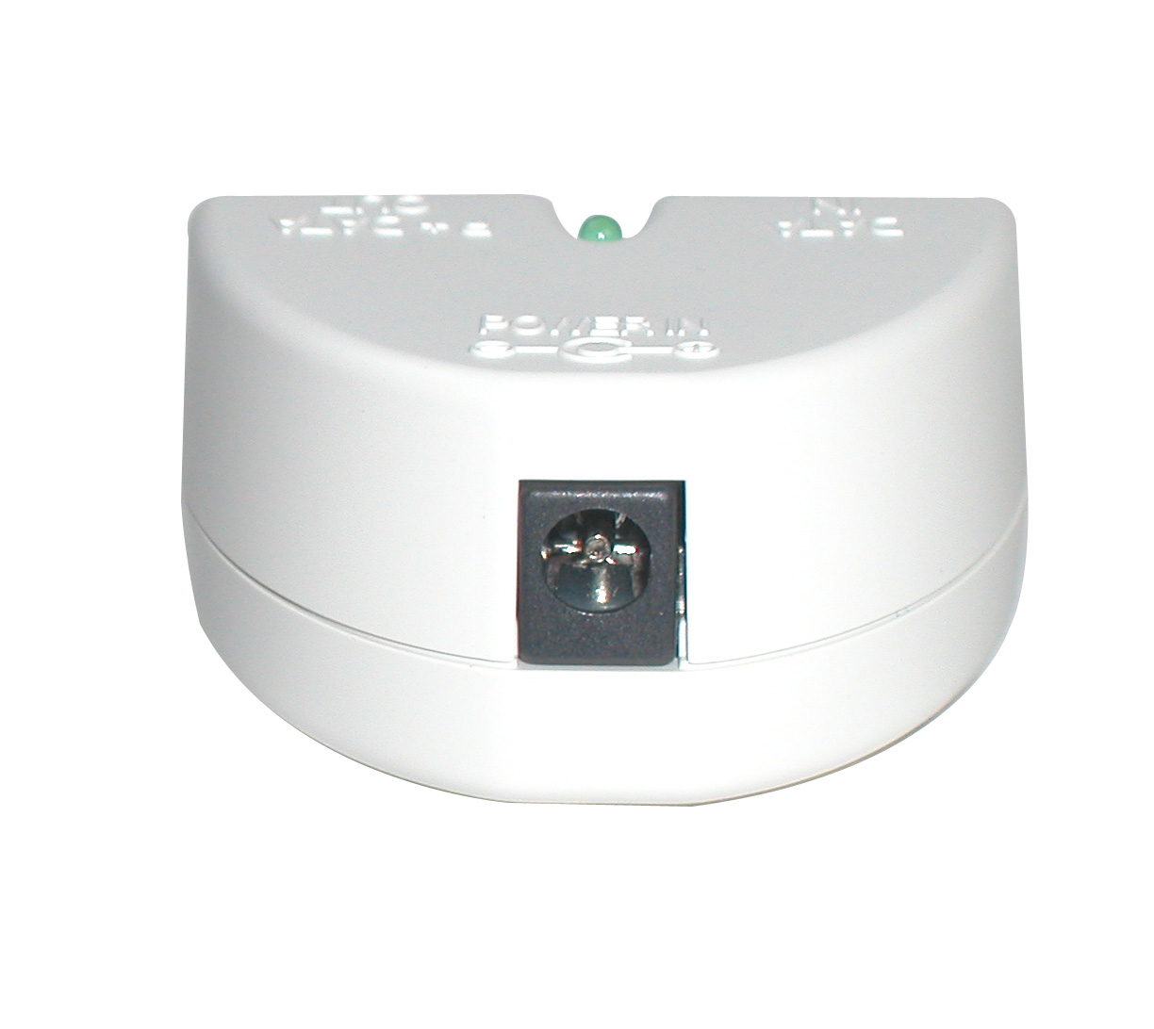
Connect back of base unit to power source.


Using The Setup Wizard

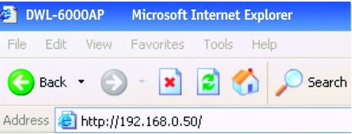
Open your Web browser and type “http://192.168.0.50” into the URL address box. Then press the Enter or Return key.
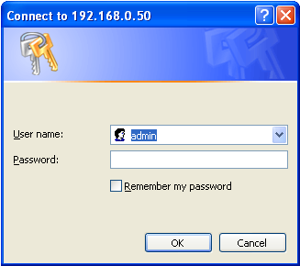

The logon pop-up
screen will appear.

Type “admin” for the username and leave the password field blank.

Click OK

Using The Setup Wizard (continued)
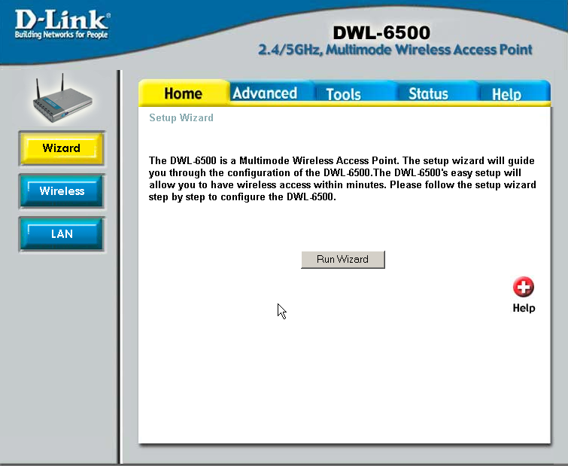
Click Run Wizard
Once you have
logged in, the
Home screen
will appear.

You will see the following screens.
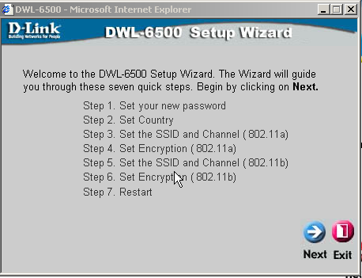
Click Next

Step 1 - Set up your new password. You have the option to establish a password.
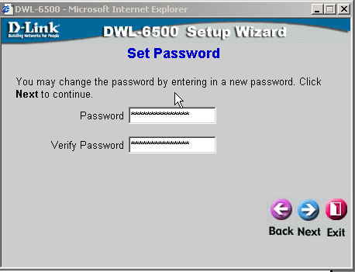
Click Next

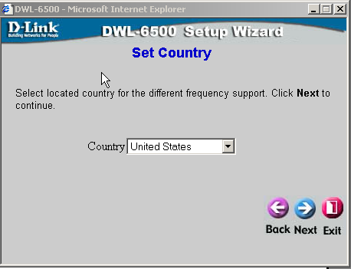
Click Next
Step 2 – Set Country.
Choose the country where you are setting up the DWL-6500. This will adjust the frequency settings to comply with local regulations.

Step 3 - Wireless Setup for your 802.11a Connection.
The default SSID is default.
The default Channel and the range of usable channels depend on which country was selected in the previous menu (Step 2).
You can change these settings to match an existing wireless network.

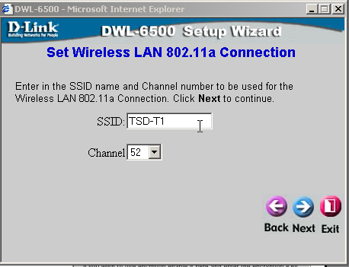
Click Next

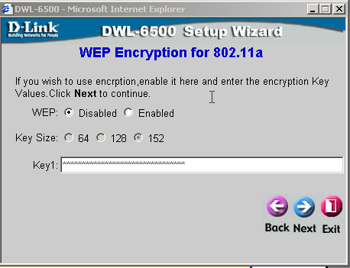
Click Next
Step 4 – Encryption for 802.11a Network
The DWL-6500 is capable of three levels of wireless encryption - 64-bit, 128-bit, and 152-bit. By default the encryption is disabled. You can change the encryption settings for more secure wireless communication.

If you enable encryption on the DWL-6500 make sure to also enable encryption on all 802.11a wireless clients or wireless connection will not be established

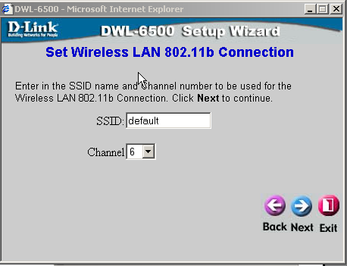
Click Next
Step 5 - Wireless Setup for your 802.11b Connection.
The default SSID is default.
The default Channel and the range of usable channels depend on which country was selected in Step 2.
You can change these settings to match an existing wireless network.

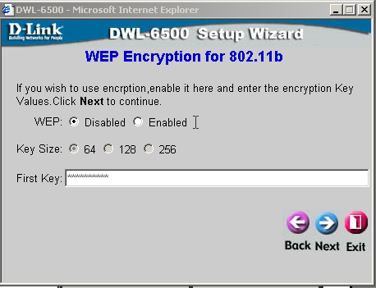
Click Next
S Step 6 – Encryption for
802.11b Network.
The DWL-6500 is capable of three levels of wireless encryption - 64-bit, 128-bit, and 256-bit. By default the encryption is disabled. You can change the encryption settings for more secure wireless communication.

If you enable encryption on the DWL-6500 make sure to also enable encryption on all 802.11b wireless clients or wireless connection will not be established


Your Setup is Complete!

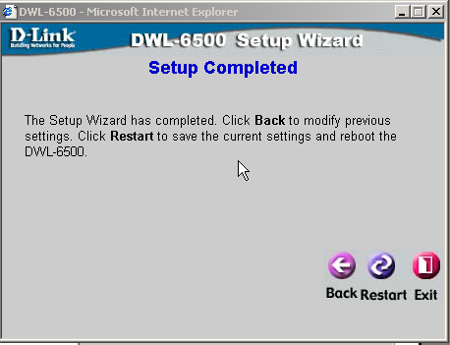
Click Restart

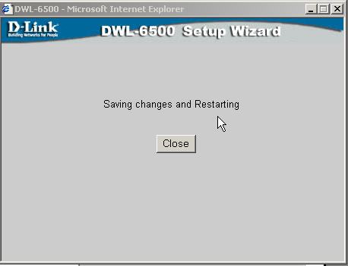
Click Close

You will be returned to the Home tab.

Click Exit
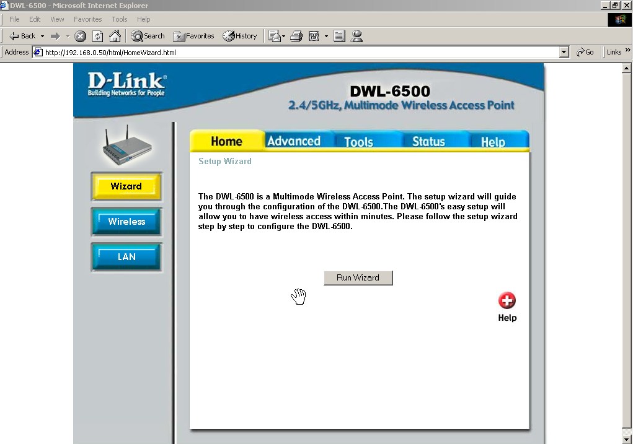

For additional settings or information, refer to the Advanced, Tools, or Status tabs on the web-management interface; or to the manual located on the CD-ROM.

APPENDIX

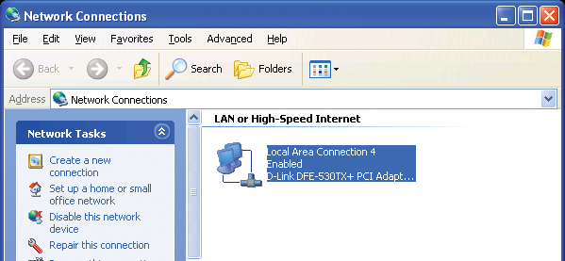
To assign a Static IP address to the Ethernet adapter, please do the following steps. The examples below are using a DFE-530TX+ in Microsoft Windows XP, and Mac OS X.
Note: Screens in other Operating Systems will look different

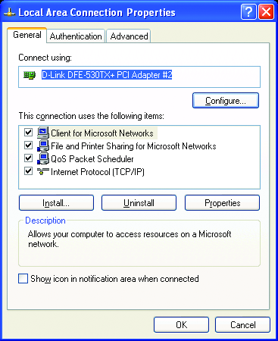
For Microsoft Windows XP:
Go to Start > right click on
My Network Places >
select Properties > Double-click on
the Network Connection associated
with the Ethernet adapter (i.e.,
D-Link DFE-530TX+).

Click Internet Protocol (TCP/IP)

Click Properties

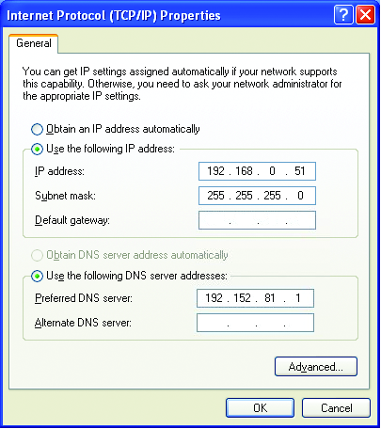

Select Use the following IP address
Enter the following:
IP address: 192.168.0.51
Subnet mask: 255.255.255.0

Click OK

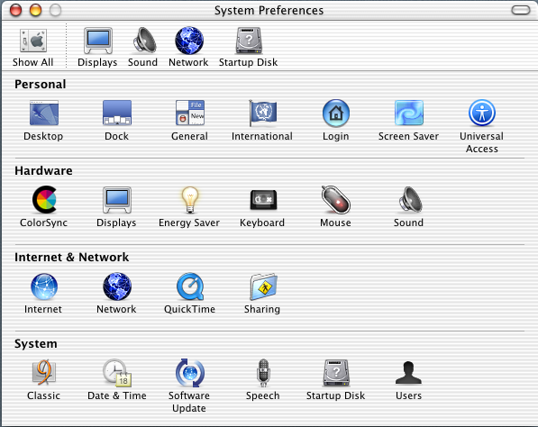
Setting a Static IP address for
Apple Macintosh OS X:

Go to the Apple Menu
Click on Network
and Select System
Preferences.

Select Built-in Ethernet in the Show pull-down menu
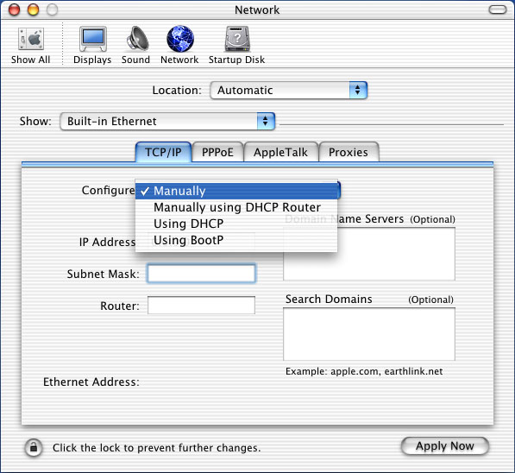

Select Manually in the Configure pull-down menu

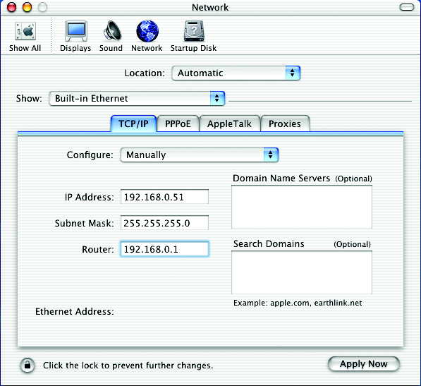

Enter the IP address information,
the Subnet Mask and the Router’s IP address.

Click on Apply Now

NOTES


Technical Support
Software updates and documentation are available on the D-Link website.

D-Link provides free technical support for customers within the United States for the duration of the warranty period on this product.

U.S. customers can contact D-Link technical support through our web site or by phone.

D-Link Technical Support over the Telephone:
(877) 453-5465
24 hours a day, seven days a week

D-Link Technical Support over the Internet:
http://support.dlink.com
email: support@dlink.com

