DWL-8200AP

Date:TBD

Product name: | AirPremier DWL-8200AP 802.11a/g Managed Dualband Access Point
Revision: | A1
Available: | B/Aug. 2005
Picture: | 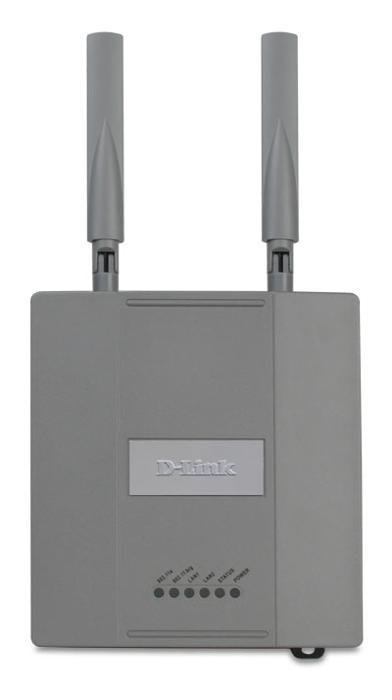
Why Sell This Product: | By Marketing
Key Features: | By Marketing
Technical Details: | By Marketing
EMI/EMC Report | ☑FCC No. KA2DWL8200APA1 ☑ CE No. ◻ VCCI No.  ◻ CTR-21 No. ☑ C-Tick No. ◻ A-Tick No.  ◻ FDA No. ◻ R&TTE No. ◻ BSMI No.  ◻ Others ICES: WiFi
Safety | ◻ TUV No. ☑◻ UL No. ☑ ◻ CSA No._________  ◻ Others
Packaging Style | ◻ Clamshell ◻ White Box ◻ Gift Box ◻ Bulk ◻ White Box with D-Link Logo  ☑ Others (BROWN BOX)
Packaging Contents: | - DWL-8200AP Device  - Power over Ethernet base unit  - CAT5 Ethernet cable  - Power Adapter/Cord  - Two detachable antennas  - Manual and Warranty on CD  - QIG  - Mounting plate
UPC Code:
  BWL8200ANAA1 | 790069 276590
  CWL8200ACAA1 | 790069 276590
  TWL8200ATWA1 | 790069 281990
  NWL8200CCNA1 | 790069 282003
  IWL8200ESGA1 | 790069 282010
  IWL8200ALAA1 | 790069 282027
  IWL8200ELAA1 | 790069 282034
  IWL8200NAUA1 | 790069 282041
Units Per Carton: | 5
Cartons Per Pallet: | For USA Air: 30, Sea:48 | For WW Air:30, Sea:48  For EU/UK Air: 42, Sea:42
Dimensions and Weight: | Box:  ,Others , kg  Carton: 620*300*250 mm, 9.455 kg  Pallet: (by Air) 1220*1020*1380 mm, 314.65 kg (for USA)  _1100*1200*1400 mm, 309.65 kg (for WW)  _1100*1200*1885 mm, 431.11 kg (for UK/EU)  (by Sea)1220*1020*2130 mm, 484.84 kg (for USA)  _1100*1200*2150 mm, 479.84 kg (for WW)  _1100*1200*1885 mm, 431.11 kg (for UK/EU)  INTRASTAT weight: 1.741 kg (Box)  Packing material weight (Box):  - Paper: 0.320 kg  - Plastic: 0.0214 kg  - Mixed: 0.0034 kg

PMA
Product Class
Item Group
Sub Group
Intelligence
Tech.(Features)
Layer
Application
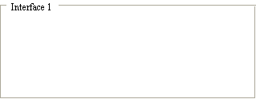
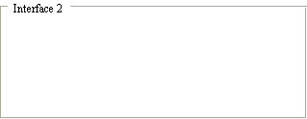
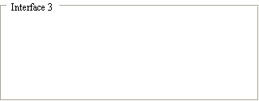
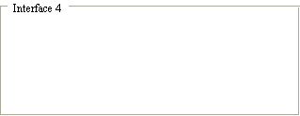
Q'ty

Interface
Net Interface
Port NO.
Interface
Net Interface
Port NO.
Interface
Net Interface
Port NO.
Interface
Net Interface
Port NO.
Approved | Checked | PM
Robert Lin |  | Matt Chen

