ROM File recover unit procedure

Step1. Power the unit off by unplugging its power adapter .

Step2. Insert a paper clip in to the reset pinhole , press and hold the reset button.

Step3. Power the device back on by plugging it in , continue to hold the reset button .

Step4. After 5 seconds , release the reset button , type http://192.168.0.50/ on network
address in the Web browser , the unit should be at “Firmware Upgrade” .

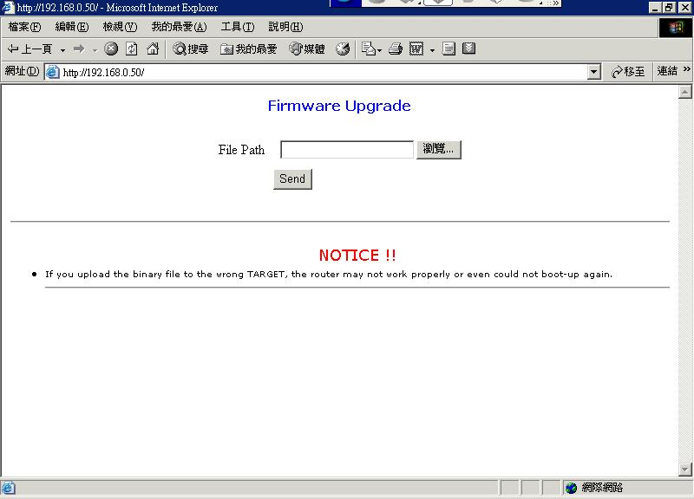

Press browse button , browse the directory of ROM file located, then press Send
button .
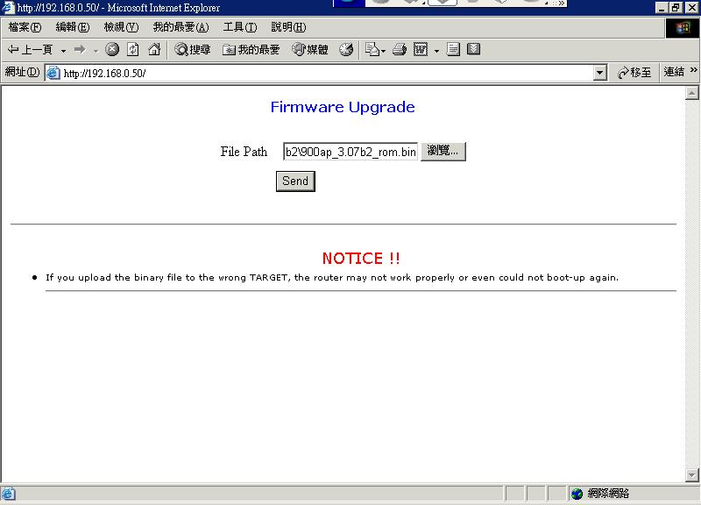

The unit will reboot itself , after wait for a minute and then close the browser .
Reopen browser , type http://192.168.0.50/ on network address .
Lastly , the unit will into normal Web configuration .

