DWL-AG530

Date: March 8, 2004

Product name: | 802.11a/g Wireless PCI Adapter
Product Group & Type: | Wireless PCI Adapter
Revision: | A1
Available:
Picture: | 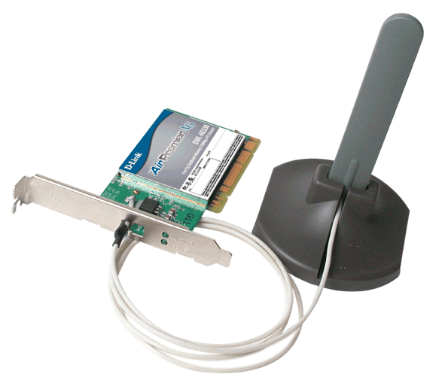
Why Sell This Product: | - Super AG 108Mbps high speed dualband. This DWL-AG530 card will eventually replace the current DWL-AG520 card that supports only 54Mbps speed. The DWL-AG530's Super AG 108Mbps speed is provided by means of a software driver provided on the CD.  Selling Points  - Same price as DWL-AG520 but has higher speed.  - Tri-mode a/b/g, dualband wireless.  - Advanced security with WPA, 802.1x authentication, TKIP and Pre-Shared Key function support.
Keyfeatures: | - 802.11a/g industry standard  - Dual 5GHz and 2.4GHz frequency bands  - Up to 108Mbps (Turbo mode) network data transfer rate on both frequency bands, 15 times faster than 802.11b  - Strong 64/128/152-bit WEP data encryption security  - Compatible with existing 802.11b wireless devices  - Advanced security with WPA, 802.1x authentication, TKIP and Pre-Shared Key function support  - Powerful integrated antenna provides 100-meter indoor,400-meter outdoor operation range *  - Runs Windows 98 SE, 2000, ME, XP  *Environmental factors may adversely affect range
Technical Details: | Standards  - IEEE 802.11a  - IEEE 802.11b  - IEEE 802.11g  Bus Type  - PCI 2.2  - PCI 32-bit interface  Media Access Control  CSMA/CA with ACK  Data Rates  (With automatic fallback)  54Mbps, 48Mbps, 36Mbps, 24Mbps, 18Mbps, 12Mbps, 11Mbps,  9Mbps, 6Mbps, 5.5Mbps, 2Mbps, 1Mbps  Modulation Technology  - Orthogonal Frequency Division Multiplexing (OFDM)  - Complementary Code Keying (CCK)  - Direct Sequence Spread Spectrum (DSSS)  Frequency Range *  - 2.4GHz to 2.5GHz  - 5.15GHz to 5.875GHz  * Software configurable as allowable frequency will vary from country to country in the  European region.  Transmit Output Power  - 802.11a:  +10 to 14dBm for 54Mbps  +11 to 15dBm for 48Mbps  +13 to 15dBm for 36Mbps  +17 to 18dBm for 24, 18, 12, 9 and 6Mbps  - 802.11b:  +18dBm for 11, 5.5, 2 and 1Mbps  - 802.11g:  +10 to 14dBm for 54Mbps  +11 to 15dBm for 48Mbps  +13 to 15dBm for 36Mbps  +17 to 18dBm for 24, 18, 12, 9 and 6Mbps  Receive Sensitivity  - 802.11a (@ 10% PER):  -87dBm for 6Mbps  -86dBm for 9Mbps  -85dBm for 12Mbps  -83dBm for 18Mbps  -80dBm for 24Mbps  -76dBm for 36Mbps  -71dBm for 48Mbps  -66dBm for 54Mbps  -73dBm for 108Mbps (Turbo mode)  - 802.11b (@ 8% PER):  -84dBm for 11Mbps  -90dBm for 2Mbps  - 802.11g (@ 10% PER):  -87dBm for 6Mbps  -86dBm for 9Mbps  -85dBm for 12Mbps  -83dBm for 18Mbps  -80dBm for 24Mbps  -76dBm for 36Mbps  -71dBm for 48Mbps  -66dBm for 54Mbps  Antenna  2dBi to 4dBi Gain omni-directional dipole antenna  Operation Range  - Indoors: up to 100 meters (328 feet)*  - Outdoors: up to 400 meters (1,312 feet)*  * Environmental factors may adversely affect range  Security  - 64/128/152-bit WEP data encryption  - 802.1x authentication  - WPA (Wi-Fi Protected Access): 802.1x, Pre Share Key, WEP, TKIP,  AES  Physical & Environmental  LED Indicators  - Power  - Network  Operating Voltage  5 VDC +/- 10%  Power Consumption  - Transmit mode: 1650mW  - Receive mode: 1250mW  - Sleep mode: 40mW  Dimensions  133 (L) x 120 (W) x 22 (H) mm  Weight  63grams  Operating Temperature  0 to 45 °C  Storage Temperature  -10 to 60 °C  Humidity  95% maximum (non-condensing)  EMI Certification  - FCC Class B  - CE Class B  O.S. Support  Windows 98 SE, ME, 2000, XP
EMI/EMC Report | ☑FCC No.KA22002080002-2 (USA V.A1) ; KA22003070024-2 (USA V.A2/A3) ; KA22003070024-1 (WW V.A1) ☑ CE&RTTE No. ◻ VCCI No. ◻ CTR-21 No.  ☑ C-Tick No. ◻ A-Tick No. ◻ FDA No. ◻ R&TTE No. ◻ BSMI No. ◻ Others
Safety | ◻ TUV No. ◻ UL No. ◻ CSA No.  ◻ Others
Packaging Style | ◻ Clamshell ☑ White Box ☑ Gift Box ◻ Bulk ◻ Others
Packaging Contents: | - DWL-AG530 wireless PCI adapter  - One QIG and one  - CD-ROM for manual and driver.  - Only provide low profile bracket for U.S.A.
UPC Code:
  BDWLAG530.A1  790069 264375 | BDWLAG530.A2  790069 264375 | BDWLAG530.A3  790069 264375
  BWLAG530ODA1  790069 264375 | BWLAG530ODA2  790069 264375 | BWLAG530ODA3  790069 264375
  DWLAG530AUA1  790069 265297 | DWLAG530EUA1  790069 265341 | TDWLAG530.A1  790069 265358
  DWLAG530SGA1  790069 265310 | DWLAG530LAA1  790069 265327 | DWLAG530FRA1  790069 265334
Units Per Carton: | 20
Cartons Per Pallet: | Air::15, Sea: 20
Dimensions and Weight: | Box: 280 x 203 x 70 mm, 0.625 kg  Carton: 592 x 397 x 452 mm, 14 kg  Pallet: (by Air)120 x110 x 148 cm/Per Pallet A (Air)  120 x110 x 149 cm/Per Pallet C (Air)  110 x120 x 149 cm/Per Pallet E (Air)  122 x 102 x 149 cm/Per Pallet F (Air)  225 Kg/Per Pallet A (Air)  225 Kg/Per Pallet C (Air)  228.5 Kg/Per Pallet E (Air)  (by Sea) 120 x110 x 192.8 cm/Per Pallet A(Sea)  120 x110 x 193.8 cm/Per Pallet C(Sea)  110 x120 x 194.3 cm/Per Pallet E(Sea)  122 x 102 x 193.8 cm/Per Pallet F(Sea)  295Kg/Per Pallet A (Sea)  295Kg/Per Pallet C (Sea)  298.5 Kg/Per Pallet E (Sea)  - Paper: kg  - Plastic: kg  - Mixed: kg

