

Product Announcement

Date: 2005/04/26
To: USA/WW

Subject: New Product Release for DWL-G510 PCI Adapter

D-Link is pleased to make this formal announcement for the following new product.
Please start to promote for this new product and advise if we can be helpful in any aspects.

Model Name: DWL-G510

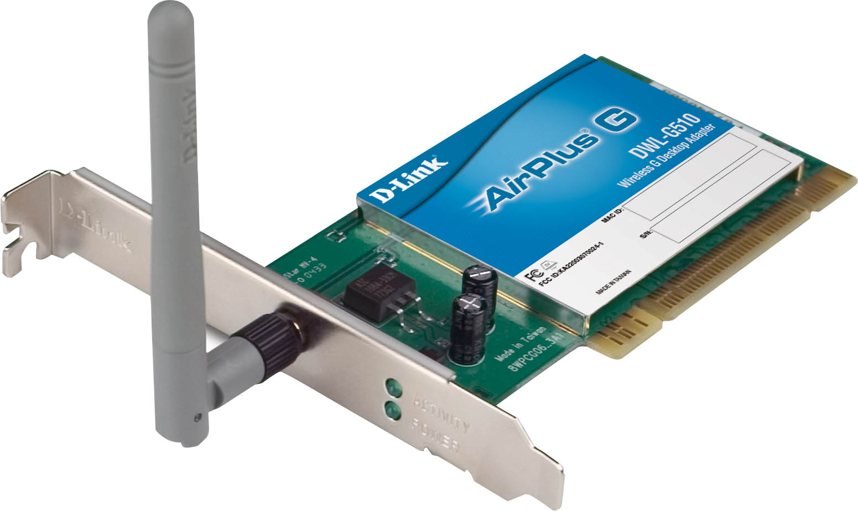

About DWL-G510
The D-Link AirPlusG DWL-G510 PCI Adapter is a Wireless PCI Adapter featuring the very latest in advanced wireless silicon chip technology to deliver a maximum wireless signal rate of up to 54Mbps in the 2.4GHz frequency, also works with 802.11b standard wireless devices and when used with other D-Link AirPlus G products delivers throughput speeds capable of handling heavy data payloads

The DWL-G510 Wireless PCI Adapter includes an intuitive configuration utility that allows you to discover and connect to other wireless networks in nearby areas. In addition, the utility can also create detailed connectivity profiles of networks you frequently access. You can also enable support for WPA and 802.1x for enhanced data encryption and user authentication.

The DWL-G510 is a powerful 32-bit PCI adapter that installs quickly and easily into desktop PCs and when used with other D-Link AirPlus G products automatically connects to the network. Like all D-Link wireless adapters, the DWL-G510 can be used in Ad-Hoc mode to connect directly with other 2.4GHz wireless computers for peer-to-peer file sharing or in Infrastructure mode to connect with a wireless access point or wireless router for access to the Internet in your office or home network. The DWL-G510 is an ideal solution enabling wireless networking capabilities on desktops PCs for the home or office.

Product Feature

- 802.11g wireless Connectivity for Your Desktop PC
- Up to 54Mbps
- Installation Wizard Included
- Built-in Configuration Utility for Management and Network Setup
- Enhance Security Features Including WPA and 802.1x
- 802.11g Standard, 802.11b backward Compatible
- 32-bit PCI Performance/Plug&Play Connectivity
- Driver supported : Windows XP/2000/98/Me

Technical Specifications

IEEE 802.11b Section
Feature | Detailed Description
Standard | - IEEE 802.11b
Radio and Modulation Schemes | - DQPSK, DBPSK, DSSS, and CCK
Operating Frequency | - 2400 ~ 2497MHz ISM band
Channel Numbers | - 11 channels for United States  13 channels for Europe Countries  - 14 channels for Japan
Data Rate | - 11, 5.5, 2, and 1Mbps
Media Access Protocol | - CSMA/CA with ACK
Transmitter Output Power | - Typical 18dBm at 11, 5.5, 2, and 1Mbps
Receiver Sensitivity | - Typical –84dBm for 11Mbps @ 8% PER  - Typical –90dBm for 2Mbps @ 8% PER

IEEE 802.11g Section
Feature | Detailed Description
Standard | - 2.4GHz OFDM (IEEE 802.11g )
Radio and Modulation Schemes | - BPSK, QPSK, 16QAM, 64QAM, and OFDM
Operating Frequency | - 2400 ~ 2497MHz ISM band
Channel Numbers | - 11 channels for United States  13 channels for Europe Countries  - 14 channels for Japan
Data Rate | - 54, 48, 36, 24, 18, 12, 9, and 6Mbps
Media Access Protocol | - CSMA/CA with ACK
Transmitter Output Power | - Typical RF Output Power at each Data Rate  - +12 ~ 15dBm at 54Mbps  - +13 ~ 16dBm at 48Mbps  - +14 ~ 17dBm at 36Mbps  - +17 ~ 18dBm at 24, 18, 12, 9, and 6Mbps
Receiver Sensitivity | - Typical Sensitivity at Which Frame (1000-byte PDUs) Error Rate = 10%  - –87dBm at 6Mbps  - –86dBm at 9Mbps  - –85dBm at 12Mbps  - –83dBm at 18Mbps  - –80dBm at 24Mbps  - –76dBm at 36Mbps  - –71dBm at 48Mbps  - –66dBm at 54Mbps

General Section
Feature | Detailed Description
Antenna Type  Internal Antenna | - Omni-directional dipole antenna with 2dBi  - Provides provision for an Internal Antenna attach (opton)
Operating Voltage | - 5VDC +/- 10%
Current Consumption | - 1650 mA at continuous transmit mode  - 950 mA at continuous receive mode  - 40mW at sleep mode
Form Factor and  Interface | - PCI Local Bus 2.2 Compliance  - Low-profile and half-length (PCI Raw Variable Height Short Card)  - PCI 32-bit Interface
LEDs | - Act LED  - Power LED

Physical Environmental:
Feature | Detailed Description
Operating Temperature Conditions | - The product is capable of continuous reliable operation when operating in ambient temperature of 0 ℃ to +55℃.
Non-Operating Temperature Conditions | - Neither subassemblies is damaged nor the operational performance is degraded when restored to the operating temperature after exposing to storage temperature in the range of –20 ℃ to +75 ℃.
Operating Humidity conditions | - The product is capable of continuous reliable operation when subjected to relative humidity in the range of 10% and 90% non-condensing.
Non-Operating Humidity Conditions | - The product is not damaged nor the performance is degraded after exposure to relative humidity ranging from 5% to 95% non-condensing

EMI
- FCC Class B
- CE
- C-Tick

System Requirements

PC with
- 300MHz Processor
- 64 MB Memory or Higher
- CD-ROM Drive
- Available 32-bit PCI Slot
- TCP/IP Protocol Installed
- Microsoft Windows XP/2000/98/Me

Packaging Content

- DWL-G510 Wireless G PCI Adapter
- Detachable Antenna
- Low Profile Bracket
- CD-ROM with Software and Manual
- Quick Installation Guide

Ordering Information(Part no. & Packing Description)

- BWLG510NA.B1: DWL-G510 REV.B1 FOR USA and NA freq.
- CWLG510NA.B1: DWL-G510 REV.B1 FOR Canada and NA freq.
- EWLG510EU.B1: DWL-G510 REV.B1 FOR Europe and EU freq.
- IWLG510EU.B1: DWL-G510 REV.B1 FOR DI and EU freq.
- IWLG510NA.B1: DWL-G510 REV.B1 FOR DI and NA freq.
- NWLG520+A.B1: DWL-G510 REV.B1 FOR China and EU freq.
- TWLG510NA.B1: DWL-G510 REV.B1 FOR Taiwan and NA freq.

Ordering Price

Please refer to “Price Book”

Lead Time:

4 Weeks Per Order(with Forecast)

