DWL-G700AP

Date: May 18,2005

Product name: | 802.11g/2.4GHz 54Mbps Wireless Access Piont
Revision: | B1
Available: | E/May, 2005
Picture: | 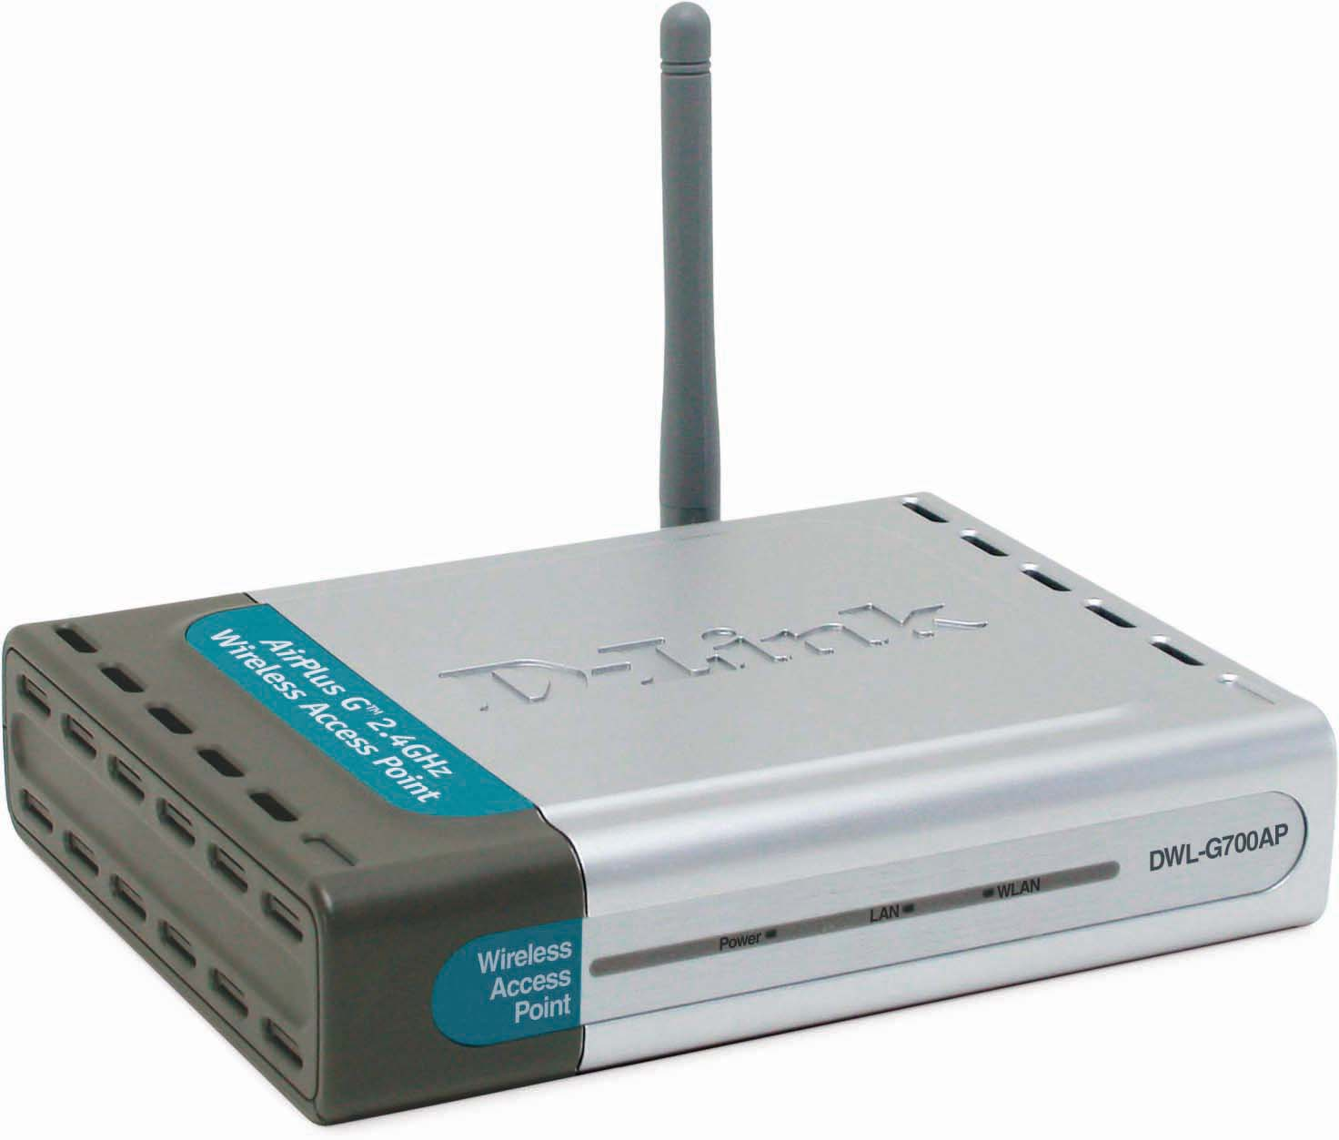
Why Sell This Product: | As margins for the basic 802.11b gear is slipping, we are phasing in more 802.11g products for you to boost wireless LAN profits. This product belongs to the cost-down 802.11g AirPlusG product line, and can supplement products like DWL-G510 and DWL-G630 wireless adapters.  Selling Points  - No 108Mbps Turbo mode, but lower cost, lower price.  - 54Mbps speed.  - More WPA and WPA2 functions added (WPA EAP, WPA PSK)
Key Features: | - 802.11g 2.4GHz standard  - Up to 54Mbps wireless data transfer rates  - 10/100BASE-TX port for connection to Ethernet or DSL/cable modem  - Compatible with existing 802.11b wireless devices  - Built-in DHCP server for multiple user access  - 64/128-bit WEP data encryption  - WPA and the latest standard WPA2 security support  - Web-based configuration & management
Technical Details: | Network Standards  - 802.11g wireless LAN  - 802.11b wireless LAN  - 802.3/802.3u 10BASE-T/100BASE-TX Ethernet  - ANSI/IEEE 802.3 NWay auto-negotiation  Media Access Control Protocol  CSMA/CA with ACK  Network Architecture Type  Infra-structure mode  Operating Frequency  2.4 to 2.4835 GHz ISM band  Operating Channels  - FCC: 11  - ETSI: 13  Radio and Modulation Schemes  DQPSK, DBPSK, CCK, OFDM  Transmit Output Power (for 802.11b)  Minimum +16dBm typically  Transmit Output Power (for 802.11g)  Minimum +13dBm typically  Security  - 64/128-bit WEP data encryption  - WPA EAP, WPA PSK  - WPA2 AES  - MAC address filtering  - SSID broadcast disable function  Antenna  2dBi Gain detachable external omni-directional dipole antenna with RP-SMA connector  Device Management  Web-based management through Internet Explorer v.6 or later, Netscape Navigator v.6 or later or other Java-enabled browser  Operating Voltage  7.5VDC 1A  Power Input  Through external power adapter  Certification  - FCC Part 15.247  - ETS 300 328
EMI/EMC Report | ☑FCC No. ☑ CE No. ◻ VCCI No.  ◻ CTR-21 No. ☑ C-Tick No. ◻ A-Tick No.  ◻ FDA No. ◻ R&TTE No. ◻ BSMI No.  ◻ Others
Safety | ◻ TUV No. ◻ UL No. ◻ CSA No.  ◻ Others
Packaging Style | ◻ Clamshell ◻ Brown Box ☑ Gift Box ◻ Bulk ◻ Others
Packaging Contents: | - DWL-G700AP Device  - Detachable Antenna  - CAT5 Ethernet cable  - Power Adapter (7.5V/1A)  - CD with Manual  - QIG  - Mounting Kits  - Vertical Stand
UPC Code:
  Part Number | UPC Code
  EWLG700BEUB1 | 790069 | 281679
  EWLG700EEUB1 | 790069 | 281686
  IWLG700ANAB1 | 790069 | 281693
  IWLG700BEUB1 | 790069 | 281709
  IWLG700EEUB1 | 790069 | 281716
  IWLG700ENAB1 | 790069 | 281723
  IWLG700EISB1 | 790069 | 281730
  IWLG700NEUB1 | 790069 | 281747
  TWLG700ANAB1 | 790069 | 281822
  NWL2K+ACEUB1 | 790069 | 281754
Units Per Carton: | 10
Cartons Per Pallet: | For WW by Air: 33 Sea: 44 | For EU by Air: 44 Sea: 44
Dimensions and Weight: | Box:  , Others mm, 1 kg  Carton: 366*287*442 mm, 11 kg  Pallet: (by Air) 120*110*150 cm, 378 kg (for WW)  (by Sea) 120*110*195 cm, 499 kg (for WW)  (by Air) 120*110*195 cm, 499 kg (for EU)  (by Sea) 120*110*195 cm, 499 kg (for EU)  INTRASTAT weight: 900 g (Box)  Packing material weight (Box):  - Paper: 80.5 g  - Plastic: 15.5g  - Mixed: 4 g

